WEEK 1 DATA SCIENCE PROJECT PLAN
Customer Churn Prediction for a Subscription-Based Service
Project Planning, Strategy, Methodology, Timeline & Expected Outcomes
Prepared for: Week 1 Data Science Project
Planned technology: Python
Planned effort: 32 hours

1. Project Background & Problem Statement
Customer churn is the situation in which a customer stops using or paying for a subscription service. For a hypothetical subscription-based digital service, management may have large volumes of customer, billing, engagement, and support data but limited visibility into which customers are at elevated risk of leaving. The proposed project will use Python-based data science to develop a repeatable analytical workflow that identifies patterns associated with churn and produces a predictive model that can support retention planning.

Motivation and Business Justification
- Retaining existing customers can be operationally important because acquisition and retention decisions should be informed by evidence rather than intuition alone.
- Customer-level behavioral data can reveal relationships among engagement, tenure, payment behavior, service usage, and churn.
- A predictive workflow can help prioritize which cases warrant further review, while an interpretable analysis can help teams understand the factors associated with risk.
- The project is appropriate for a data science workflow because it combines data preparation, exploratory analysis, supervised learning, evaluation, and communication.

2. Project Objectives
The Week 1 plan will establish a complete, testable strategy for the following objectives:
- Define the target variable as customer churn within a specified future observation window.
- Assess candidate data sources and establish a data dictionary, data-quality rules, and governance requirements.
- Clean and transform customer, transaction, usage, and support data into an analysis-ready dataset.
- Explore distributions, relationships, missingness, outliers, and potential churn segments using statistical summaries and visualizations.
- Develop a transparent baseline classification model and compare it with at least one stronger candidate model.
- Evaluate models using metrics appropriate for class imbalance, including precision, recall, F1-score, ROC-AUC and/or PR-AUC.
- Translate model findings into non-prescriptive business insights and identify limitations, risks, and recommended next analytical steps.

3. Project Scope
In Scope | Out of Scope | Scope Boundary
Customer-level churn prediction; data quality; EDA; feature engineering; model development; evaluation; interpretability; reporting. | Automated customer messaging; direct retention offers; production deployment; real-time scoring; financial forecasting; causal claims. | Focus on a hypothetical subscription service and a defined historical prediction window.
Python-based reproducible workflow, notebooks/scripts, validation plan, and documentation. | Building a full cloud/MLOps platform or enterprise dashboard. | Deployment architecture may be documented conceptually but not implemented in Week 1.

4. Success Criteria
- All project stages have a documented purpose, input, output, and quality check.
- Data leakage is explicitly checked before model training.
- Training, validation, and test procedures are separated appropriately.
- Model performance is assessed against a simple baseline and reported with multiple relevant metrics.
- Key findings are traceable to reproducible code and documented assumptions.
- The final report clearly distinguishes observed patterns, model outputs, limitations, and business interpretation.

5. Methodology & Strategy
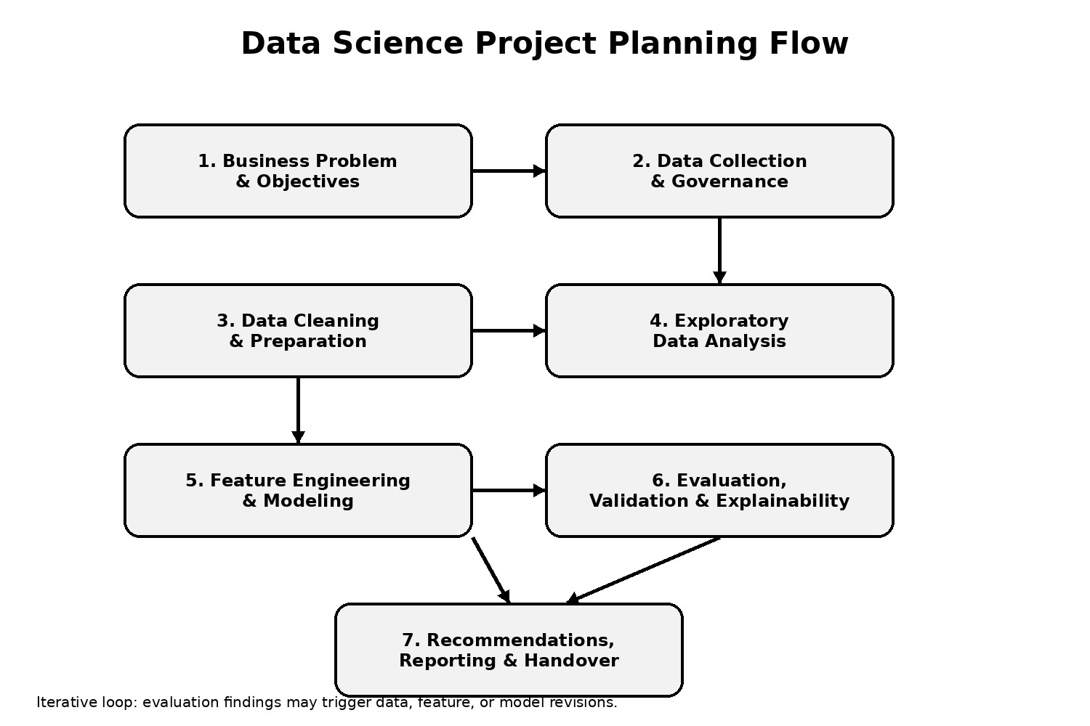
Figure 1. Planned end-to-end data science workflow.

5.1 Problem Definition & Requirements
Define churn, prediction horizon, unit of analysis, stakeholders, constraints, and measurable success criteria. Confirm what decision the model is intended to support and document assumptions before accessing data.

5.2 Data Collection & Governance
Identify candidate sources such as customer profiles, subscriptions, transactions, product usage, support interactions, and historical churn outcomes. Record source ownership, refresh frequency, fields, data types, access permissions, privacy considerations, and retention requirements. Create a data dictionary.

5.3 Data Cleaning & Preparation
Inspect schema, duplicates, missing values, invalid categories, inconsistent dates, impossible values, and outliers. Standardize types and categories, create a consistent customer key, resolve duplicate records, and document every transformation. Avoid using post-churn information as predictors.

5.4 Exploratory Data Analysis
Summarize churn rate, customer tenure, usage patterns, payment behavior, support contacts, and segment-level differences. Use histograms, box plots, bar charts, correlation analysis, and time-based summaries where appropriate. Treat associations as descriptive rather than causal.

5.5 Feature Engineering
Create defensible features such as tenure, recent usage frequency, usage trend, payment delays, support-contact counts, plan changes, and recent activity indicators. Use domain reasoning and ensure each feature would have been available at prediction time.

5.6 Modeling
Start with a simple baseline such as logistic regression. Compare it with a tree-based classifier such as Random Forest or Gradient Boosting. Use a reproducible pipeline for preprocessing and modeling. Apply stratified splitting and cross-validation where appropriate.

5.7 Evaluation & Validation
Evaluate using confusion matrix, precision, recall, F1-score, ROC-AUC and/or PR-AUC. Inspect calibration or threshold behavior if the model will support prioritization. Compare performance against the baseline, assess subgroup behavior where appropriate, and test robustness to reasonable data variations.

5.8 Interpretation & Reporting
Use coefficients, feature importance, permutation importance, or SHAP where appropriate to explain model behavior. Communicate findings with charts and concise narrative. Clearly separate predictive association from causal explanation and document limitations.

6. Data Architecture & Quality Strategy
A conceptual data structure for the project is shown below:
Source | Example Fields | Quality Checks | Output
Customer profile | customer_id, age_band, region, signup_date, plan | Unique ID, valid dates, category consistency | Customer table
Subscription/billing | plan, monthly_fee, payment_status, billing_date | Duplicates, currency/type, date alignment | Billing features
Product usage | sessions, minutes, active_days, last_active | Range checks, missingness, timestamp validity | Engagement features
Support | tickets, resolution_time, issue_type | Duplicate tickets, valid categories, date logic | Support features
Churn outcome | churn_flag, churn_date | Definition consistency, leakage check | Target variable

7. Modeling and Evaluation Strategy
- Baseline: majority-class or simple logistic regression benchmark to establish a meaningful reference point.
- Candidate model: Random Forest or Gradient Boosting, selected after reviewing data size, feature types, interpretability needs, and validation results.
- Class imbalance: inspect the target distribution; consider class weights, threshold tuning, or resampling only within the training process.
- Validation: use stratified train/validation/test splitting; if observations are time-dependent, use time-aware validation instead of random splitting.
- Primary interpretation: focus on precision/recall trade-offs and PR-AUC when churn is relatively uncommon; report ROC-AUC as a complementary metric.
- Error analysis: examine false positives and false negatives and identify whether errors concentrate in specific customer segments.
- Reproducibility: fix random seeds where appropriate, capture package versions, and save preprocessing/model configurations.

8. Tools & Python Libraries
Tool/Library | Planned Use | Reason
Python | Core project language | Widely used ecosystem for data preparation, analysis and machine learning.
pandas | Tabular data manipulation | Filtering, joining, reshaping and feature creation.
NumPy | Numerical operations | Efficient numerical calculations and array handling.
Matplotlib / Seaborn | Visualization | EDA charts and model-performance visuals.
scikit-learn | Preprocessing, modeling, validation, metrics | Consistent ML workflow and evaluation utilities.
Jupyter Notebook | Exploration and documentation | Interactive, reproducible analysis narrative.
Git / GitHub | Version control | Track code, documentation and project changes.
Excel/CSV/SQL (as applicable) | Data access and review | Common formats/interfaces for source data.

9. 32-Hour Project Timeline
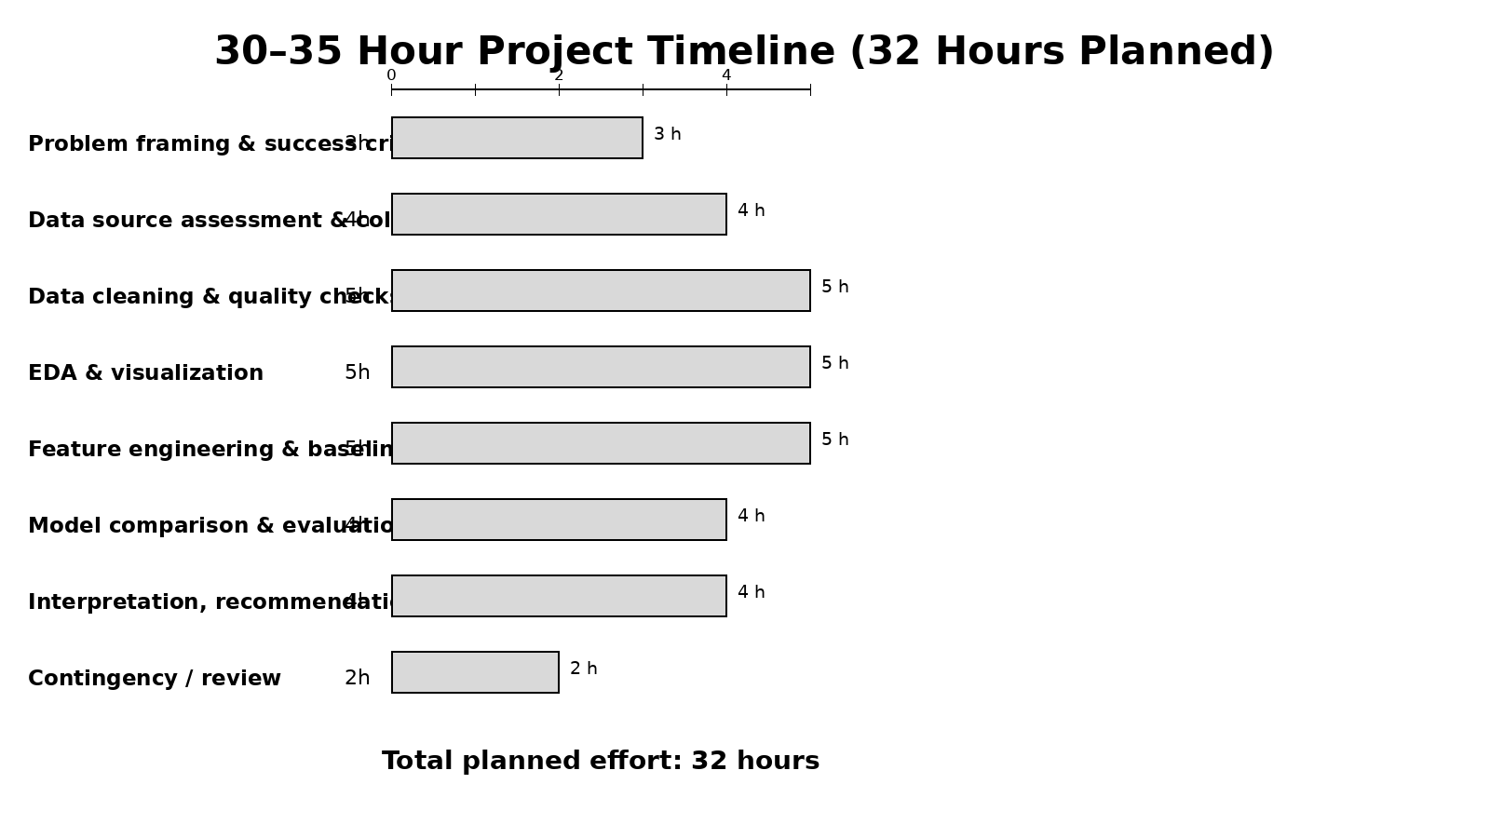
Figure 2. Planned allocation of approximately 30–35 hours (32 hours total).
Work Package | Hours | Key Deliverable
Problem framing & success criteria | 3 | Problem statement, target definition, success metrics
Data source assessment & collection plan | 4 | Data dictionary and acquisition/governance plan
Data cleaning & quality checks | 5 | Cleaned dataset specification and quality report
EDA & visualization | 5 | EDA notebook and visual findings
Feature engineering & baseline model | 5 | Feature set and baseline performance
Model comparison & evaluation | 4 | Validated model comparison and error analysis
Interpretation, recommendations & report | 4 | Final findings and project documentation
Contingency / review | 2 | Issue resolution and quality review

10. Expected Outcomes
- A documented, reproducible Python project structure that can progress from raw data to validated analytical results.
- A cleaned analytical dataset specification and data-quality checklist.
- EDA visualizations describing customer behavior and churn patterns.
- A baseline and candidate churn-classification model with transparent evaluation.
- An interpretation layer identifying variables that are strongly associated with model predictions, without presenting association as causation.
- A final project report containing assumptions, limitations, risks, and next steps.

11. Anticipated Challenges & Mitigation
Challenge | Potential Impact | Mitigation Strategy
Missing or inconsistent data | Biased or unreliable analysis | Profile missingness, define business rules, document imputation, and retain missingness indicators when informative.
Class imbalance | Poor minority-class detection | Use appropriate metrics, stratification, class weights/threshold tuning, and inspect PR-AUC.
Data leakage | Overly optimistic validation | Define a prediction cutoff and verify every feature is available before that cutoff.
Changing customer behavior | Model drift over time | Use time-aware validation where appropriate and plan periodic monitoring.
Overfitting | Weak generalization | Use cross-validation, regularization, feature control, and a held-out test set.
Interpretability limits | Difficult stakeholder adoption | Prefer interpretable baselines and supplement complex models with feature-importance/explanation methods.
Privacy and governance | Compliance and trust risk | Minimize sensitive data, restrict access, document lineage, and anonymize identifiers for analysis where feasible.

12. Project Deliverables
- Project plan and methodology document (this Week 1 deliverable).
- Project folder structure with README, notebooks/scripts, data dictionary, and requirements/environment file.
- Data-quality checklist and preprocessing specification.
- EDA notebook with visualizations.
- Modeling notebook/script with baseline and candidate models.
- Evaluation report with metrics, confusion matrix, error analysis, and limitations.
- Final presentation/report summarizing methodology and findings.

13. Proposed Project Structure
project/
├── data/ # raw, interim and processed data references
├── notebooks/ # exploratory and modeling notebooks
├── src/ # reusable Python modules
├── reports/ # figures and final reports
├── models/ # serialized model artifacts, if permitted
├── tests/ # data and utility checks
├── requirements.txt # package versions
└── README.md # setup, assumptions and usage

14. Evaluation Criteria Alignment
Assessment Area | How This Plan Addresses It
Completeness | Covers background, objectives, scope, methodology, timeline, tools, outcomes, challenges, deliverables and evaluation.
Understanding of data science | Uses an end-to-end workflow from problem definition through validation and communication.
Logical organization | Stages are sequenced, with inputs, outputs, risks and quality controls described.
Visual clarity | Includes an end-to-end flowchart and a 32-hour timeline chart integrated into the document.
Strategic thinking | Defines success criteria, governance, leakage prevention, validation, interpretability and mitigation strategies.

15. Conclusion
This Week 1 plan establishes a structured strategy for a hypothetical customer churn data science project. The approach emphasizes problem definition, data quality, reproducibility, leakage prevention, appropriate validation, interpretability, and clear communication. The planned 32-hour schedule is intentionally staged so that early work on requirements and data quality reduces downstream modeling risk. The strategy can be adapted once the actual dataset, business context, and prediction requirements are known.
Note: The project is hypothetical and does not rely on a real dataset. All data fields, outcomes, and workflow decisions are planning assumptions to be validated in later technical phases.

