WEEK 3: MACHINE LEARNING MODEL DEVELOPMENT PLAN
Hypothetical Customer Churn Prediction Project
Python-based planning document
Planned effort: 32 hours

1. Problem Definition
The hypothetical project is a supervised binary classification problem. The target indicates whether a customer churns within a defined future period. Only information available at the prediction cutoff will be used.

2. Why Machine Learning Fits
- The target has two outcomes: churn or no churn.
- Historical customer behavior can provide predictive signals.
- Classification metrics can quantify model performance.
- Predictions can support prioritization, while final decisions remain subject to human review.

3. Data Preprocessing
- Clean duplicates, invalid values and inconsistent categories.
- Handle missing values using appropriate imputation and, when useful, missingness indicators.
- Encode categorical variables with suitable methods.
- Scale numerical features for scale-sensitive models.
- Engineer tenure, recency, activity frequency, payment delay and trend features.
- Remove leakage and variables unavailable at prediction time.

4. Model Selection and Training
- Logistic Regression as a transparent baseline.
- Decision Tree as an interpretable nonlinear alternative.
- Random Forest as a strong tabular-data candidate.
- Gradient Boosting as another candidate for comparison.
- Use a scikit-learn Pipeline, stratified splitting and cross-validation. Tune selected hyperparameters with GridSearchCV or RandomizedSearchCV.

5. Evaluation Metrics
- Accuracy: overall correctness, but potentially misleading with imbalance.
- Precision: how many predicted churn cases are actually churn.
- Recall: how many actual churn cases are detected.
- F1-score: balance between precision and recall.
- ROC-AUC: discrimination across thresholds.
- PR-AUC: useful when the positive class is uncommon.

6. Validation Strategy
- Use a held-out test set for final evaluation.
- Use stratified k-fold cross-validation when observations are independent.
- Use time-aware validation if behavior is time-dependent.
- Inspect confusion matrices and false positives/false negatives.
- Check performance across relevant segments when sample sizes allow.
- Fit preprocessing only on training data/folds to prevent leakage.

7. Challenges and Mitigation
- Class imbalance → appropriate metrics, class weights and threshold analysis.
- Data leakage → define a prediction cutoff and audit every feature.
- Overfitting → cross-validation, regularization and held-out testing.
- Model drift → monitor data and performance over time.
- Interpretability → retain a transparent baseline and use explanation methods.

8. Conceptual Deployment
If later deployed, the model could run as a batch scoring process or API. Maintenance would include versioning, input validation, monitoring, retraining criteria, access control and rollback procedures. Deployment is conceptual for this assignment.

32-Hour Work Plan
Work Package | Hours | Planned Output
Problem definition | 3 | ML specification
Preprocessing and leakage plan | 5 | Preprocessing strategy
Feature engineering | 4 | Feature specification
Model selection and baseline | 5 | Baseline plan
Training and tuning | 5 | Tuning strategy
Evaluation and validation | 5 | Metrics plan
Deployment concept | 3 | Maintenance plan
Review | 2 | Quality review

Conclusion
This plan provides a practical bridge from EDA to machine learning and emphasizes robust validation, appropriate metrics and leakage prevention.

Strategic Workflow Diagram
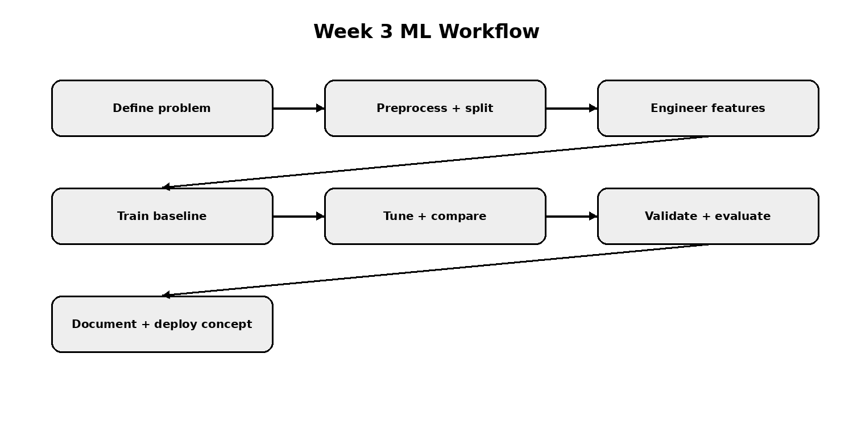
Machine learning workflow diagram

