WEEK 2: EDA & VISUALIZATION FRAMEWORK
Hypothetical Customer Churn Prediction Project
Python-based planning document
Planned effort: 32 hours

1. Introduction to EDA
Exploratory Data Analysis is the process of inspecting, summarizing and visualizing data before formal modeling. For the hypothetical churn project, EDA will be used to understand customer, subscription, billing, usage and support data, identify quality issues, discover patterns and guide later feature engineering.

2. Potential Data Types
- Numerical: monthly fee, sessions, usage minutes and tenure.
- Categorical: plan type, region and payment method.
- Binary: churn flag and auto-renewal status.
- Datetime: signup date, billing date and last active date.
- Text: support notes, if later required for NLP.

3. Data Exploration Techniques
- Initial inspection with pandas shape, info, describe, value_counts and duplicated.
- Missing-value analysis using counts and percentages; decide whether to drop, impute or flag missing values.
- Duplicate and consistency checks for IDs, dates, categories and numeric ranges.
- Univariate analysis using distributions, summary statistics and frequency tables.
- Bivariate analysis using grouped summaries, box plots, count plots and scatter plots.
- Multivariate analysis using correlation heatmaps, pair plots and selected grouped views.
- Outlier investigation using IQR, z-scores where appropriate, box plots and domain limits. Outliers will be investigated rather than automatically deleted.

4. Visualization Strategies
- Histograms: inspect numerical distributions and skewness.
- Box plots: compare spread and outliers across churn groups.
- Bar/count plots: compare categories and churn proportions.
- Scatter plots: inspect relationships between numerical variables.
- Line charts: examine churn or usage trends over time.
- Heatmaps: summarize correlations or missingness patterns.
- Interactive Plotly charts: use when interactive exploration adds value.

5. Python Libraries and Tools
- pandas — data loading, cleaning, reshaping and summaries.
- NumPy — numerical calculations.
- Matplotlib — flexible base charts.
- Seaborn — statistical visualizations.
- Plotly — interactive visualizations.
- Jupyter Notebook — reproducible analysis and narrative documentation.
- scikit-learn — later preprocessing, splitting and validation.

6. Reporting and Documentation
- Start with dataset context and analysis questions.
- Report data-quality findings before substantive patterns.
- Give every important chart a clear title, labeled axes and a short interpretation.
- Document transformations, exclusions and assumptions.
- End with key findings, limitations and questions for modeling.

7. Expected Outcome
A reusable EDA framework that can be applied when the actual dataset becomes available, with clear checks for data quality, distributions, relationships, outliers and useful variables.

32-Hour Work Plan
Work Package | Hours | Planned Output
EDA objectives and assumptions | 3 | Analysis checklist
Data inspection and quality framework | 5 | Quality audit
Missing values, duplicates and outliers | 5 | Cleaning decisions
Univariate analysis | 4 | Distribution plan
Bivariate and multivariate analysis | 5 | Relationship plan
Visualization framework | 4 | Chart catalogue
Documentation design | 3 | Reporting template
Review and contingency | 3 | Final review

Conclusion
This framework prepares the project for practical analysis without assuming that a dataset is already available.

Strategic Workflow Diagram
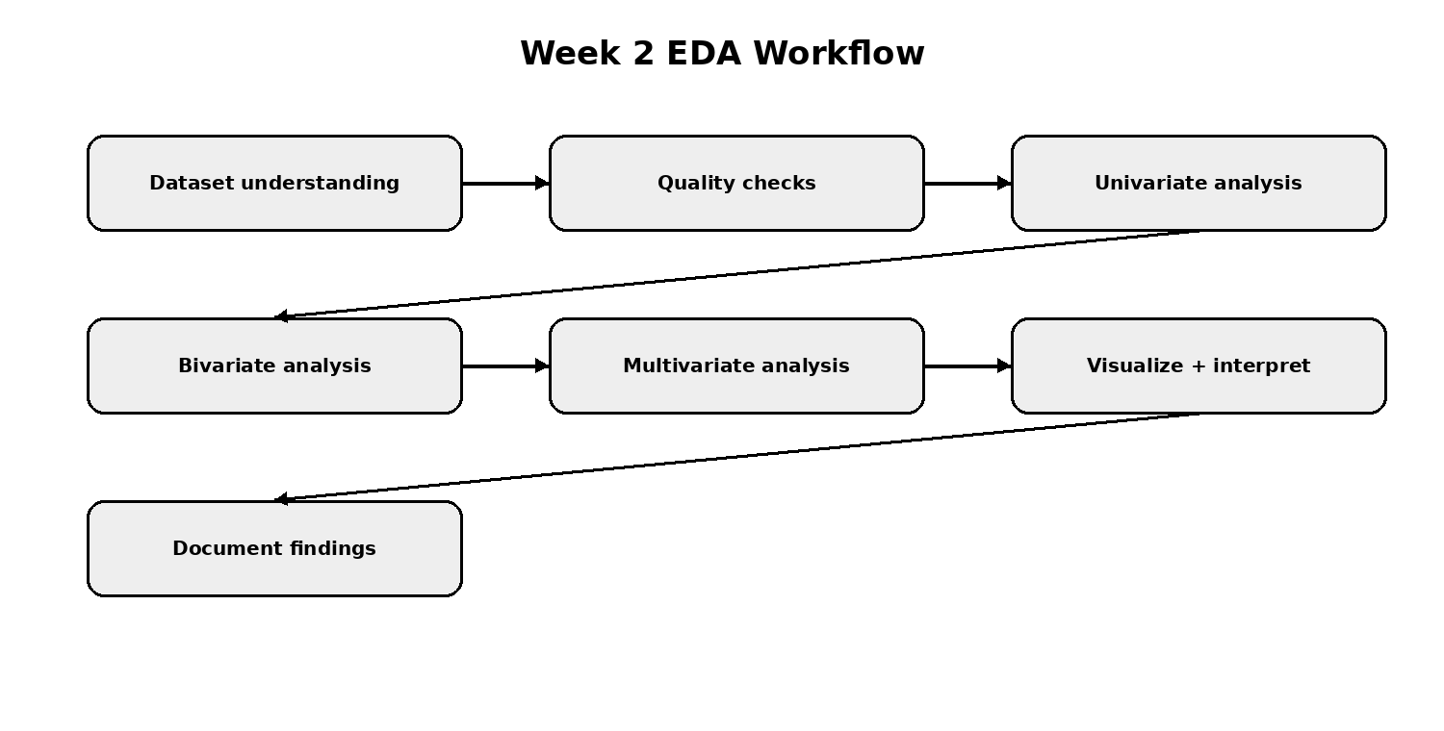
EDA workflow diagram

