**Milestone-2 : Collection and processing of real-time data with Kafka/Spark streaming**

Solution:

Starting the Zookeeper:

/opt/homebrew/opt/kafka/bin/zookeeper-server-start /opt/homebrew/etc/zookeeper/zoo.cfg

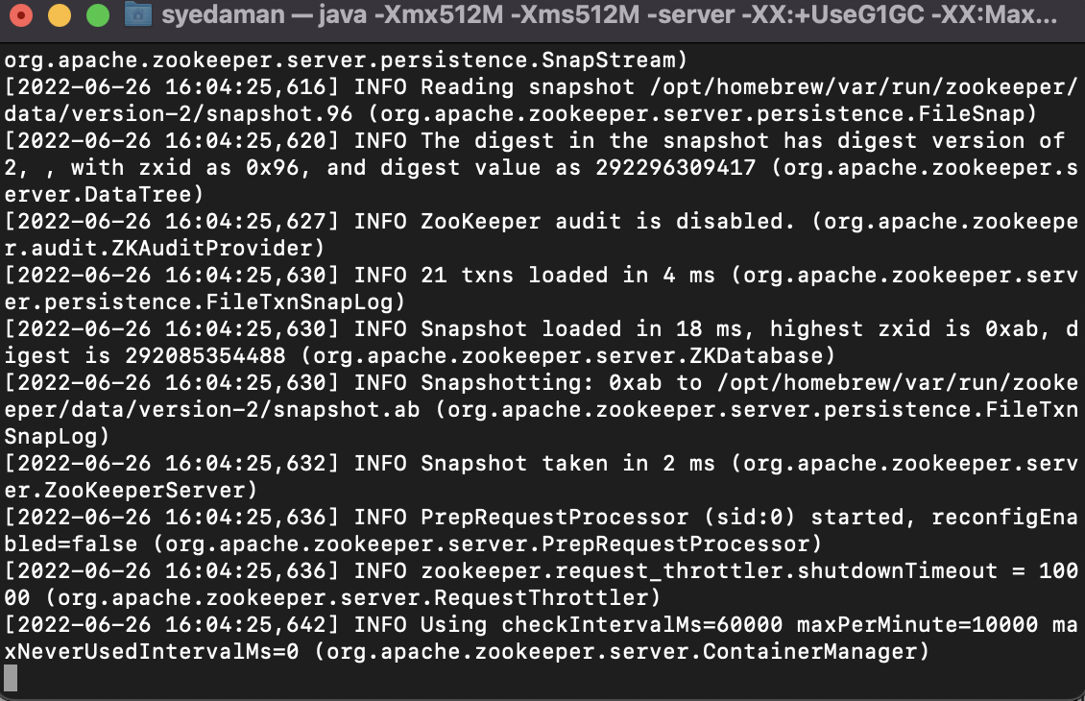

Starting apache kafka with the below command:

/opt/homebrew/opt/kafka/bin/kafka-server-start /opt/homebrew/etc/kafka/server.properties

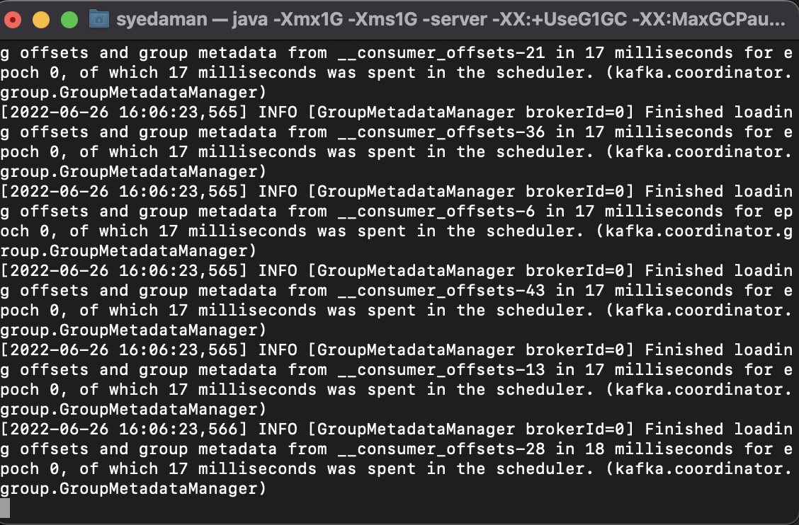

Starting the Topic with the below command:

kafka-topics --bootstrap-server localhost:9092 --topic first_topic –create

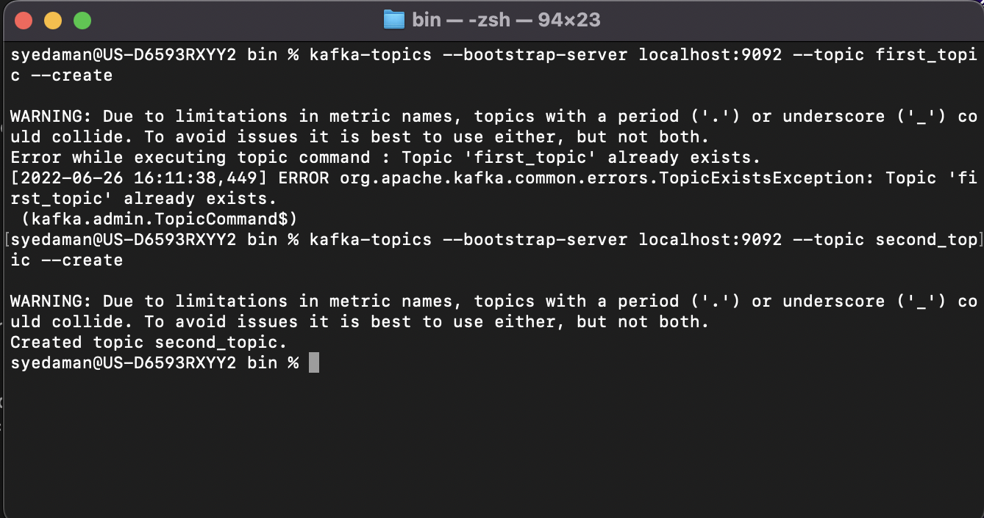

Starting the Producer with the below command and generating the message will be reflected on consumer:

kafka-console-producer --bootstrap-server localhost:9092 --topic first_topic

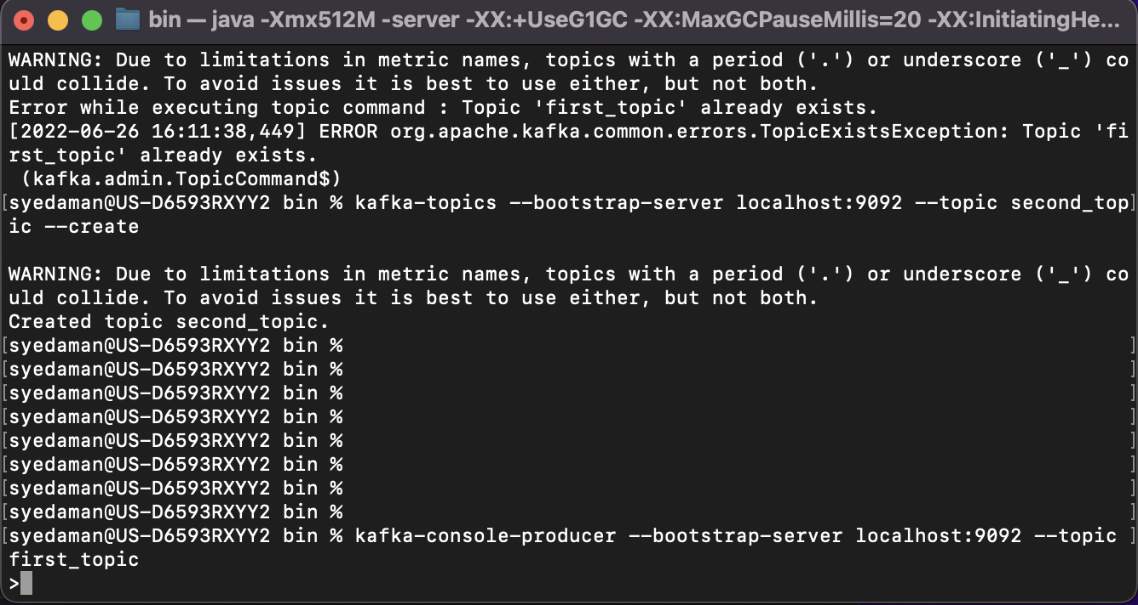

Staring the consumer which will showcasing our messages with the below command :

Kafka-console-consumer --bootstrap-server localhost:9092 --topic first_topic

