**Exp. 3 To Design Doorbell**

**Circuit Diagram:**

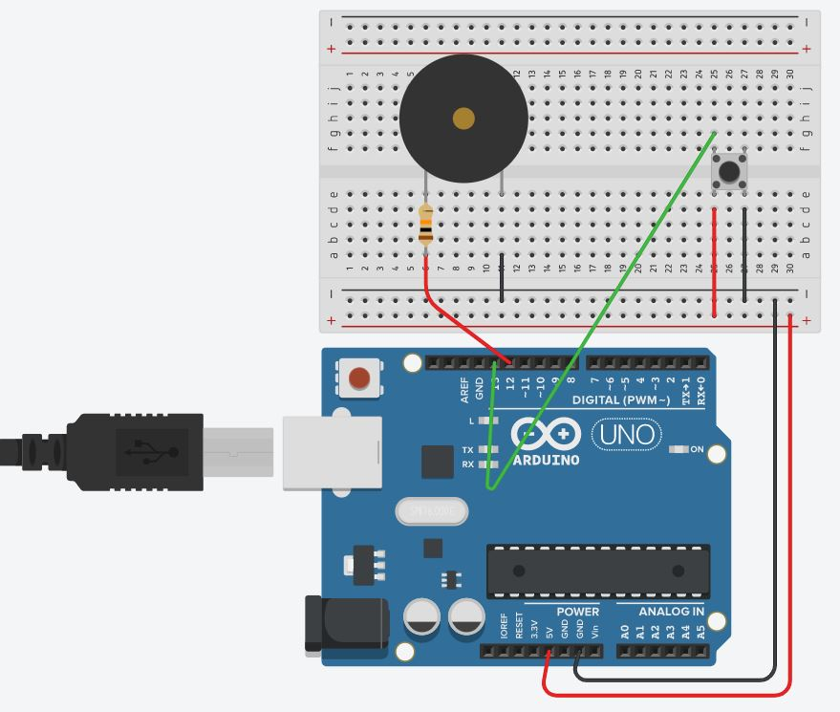

**Theory**

**Concept Used:**

1. Buzzer is unidirectional element implies it is p-n junction diode, so the negative terminal of Buzzer is connected to n-type inside diode is smaller in length will be grounded.
2. Positive terminal of Buzzer which is connected to p-type inside diode is greater in length will be connected to power supply.
3. However, the programing language in Arduino IDE is based on C++ that makes programming easy and handy.
4. For sake of safety of our buzzer diode we have introduced a resistor of 10K Ω.

**Learning & Observation:**

1. Properly using breadboard to make circuit efficiently.
2. Since by default Arduino send the signal for a very short period of time so we have used ‘*delay ()*’ that it doesn’t irritate.
3. As more we increase value inside delay as more period of time Buzzer make sound.

**Problems & Troubleshooting:**

1. Making sure Arduino is connected with computer properly via Power cable.
2. Making sure Arduino UNO is selected in Board Menu in Tools.
3. Making sure Port for Arduino UNO is selected.
4. If buzzer does not blow then checking the faulty element i.e. fused buzzer, Resistor or Jumper wire etc. and replace it.
5. If problem still arises then checking jumper wire connected properly with breadboard.

**Precautions:**

1. Resistor is used for safety of Buzzer.
2. Checking for selection of port and Arduino UNO.

**Learning Outcomes:**

1. Making proper circuit using breadboard.
2. Delay is used for increasing/decreasing duration of blow of buzzer.
3. Buzzer make sound, blow again and again with various delay time.