**Exp. 1** **Design an LED flasher**

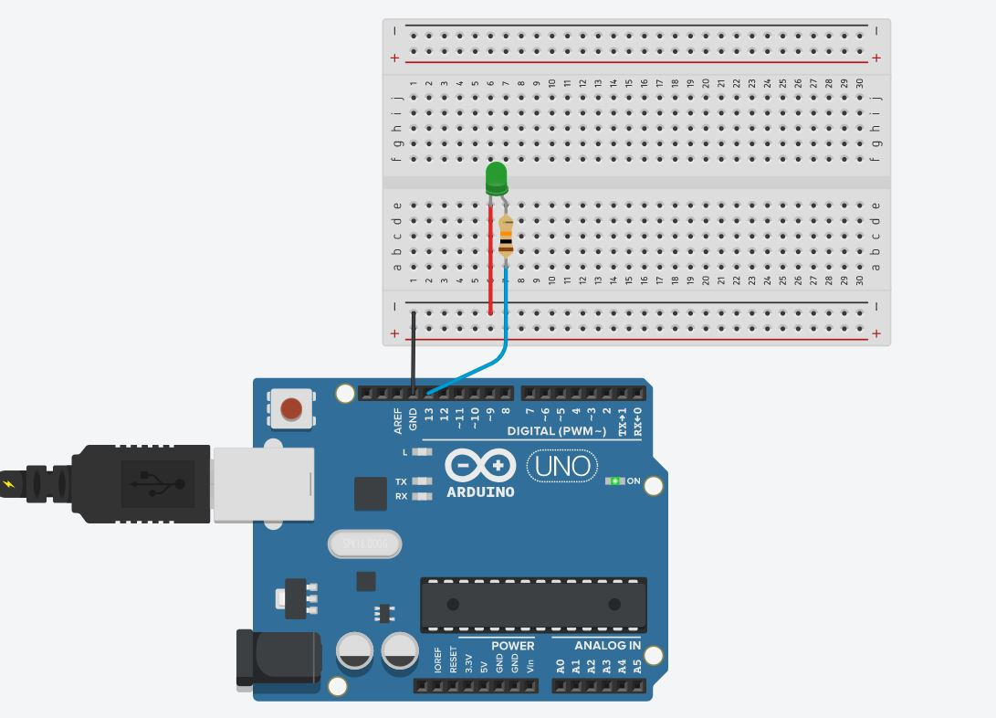**Circuit Diagram:**

**Theory**

**Concept Used:**

1. LED is p-n junction diode, so the negative terminal of LED which is connected to n-type inside diode is smaller in length will be grounded.
2. Positive terminal of LED which is connected to p-type inside diode is greater in length will be connected to power supply.
3. However, the programing language in Arduino IDE is based on C++ that makes programming easy and handy.
4. For sake of safety of our LED diode we have introduced a resistor of 10K Ω.

**Learning & Observation:**

1. Properly using breadboard to make circuit efficiently.
2. Since by default Arduino send the signal of blinking for a very short period of time so we have used ‘*delay ()*’ for making blink visible.
3. As more we increase value inside delay as more period of time LED light up.

**Problems & Troubleshooting:**

1. Making sure Arduino is connected with computer properly via Power cable.
2. Making sure Arduino UNO is selected in Board Menu in Tools.
3. Making sure Port for Arduino UNO is selected.
4. If LED does not flash/blink then checking the faulty element i.e. fused LED, Resistor or Jumper wire etc. and replace it.
5. If problem still arises then checking jumper wire connected properly with breadboard.

**Precautions:**

1. Resistor is used for safety of LED.
2. Checking for selection of port and Arduino UNO.

**Learning Outcomes:**

1. Making proper circuit using breadboard.
2. Delay is used for increasing/decreasing duration of blink of LED.
3. LED light up and light off again and again with various delay time.