**Exp. 1** **Design a Smartphone LED interface**

**Circuit Diagram:**

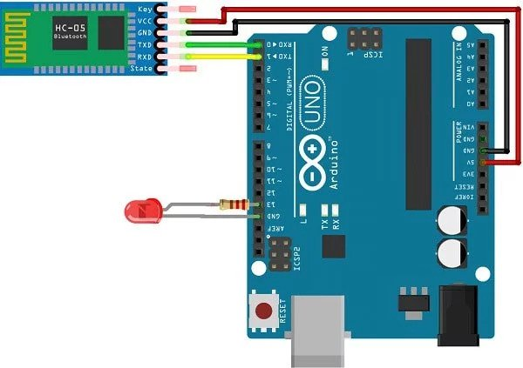

**Theory**

**Concept Used:**

1. LED is p-n junction diode, so the negative terminal of LED which is connected to n-type inside diode is smaller in length will be grounded.
2. Positive terminal of LED which is connected to p-type inside diode is greater in length will be connected to power supply.
3. However, the programming language in Arduino IDE is based on C++ that makes programming easy and handy.
4. For sake of safety of our LED diode we have introduced a resistor of 10K Ω.
5. Since signal is received by Arduino, so we will connect Rx pin of Arduino to Tx pin of Bluetooth.
6. There are so many signals around Arduino so it can glow LED with any type of signal. To getting rid of it we will use char type variable to glow LED.

**Learning & Observation:**

1. Properly using breadboard to make circuit efficiently.
2. The LED will glow when we tap on ON button in mobile application and turn off by tap on OFF button in app.

**Problems & Troubleshooting:**

1. Making sure Arduino is connected with computer properly via Power cable.
2. Making sure Arduino UNO is selected in Board Menu in Tools.
3. Making sure Port for Arduino UNO is selected.
4. If LED does not flash/blink then checking the faulty element i.e. fused LED, Resistor or Jumper wire etc. and replace it.
5. If problem still arises then checking jumper wire connected properly with breadboard.
6. During program upload, we need to disconnect pin 0 since it is a serial pin, and Arduino will not receive program.

**Precautions:**

1. Resistor is used for safety of LED.
2. Checking for selection of port and Arduino UNO.

**Learning Outcomes:**

1. Making proper circuit using breadboard.
2. Tap ON to glow LED and tap OFF button to turn off LED.