**Problem. Design an automatic night lighting system (with 4 connected LEDs) such the system is only activated when the master control switch is pressed. a) Below 50% value of full brightness all LED’s constantly ON. b) Above 50% value of full brightness only first LED is ON.**

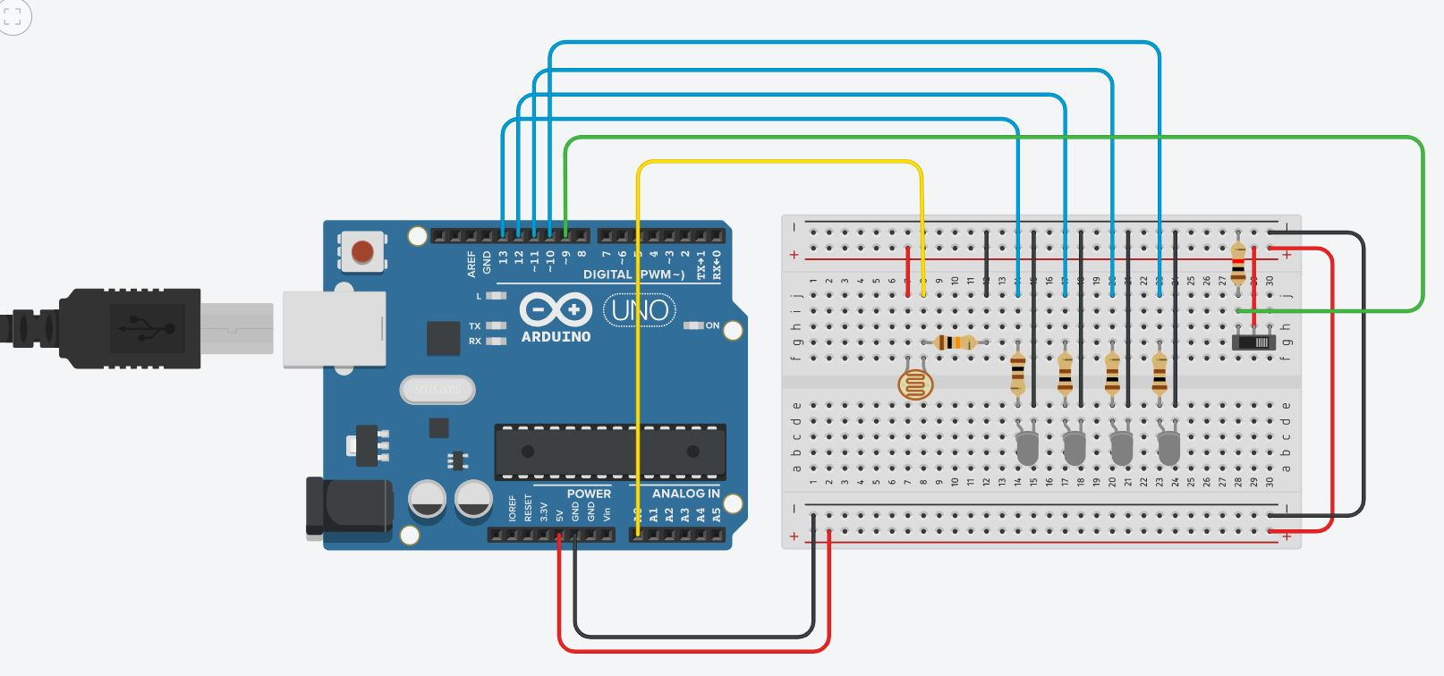**Circuit Diagram:**

**Theory**

**Concept Used:**

1. LED is p-n junction diode, so the negative terminal of LED which is connected to n-type inside diode is smaller in length will be grounded.
2. Positive terminal of LED which is connected to p-type inside diode is greater in length will be connected to power supply.
3. However, the programing language in Arduino IDE is based on C++ that makes programming easy and handy.
4. For sake of safety of our LED diode we have introduced a resistor of 10K Ω.
5. The voltage resolution of an ADC is equal to its overall voltage measurement range divided by the number of intervals:

$$Q=\frac{E_{FSR}}{2^{M}}$$

where *M* is the ADC's resolution in bits and *E*FSR is the full-scale voltage range (also called 'span').

**Learning & Observation:**

1. Properly using breadboard to make circuit efficiently.
2. The resistance of an LDR decreases with increasing incident light intensity.

**Problems & Troubleshooting:**

1. Making sure Arduino is connected with computer properly via Power cable.
2. Making sure Arduino UNO is selected in Board Menu in Tools.
3. Making sure Port for Arduino UNO is selected.
4. If LEDs do not turn on then checking the faulty element i.e. fused LED, Resistor or Jumper wire, LDR etc. and replace it.
5. If problem still arises then checking jumper wire connected properly with breadboard.

**Precautions:**

1. Resistor is used for safety of LED.
2. Checking for selection of port and Arduino UNO.
3. Connections should be tight.

**Learning Outcomes:**

1. Making proper circuit using breadboard.
2. Automatic night lamp functioning was verified after uploading the program.
3. All LEDs are light off when switch is off and turn on when brightness < 50% and only one LED light up when brightness > 50%.