Question 1 Write a program to calculate the volume, surface area, and circumference of a capsule having radius r ranging from 6 to N in increments of 6 and side length a, where N and a are determined by the user.

ScreenShot-1:

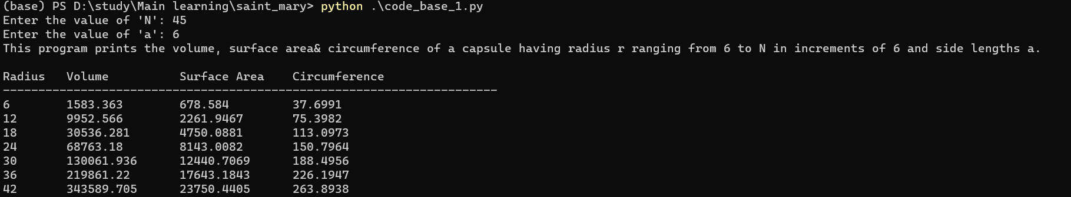

ScreenShot-2:

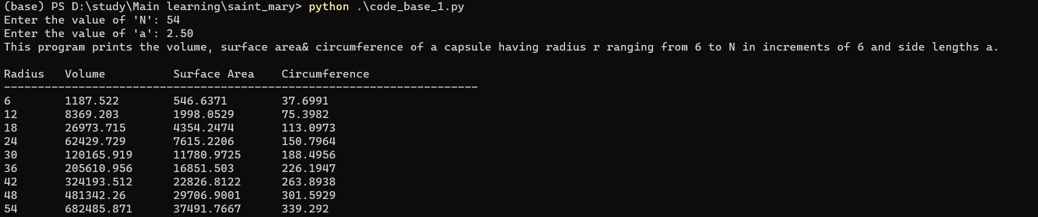

ScreenShot-3:

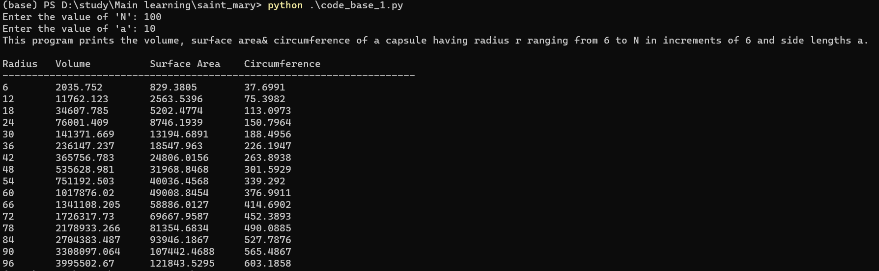

Question 2 Write a program to determine which project should be executed using cost-benefit analysis. If the upfront cost is incurred, using the cashflow during a single period and the discount rate, calculate the Net Present Value (NPV) of the project. Also, determine whether the project is viable by comparing projects based on their anticipated revenue and NPV value.

ScreenShot-1:

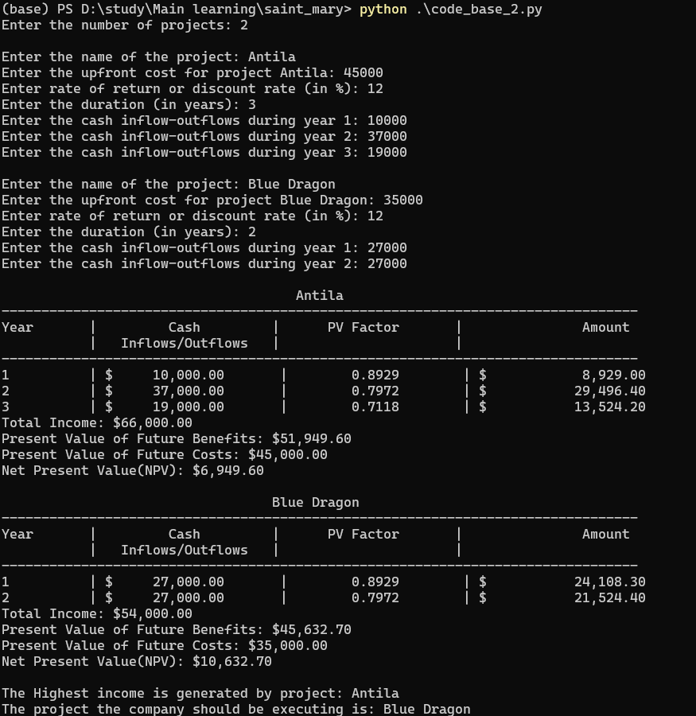

ScreenShot-2:

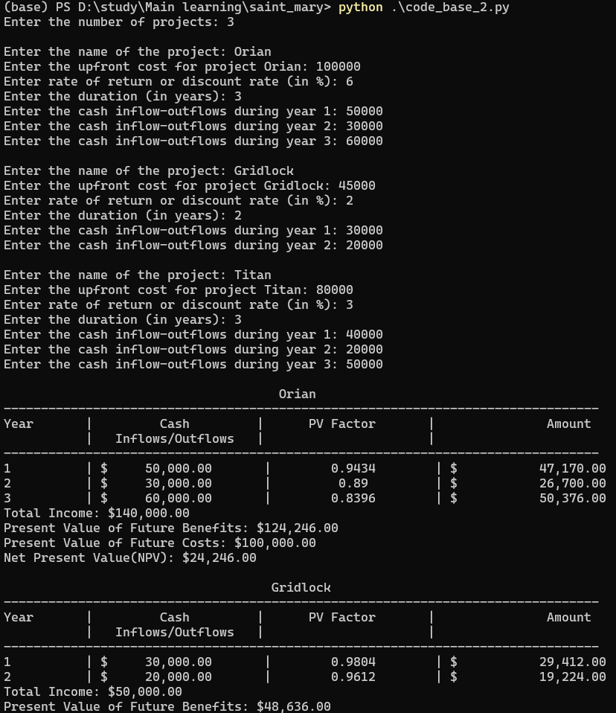

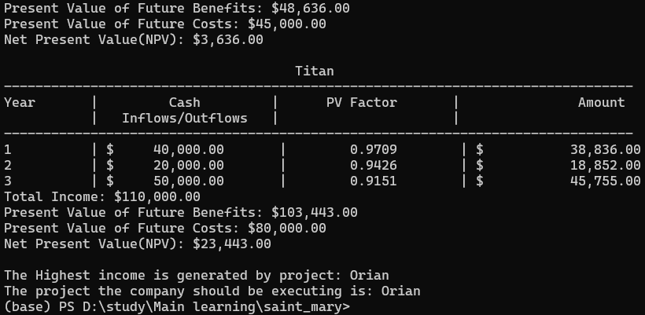

ScreenShot-3:

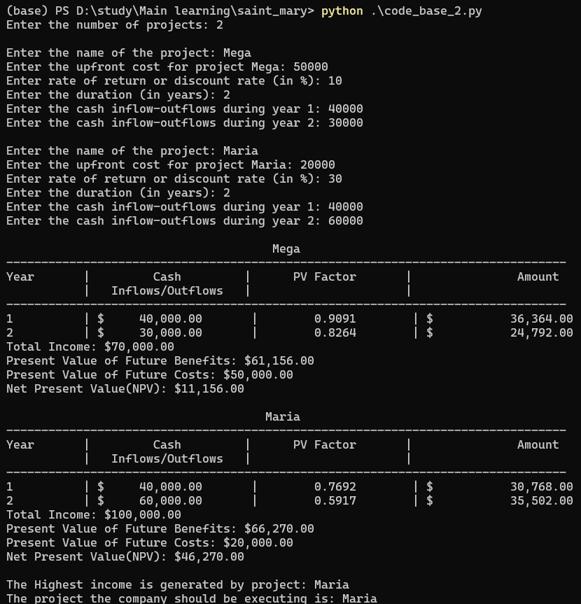

Question 3 The following table shows vacation days taken by employees.

1. There are functional dependencies in this table, so first, normalise the relation/table to the second normal form (2NF). Please show the resulting table(s) after the normalization.

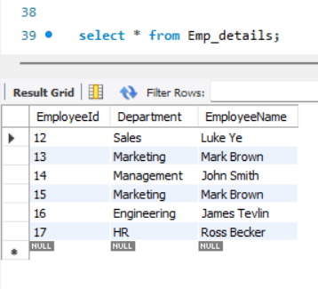

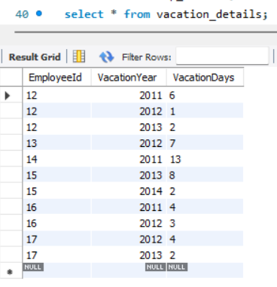

1. Using the table(s) in 2NF, write a query to display the total vacation days per year for each employee, sorted by employee name and year.

