Contents
1 Introduction 5
2 Workflow Overall 6
Application Flow 6
3 Data Ingestion and File Conversion 8
3.1Technical solution design 10
3.2Exceptions Scenarios 10
4 Exploratry Data Analysis 11
4.1Steps 11
4.2Technical solution design 11
4.3Exceptions Scenarios Module Wise 11
5 Graph-Based EDA 12
5.1Technical solution design 12
5.2Exceptions Scenarios Module Wise 13
7 Data Transformers( Pre-processing steps) 15
7.1Technical solution design 15
7.2Exceptions Scenarios Module Wise 15
8 ML Model Selection 16
8.1Technical solution design 16
8.2Exceptions Scenarios Module Wise 16
9 Model Tuning and Optimization 17
9.1Technical solution design 18
9.2Exceptions Scenarios Module Wise 18
10 Testing Modules 19
10.1Technical solution design 19
10.2Exceptions Scenarios Module Wise 20
11 Prediction Pipeline 21
11.1Technical solution design 22
11.2Exceptions Scenarios Module Wise 23
12 Deployment Strategy 24
12.1Technical solution design 25
12.2Exceptions Scenarios Module Wise 26
13 Monitoring 27
13.1Technical solution design 27
13.2Exceptions Scenarios Module Wise 27
14 Logging 28
14.1Technical solution design 28
14.2Exceptions Scenarios Module Wise 28
15 Hardware Requirements 29
15.1Requirements for model training 29
15.2Requirements for model testing 29

1.Introduction
Problem Statement: We have been given a total of 54 attributes, these attributes contain Binary and quantitative attrib ute to predict which Forest Cover-Type is it from the given features. Each observation is 30m x 30m forest cover type determined from US Forest Service (USFS) Region 2 Resource Information System (RIS) data. Independent variables were derived from the data originally obtained from US Geological Survey (USGS) and USFS data.
The target variable has 7 different classes hence making this a Multi-Class Classification problem.
let’s look at the names of these types of Forest Cover:
1 Spruce / Fir
2 Lodgepole Pine
3 Ponderosa Pine
4 Cottonwood / Willow
5 Aspen
6 Douglas-fir
7 Krummholz

Dataset Info:
No. of Instances 581,011
No. of Attributes (Features)¹ 54
Associate Task Classification Dataset
Characteristic Multivariate Attribute Characteristic Categorical, Integer
Missing Value None
Area Life
Target Variable Forest Cover Type

Attribute Info:
Given is the attribute name, attribute type, the measurement unit and a brief description
No. of Attributes consists of :10 Quantative variable, 4 Binary Variable (Wilderness Area) and other 40 Binary Variable (Soil Type). Which makes a total of 54
Variable/Features/Attributes.
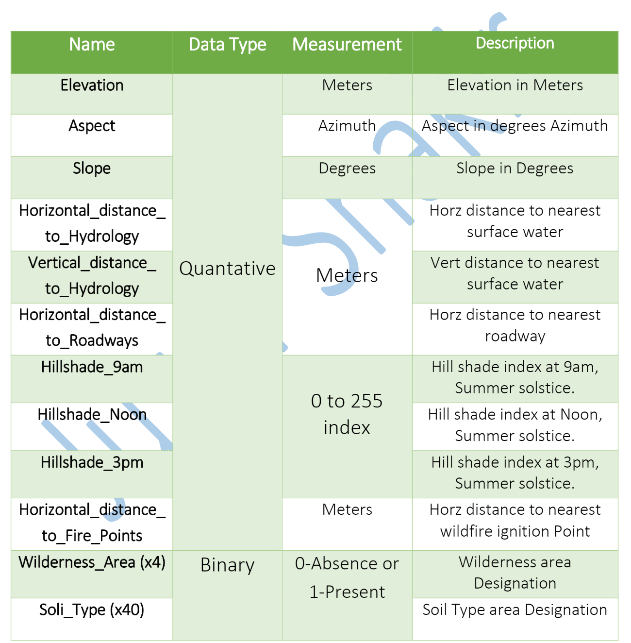

Dataset Link: Download
Downloaded From UCI: Visit Site

2. Workflow Overall
Application Flow
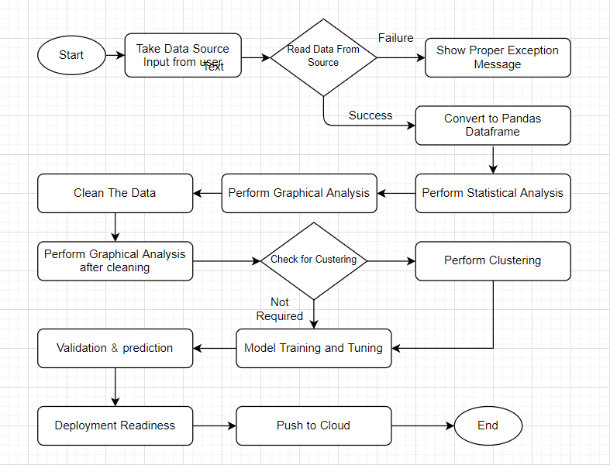

3.Data Ingestion and File Conversion
  - Raw Data Validation: After Collect the data from the client first we perform data validation, in the data validation we follow the certain type of steps like
- sample file name validation
- number of columns
- name of the column’s length of date stamp in file,
- length of time stamp in file.
- Missing value in whole column
- Data type of column

  - Data Storage in Database: After the data validation we store the data into the data bases like SQL databases and No-Sql databases for integration of data.
In our project we have used No-Sql database Mongo Db. In the data base server, we have created train and test database and for each and every data base we have define a collection.
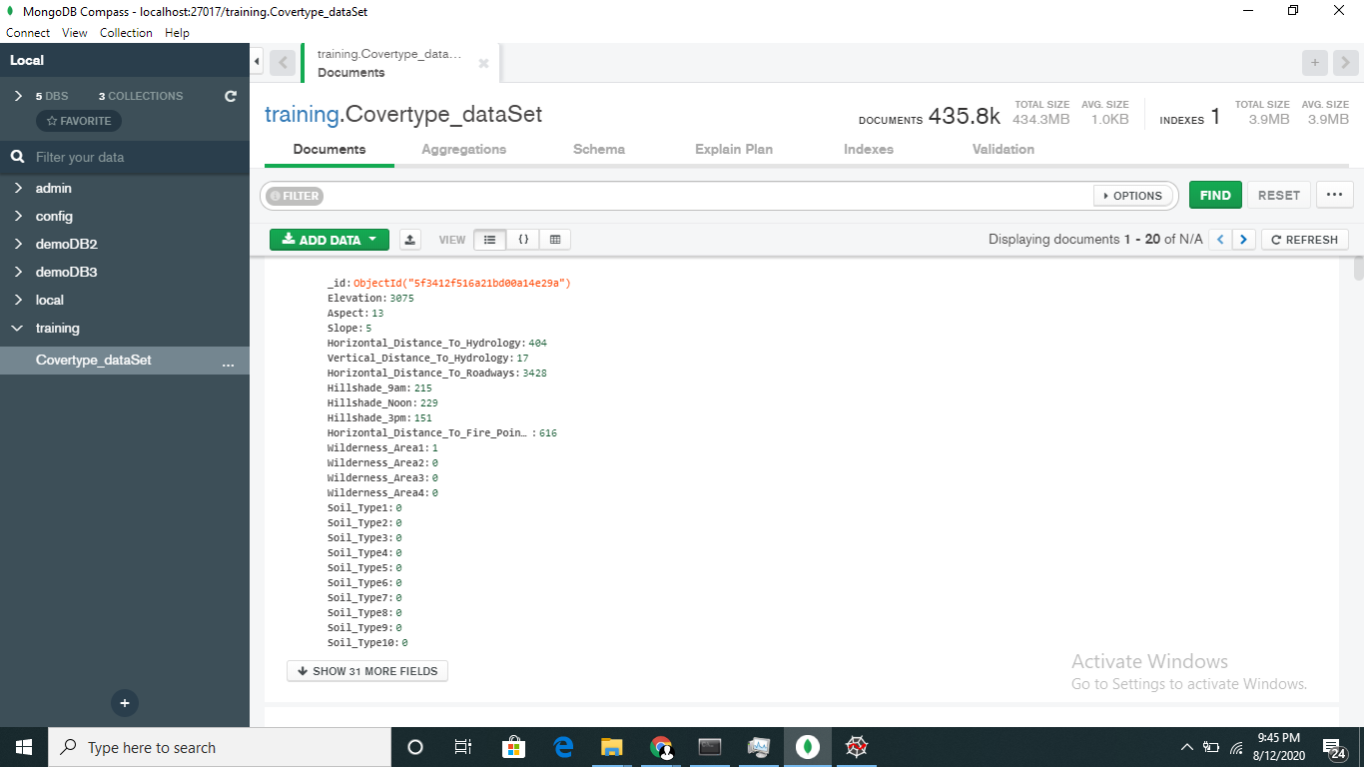

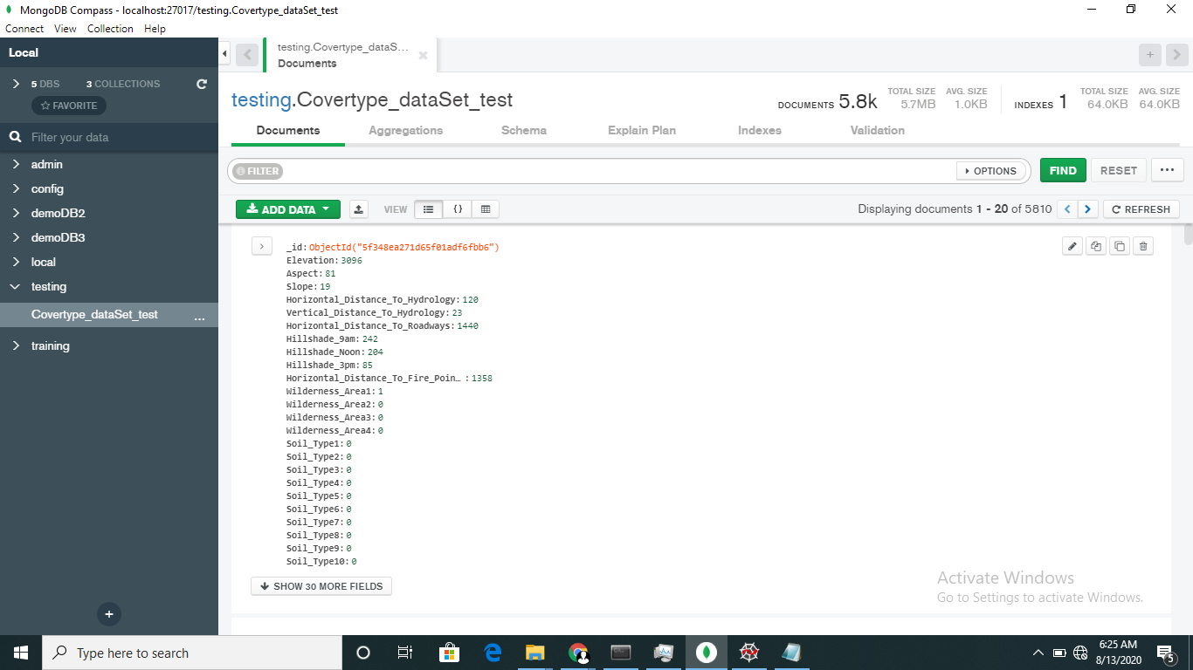

Exceptions Scenarios
Step | Exception | Mitigation
User gives Wrong Data Source | Give proper error message | Ask the user to re-enter the details
User gives corrupted data | Give proper error message

4.Exploratry data analysis
- Data Profiling
After reading the data, automatically the following details should be shown:
- The number of rows
- The number of columns
- Number of missing values per column and their percentage
- Total missing values and it’s percentage
- Number of categorical columns and their list
- Number of numerical columns and their list
- Number of duplicate rows
- Number of columns with zero standard deviation and their list
- Size occupied in RAM

- stats based analysis
- Column contributions/ importance
- Check skewness of data
- Check correlation between the variable
- Check mean, median, mode, standard deviation and variation of the variable
Elevation Aspect Slope Horizontal_Distance_To_Hydrology Vertical_Distance_To_Hydrology Horizontal_Distance_To_Roadways Hillshade_9am Hillshade_Noon Hillshade_3pm Horizontal_Distance_To_Fire_Points
count 435759.000000 435759.000000 435759.000000 435759.000000 435759.000000 435759.000000 435759.000000 435759.000000 435759.000000 435759.000000
mean 2959.238476 155.587983 14.099321 269.421084 46.414213 2350.163928 212.146721 223.331477 142.544753 1979.963218
std 280.150241 111.904829 7.484419 212.427137 58.265370 1558.879443 26.774641 19.753319 38.242423 1323.404931
min 1860.000000 0.000000 0.000000 0.000000 -173.000000 0.000000 0.000000 0.000000 0.000000 0.000000
25% 2809.000000 58.000000 9.000000 108.000000 7.000000 1106.000000 198.000000 213.000000 119.000000 1024.000000
50% 2996.000000 127.000000 13.000000 218.000000 30.000000 1997.000000 218.000000 226.000000 143.000000 1710.000000
75% 3163.000000 260.000000 18.000000 384.000000 69.000000 3326.000000 231.000000 237.000000 168.000000 2550.000000
max 3857.000000 360.000000 66.000000 1390.000000 601.000000 7117.000000 254.000000 254.000000 254.000000 7172.000000

Graph-Based EDA:
We have performed graph-based analysis with the help of different libraries like:
1.matpotlib
2.seaborn
3.plotly
data quantitative=data [['Elevation', 'Aspect', 'Slope', 'Horizontal_Distance_To_Hydrology', 'Vertical_Distance_To_Hydrology', 'Horizontal_Distance_To_Roadways', 'Hillshade_9am ', 'Hillshade_Noon', 'Hillshade_3pm','Horizontal_Distance_To_Fire_Points']]
data qualitative=data[['Wilderness_Area1','Wilderness_Area2', 'Wilderness_Area3', 'Wilderness_Area4', 'Soil_Type1', 'Soil_Type2', 'Soil_Type3', 'Soil_Type4', 'Soil_Type5', 'Soil_Type6', 'Soil_Type7', 'Soil_Type8', 'Soil_Type9', 'Soil_Type10','Soil_Type11', 'Soil_Type12', 'Soil_Type13', 'Soil_Type14', 'Soil_Type15', 'Soil_Type16', 'Soil_Type17', 'Soil_Type18''Soil_Type19', 'Soil_Type20', 'Soil_Type21', 'Soil_Type22', 'Soil_Type23', 'Soil_Type24', 'Soil_Type25', 'Soil_Type26','Soil_Type27', 'Soil_Type28', 'Soil_Type29', 'Soil_Type30',‘Soil_Type31', 'Soil_Type32', 'Soil_Type33', 'Soil_Type34','Soil_Type35', 'Soil_Type36', 'Soil_Type37', 'Soil_Type38','Soil_Type39', 'Soil_Type40']]
- Distribution plot: This operation we have perform with quantitative variable in our data set we have total 10 quantitative variable. distribution plot is used to check the distribution of data after checking of the distribution we can say that our data is right skewed left skewed or in normal distribution
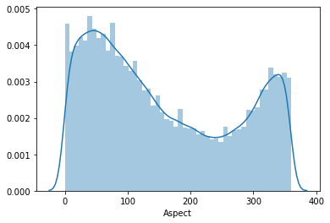

- Count plot: This operation we have perform with qualitative variable in our data set we have total 44 qualitative variable. Count plot is used to check the counting of classes of each feature, after checking of the counting of the classes we can say that our data is balanced or imbalanced.
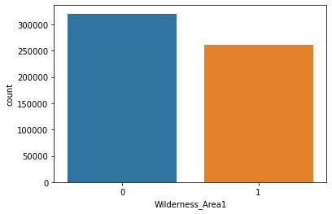

- Box-plot: A box plot (also known as box and whisker plot) is a type of chart often used in explanatory data analysis to visually show the distribution of numerical data and skewness through displaying the data quartiles (or percentiles) and averages.

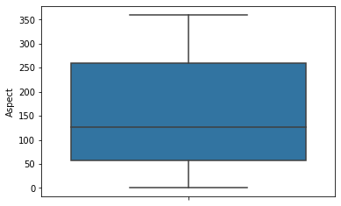

- Correlation Heatmaps: A correlation heatmap uses coloured cells, typically in a monochromatic scale, to show a 2D correlation matrix (table) between n-dimension numerical variable. ... Correlation heatmaps are ideal for comparing the measurement for each pair of dimension values or checking for correlation value.

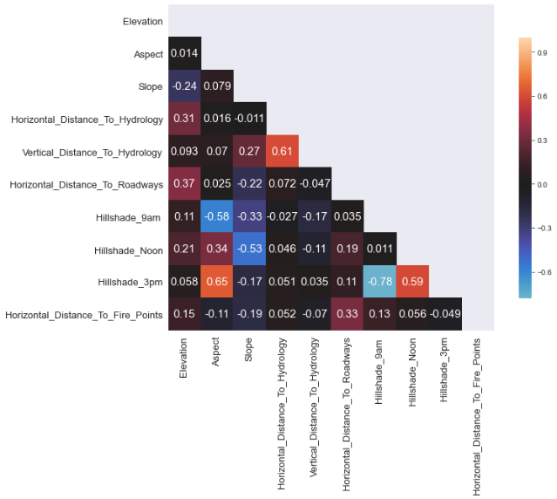

5. Data Transformers (Pre-processing steps):
- Missing value handling: Handling Observation which has any Missing Values in it. In our data set we don’t have a missing value so we don’t need to handle it…That's great!

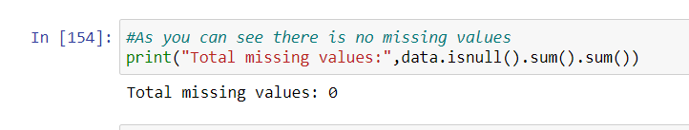

- Outlier handling Transform data into Box-Cox Transformation : In our dataset we have a several Outliers so first I performed a transformation over the dataset to get a data in normal distribution or removing the outlier effect.

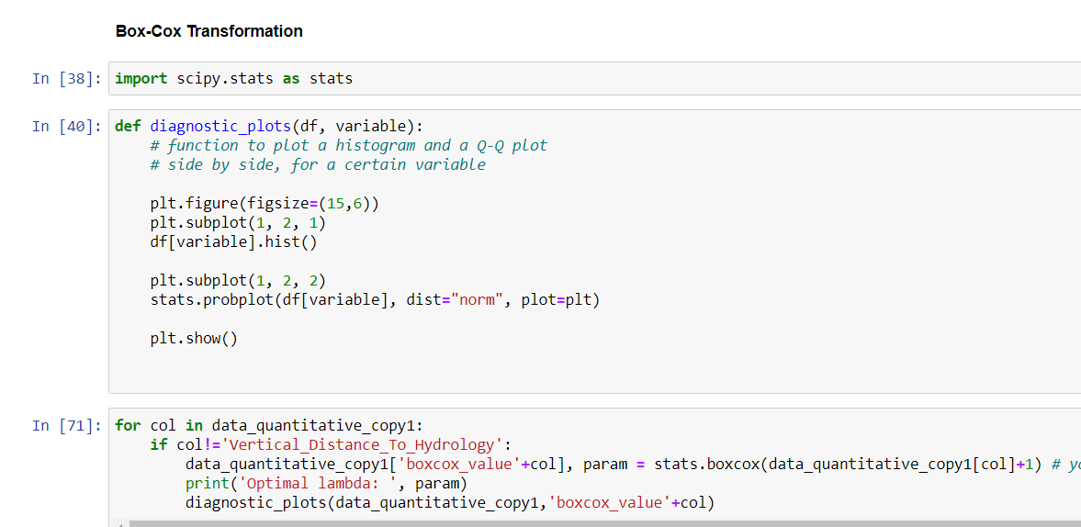

- Data Scaling/ Normalisation:
we move to splitting our data to Train-Test Split is to scale the features to some specific range. This is called Feature Scaling. We will scale all feature values to specific like range of 0 to 1 or in standard normal distribution where standard deviation is 1 and mean is 0. but before we do this we will split the feature and target variables because we don’t want to scale our target variable. In our project we have used Robust scaler because this is robust for outliers.
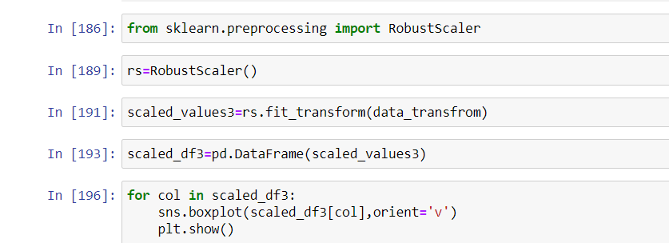

- Handling the imbalance dataset:
In the dataset target we have total 7 classes but it is imbalance we can clearly see in the count plot so we have to handle it

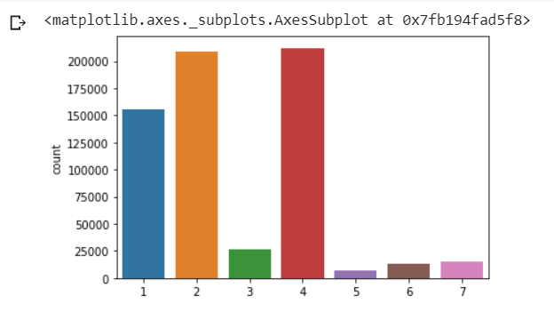
For handling a imbalanced dataset we have performed a Over Sampling technique with SMOTETomek module. from imblearn. combine import SMOTETomek
so after handling the imbalanced dataset we got the data look like this.

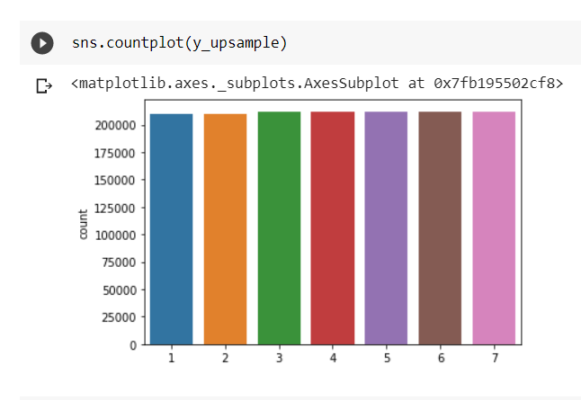
- Feature selection with Extra Tree Classifier:
Since we already have lots of observation now to train the model, we also happen to have lots of features. This will make algorithm run very slowly, have difficulty in learning and also tend to overfit in training set and do worse in testing.To approach such a problem, we need to see how each feature has an impact on prediciting classes, and the best way to do this is by asking the models only. Classifiers like Extra Trees, Random Forest, Gradient Boosting Classifiers and AdaBoost offer an attribute called 'feature_importance_' with which we can see that which feature has more importance compared to others and by how much.

We have used a ETC (Extra Trees Classifier) and RFC (Random Forest Classifier) We can see that RFC and ETC show similar results, yes there are features which show-up different ranks but not of a great difference. Each feature shows a little similar number.

ETC
Elevation | 0.197048
Horizontal_Distance_To_Roadways | 0.109549
Horizontal_Distance_To_Fire_Points | 0.103660
Horizontal_Distance_To_Hydrology | 0.064404
Vertical_Distance_To_Hydrology | 0.059156
Aspect | 0.052901
Hillshade_Noon | 0.046417
Hillshade_9am | 0.044147
Hillshade_3pm | 0.043711
Slope | 0.038203

RFC
Elevation | 0.238605
Horizontal_Distance_To_Roadways | 0.117411
Horizontal_Distance_To_Fire_Points | 0.110403
Horizontal_Distance_To_Hydrology | 0.060739
Vertical_Distance_To_Hydrology | 0.057661
Aspect | 0.048340
Hillshade_Noon | 0.043726
Hillshade_3pm | 0.041459
Hillshade_9am | 0.040985
Wilderness_Area4 | 0.035480

All these classifications tell us one thing in common, Numerical Features dominate when it comes to predicting forest classes. All that being said, I will now go with features that show up in the top in most classifiers. Top 20 would be a reasonable choice.

Method Definitions
Class Name | Data Pre-processor
Method Name | impute_missing_values
 | Method Description | This method will be used to read data from a csv file or a flat file
 | Input parameter names | self, filename, header, names, use_cols, separator
 | Input Parameter Description | filename: name of the file to be read  header: Row number(s) to be used as column names  names List of column names to use. If file contains no header row, then you should explicitly pass  ``header=None``.  Use_cols: To load a subset of columns  Separator: Delimiter to use
 | output | A pandas Data frame
 | On Exception | Write the exception in the log file. Raise an exception

Exceptions Scenarios
Step | Exception | Mitigation
Wrong parameters passed to the methods | Handle Internally | Code should never give a wrong input

6. Model Building with Hyperparameter Optimization:
After the pre-processing of the data we go towards to model building so we implemented a different type of models along with hyperparameter optimization but before applying the model building we make a cluster of data and apply a model building over the each and every cluster and found a model with respect to greater accuracy or a greater AUC score.
Applying K-means: Firstly, you will want to determine what the optimal k is given the dataset. In our case, because we used the The Elbow Method. Therefore, we do not need to determine the optimal k; however, we do need to identify the clusters!
Calculate the Within-Cluster-Sum of Squared (WCSS) for different values of k and choose the k for which WCSS becomes first starts to diminish. In the plot of WCSS-versus-k, this is visible as an elbow.

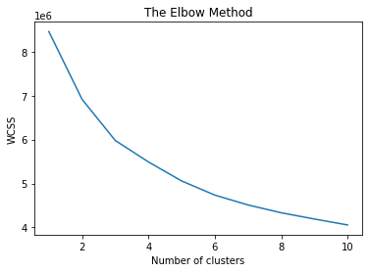
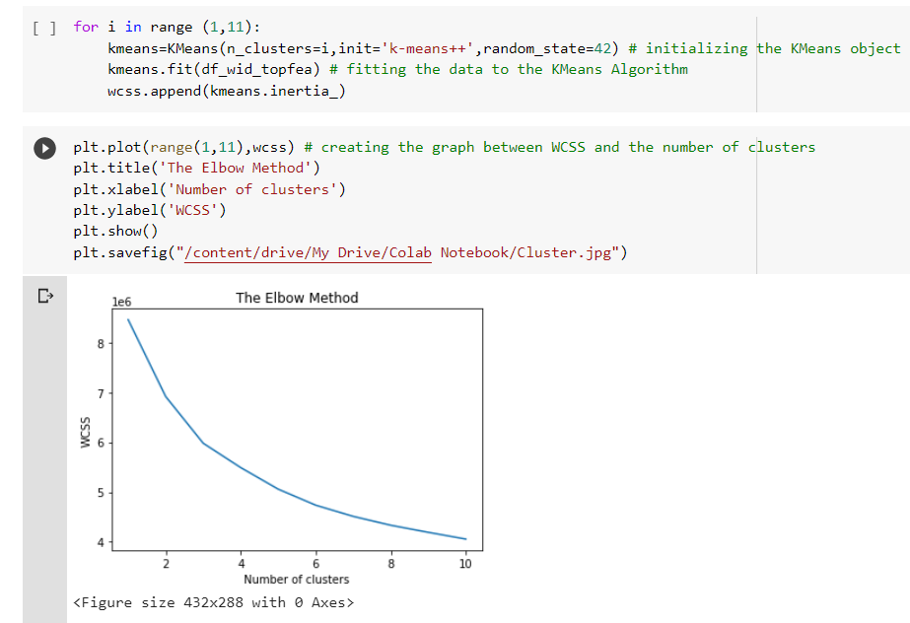

And finally, we got K=3.For getting the optimal k value we
The we create 3 clusters
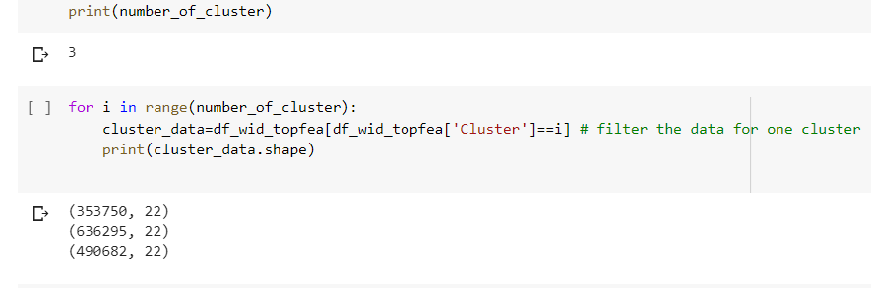

After the applying clustering we started a model building for each and every cluster.
We implemented two models for this study, a Bagging technique Random Forest classifier and a Boosting technique XGBoost classifier. The overall objectives of this research were to first construct the se t two predictive models, and second to compare and evaluate their respective classification accuracy or AUC score.

We perform a hyperparameter optimization technique for a model building. hyperparameter optimization or tuning is the problem of choosing a set of optimal hyperparameters for a learning algorithm. A hyperparameter is a parameter whose value is used to control the learning process. There are various technique to choose a hyperparameter like:
- Manual Search
- Random Search
- Grid Search
For performing hyperparameter optimization We used Grid Search along with cross-validation. There is class available in sklearn library called GridSearchCV
from sklearn. model selection import GridSearchCV
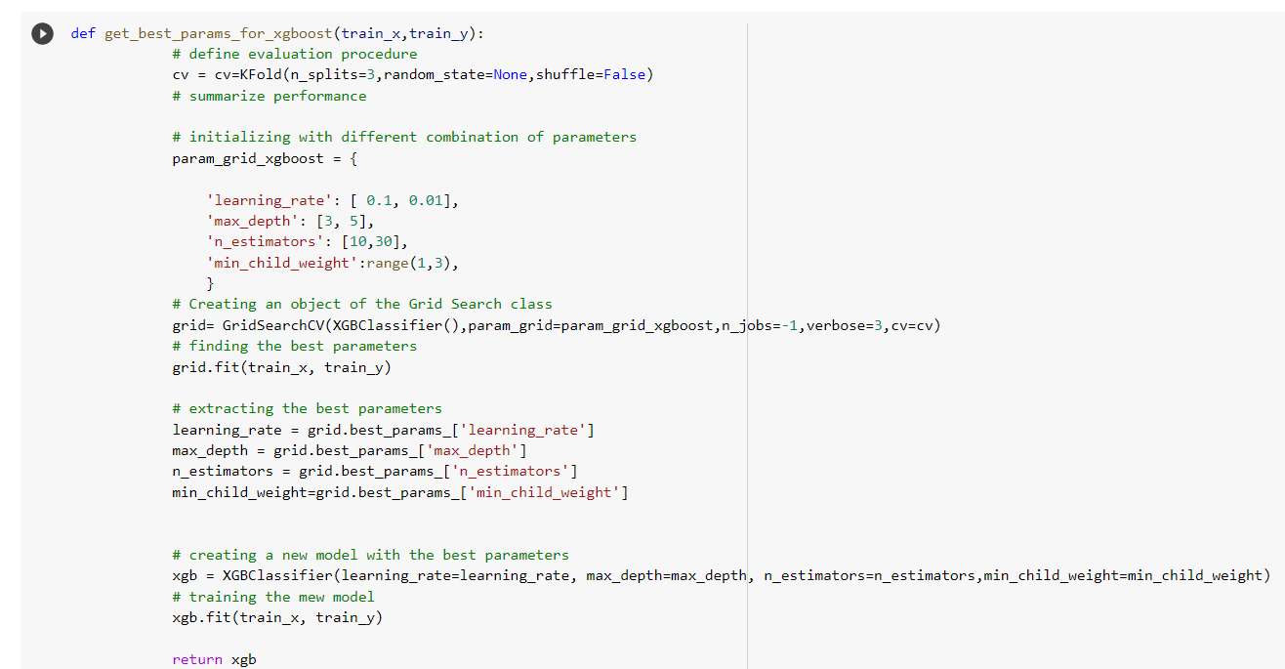

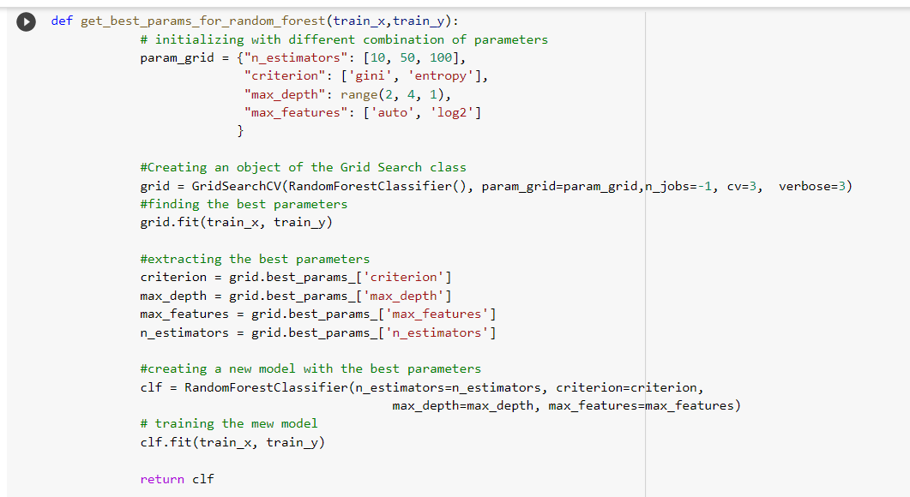

8. Model Evaluations:

After feeding our data and train the models to see how each model performs using 2 different evaluation technique first is performance matrices and second is a probabilistic method auc-roc curve and see which model performs the best.

Accuracy Score: Accuracy is the measure of the correct predicted data divided by total number of observations hence giving a value ranging between 0 and 1, while 0 is no correctly predicted class whereas 1 is all correctly predicted class. We can multiply the result by 100 to get the accuracy score in terms of percent.
Roc-Auc Score: A receiver operating characteristic curve, or ROC curve, is a graphical plot that illustrates the diagnostic ability of a binary classifier system as its discrimination threshold is varied. The method was developed for operators of military radar receivers, which is why it is so named.
We have a 3 cluster, so we apply XGBoost Classifier and Random Forest Classifier each and very cluster.
But before this we have performed train_test_split over the data the dataset for validation of the model
test_size — This parameter decides the size of the data that has to be split as the test dataset. This is given as a fraction. For example, if you pass 0.5 as the value, the dataset will be split 50% as the test dataset. So in my case I have chosen 0.25 as my validation dataset and rest of the for training.
train_size —This is the same as test size, but instead you tell the class what percent of the dataset you want to split as the training set. In my model building we choose 0.75 as my train data.
from sklearn.model_selection import train_test_split
X_train, X_test, y_train, y_test= train_test_split(x, y, test_size = 0.25, random state = 0)

Cluster-0
XGB0 Accuracy Score 0.7866507747318237
XGB0 Auc-Roc Score 0.9632743219235567
Random Forest0 Accuracy Score 0.6698450536352801
Random Forest0 Auc-Roc Score 0.9275703524425395
Final model=XGBoost0
Cluster-1
XGB1 Accuracy Score 0.8019281332164768
XGB1 Auc-Roc Score 0.9600465872028704
Random Forest1 Accuracy Score 0.6695880806310254
Random Forest1 Accuracy Score 0.9414377950468683
Final model=XGBoost1
Cluster-2
XGB2 Accuracy Score 0.7621951219512195
XGB2 Auc-Roc Score 0.9574533517694802
Random Forest2 Accuracy Score 0.5975609756097561
Random Forest2 Accuracy Score 0.9093521904980139
Final model=XGBoost2
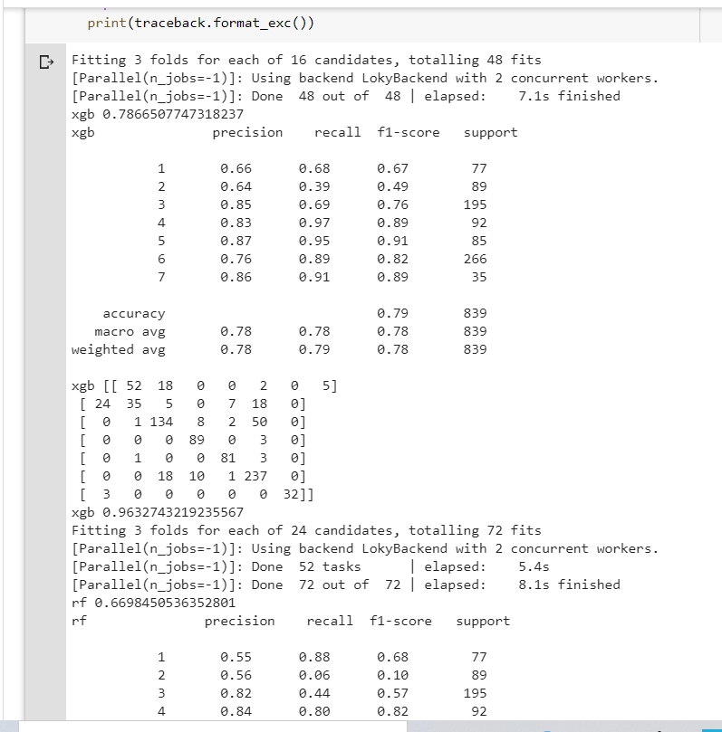

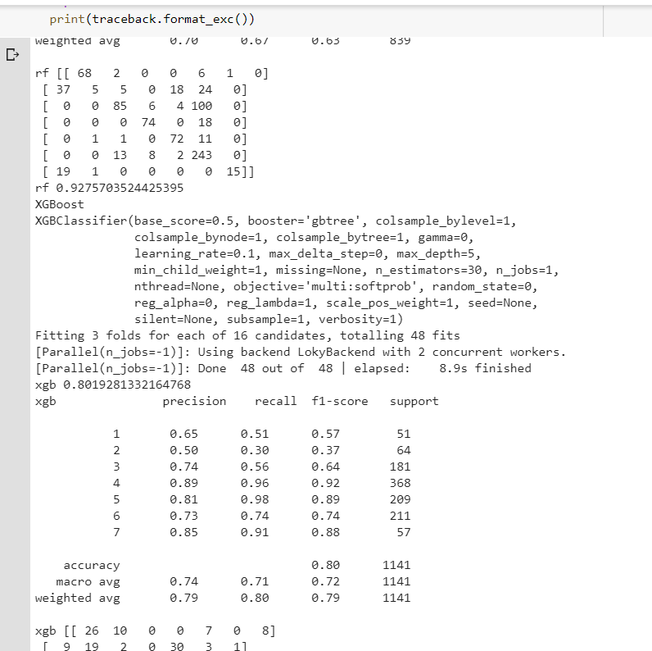

9.Choosing Model:

Out of 2 Models evaluated above model, which performs better? Let’s see all the scores of all the given models scores : So to pick one model I would consider not only having best accuracy score but also having a best roc -auc score since roc-auc socre is more important as they give us relation between sensitivity and specificity and regarding area under curve and whatever area under curve is more we select that model.
So, with that said, I will be picking XGBoost Classifier as my final model to evaluate on the validation set and saw its performance on it.
Class Name | Model Tuner
Method Name | get_tuned_knn_model
 | Method Description | to get the hyper tuned KNN Model
 | Input parameter names | self, data
 | Input Parameter Description | Data: the training data
 | Hyperparameters to tune
 | On Exception | Write the exception in the log file. Raise an exception

Technical solution deigned
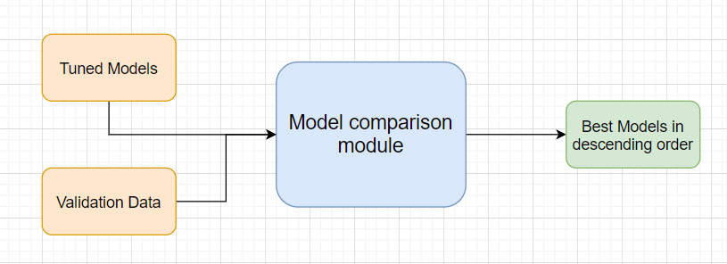

10.Prediction Pipeline:

After completion the training we go for prediction, but we can not do directly prediction because at the time of training we have follow certain pre-processing steps which is also necessary for prediction.so there are few steps
  - Use the validation data read modules
  - Use the existing pre-processing module
  - Load the model into memory
  - Do prediction
  - Store prediction results into the csv file (show sample predictions)

Technical solution design

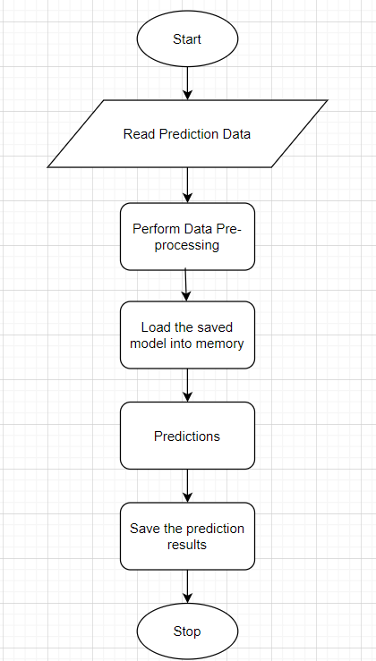

Phase 2:
UI for predictions
1.Home.html: It can be used for bulk prediction.
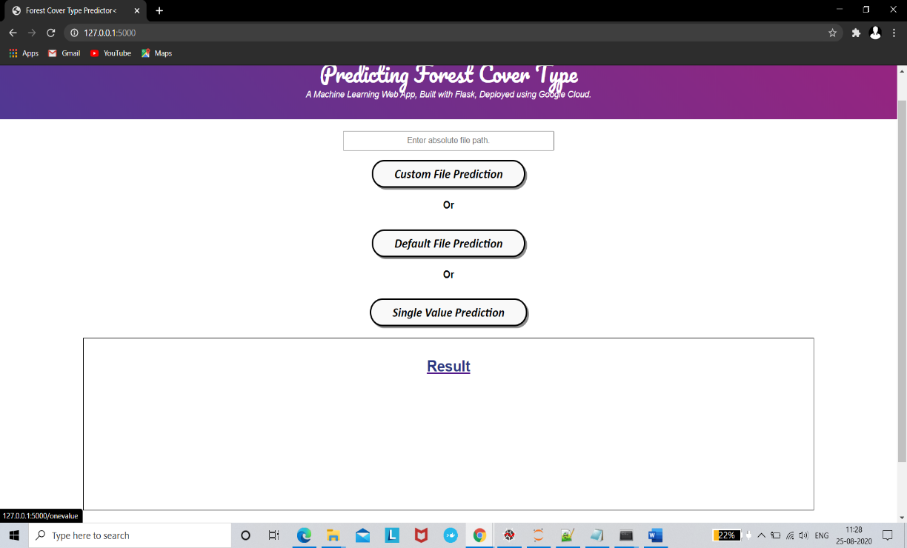

2. single_value_prediction.html: it can be used for single value prediction.
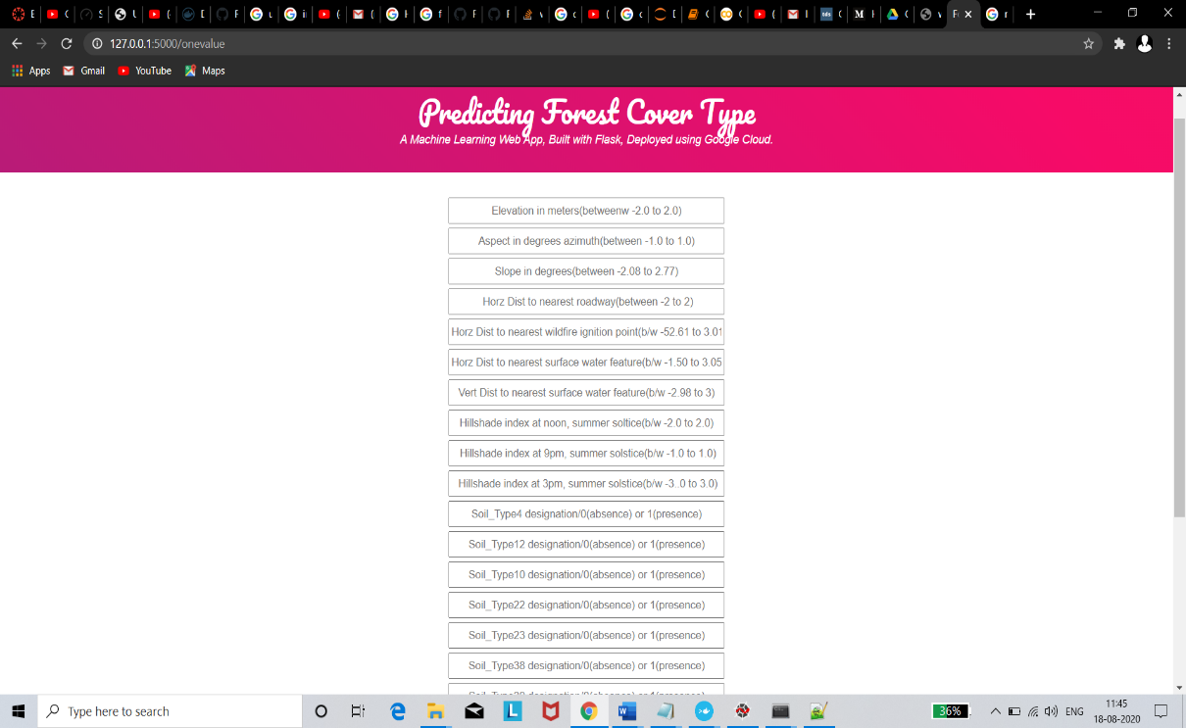

3.Result.html: it is used for showing the result or prediction. 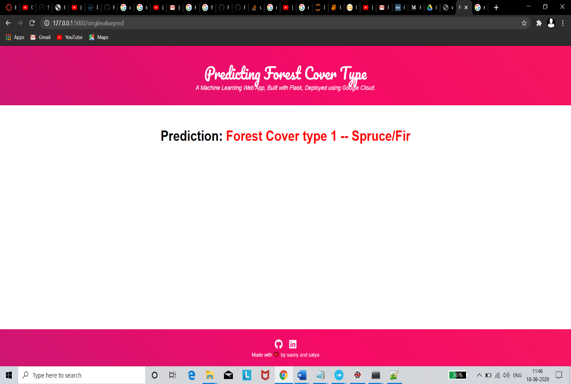

11.Deployment Strategy

a) Create a flask app: Create a file called main.py and put the following code.
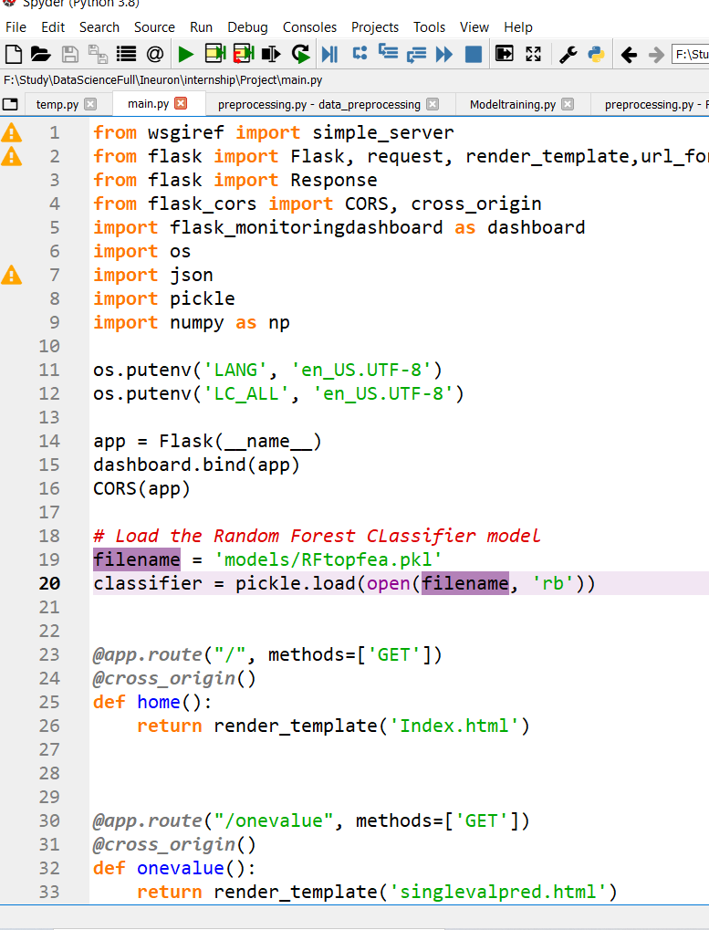
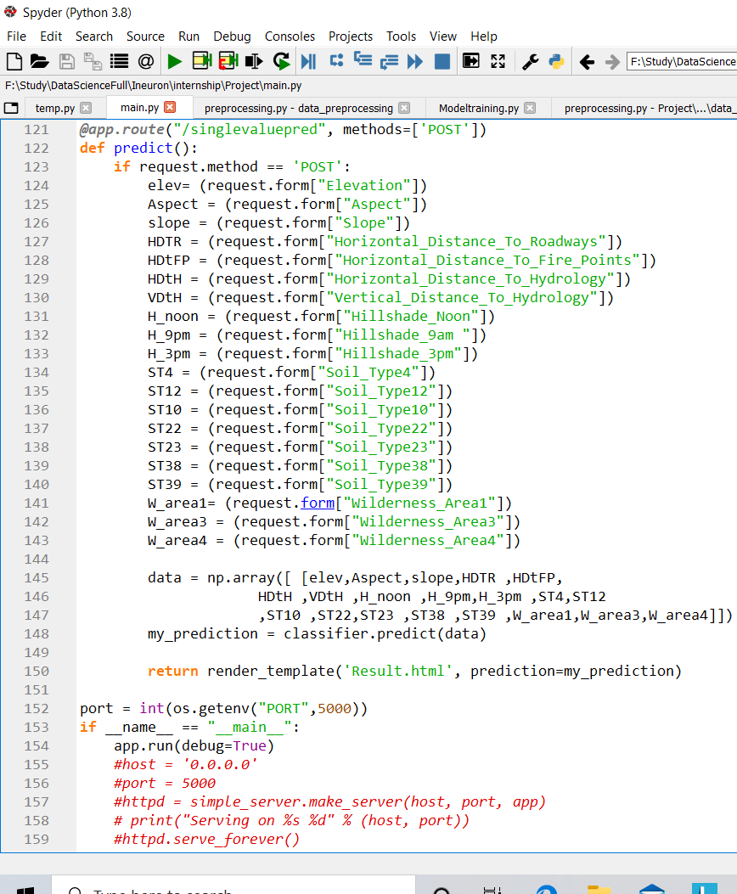

- created a html file:

index.html
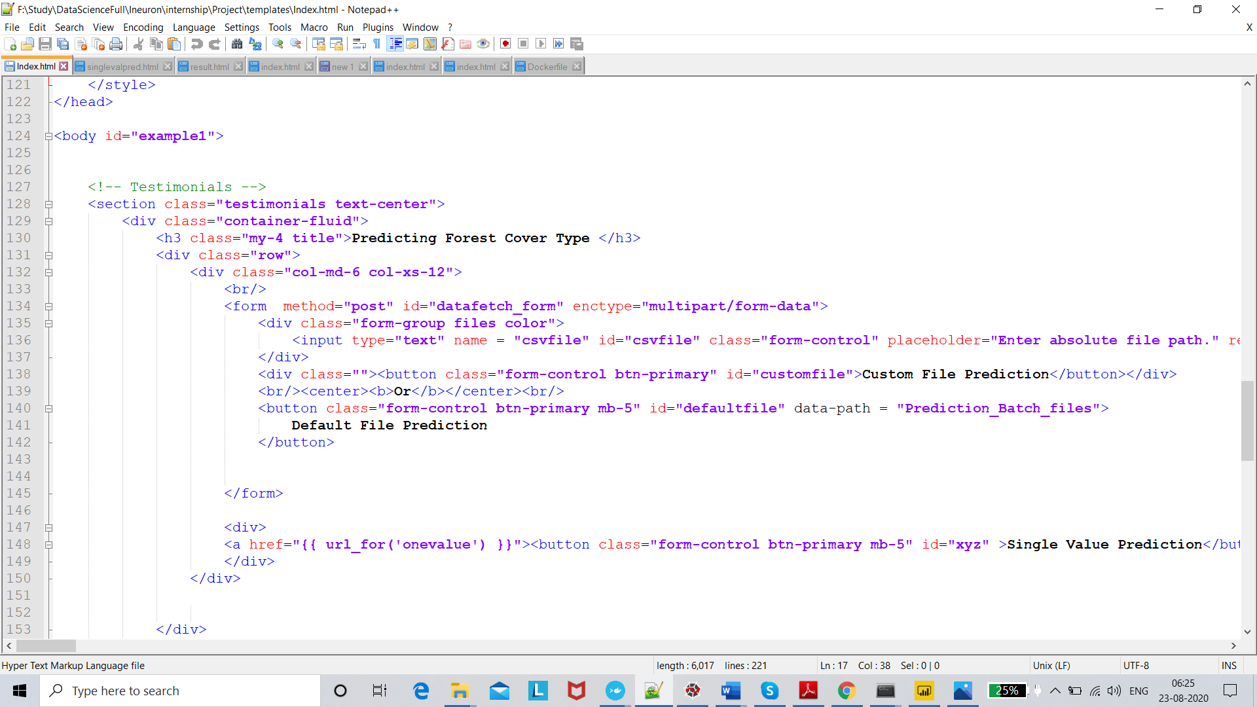

Single value prediction.html
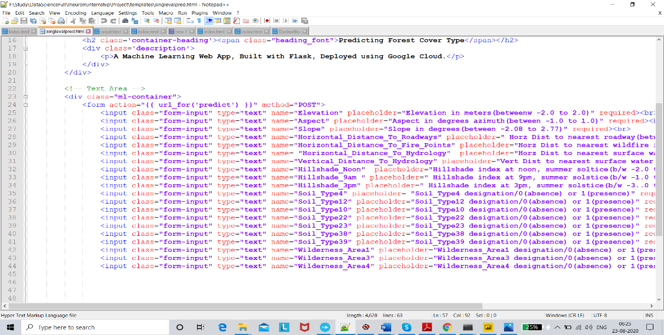

Result.html
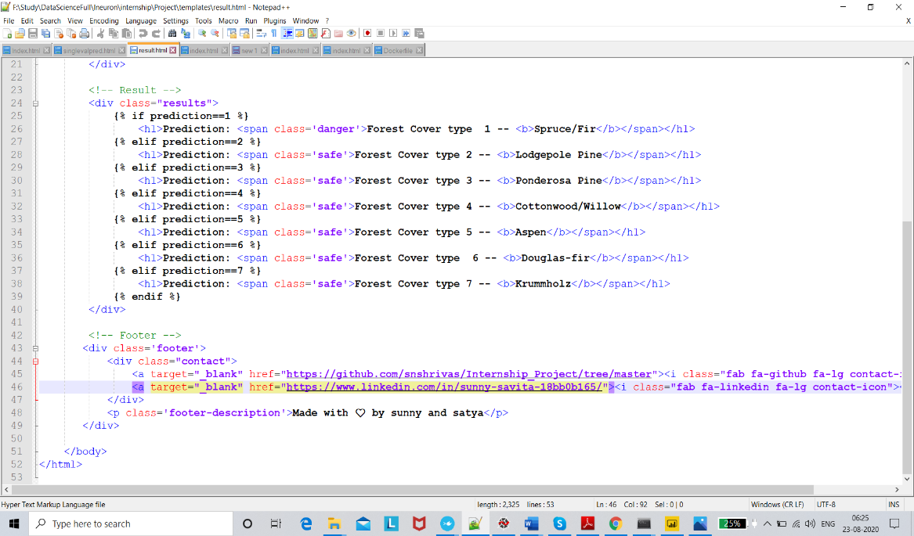

- Deployment to G-cloud:
- Create a file ‘app. yaml’ and put ‘runtime: python37’ in that file.
- Create a ‘requirements.txt’ file by opening the command prompt/anaconda prompt, navigate to the project folder and enter the command ‘pip freeze > requirements.txt’.
It is recommended to use separate environments for different projects.
- Your python application file should be called ‘main.py’. It is a GCP specific requirement.
- Then go to the https://console.cloud.google.com/ and create a account over there. After creating a account (free trail account) over the gcp google gives a 300$ free credit with one year validation.
- Go to the I Am and Admin and click over the manage resources.

- Click over Create project to create a new project for deployment.
- In my case the project is forestcovertype

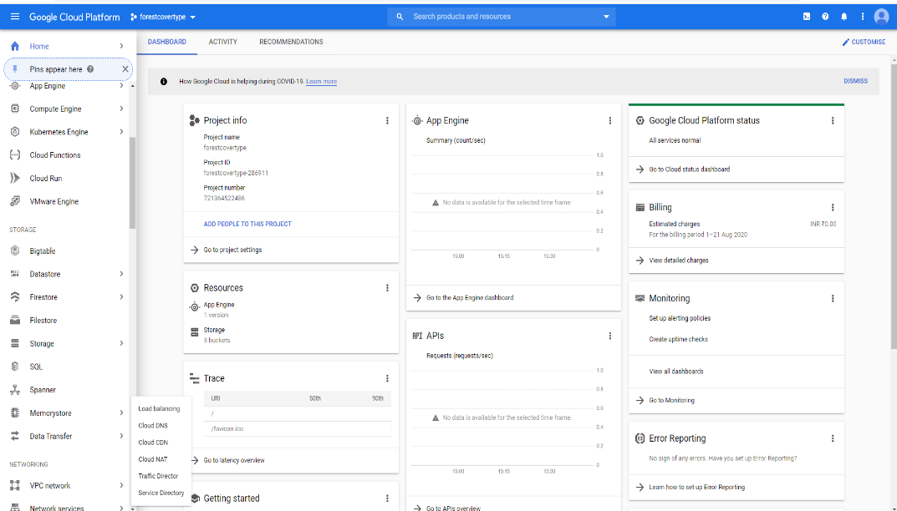
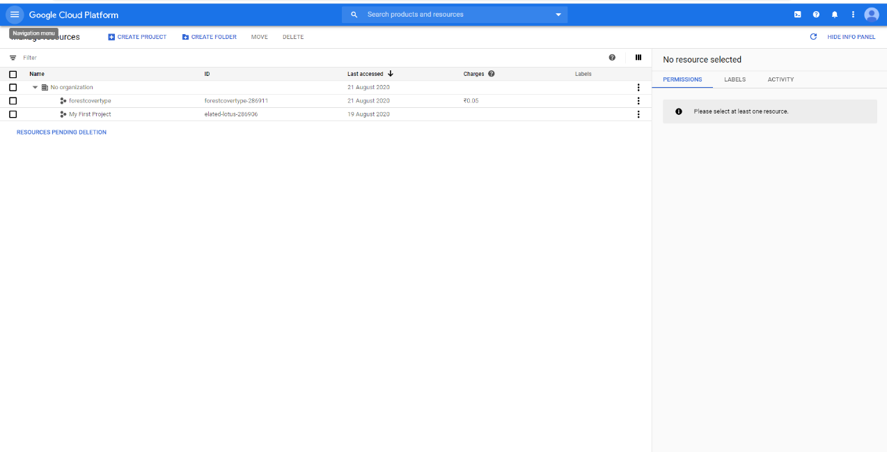

- Once the project gets created, select App Engine and select Dashboard. Go to below link and download the google cloud SDK to your machine. https://dl.google.com/dl/cloudsdk/channels/rapid/GoogleCloudSDKInstaller.exe
- Open command prompt or google cloud sdk installer window, navigate to the project folder and enter the command gcloud init to initialise the gcloud context. It asks you to select from the list of available projects.
- It asks you to select from the list of available projects.
- Once the project name is selected, enter the command gcloud app deploy app. yaml --project <project name>.
- After executing the above command, GCP will ask you to enter the region for your application. Choose the appropriate one.

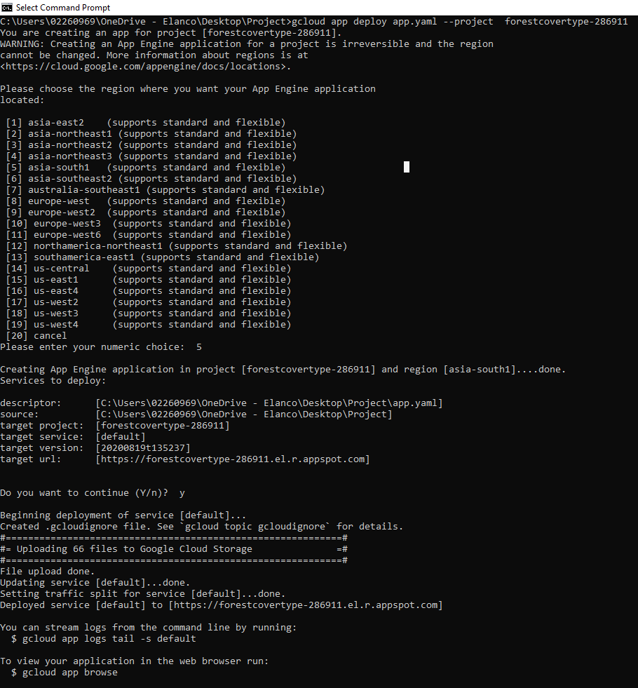

- After the deployment you will get the link In my case the link is:
https://forestcovertype-286911.el.r.appspot.com/
- And then it will give you the link for your app, and the deployed app looks like:

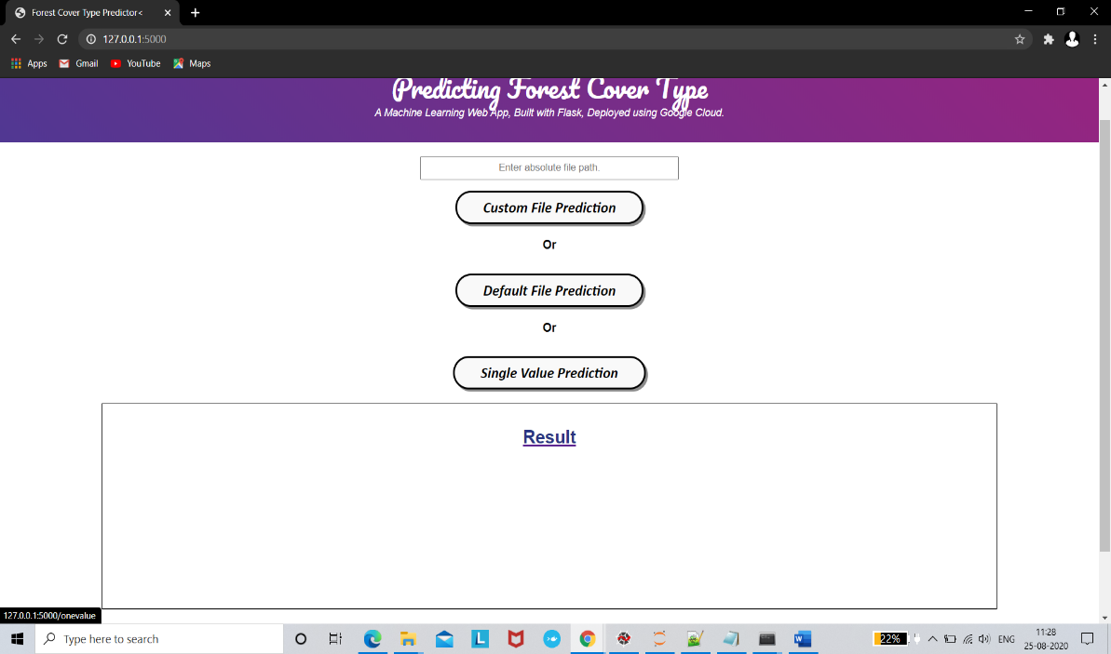

- To save money, go to settings and disable your app.

- Dockerized the application:

- Dockerizing an application is the process of converting an application to run within a Docker container. While Dockerizing most applications is straight-forward, there are a few problems that need to be worked around each time.
- Because Docker containers encapsulate everything an application needs to run (and only those things), they allow applications to be shuttled easily between environments. Any host with the Docker runtime installed—be it a developer's laptop or a public cloud instance—can run a Docker container

Steps to follow to run docker on the single machine
- First, we have to install docker, for installing the docker we have to visit this link https://docs.docker.com/docker-for-windows/install/
- If you have windows enterprise or professional edition the directly go to Download from docker hub and install the docker
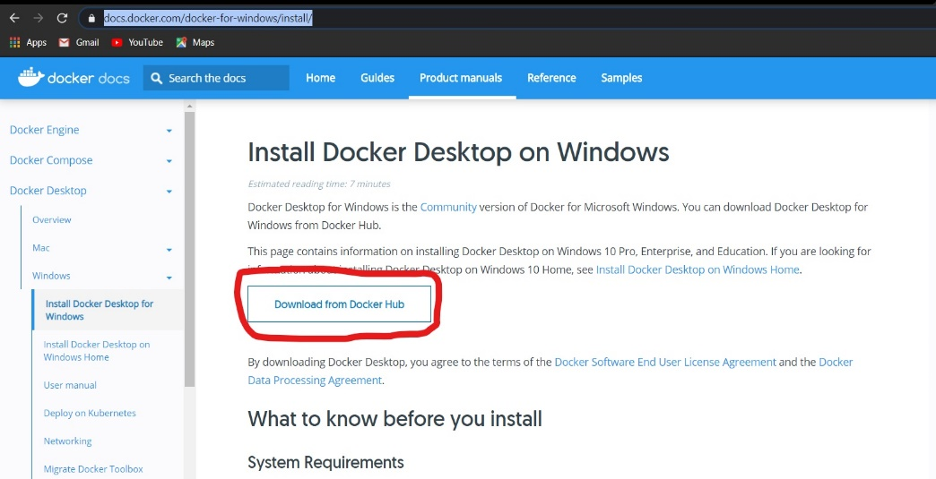

- If you have windows single language home or another version then go to the this GitHub page https://github.com/docker/toolbox/releases and install it.
- After the installing you will get command prompt like this
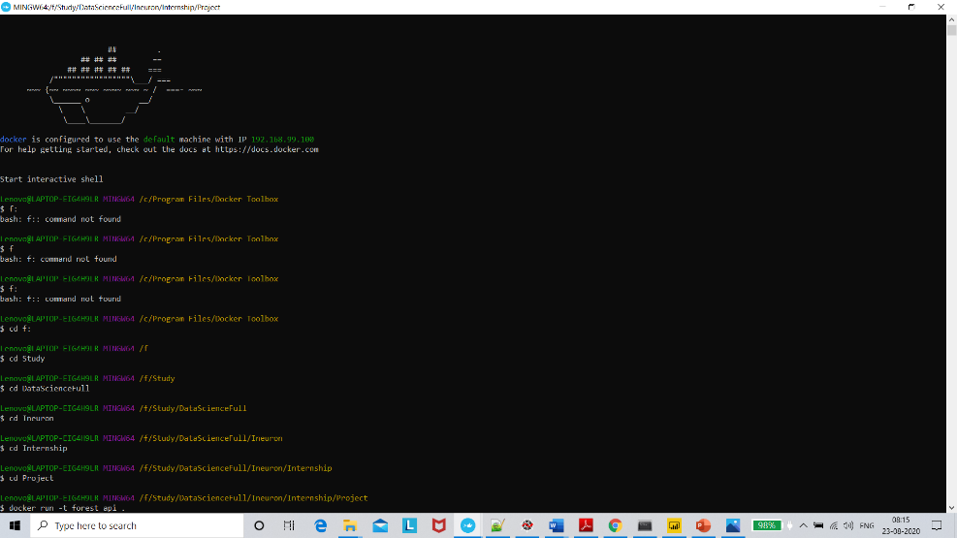

Once installation has completed so you have to these command to Dockerized your application
Command to follow for the dockerization
- FROM continuumio/anaconda3:4.4.0COPY
- COPY. /usr/app/
- EXPOSE 5000
- WORKDIR /usr/app/
- RUN pip install –r requirements.txt
- CMD python main.py
- Link after the Containerized the application: http://127.0.0.1:5000/

12.Logging: we must create a logging framework for monitoring our application logs have been an essential part of troubleshooting application and infrastructure performance. They help provide visibility into how our applications are running on each of the various infrastructure components. Log data contains information such as out of memory exception or hard disk errors. There are some steps for logging.
  - Separate Folder for logs
  - Logging of every step
  - Entry to the methods
  - Exit from the methods with success/ failure message
  - Error message Logging
  - Model comparisons
  - Training start and end
  - Prediction start and end
  - Achieve asynchronous logging

Technical solution design

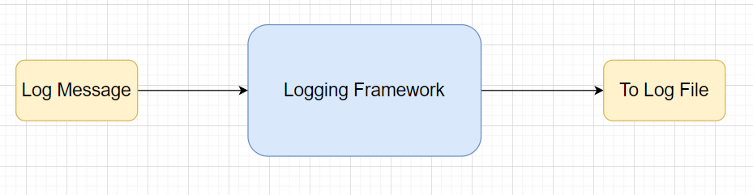

Common Logging Framework Code
Class Name | App Logger
Method Name | log
Method Description | This method will be used for logging all the information to the file.
Input parameter names | self,file_object, log message
Input Parameter Description | file object: the file where the logs will be written  log message: the message to be logged
output | A log file with messages

from datetime import datetime
class App_Logger:
def __init__(self):
pass

def log(self, file_object, log message):“””This method will be use for logging all the information to the file.”””
self. Now = datetime.now()
self. Date = self.now.date()
self.current_time = self.now.strftime("%H:%M:%S")
file_object. Write(
str(self. Date) + "/" + str(self.current_time) + "\t\t" + log message +"\n")

13.Retrainin approach:

In a simple word retraining means periodically train your Machine leaning model as per your need. When designing a machine learning system, it is important to understand how your data is going to change over time. A well-architected system should take this into account, and a plan should be put in place for keeping your models updated. One way to maintain models with fresh data is to train and deploy your models using the same process you used to build your models in the first place. As you can imagine this process can be time-consuming. How often do you retrain your models? Weekly? Daily?
So, answer is it is depending on the client requirement or as per our model need.
One way, as you are manually retraining your models:
- you may discover a new algorithm
- With using a feature engineering techniques(different set of features that provide improved accuracy).
- With regularization techniques like ridge(L1) and lasso(L2)

Continuous learning

Another way to keep your models up to date is to have an automated system to continuously evaluate and retrain your models. This type of system is often referred to as continuous learning, and may look something like this:
- Save new training data as you receive it. For example, if you are receiving updated prices of houses on the market, save that information to a database.
- When you have enough new data, test its accuracy against your machine learning model.
- If you see the accuracy of your model degrading over time, use the new data, or a combination of the new data and old training data to build and deploy a new model.
The benefit to a continuous learning system is that it can be completely automated.
It’s probably a still a good idea to review your process on a regular basis. As I mentioned before, you may find a different algorithm or a new set of features that improves your predictions, and this isn’t necessarily something a continuous learning system is good at.

Reference Link: visit link

14. What I learned:
- How to research and investigate a real-world problem of interest.
- How to perform data ingestion with no sql data base(Mongo DB).
- How to accurately apply specific machine learning algorithms and techniques.
- How to properly analyse and visualize your data and results for validity.
- How to document and write a report of your work.
Hardware Requirements

Requirements for model training

The minimum configuration should be:

8GB RAM
        - 2GB of Hard Disk Space
        - Intel Core i5 Processor

Requirements for model testing
The minimum configuration should be:
- 4 GB RAM
- 2 GB of Hard Disk Space
- Intel Core i5 Processor

Thank You!

Hardware Requirements

Requirements for model training
The minimum configuration should be:
- 8 GB RAM
- 2 GB of Hard Disk Space
- Intel Core i5 Processor

Requirements for model testing
The minimum configuration should be:
- 4 GB RAM
- 2 GB of Hard Disk Space
- Intel Core i5 Processor

