Journey Management & Fleet Monitoring System
Developer Handover Scope / Functional Specification
For oil & gas-grade fleet, journey, IVMS, maintenance, HSE, NFC driver identification, and passenger/headcount control

Document Field | Value
Prepared for | AR Technology / Developer Handover
Prepared by | ChatGPT technical drafting support
Version | 1.0
Date | 09 May 2026
Status | Draft scope for technical review

Purpose: provide a complete functional and technical scope that a software development team can use to design, estimate, and start implementation.

Revision History
Version | Date | Description | Owner
1.0 | 09 May 2026 | Initial developer handover scope combining journey management, fleet tracking, NFC driver ID, passenger headcount, maintenance release, tire/parts/licensing control, and reporting. | AR Technology / Consultant
1.1 | 09 May 2026 | Added Passenger Logistics App extension inspired by Tasnim Logistics Passenger app: pickup/drop requests, planner pooling, driver trip visibility, live progress, inspection campaigns, loading/unloading activities, and analytics. | AR Technology / Consultant

Table of Contents
- 1. Executive Summary
- The system shall include a Passenger Logistics App extension for employee pickup/drop requests, planner request pooling, vehicle/driver assignment, live trip progress, driver trip visibility, passenger validation, inspection campaigns, loading/unloading records, and analytics.
- 2. Design Principles
- 3. System Overview
- 4. High-Level Architecture
- 5. User Roles and Access Control
- 6. Core Functional Modules
- 7. Detailed Workflows
- 8. Data Model and Master Records

8.2 Passenger Logistics App Data Entities
Entity | Key Fields
PassengerRequest | request_id, passenger_user_id, pickup_location_id, drop_location_id, requested_time, priority, status, reason, created_by, approved_by.
TransportEntitlement | user_id, company/project, eligible_routes, allowed_days/times, approver_id, validity_start, validity_end, entitlement_status.
RequestPool | pool_id, route_id, shift_time, pickup_window, planner_id, request_count, capacity_required, pool_status.
PassengerManifest | manifest_id, journey_id, passenger_id, boarding_status, validation_method, boarded_time, dropped_time, no_show_reason.
BoardingValidationEvent | event_id, journey_id, passenger_id, method, timestamp, location, validation_result, exception_flag.
TripScore | trip_id, driver_score, punctuality_score, passenger_service_score, safety_score, closure_score, comments.
LoadingActivitySegment | segment_id, journey_id, item/material_ref, quantity, loading_clerk_id, load_time, unload_time, photos, signature.
InspectionCampaign | campaign_id, campaign_type, vehicles_scope, start_date, end_date, created_by_workshop_or_hse, status, findings_summary.
- 9. Hardware and IoT Integration Scope
- 10. Reporting Requirements
- 11. Notifications and Escalations
- 12. Cybersecurity and Audit Requirements
- 13. API and Integration Requirements
- 14. Non-Functional Requirements
- 15. Developer Backlog / Epics
- 16. Acceptance Criteria

16.1 Additional Acceptance Criteria for Passenger Logistics App Extension
- Passenger users can submit pickup/drop requests and receive approval, vehicle/driver, ETA, delay, and closure notifications.
- Logistics planners can pool passenger requests, group them by route/shift/site, assign vehicle and driver, and convert them into an approved journey plan.
- Driver app displays allocated passenger trips, route sequence, passenger manifest, boarding validation actions, and trip closure action.
- Passenger boarding can be validated by QR/NFC/employee ID/manual confirmation, and actual headcount is reconciled with approved manifest and vehicle capacity.
- The system blocks or alerts when passenger count exceeds capacity, manifest is missing, vehicle is No-Go, driver is unauthorized, or inspection campaign rules are not satisfied.
- Vehicle inspectors, central workshop, and HSE users can schedule and complete focused inspection campaigns with findings, photos, corrective actions, and closure status.
- Loading/unloading activities can be recorded per journey segment with clerk identity, timestamp, quantity/material reference, photos, and closure status.
- Analytics dashboards show passenger demand, fulfilment, route performance, delays, no-shows, trip score, driver score, inspection campaign findings, and service trends.
- 17. Implementation Roadmap
- 18. Open Questions for Developer Discovery
- Should passenger trip visibility show driver name/mobile number, or only vehicle ID and ETA due to privacy policy?
- Should employee transport eligibility be imported from HR, project access control, or manually managed by logistics admin?
- What boarding validation method is preferred for oil & gas use: NFC card, QR code, employee ID, camera/headcount sensor, or a hybrid method?
- Should passenger requests support recurring schedules by shift, camp, office, project, and roster pattern?
- Should material logistics and passenger logistics be combined in the same trip, or separated by policy?
- 19. References

1. Executive Summary
This document defines the required scope for an integrated Journey Management, Fleet Monitoring, IVMS, Maintenance Control, Driver Identification, Passenger Headcount, and HSE Compliance system. It is written as a developer handover scope and can also be used as the basis for an RFQ.
The target platform should provide one digital control tower where the vehicle, driver, journey plan, job plan, passengers, maintenance status, tires, documents, IVMS data, and HSE approvals are linked before and during vehicle movement.
- A journey cannot start unless the driver is authorized, the vehicle is technically fit, documents are valid, headcount is confirmed, and the journey is approved.
- Maintenance and HSE users can release, block, or conditionally approve vehicles using a Go / No-Go workflow.
- The system must support oil & gas operational discipline, auditability, role-based approvals, and future extension to CCTV, dashcam, AI safety, and equipment monitoring.

2. Design Principles
Principle | Description
Safety first | A vehicle marked No-Go, expired, unsafe, or non-compliant must not be assignable to an approved journey.
Modular architecture | The system should be built in modules so fleet, journey, maintenance, HSE, documents, reporting, and integrations can evolve independently.
Driver-vehicle-journey linkage | Every trip must be linked to a verified driver, vehicle, journey plan, passenger record, and job execution record.
Auditability | Every important action must be timestamped and attributed to a user, device, or system event.
Oman hosting readiness | The architecture should support cloud, local Oman cloud, or on-premise deployment.
Configurable workflow | Approvals, checklists, escalation times, required fields, and report templates must be configurable by admin users.

3. System Overview
The system shall include web dashboards, mobile applications, IoT/IVMS device ingestion, role-based workflows, and reporting. The developer should treat this as a multi-module enterprise platform, not a simple GPS tracking tool.
Layer | Main Components
Vehicle / Edge Layer | IVMS/GPS tracker, NFC/RFID driver reader, CAN/J1939/OBD integration, ignition input/relay, panic button, passenger counter, camera/MDVR optional, driver mobile app.
Connectivity Layer | 4G/5G SIM, private APN where required, MQTT/HTTPS/WebSocket, secure device authentication, offline buffering.
Platform Layer | Journey management, fleet tracking, maintenance control, HSE workflows, parts/tires, documents, reports, notifications, APIs.
User Layer | Driver, Journey Manager, Maintenance, HSE, General Manager, Storekeeper, Admin, Client/Contractor viewer.

4. High-Level Architecture
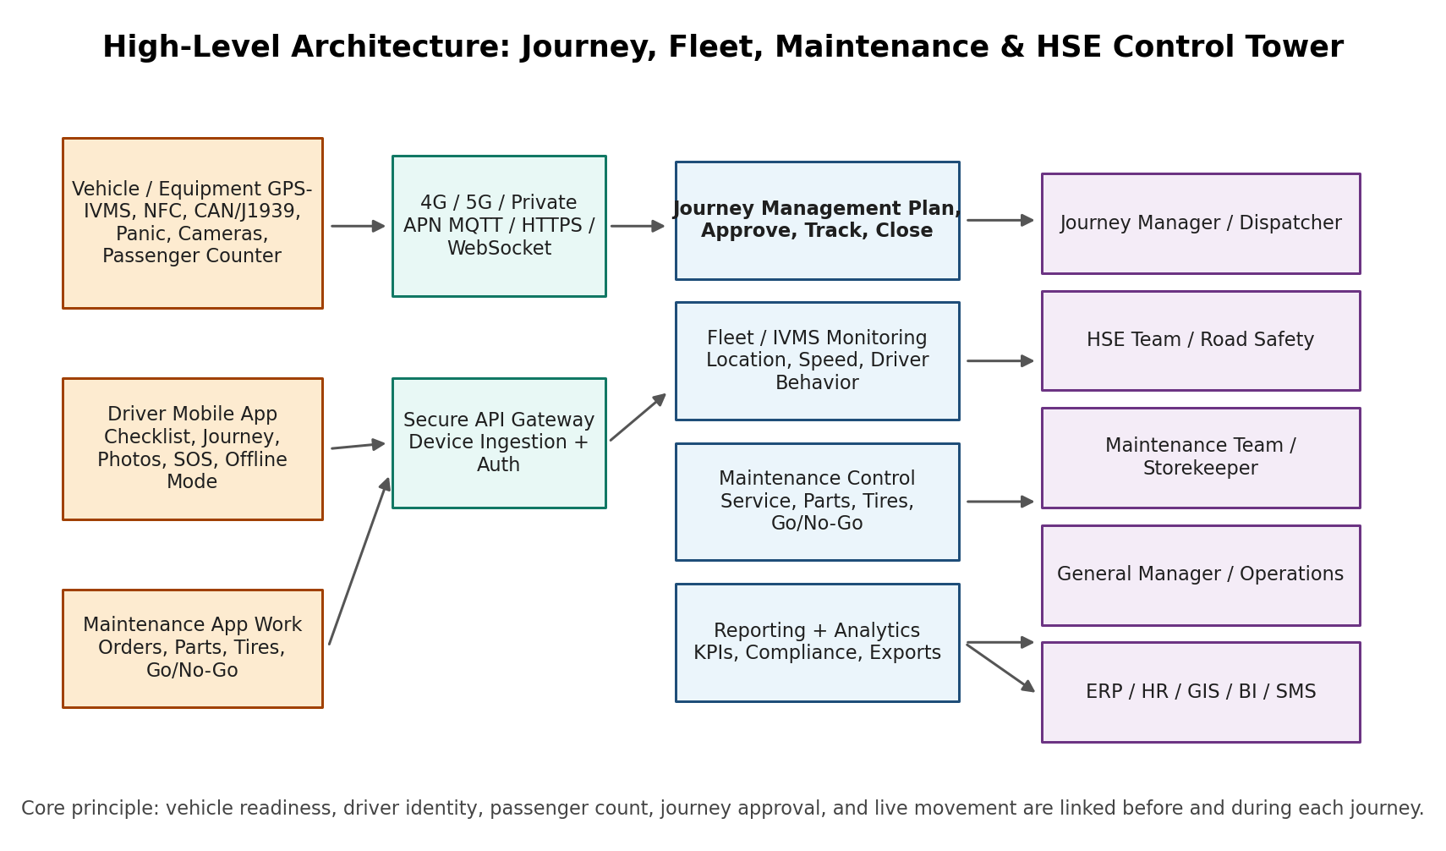
Figure 1. Proposed high-level architecture for the integrated journey, fleet, maintenance, and HSE control tower.

5. User Roles and Access Control
Role-based access control must be enforced across the user interface, API, workflow engine, reports, and data exports. Users should only see and approve the records that match their authority level.
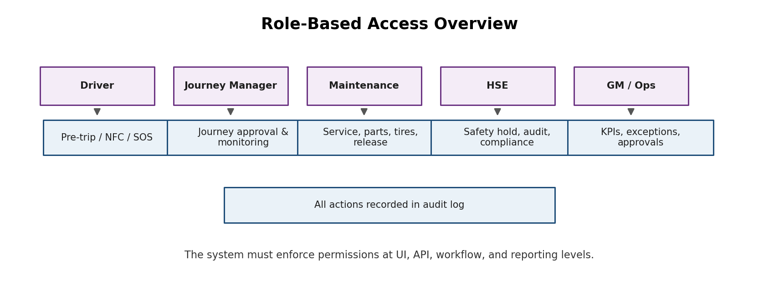
Figure 2. Role-based access overview.
Role | Allowed Actions | Restricted Actions
Driver | View assigned journeys, complete pre-trip checklist, tap NFC, confirm passengers, report defects, upload photos, raise SOS/breakdown. | Cannot approve journey, release vehicle, edit maintenance status, or override HSE hold.
Journey Manager / Dispatcher | Create journeys, assign approved vehicles/drivers, monitor route execution, close journeys, handle delays and deviations. | Cannot assign No-Go vehicles or override HSE/Maintenance blocks without formal authorization.
Maintenance Team | Open work orders, add maintenance photos, update service records, replace parts/tires, recommend or set Go/No-Go based on policy. | Cannot approve high-risk HSE release if workflow requires HSE approval.
HSE Team | Audit journeys, block unsafe vehicles, review incidents, approve conditional releases, monitor IVMS compliance, review headcount and safety reports. | Cannot alter financial records or inventory values unless explicitly granted.
General Manager / Operations Manager | View fleet KPIs, approve exceptions, review utilization/downtime/compliance, approve major operational overrides. | Should not bypass mandatory HSE/legal controls without audit trail.
Storekeeper / Procurement | Manage spare parts, issue parts to work orders, upload invoices, monitor stock levels. | Cannot release vehicle unless granted maintenance authority.
System Administrator | Manage users, permissions, configuration, integrations, templates, master data, and audit settings. | Should not delete audit logs or safety records.

6. Core Functional Modules

6.1 User, Role & Organization Module
- Multi-tenant structure for company, contractor, department, project, and site.
- Role-based permissions for driver, journey manager, maintenance, HSE, GM/Ops, storekeeper, admin, and read-only viewer.
- User status, account lock, MFA support for admin/manager roles, and user audit log.
- Organization hierarchy: business unit, project, base, camp, workshop, and site.

6.2 Vehicle Master File Module
- Create full vehicle profile by plate number, fleet number, VIN/chassis number, engine number, make, model, year, type, owner, project, and base location.
- Maintain current status: Available, Conditional Release, Under Maintenance, No-Go, Expired Documents, IVMS Fault, HSE Hold, Decommissioned.
- Attach documents: registration/Mulkia, insurance, RAS/inspection certificate, site permit, photos, and device installation records.
- Track odometer, engine hours, IVMS device ID, SIM number, APN, camera/MDVR ID, NFC reader ID, and passenger counter ID.

6.3 Driver Management & NFC Authentication Module
- Create driver profile with name, ID, license class, defensive driving certificate, medical/fitness status where applicable, authorized vehicle types, and active/inactive status.
- Assign NFC/RFID card or iButton to each driver and maintain card issue/revoke history.
- Vehicle must request driver identification by NFC before or immediately after ignition, based on hardware feasibility.
- Unauthorized driver attempts must trigger alerts and be recorded as events.
- Each trip must automatically attach the driver name, ID, card number, vehicle, timestamp, and location.

6.4 Journey Management Module
- Create, submit, approve, monitor, and close journey plans.
- Required fields: journey ID, vehicle, driver, passengers, start location, destination, route, waypoints, job purpose, planned departure/arrival, risk level, emergency contact, journey manager, and approval status.
- System must validate vehicle readiness, driver validity, documents, maintenance status, IVMS status, NFC status, headcount, and route risk before approval.
- Support journey states: Draft, Pending Approval, Approved, Active, Delayed, Deviated, Completed, Closed, Rejected, Cancelled, Emergency.

6.5 Job Plan Execution Module
- Attach each journey to a work order or job plan where required.
- Support job status: Assigned, En Route, Arrived, In Progress, Completed, Delayed, Failed, Cancelled.
- Allow GPS-based check-in/out at waypoints and destination.
- Support proof of arrival/completion using photos, QR, NFC, digital signature, supervisor approval, or geofence confirmation.
- Allow digital forms and checklists by job type.

6.6 IVMS / Fleet Tracking Module
- Live GPS location, speed, ignition, route, geofence, trip distance, idle time, engine hours, harsh braking, harsh acceleration, and movement history.
- Link IVMS trip data to driver, vehicle, journey plan, and job plan.
- Support event-based alerts: overspeed, harsh driving, panic, tamper, device offline, GPS loss, route deviation, delayed arrival, unauthorized movement, and night driving violation.
- Support history replay and export by vehicle, driver, journey, date range, and project.

6.7 Passenger / Headcount Module
- Maintain passenger manifest for each journey.
- Support passenger NFC/RFID check-in where required.
- Support automatic passenger count for buses/vans using door counter, cabin camera, or seat occupancy sensors where available.
- Alert if actual headcount does not match approved passenger list or maximum capacity.
- Log passenger count at start, waypoints, destination, and journey closure.

6.7A Passenger Logistics Mobile App Module
This module adds passenger-facing and planner-facing functionality inspired by the public Tasnim Logistics Passenger app description. It must be implemented as an original AR Technology oil & gas-grade module, not as a clone of any proprietary system. The objective is to digitally control employee pickup/drop requests, pooled logistics planning, driver allocation, live trip progress, passenger validation, inspections, loading/unloading activity, and analytics.
- Employee/passenger users shall request pickup and drop services between approved company locations, camps, sites, offices, hubs, and project areas.
- Requests shall be pooled into a central planner hub where logistics planners can group passengers by route, shift timing, destination, vehicle capacity, eligibility, and priority.
- Planner users shall assign the approved vehicle, driver, route, pickup sequence, drop sequence, journey plan, and passenger manifest.
- Passengers shall see request status, approval/rejection reason, vehicle details, driver name where permitted, pickup location, ETA, trip progress, delay alerts, and closure status.
- Drivers shall see allocated trips and journeys, passenger pickup/drop list, route sequence, check-in/out actions, boarding validation, and trip closure actions.
- The module shall support passenger boarding validation using QR code, NFC/RFID card, employee ID, or manual supervisor confirmation according to site policy.
- The actual boarding count shall reconcile with the approved passenger manifest and the vehicle capacity/headcount sensors before journey start and at closure.
- Drivers and loading clerks shall be able to record loading/unloading activities for each journey segment where material logistics is enabled.
- Vehicle inspectors shall be able to complete routine inspections, while workshops and HSE users shall schedule time-bound focused inspection campaigns.
- The system shall generate analytics and trends for request demand, approval rate, vehicle utilization, route performance, delays, passenger no-shows, trip scores, inspection findings, and service quality.
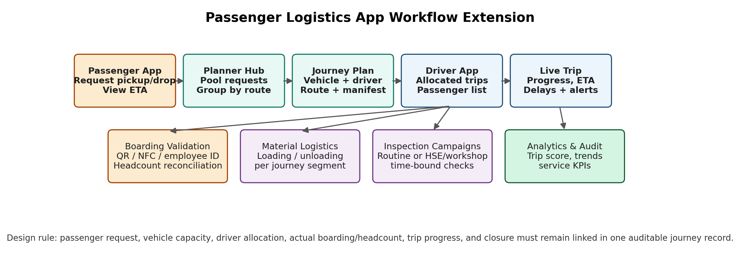
Figure 6. Passenger logistics app workflow extension.
Sub-Module | Minimum Functional Requirement
Passenger / Employee App | Pickup/drop request, entitlement check, request status, live trip progress, ETA, notifications, cancellation, feedback.
Logistics Planner Hub | Request pooling, grouping, route planning, capacity validation, vehicle/driver assignment, approval/rejection, exception handling.
Driver App | Allocated journeys, passenger list, route sequence, boarding validation, trip start, arrivals, trip closure, driver trip score view.
Passenger Validation | QR/NFC/employee ID/manual validation, headcount reconciliation, capacity control, no-show logging, manifest audit.
Material Logistics Add-on | Segment-based loading/unloading record, loading clerk role, quantity/photo/signature evidence, journey segment closure.
Inspection Campaigns | Routine inspections by vehicle inspectors and time-bound focused campaigns scheduled by central workshop or HSE.
Analytics | Demand trends, utilization, delay reasons, no-shows, trip fulfilment, route performance, inspection findings, and HSE compliance.

6.8 Maintenance, Service & Vehicle Release Module
- Manage preventive maintenance, major service, minor service, corrective maintenance, breakdowns, accident repair, tire replacement, battery replacement, IVMS/camera/NFC repair, and license renewal tasks.
- Create maintenance reports with before/after photos, odometer/engine hours, fault description, technician, parts replaced, and approval status.
- Apply Go / No-Go / Conditional Release decision to each vehicle.
- Automatically block journey assignment for No-Go, Under Maintenance, Expired Documents, IVMS Fault, NFC Fault, or HSE Hold status.
- Allow authorized override only through a documented workflow with reason, expiry time, approving user, and audit log.

6.9 Spare Parts & Replacement History Module
- Track part number, part name, OEM/aftermarket, supplier, warranty period, quantity, replacement date, linked vehicle, linked work order, technician, old/new photos, and cost field optional/configurable.
- Support stock issue against a work order and return/disposal record for old parts.
- Maintain replacement history by vehicle VIN, plate number, and fleet number.

6.10 Tire Management Module
- Track tire serial number, brand, model, size, installation date, axle position, odometer at installation, tread depth, pressure, damage photos, rotation history, repair, replacement, and disposal reason.
- Generate tire condition, tire age, tire mileage, replacement frequency, unsafe tire, and tire cost-per-km-ready reports where cost data is enabled.
- A critical tire defect should trigger No-Go or Conditional Release status based on policy.

6.11 Licensing, Renewal & Document Control Module
- Track Mulkia/registration, insurance, inspection/RAS where applicable, site permits, IVMS calibration, fire extinguisher expiry, first aid kit expiry, driver license, and defensive driving certificate.
- Generate reminders at configurable periods such as 90/60/30/7 days before expiry.
- Expired critical documents must automatically place vehicle or driver in blocked status until renewed.

6.12 CCTV / Dashcam / Evidence Module
- Optional integration with dashcam, cabin camera, MDVR/NVR, or 360-degree camera systems.
- Event-triggered video/photo attachment for harsh braking, collision, panic, accident, or maintenance evidence.
- Access to cabin cameras must follow privacy policy and user permissions.

6.13 Reporting & Analytics Module
- Dashboards for fleet readiness, active journeys, delayed journeys, No-Go vehicles, open defects, driver score, service compliance, document expiry, tire condition, passenger headcount, and HSE violations.
- Export reports in PDF, Excel/CSV, and API format.
- Support scheduled daily, weekly, and monthly email reports.

7. Detailed Workflows

7.1 Journey Workflow
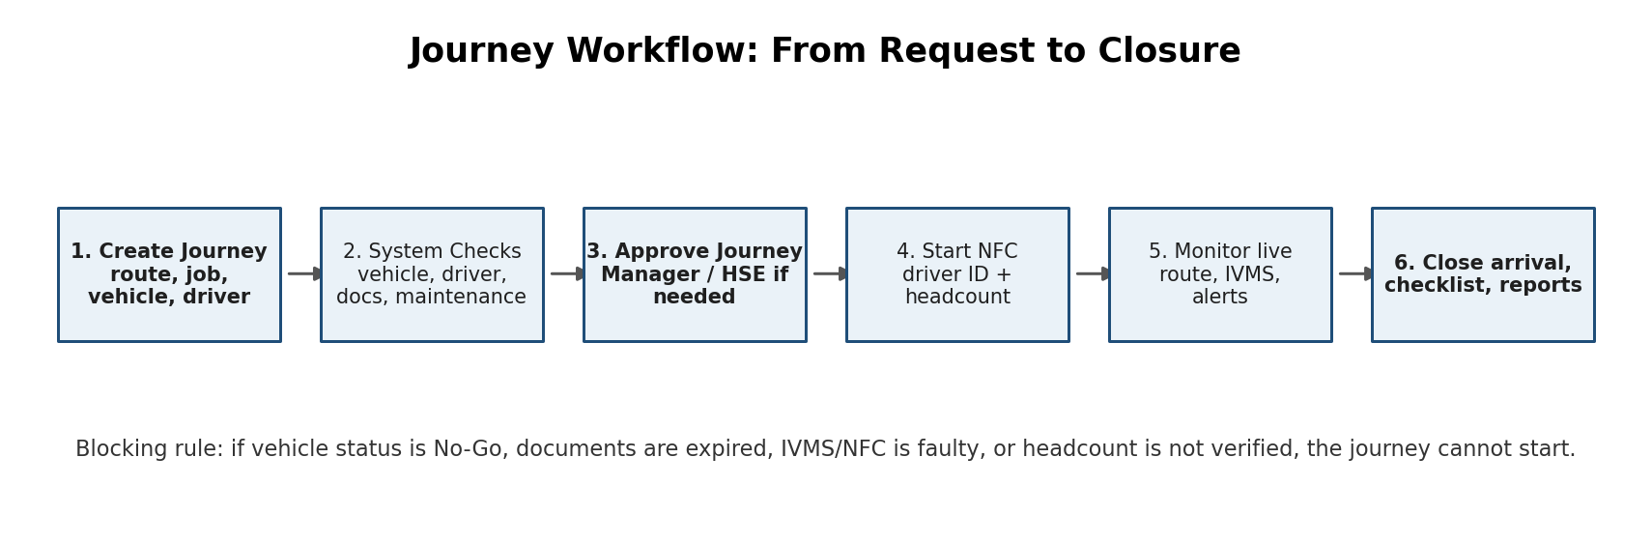
Figure 3. Journey workflow from request to closure.
- Journey Manager creates a journey plan and selects vehicle, driver, route, job, and passengers.
- System validates driver, vehicle, documents, maintenance release status, IVMS/NFC status, route risk, and headcount requirement.
- If validation passes, the journey is submitted for approval. If validation fails, the system displays blocking reasons.
- Approver approves or rejects the journey. High-risk journeys may require HSE approval.
- Driver completes pre-trip checklist and taps NFC/RFID card.
- Passenger/headcount is confirmed manually or automatically.
- Vehicle movement is monitored live until destination and closure.
- System generates journey close-out report, exceptions, and compliance metrics.

7.1A Passenger Request to Journey Fulfilment Workflow
- Passenger/employee submits pickup/drop request from mobile app using approved locations or GPS-assisted location selection.
- System validates user eligibility, department/project, requested date/time, route availability, and whether the request is passenger-only or linked to material movement.
- Request enters the central logistics planner hub and is pooled with similar requests by route, shift, destination, camp, project, or pickup window.
- Planner groups requests, validates vehicle capacity, selects approved vehicle and authorized driver, and creates or links the journey plan.
- Passenger receives status notifications including approved/rejected/pending, vehicle/driver details where permitted, pickup time, pickup point, ETA, and live trip progress.
- Driver receives allocated trip and passenger manifest in the driver app, then performs pre-trip checklist and NFC driver authentication.
- Boarding is validated by QR/NFC/employee ID/manual supervisor approval; actual passenger count is reconciled with manifest and vehicle capacity.
- During the trip, the platform monitors route, ETA, delays, deviations, IVMS events, passenger count, and waypoint arrival/departure.
- At trip closure, the system records completion, missed passengers/no-shows, trip score, driver score, passenger feedback, and analytics data.
Exception Scenario | Required System Behaviour
Passenger request without eligibility | Reject or route to supervisor approval with reason recorded.
Vehicle capacity exceeded | Block assignment until planner removes passengers or assigns larger/additional vehicle.
Passenger boarded but not on manifest | Generate exception; require supervisor/driver confirmation according to policy.
Passenger no-show | Record no-show reason/time and continue according to journey manager policy.
Driver starts without passenger validation where required | Block start or generate HSE/Journey Manager alert based on configuration.
Loading/unloading mismatch | Require correction, photo evidence, or supervisor approval before segment closure.

7.2 Maintenance & Go / No-Go Workflow
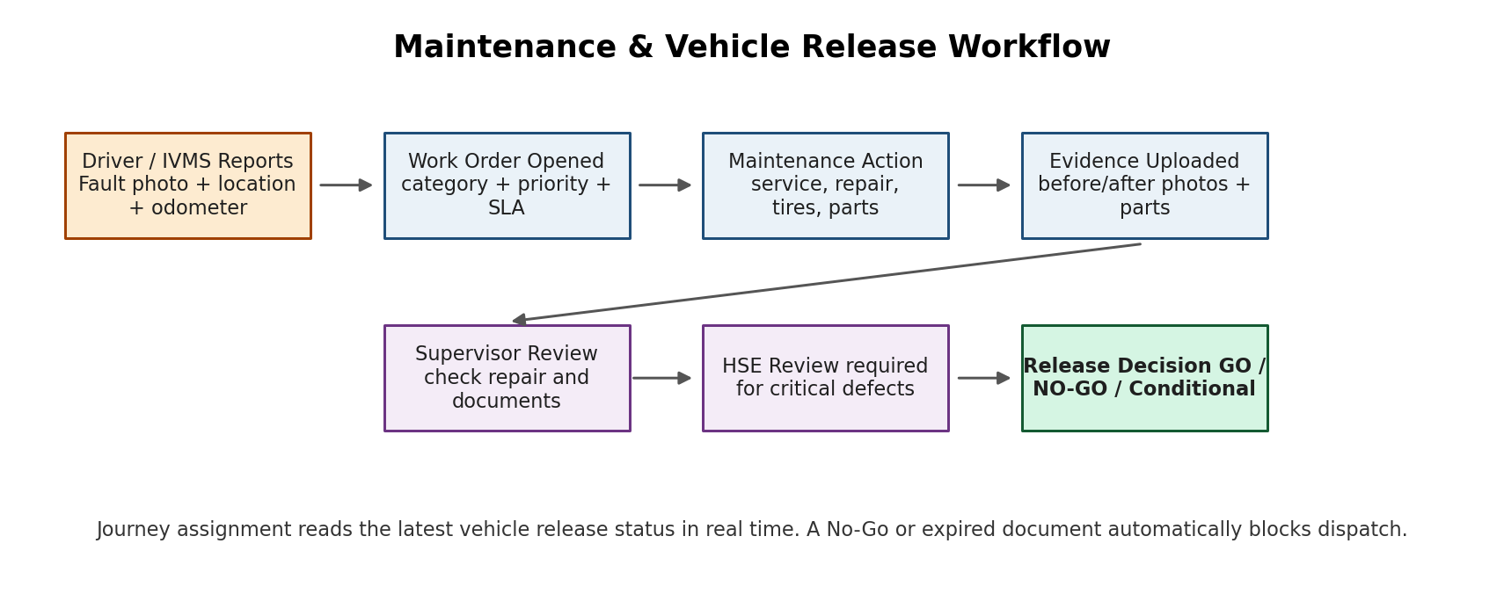
Figure 4. Maintenance release workflow.
- Fault is created by driver, IVMS, maintenance team, HSE, or system scheduler.
- Work order is opened with fault category, priority, photos, odometer, engine hours, and GPS location if available.
- Maintenance team inspects the vehicle and updates work order with findings, photos, replaced parts, and labor notes.
- Vehicle status is set to Available, Conditional Release, Under Maintenance, No-Go, IVMS Fault, Expired Documents, or HSE Hold.
- Critical safety defects require HSE review before release.
- Journey assignment engine reads the release status. No-Go/blocked vehicles cannot be selected for new journeys.
- All decisions and overrides are recorded in audit log.

8. Data Model and Master Records
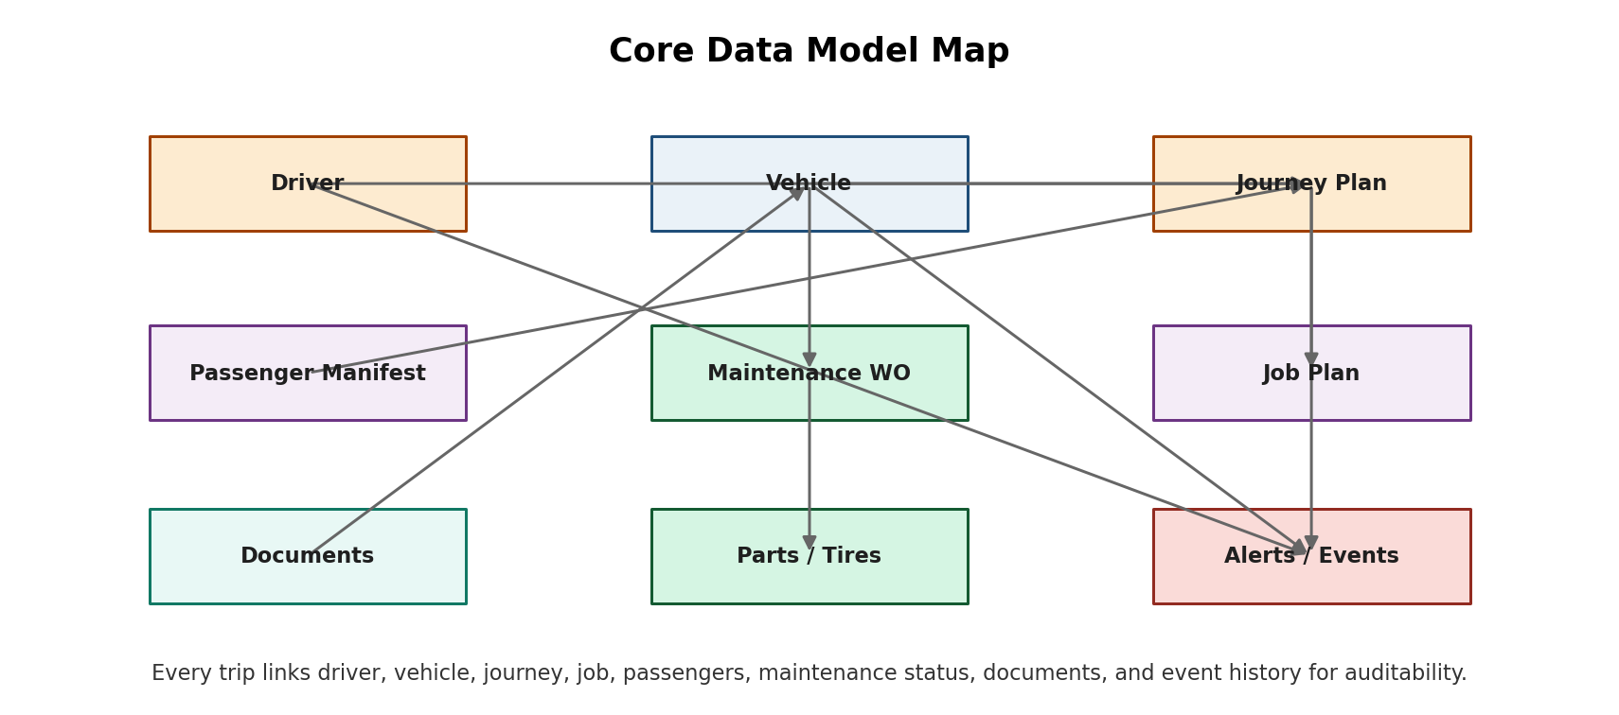
Figure 5. Core data model map linking vehicle, driver, journey, job, passengers, maintenance, documents, and alerts.

8.1 Main Entities
Entity | Key Fields
Organization | organization_id, name, type, parent_organization_id, project_id, active_status
User | user_id, name, email/mobile, role_id, organization_id, MFA_status, active_status
Driver | driver_id, employee_id, name, license_no, license_class, card_id, authorized_vehicle_types, certification_expiry, status
Vehicle | vehicle_id, plate_no, fleet_no, VIN, engine_no, make, model, year, type, owner, project, current_status, odometer, engine_hours
Device | device_id, type, serial_no, IMEI, SIM, APN, vehicle_id, firmware, last_seen, health_status
Journey Plan | journey_id, vehicle_id, driver_id, route_id, passengers, purpose, planned_start, planned_end, status, risk_score, approver_id
Job Plan | job_id, journey_id, work_order_no, job_type, destination, waypoint_list, status, proof_records
Passenger Manifest | manifest_id, journey_id, passenger_id/name, NFC_card, check_in_time, check_out_time, verification_method
Maintenance Work Order | wo_id, vehicle_id, issue_type, priority, status, photos_before, photos_after, technician_id, release_decision
Part Replacement | part_record_id, wo_id, part_number, part_name, quantity, supplier, warranty, installed_date, old_part_photo, new_part_photo
Tire Record | tire_id, vehicle_id, serial_no, size, axle_position, install_date, install_odometer, tread_depth, pressure, replacement_date, disposal_reason
Document | document_id, entity_type, entity_id, document_type, expiry_date, file_url, status, reminder_rules
Event / Alert | event_id, vehicle_id, driver_id, journey_id, event_type, severity, timestamp, location, action_status
Audit Log | audit_id, user_id/system_id, action, entity_type, entity_id, before_value, after_value, timestamp, IP/device

9. Hardware and IoT Integration Scope
The software must be hardware-agnostic where possible. The developer should design a device ingestion layer that can support multiple IVMS/GPS tracker vendors, NFC/RFID readers, CAN/J1939 devices, camera/MDVR systems, and passenger counters.
Hardware Component | Expected Data / Function
GPS / IVMS device | Location, speed, ignition, trip start/stop, harsh events, tamper, power loss, device health, driver ID where supported.
NFC/RFID driver reader | Driver card UID, authorized/unauthorized status, timestamp, vehicle ID, start authorization event.
Ignition / immobilizer relay | Enable/disable start based on approved policy, NFC driver verification, and vehicle release status.
CAN/J1939/OBD interface | Engine hours, odometer, RPM, fuel, engine status, fault codes where available.
Panic button | Emergency alert with vehicle, driver, location, time, and journey context.
Passenger counter | Automatic headcount events, boarding/alighting count, actual vs planned count.
Dashcam / MDVR | Event clips, still images, optional live view, incident evidence, maintenance evidence.
Mobile app | Checklist, photos, journey status, offline capture, signature, defect reports, SOS.

9.1 Device Integration Requirements
- Support inbound MQTT and HTTPS webhooks for device events.
- Store raw payloads for troubleshooting and normalized events for application use.
- Device mapping table must link device serial/IMEI to vehicle and project.
- Device health dashboard must show online/offline, last seen, GPS quality, battery/power, SIM status where available, and firmware version.
- The platform should allow new device adapters without rewriting business logic.

10. Reporting Requirements
Report | Primary Users | Minimum Content
Active Journey Report | Journey Manager, HSE | Active vehicles, route, driver, passengers, status, ETA, alerts, last location.
Journey Compliance Report | HSE, GM/Ops | Approved vs actual route, delays, deviations, closure status, call-in/checkpoint compliance.
Driver Behavior Report | HSE, Operations | Overspeed, harsh braking, harsh acceleration, fatigue/driving hours, driver score.
Vehicle Readiness Report | GM/Ops, Maintenance, HSE | Available, Conditional, No-Go, under maintenance, expired documents, IVMS/NFC faults.
Go / No-Go Report | Maintenance, HSE, Journey Manager | Vehicle release decision, reason, approver, expiry, linked work order, photos.
Maintenance Report | Maintenance, GM/Ops | Service history, major/minor service, defects, before/after photos, parts, technician, next due.
Parts Replacement Report | Maintenance, Procurement | Part number, part name, quantity, supplier, vehicle, work order, warranty.
Tire Report | Maintenance, HSE | Tire serial, axle position, tread depth, pressure, replacement date, photos, unsafe findings.
Licensing & Renewal Report | Admin, GM/Ops, HSE | Mulkia, insurance, inspection, permits, IVMS calibration, fire extinguisher, first aid, expiry reminders.
Passenger / Headcount Report | Journey Manager, HSE | Planned passengers, actual count, mismatch events, check-in/out, capacity compliance.
Incident / Panic Report | HSE, Emergency, GM/Ops | SOS event, location, driver, vehicle, journey, event timeline, action closure.
Audit Log Report | Admin, HSE, Compliance | Approvals, overrides, edits, deletions, status changes, exports, user actions.
Passenger Request Fulfilment Report | Logistics Planner, GM/Ops | Requests submitted, approved, rejected, pooled, assigned, completed, cancelled, and pending by route/site/department.
Passenger Manifest & Boarding Report | Journey Manager, HSE | Approved manifest, actual boarded passengers, validation method, headcount mismatch, no-shows, capacity exceptions.
Pickup/Drop Performance Report | Logistics Planner, GM/Ops | On-time pickup, on-time drop, ETA variance, delayed trips, route efficiency, passenger feedback.
Inspection Campaign Report | HSE, Maintenance, GM/Ops | Campaign scope, completed inspections, failed inspections, critical defects, corrective actions, closure status.
Loading/Unloading Segment Report | Operations, Logistics Planner, HSE | Material/segment records, loading clerk actions, timestamps, photos, exceptions, supervisor approvals.

11. Notifications and Escalations
Trigger | Recipient | Required Action
Unauthorized driver/NFC attempt | Journey Manager, HSE | Investigate and block vehicle if needed.
Vehicle selected but status is No-Go | Journey Manager | Cannot proceed; select approved vehicle or resolve defect.
Route deviation | Journey Manager, HSE if severe | Contact driver and record action.
Overspeed / harsh driving | Driver, HSE, Operations | Warn driver, record event, update driver score.
Panic button | Emergency contacts, HSE, Journey Manager | Emergency response workflow.
Missed checkpoint / delayed arrival | Journey Manager | Call driver; escalate if no response.
Headcount mismatch | Journey Manager, HSE | Stop journey approval or investigate during active trip.
Critical maintenance defect | Maintenance, HSE, GM/Ops | Place vehicle on No-Go or HSE Hold.
Document expiry approaching | Admin, Maintenance, GM/Ops | Renew before expiry; block if expired.
Device offline / tamper | Maintenance, HSE, Journey Manager | Check IVMS device and block vehicle if policy requires.
Passenger request pending beyond SLA | Logistics Planner | Approve, reject, pool, or escalate request.
Vehicle capacity/headcount mismatch | Driver, Journey Manager, HSE | Reconcile manifest and actual boarded passengers before departure.
Passenger trip delay/ETA change | Passengers, Journey Manager | Notify affected passengers and update live trip status.
Passenger boarded without valid manifest | Driver, Journey Manager, HSE | Validate exception or remove passenger according to site policy.
Inspection campaign overdue | Maintenance, HSE, GM/Ops | Complete inspection or block vehicle according to campaign rules.
Loading/unloading segment not closed | Operations, Loading Clerk, Journey Manager | Complete segment closure with evidence and approval if required.

12. Cybersecurity and Audit Requirements
- Role-based access control for all modules and APIs.
- MFA for admin, HSE, GM/Ops, and system configuration roles.
- Audit logs for login, approval, rejection, override, vehicle release, journey closure, document upload, report export, and data changes.
- Encryption in transit using TLS and encryption at rest for sensitive data.
- Secure device authentication using per-device credentials, API keys, tokens, or certificates depending on device capability.
- Data retention policies by event type, journey, maintenance report, image/video evidence, and audit log.
- Backup and disaster recovery plan with documented recovery point objective (RPO) and recovery time objective (RTO).
- Privacy controls for cabin camera, passenger records, and personal data access.
- No deletion of safety records without admin approval and audit trail. Prefer soft-delete with retention.

13. API and Integration Requirements
Integration Area | Expected Capability
ERP / Finance | Vehicle master, cost centers, work orders, supplier invoices, purchase orders, optional cost fields.
HR System | Driver/user profile sync, employment status, department, training/certification records.
GIS System | Routes, sites, geofences, road hazards, approved roads, red zones, camps, and project boundaries.
IVMS / GPS Vendors | Device telemetry ingestion, driver ID events, trip events, alerts, device health.
SMS / Email / WhatsApp Gateway | Notifications and escalation messages.
BI / Power BI | Scheduled export or API for dashboards and management reports.
Document Storage | Secure file storage for photos, PDF certificates, insurance, inspection, service records, and videos.
Passenger Logistics App / Transport Portal | Create/update passenger requests, pool requests, assign trips, sync passenger status, validate boarding, update ETA/progress, close trips, and export passenger logistics analytics through API/webhooks.

13.1 API Design Expectations
- REST API for core CRUD operations and reporting exports.
- Webhook support for journey status, device alerts, maintenance status, and approval events.
- Webhook retry and failure log.
- Pagination, filtering, sorting, and date-range queries for all list endpoints.
- Strict API permission checks matching user roles.
- API versioning from the first release, for example /api/v1/.
- Swagger/OpenAPI documentation required.

14. Non-Functional Requirements
Requirement | Target
Availability | Target 99.5% or higher for production; final SLA to be agreed.
Scalability | Support phased growth from pilot fleet to hundreds/thousands of vehicles.
Performance | Live map events should update within near-real-time limits subject to device transmission interval and network coverage.
Offline Support | Driver mobile app must capture checklist, photos, and defect reports offline and sync when network returns.
Localization | English first, Arabic-ready UI and report labels recommended.
Hosting | Support cloud, local Oman cloud, and on-premise deployment options.
Configurability | Admin can configure checklist templates, approval rules, notification rules, expiry reminders, and vehicle status rules.
Maintainability | Codebase must be modular, documented, and include automated tests for critical workflows.

15. Developer Backlog / Epics
Epic | Key User Stories
User & Access | As an admin, I can create roles and assign permissions so users only access approved functions.
Vehicle Master | As maintenance, I can create a vehicle profile with VIN, plate, documents, devices, and current status.
Driver NFC | As a driver, I can tap my NFC card so the system identifies me and links me to the journey.
Journey Planning | As a journey manager, I can create, approve, monitor, and close journeys.
Job Execution | As an operations user, I can assign job plans and verify waypoint completion.
IVMS Tracking | As HSE, I can see live vehicle movement and driver behavior alerts.
Passenger Headcount | As a journey manager, I can verify planned and actual passengers before departure.
Maintenance Work Orders | As maintenance, I can open, update, and close work orders with photos and parts.
Go / No-Go Control | As HSE/maintenance, I can block or release a vehicle and prevent unsafe journey assignment.
Tires & Parts | As storekeeper/maintenance, I can track tire and spare-part replacement history by VIN.
Documents & Renewal | As admin, I can receive expiry reminders and block expired vehicles/drivers.
Reports & Dashboards | As GM/Ops, I can view KPIs and export monthly compliance reports.
Notifications | As a user, I receive alerts based on my role and escalation rules.
APIs & Integrations | As a developer, I can integrate devices, ERP, HR, GIS, SMS, and BI tools through documented APIs.
Passenger Logistics App | As an employee, I can request pickup/drop transport. As a planner, I can pool requests and assign vehicle/driver. As a passenger, I can track trip progress. As a driver, I can validate passengers and close the trip. As HSE/workshop, I can schedule inspection campaigns and review analytics.

16. Acceptance Criteria
- Vehicle cannot be assigned to a journey when status is No-Go, Under Maintenance, Expired Documents, IVMS Fault, NFC Fault, or HSE Hold.
- Driver NFC/RFID identification is captured and linked to journey, vehicle, timestamp, and location.
- Journey plan can be created, approved, started, monitored, deviated, completed, and closed.
- Route deviation, overspeed, panic, unauthorized movement, device offline, and headcount mismatch alerts are generated and visible to correct users.
- Maintenance report supports before/after photos, parts, tire record, odometer/engine hours, technician, supervisor decision, and release status.
- Major service and renewal reminders are generated according to configurable rules.
- Tire history can be viewed by vehicle, axle position, serial number, and replacement date.
- Passenger manifest and actual headcount are stored per journey and included in reports.
- Audit log records all status changes, approvals, overrides, and report exports.
- Reports can be exported in PDF and Excel/CSV formats.
- Mobile app supports offline checklist/defect capture and later synchronization.
- Admin can configure roles, workflow rules, alert rules, checklist templates, and document expiry reminders.
- APIs are documented and tested for core modules.

17. Implementation Roadmap
Phase | Scope | Key Output
Phase 1: Discovery & Design | Confirm users, vehicle types, hardware, routes, documents, approval matrix, forms, and reporting format. | Signed functional specification, data model, UI wireframes, integration plan.
Phase 2: MVP Platform | Vehicle master, driver master, NFC driver ID, basic journey management, live tracking, pre-trip checklist, basic reports. | Pilot-ready platform.
Phase 3: Maintenance & Go/No-Go | Service records, work orders, photos, parts, tires, license renewal, release workflow, vehicle blocking rules. | Maintenance-controlled journey readiness.
Phase 4: HSE & Passenger Controls | Passenger manifest/headcount, HSE hold, escalations, driver score, route deviation, compliance reports. | HSE control tower.
Phase 5: Integrations | ERP/HR/GIS/SMS/BI, device vendor adapters, API hardening, data exports. | Enterprise integration layer.
Phase 6: Advanced Enhancements | Dashcam/MDVR evidence, AI event detection, predictive maintenance, multilingual UI, contractor portals. | Advanced fleet intelligence platform.

18. Open Questions for Developer Discovery
- Which IVMS/GPS device brands and protocols will be used in the pilot?
- Will the vehicle immobilizer be physically implemented or initially limited to alerting/blocking journey approval?
- Which vehicle categories are included first: light vehicles, buses, trucks, excavators, tankers, or all?
- What is the required hosting model: SaaS, Oman local cloud, on-premise, or hybrid?
- What are the exact approval levels for high-risk journeys and conditional vehicle release?
- What passenger counting method will be used first: manual manifest, passenger NFC, door counter, seat sensors, or camera analytics?
- Are cabin cameras allowed under the client privacy and HSE policy?
- Which documents are mandatory for the client and which ones should automatically block vehicle use upon expiry?
- What KPIs must appear on the GM/Ops dashboard from day one?
- What external systems must be integrated in the first release?

19. References
The following sources were used as reference points for platform architecture, journey management, IVMS/road safety alignment, and maintenance control best practices. Final implementation must be validated against the client’s latest contractual, OPAL, and legal requirements.
Source | Link / Notes
Fleetbase official platform | https://fleetbase.io/ - reference for modular logistics OS, workflows, and operational control model.
Fleetbase on-premise documentation | https://docs.fleetbase.io/deploying/on-premise/ - reference for deploy-on-own-infrastructure approach.
Oil & Gas Road Safety and Journey Management Reference | Client-specific and industry road safety standards - reference for road safety, IVMS, journey management, and vehicle/driver requirements; validate against the latest client contractual requirements.
OPAL Oman Energy Association | https://opaloman.om/ - reference for Oman Energy Association context.
OPAL Unified Services Platform | https://usp.opaloman.om/our-services/ - reference for RAS and road-safety-related services.
Fleetio preventive maintenance reference | https://www.fleetio.com/blog/5-components-of-fleet-preventive-maintenance - general fleet preventive maintenance best-practice reference.
Tasnim Logistics Passenger app listing - Google Play | https://play.google.com/store/apps/details?id=djm.cuetrans.passanger - public app description used only as a functional reference for pickup/drop requests, planner pooling, driver trip visibility, live progress, loading/unloading, inspection campaigns, and analytics.

Appendix A: Suggested Pre-Trip Checklist Fields
Category | Checklist Items
Vehicle Exterior | Tires, lights, mirrors, windshield, body damage, leaks, plate visibility.
Safety Equipment | Seatbelts, fire extinguisher, first aid kit, warning triangle, spare tire/tools where applicable.
IVMS & Devices | GPS/IVMS working, NFC reader working, camera/MDVR working, panic button test where permitted.
Documents | Mulkia, insurance, inspection/RAS, site permit, driver license, journey approval.
Passengers | Passenger names/IDs, headcount, capacity, seatbelt confirmation.
Journey Details | Destination, route, waypoints, planned time, emergency contact, rest stops.

Appendix B: Suggested Vehicle Status Rules
Condition | Automatic Status / Action
Major service overdue | Set vehicle to No-Go or Conditional Release based on policy.
Insurance / Mulkia expired | Set vehicle to Expired Documents and block journey assignment.
Critical tire defect | Set vehicle to No-Go and open maintenance work order.
IVMS device offline beyond threshold | Set IVMS Fault and alert maintenance/HSE.
NFC reader fault | Set NFC Fault and block driver-authenticated journeys unless approved override exists.
HSE incident investigation | Set HSE Hold and block assignment.
Maintenance work order closed and approved | Set Available or Conditional Release depending on approval result.

