Performance Test Report

**Test #1:** Request to turn up Cassandra Bitnami Server on Compute Engine to allow scripts to be run

**Prerequisite:** Server should be turned off at least 3 hours before test

**Results:** Crawler was run and impact was recorded for a period of three hours.

**Performance Stats:**

CPU impact:

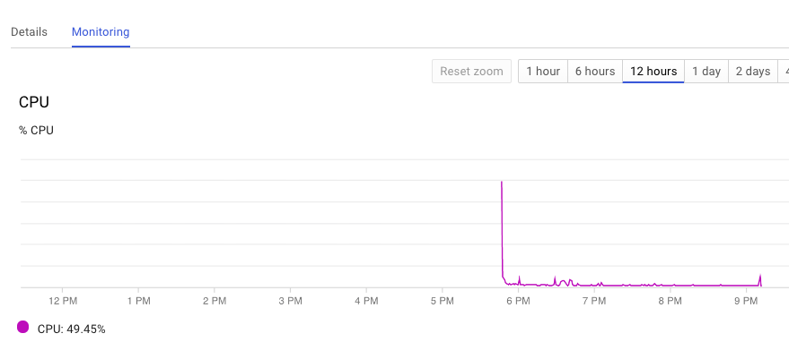

Network Impact:

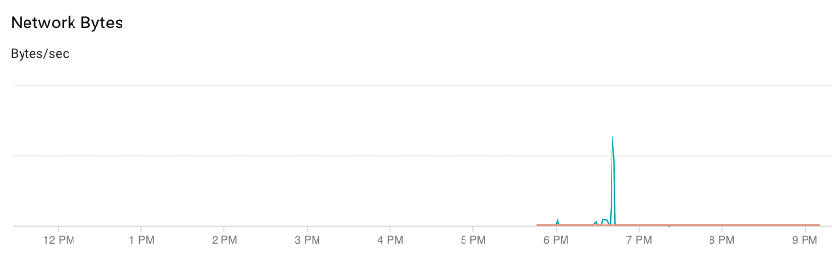

Network Packets impact:

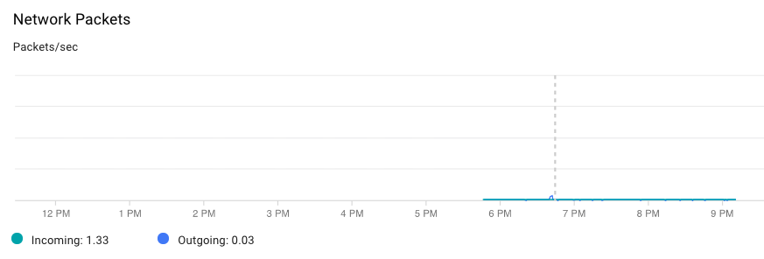

Bytes spent:

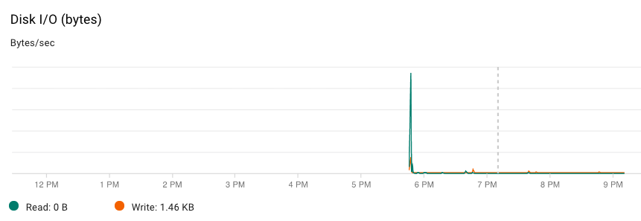

**Outcome**

The CPU usage was 49.5% when kubernaters script was run which has the highest members and channels. This was still less than our threshold of 60% when the system admin is notified.

Also 148kb worth of network packets were shared which is normal behavior and does not impact cloud server.