Q 1)-Create Database

SS-

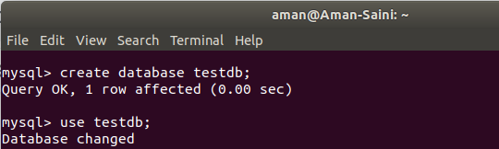

Q 2)-Design Schema

SS-

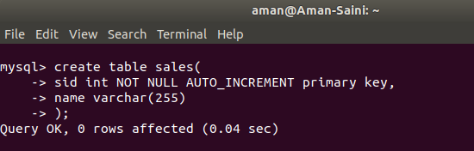

Q 3)-Create tables

SS-

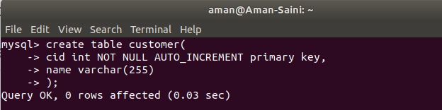



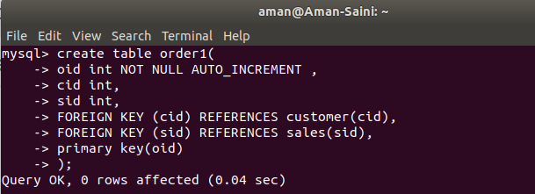

Q 4)-Insert sample data

SS-

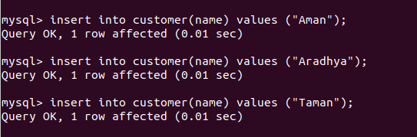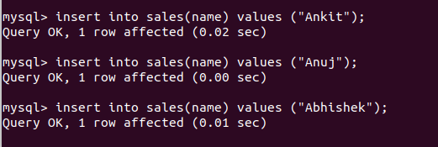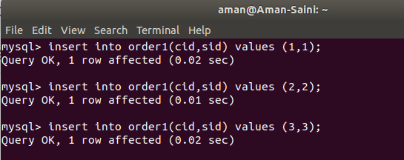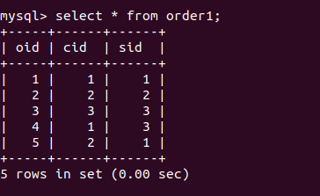

Q 5)-Find the sales person have multiple orders.

SS-

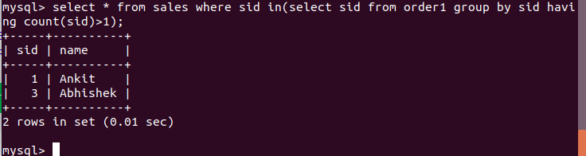

Q 6)-Find the all sales person details along with order details

SS-

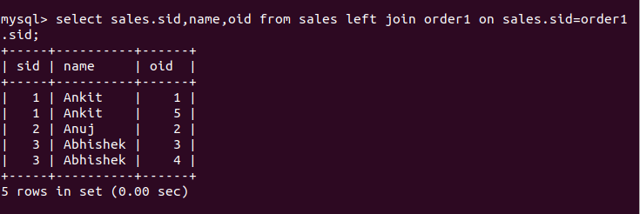

Q 7)-Create index

SS-



Q 8)-How to show index on a table

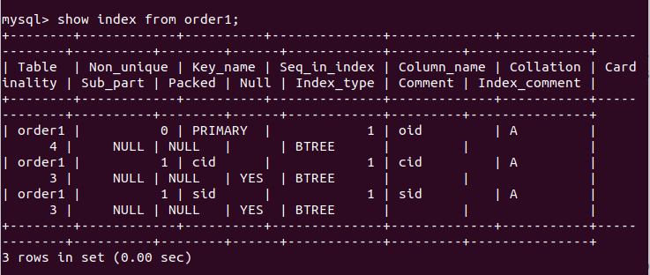

Q 9)-Find the order number, sale person name, along with the customer to whom that order belongs to

SS-

