1.How are inline and block elements different from each other?

Answer 1)-An inline element does not start on a new line and only takes up as much width as necessary while a block-level element always starts on a new line and takes up the full width available

2.Explain the difference between visibility:hidden and display:none?

Answer 2)-visibility:hidden hides an element.

However, the element will still take up the same space as before. The element will be hidden, but still affect the layout: while

display: none is commonly used with JavaScript to hide and show elements without deleting and recreating them.

3. Explain the clear and float properties.

Answer 3)- The clear property specifies what elements can float beside the cleared element and on which side while the float property is used for positioning and formatting content e.g. let an image float left to the text in a container .

4. Explain difference between absolute, relative,fixed and static.

Answer 4)-An element with position: static; is not positioned in any special way; it is always positioned according to the normal flow of the page while an element with position: relative; is positioned relative to its normal position.An element with position: fixed; is positioned relative to the viewport, which means it always stays in the same place even if the page is scrolled while an element with position: absolute; is positioned relative to the nearest positioned ancestor (instead of positioned relative to the viewport, like fixed).

5. Write the HTML code to create a table in which there are 4 columns( ID , Employee Name, Designation, Department) and at least 6 rows. Also do some styling to it.

Answer 5)-SS

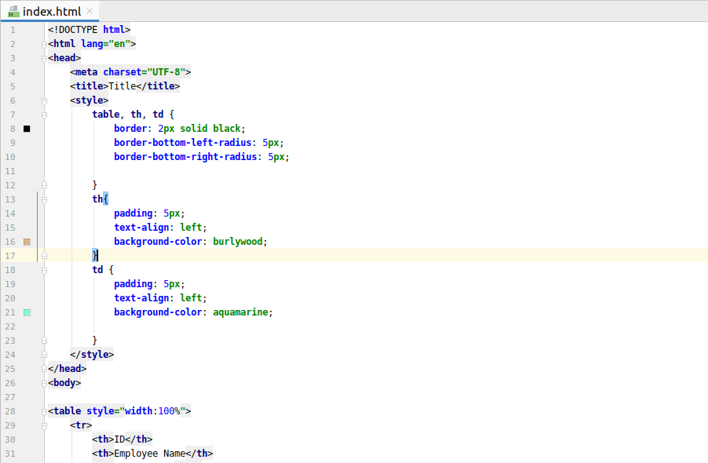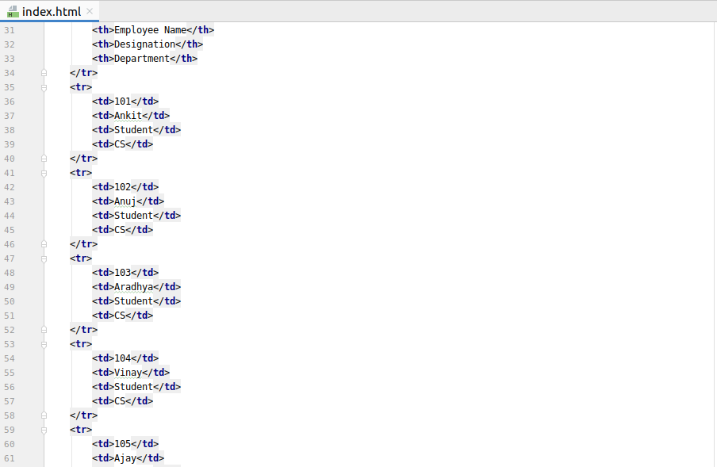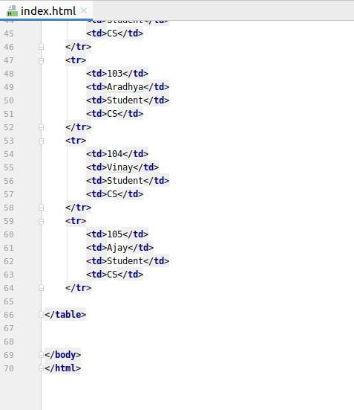

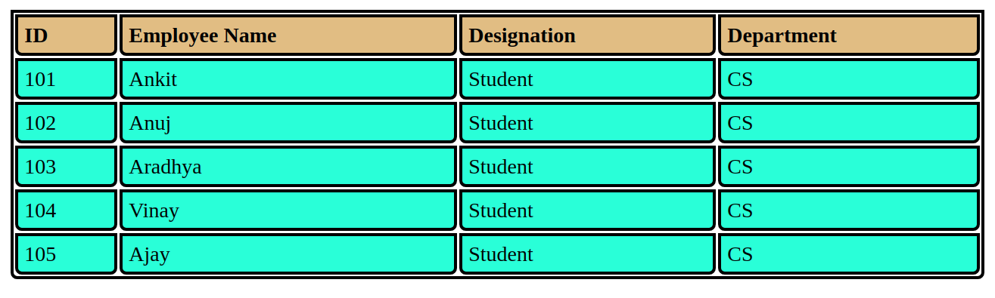

6. Why do we use meta tags?

Answer 6)-Metadata is data (information) about data.The <meta> tag provides metadata about the HTML document. Metadata will not be displayed on the page, but will be machine parsable.

7. Explain box model.

Answer 7)-All HTML elements can be considered as boxes. In CSS, the term "box model" is used when talking about design and layout.The CSS box model is essentially a box that wraps around every HTML element. It consists of: margins, borders, padding, and the actual content.

8. What are the different types of CSS Selectors?

Answer 8)-

There are several different types of selectors in CSS.

1. CSS Element Selector-The element selector selects the HTML element by name.
2. CSS Id Selector-The id selector selects the id attribute of an HTML element to select a specific element. An id is always unique within the page so it is chosen to select a single, unique element.
3. CSS Class Selector-The class selector selects HTML elements with a specific class attribute. It is used with a period character . (full stop symbol) followed by the class name.
4. CSS Universal Selector-The universal selector is used as a wildcard character. It selects all the elements on the pages.
5. CSS Group Selector-The grouping selector is used to select all the elements with the same style definitions.Grouping selector is used to minimize the code.

9. Define Doctype.

Answer 9)-The <!DOCTYPE> declaration must be the very first thing in your HTML document, before the <html> tag.The <!DOCTYPE> declaration is not an HTML tag; it is an instruction to the web browser about what version of HTML the page is written in.

10. Explain 5 HTML5 semantic tags.

Answer 10)-

1-<article>-The <article> element specifies independent, self-contained content.

2-<header>-The <header> element specifies a header for a document or section.

3.<footer>-The <footer> element specifies a footer for a document or section.

4.<nav>-The <nav> element defines a set of navigation links.

5.<aside>-The <aside> element defines some content aside from the content it is placed in (like a sidebar).

11. Create HTML for web-page.jpg (check resources, highest weightage for answers)

Answer 11)-

SS

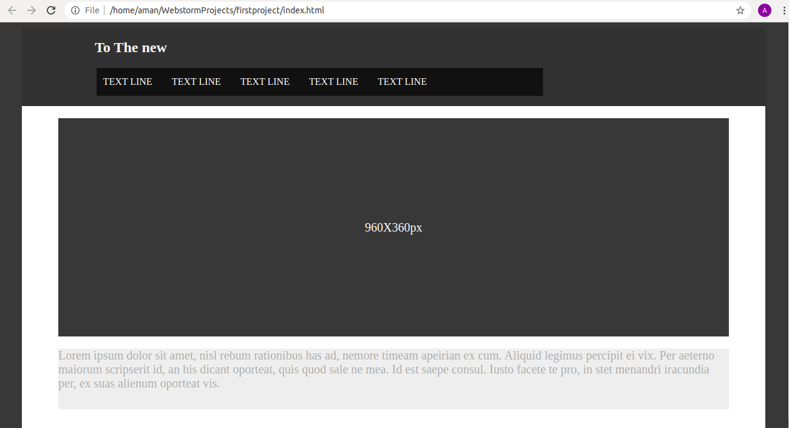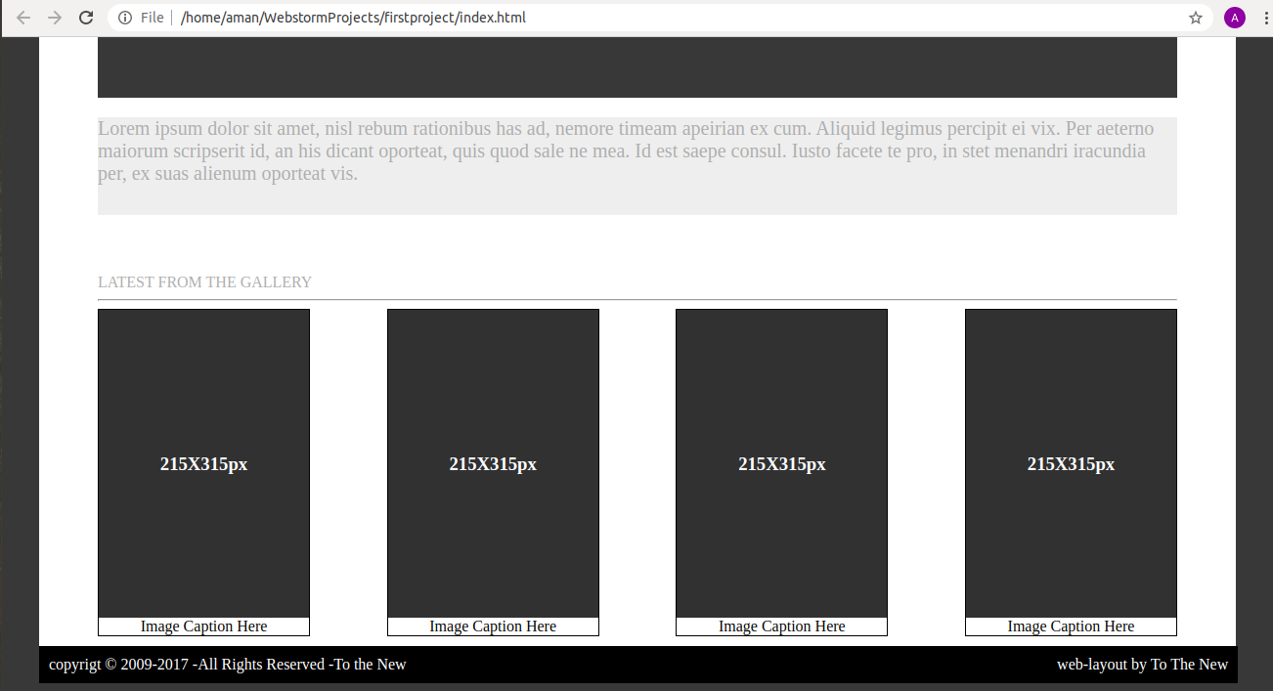

Link-

12. Create HTML for form.png (check resources, highest weightage for answers)

Answer 12)-

SS-

