**AssignmentMultithreading-**

Q-1. Name of method in Thread class to pause execution?

Ans)-

**Thread**. **sleep**() **method** can be used to **pause** the **execution** of current **thread** for specified time in milliseconds.

Q-2. Role of "volatile" keyword.

Ans)-

**Volatile keyword** is used to modify the value of a **variable** by different threads. It is also used to make classes thread safe.

The **volatile keyword** does not cache the value of the **variable** and always read the **variable** from the main memory.

Q-3. Write a program to create a thread using Thread class and Runnable interface each.

Ans)-SS

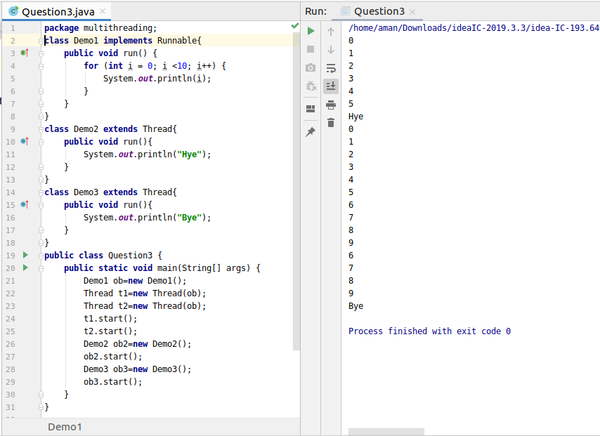

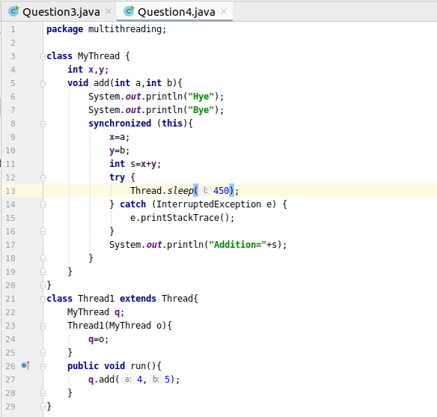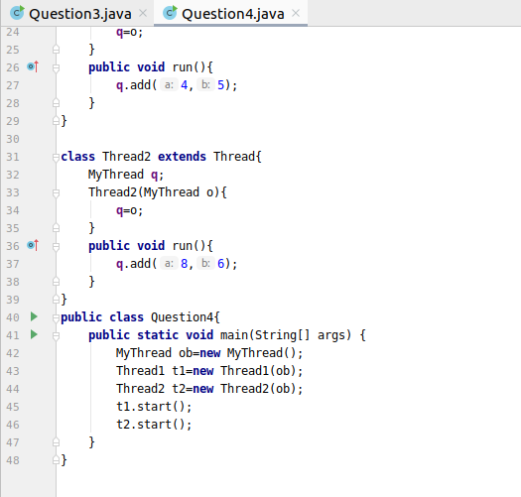

Q-5. Write a program using synchronization method

Q-6. Write a program to create a Thread pool of 2 threads where one Thread will print even numbers and other will print odd numbers.

Q-7. Write a program to demonstrate wait and notify methods.

Q-8. Write a program to demonstrate sleep and join methods.