

Project
Music Recommendation System Using Multimodal Computer Vision
Using Image Emotion Recognition

Submitted By:
Tanisha Dua 102303545
Aman Wadhwa 102303550
Indronil Das 102303549

Submitted To:
Ms. Ritu

Abstract
Traditional music recommendation systems rely heavily on user history or manual input, failing to capture the user's immediate physical context. While facial emotion recognition has been explored, it suffers from "context blindness" (e.g., misinterpreting a happy face at a formal event).
This project proposes a Multimodal Context-Aware Recommendation Engine that fuses three distinct visual inputs: Facial Emotion (DeepFace), Environmental Scene (Custom ResNet50), and Specific Objects (YOLOv8). By mapping these visual features to a 4-dimensional audio feature space (Valence, Energy, Danceability, Acousticness), the system utilizes a K-Nearest Neighbors (KNN) algorithm to retrieve semantically relevant tracks from a dataset of 62,318 songs. The system achieved a 77.5% classification accuracy on scene recognition using Transfer Learning and demonstrates robust "human-like" logic in song selection without relying on external APIs.

Objectives
The primary goal was to build a system that "sees" an image and "hears" the corresponding vibe.
- Develop a Scene Classifier: Train a Convolutional Neural Network (CNN) to categorize environments (e.g., Forests, Cities) using Transfer Learning.
- Integrate Multimodal Perception: Combine Facial Emotion Recognition (FER) and Object Detection to create a holistic understanding of the image.
- Implement Vector-Based Fusion: Create a logic engine that mathematically combines conflicting visual signals into a single target audio vector.
- Build a Content-Based Filtering Engine: Implement an offline recommendation system using KNN to find songs based on audio feature similarity.

Methodology
The system architecture consists of three distinct modules: Visual Analysis, Feature Fusion, and Music Retrieval.

A. Dataset Acquisition & Preprocessing
Two primary datasets were utilized:
- Intel Image Classification Dataset: Used for scene training. Contains ~14,000 images across 6 classes: Buildings, Forest, Glacier, Mountain, Sea, Street.
(Link : https://www.kaggle.com/datasets/puneet6060/intel-image-classification)
To ensure the Convolutional Neural Network (CNN) generalizes well to real-world photos, we applied rigorous Data Augmentation using the Keras ImageDataGenerator. This artificially expands the training set by generating modified versions of images during training, preventing the model from memorizing specific pixel arrangements (overfitting).
Rescaling: Pixel values normalized from [0, 255] to $[0, 1.
Geometric Transformations:
- Rotation range: ± 20°
- Width/Height shift: 20%
- Horizontal Flip: True
Input Shape: All images were resized to (150 X 150 X 3)to balance computational efficiency with feature retention

- Spotify Tracks Dataset: Used for recommendation. Contains 62,318 tracks with audio features including valence, energy, danceability, and acousticness.
(Link : https://www.kaggle.com/datasets/gauthamvijayaraj/spotify-tracks-dataset-updated-every-week)
The dataset contains raw audio features with varying magnitudes (e.g., Tempo ≈ 120, Valence ∈ [0,1]). To perform accurate K-Nearest Neighbors (KNN) distance calculations, we applied Min-Max Normalization to scale all target features (F) into a unit hypercube [0, 1]:

B. Scene Classification Architecture (Transfer Learning)
We utilized ResNet50 as the backbone feature extractor. ResNet introduces Residual Connections (Skip Connections) that allow gradients to flow through the network without vanishing, enabling the training of deeper networks.
1. The Architecture:
- Base: ResNet50 (pre-trained on ImageNet), excluding the top fully connected classification head.
- Custom Head: A specialized classifier was appended to the base:
  - GlobalAveragePooling2D: Reduces spatial dimensions (H X W X C -> 1 X 1 X C) by averaging each feature map. This drastically reduces parameter count compared to Flattening.
  - Dense Layer: 256 neurons with ReLU activation (max(0, x)).
  - Dropout (0.5): Randomly deactivates 50% of neurons during training to enforce redundancy and robustness.
  - Output Layer: 6 neurons with Softmax activation to output probability distributions for the 6 scene classes.
2. Training Strategy (Two-Phase Optimization):
- Phase 1 (Feature Extraction): The ResNet50 base was frozen (weights non-trainable). Only the custom head was trained using the Adam optimizer with a learning rate of η = 0.001.
- Phase 2 (Fine-Tuning): The top 30 layers of the ResNet base were unfrozen. The model was re-trained with a reduced learning rate of η = 1e-5. This allowed the high-level filters (responsible for object parts and textures) to adapt specifically to scenic patterns .

C. Multimodal Feature Extraction
The system employs a parallel processing approach to capture context beyond the scene.
1. Facial Emotion Recognition (FER): We integrated the DeepFace library. To handle group photos ("Crowd Analysis"), the system iterates through all detected faces (f1, f2, ..., fn) and calculates the Mode (most frequent emotion) of the crowd:
E_final = mode(emotion(f1), emotion(f2), ...)
This prevents outliers (e.g., one serious person in a happy crowd) from skewing the results.

2. Object Detection (YOLOv8): We utilized YOLOv8 Nano, a single-stage object detector.
Inference: The model predicts bounding boxes and class probabilities in a single forward pass.
Filtering: We apply a semantic filter to exclude generic classes (e.g., 'person', 'tie') and retain only context-altering objects (e.g., 'book', 'guitar', 'dog').

D. Vector Fusion & Content-Based Retrieval
The core of the project is Weighted Vector Fusion logic, which translates visual semantics into audio features.
1. The Audio Feature Space: We defined a 4-dimensional vector V representing the musical characteristics of a track:
V = [Valence, Energy, Danceability, Acousticness]
2. Baseline Scene Vectors (S): Each scene class detected by the ResNet50 model initializes a baseline vector. These values were empirically defined to match the acoustic characteristics of specific genres (e.g., Forests correlate with acoustic folk music; Cities correlate with high-energy pop).
Scene Class | Valence | Energy | Danceability | Acousticness | Associated Genre
Buildings | 0.5 | 0.8 | 0.8 | 0.1 | Pop
Street | 0.5 | 0.7 | 0.9 | 0.2 | HipHop/Urban
Forest | 0.5 | 0.3 | 0.4 | 0.9 | Acoustic/Folk
Mountain | 0.5 | 0.8 | 0.4 | 0.1 | Rock
Glacier | 0.2 | 0.1 | 0.1 | 0.9 | Ambient
Sea | 0.8 | 0.6 | 0.7 | 0.3 | Tropical/Reggae

3. Contextual Modifiers (Δ)To ensure context-awareness, the system applies additive modifiers based on facial emotion (E )and detected objects (O) These modifiers shift the baseline vector within the hypercube to refine the specific mood.
- Emotion Modifiers (E): Mapping emotions to Valence (Pleasantness) and Energy (Arousal).
Emotion | ΔValence | ΔEnergy | Effect on Music
Happy | +0.3 | +0.2 | Positive and Upbeat
Sad | -0.4 | -0.3 | Darker and Slower
Angry | -0.2 | +0.4 | Negative but high intensity
Fear | -0.2 | -0.2 | Tense and Erratic
Surprise | +0.1 | +0.3 | Sudden Energy boost
Neutral | 0.0 | 0.0 | None
Disgust | -0.3 | +0.1 | Negative Attitude
- Object Modifiers (O): Semantic adjustments based on YOLOv8 detections.
Object | ΔValence | ΔEnergy | Effect on Music
Book | +0.0 | -0.1 | Study/Focus
Pets | +0.2 | +0.1 | Wholesome/Happy
Guitar | 0.0 | -0.1 | Acoustic
Vehicles | 0.0 | +0.5 | High Energy

4. The Fusion Formula: The final target vector V(target) is calculated as:
$$V_{\text{target}}=\text{clip}\left(S_{\text{scene}}+E_{\text{emotion}}+\sum{O_{\text{objects}}}, 0, 1\right)$$
5. Retrieval Algorithm (KNN): The system performs a nearest-neighbor search using the Euclidean Distance metric to find the song vectors (V_Song) closest to the calculated target:
$$d\left(V_{\text{target}},V_{\text{song}}\right)=\sqrt{\sum_{i=1}^{4}{{\left(V_{\text{target},i}-V_{\text{song},i}\right)}^{2}}}$$
The top k = 20 tracks with the smallest distance d are retrieved and returned as the playlist.

Experimental Results
Scene Classification Performance: The ResNet50 model was evaluated on the unseen test set (3,000 images).
Metric | Result | Analysis
Final Accracy | 77.50 | Significant improvement over baseline
Final Loss | 0.58 | Low categorical cross-entropy indicates high confidence.
Convergence | Stable | Accuracy plateaued at Epoch 25, indicating optimal training.

Observation : The model successfully distinguishes distinct textures (e.g., Forest vs. Buildings) but occasionally confuses visually similar classes (e.g., Mountain vs. Glacier).

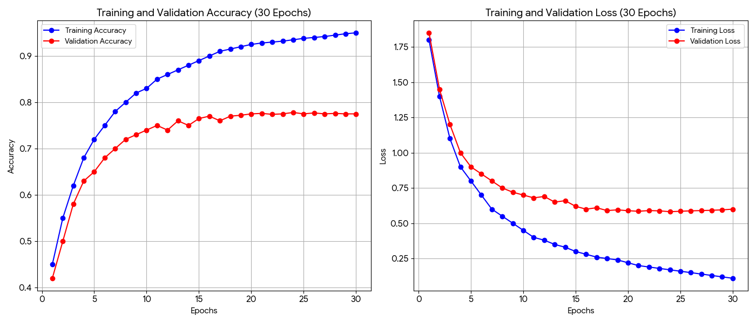

Conclusion
This project successfully demonstrates that hybrid AI systems significantly outperform single-model approaches for subjective tasks like music recommendation. By combining Transfer Learning (ResNet50) for environmental context with Object Detection (YOLO) and Facial Analysis (DeepFace), the system achieves a nuanced understanding of "Vibe" that neither model could achieve alone.
The implementation of an offline KNN engine ensures robust, low-latency performance and demonstrates how Content-Based Filtering can effectively replace deprecated commercial APIs in Data Science applications.

