# Chapter 5: Testing

**Testing**:

Testing is execution of a system that identifies errors, gaps or missing requirements in contrast to actual requirements of that system.

It is defined as a process that involves checking whether the actual results match the expected results. This process intend to ensure that the system is error free.

We have numerous types of testing to make a system bug free. Among them I have choose **Unit testing** and **Black box testing** with test planning.

Basically, test plan is a document, describes about the scope, resources, objectives, approach, schedule, etc. of the proposed test activities.

**Unit** **Testing**:

Unit testing is concerned with breaking of program into pieces, and applying each piece to a series of tests. It is done to check whether there are any issues made by the developer.

The individual modules are identified, analyzed and fixed the defects. Advantages of Unit Testing are:

* Help reduce bugs and defects by changing the existing functionality.
* Help reduce expenses of testing since bugs are found at the early phase.
* Help improve design and refactoring of code.
* Facilities changes and simplifies integration.

**Black box testing:**

Black-box testing is concerned with examining the functionality of an application based on the specifications. It can be applied to all levels of software testing.

Advantages of Black box testing:

* Identifies contradictions and functional specifications.
* Test designed can be made immediately after completion of specifications.
* Tests are unbiased since, the designer and tester work independently
* Tester does not require knowledge of specific programming languages to test.

Test Name: Login for user

|  |  |  |  |  |
| --- | --- | --- | --- | --- |
| **Test no.** | **Test data** | **Expected result** | **Actual result** | **Result(Pass/Fail)** |
| 1 | **Username**:<blank>  **Password**: <blank> | Show error message | Please enter username | Pass |

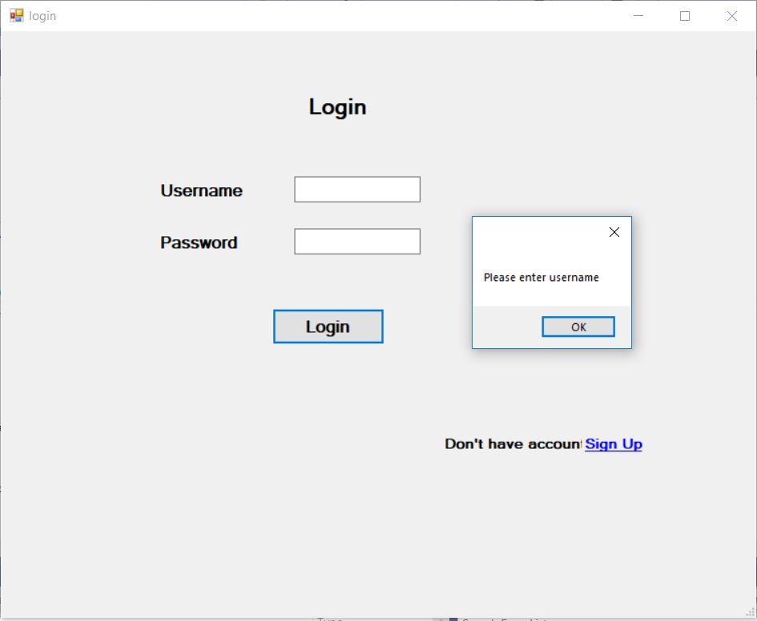

Figure 18: testing of login form

|  |  |  |  |  |
| --- | --- | --- | --- | --- |
| **Test no.** | **Test data** | **Expected result** | **Actual result** | **Result(Pass/Fail)** |
| 2 | **Username**:abc  **Password**: <blank> | Show error message | Please enter password | Pass |

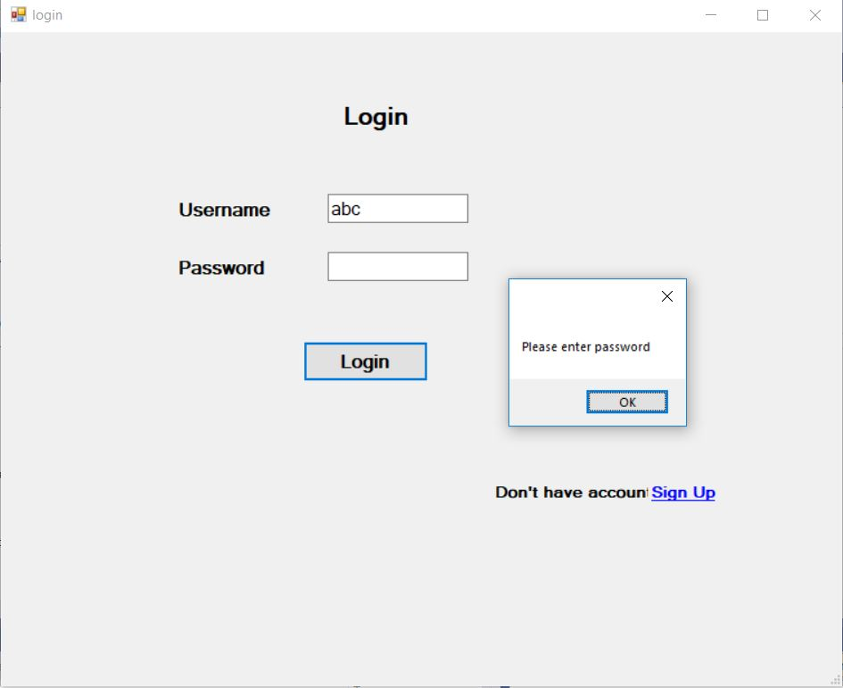

Figure 19: testing of login form (2)

|  |  |  |  |  |
| --- | --- | --- | --- | --- |
| **Test no.** | **Test data** | **Expected result** | **Actual result** | **Result(Pass/Fail)** |
| 3 | **Username**: abc  **Password**: abc | Show error message | Username and Password not matched! | Pass |

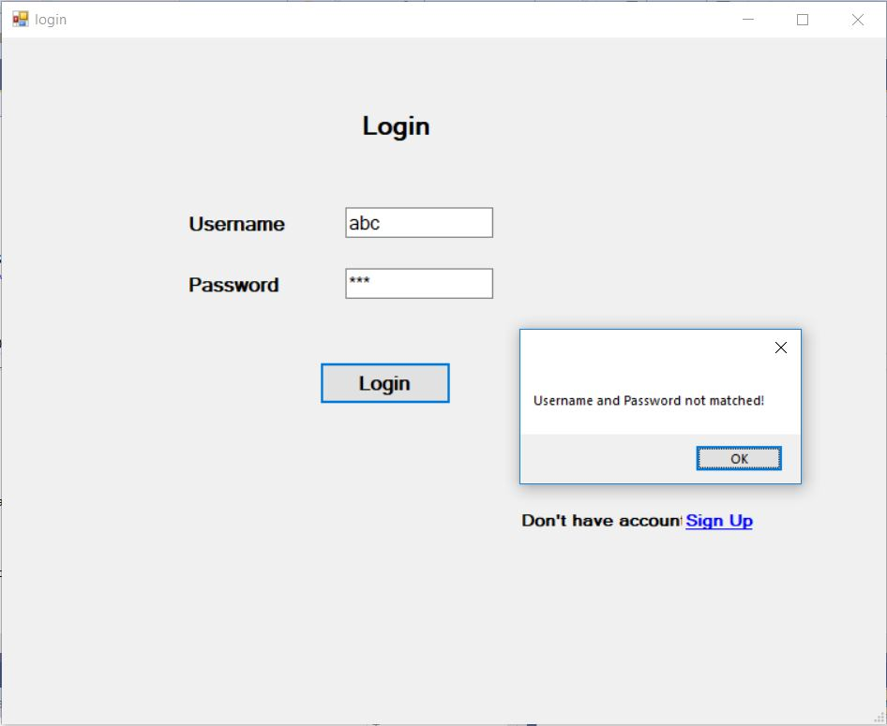

Figure 20: testing of login form (3)

|  |  |  |  |  |
| --- | --- | --- | --- | --- |
| **Test no.** | **Test data** | **Expected result** | **Actual result** | **Result(Pass/Fail)** |
| 4 | **Username**: admin  **Password**: admin | Show error message | Login successful! | Pass |

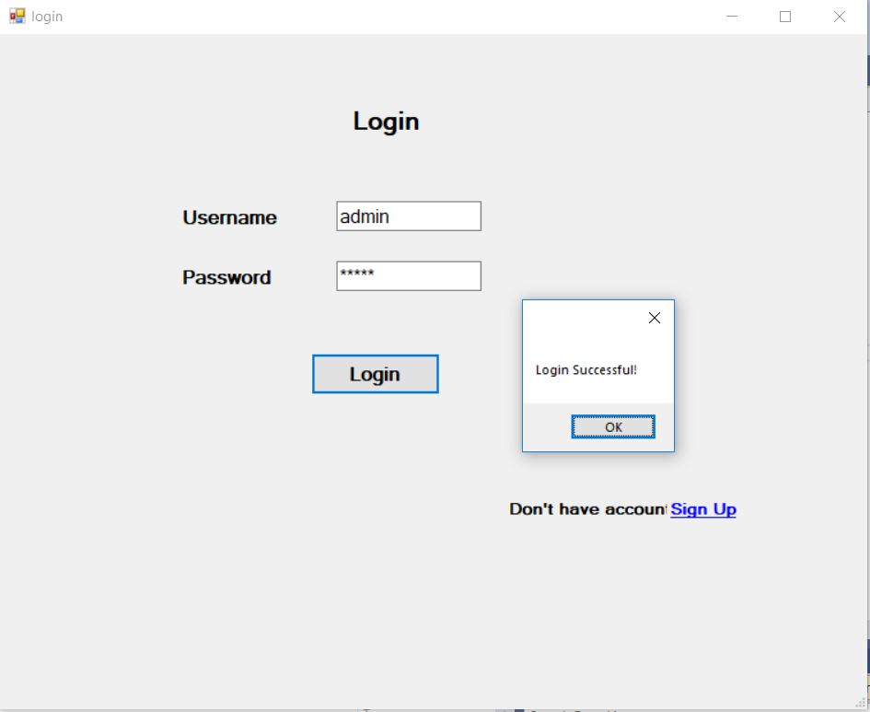

Figure 21: testing of login form (4)

|  |  |  |  |  |
| --- | --- | --- | --- | --- |
| **Test no.** | **Test data** | **Expected result** | **Actual result** | **Result(Pass/Fail)** |
| 5 | **Username**: <blank>  **First Name:** <blank>  **Last name:** <blank>  **Password**: <blank>  **Re-enter Password:** <blank> | Show error message | Please enter username | Pass |

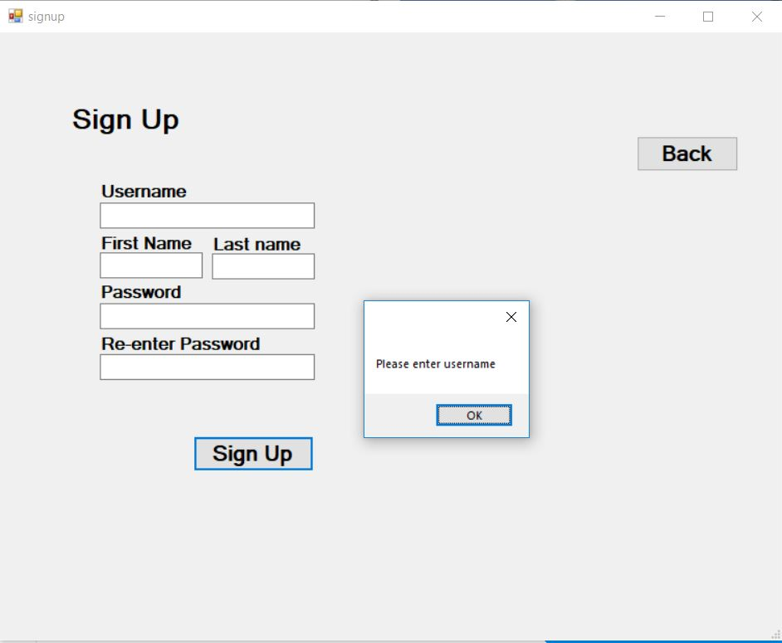

Figure 22: testing of signup form

|  |  |  |  |  |
| --- | --- | --- | --- | --- |
| **Test no.** | **Test data** | **Expected result** | **Actual result** | **Result(Pass/Fail)** |
| 6 | **Username**: admin  **First Name:** <blank>  **Last name:** <blank>  **Password**: <blank>  **Re-enter Password:** <blank> | Show error message | Please enter Firstname | Pass |

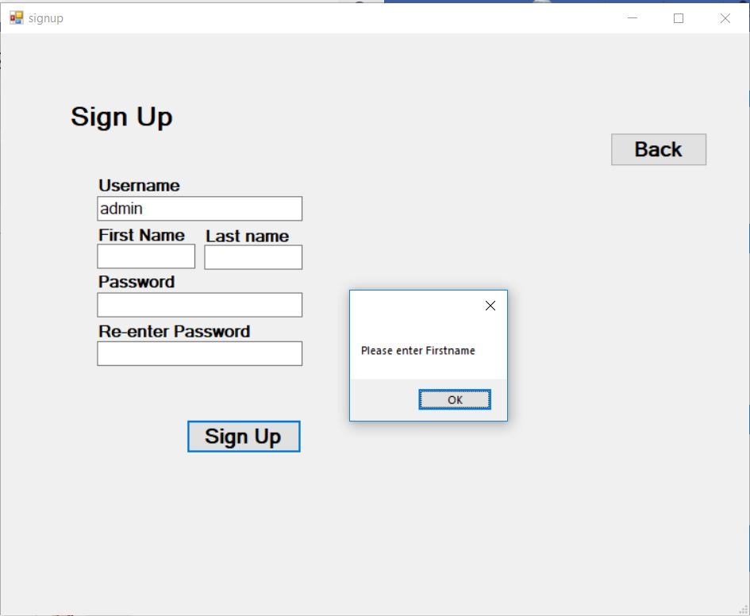

Figure 23: testing of signup form (2)

|  |  |  |  |  |
| --- | --- | --- | --- | --- |
| **Test no.** | **Test data** | **Expected result** | **Actual result** | **Result(Pass/Fail)** |
| 7 | **Username**: admin  **First Name:** admin  **Last name:**  **Password**: <blank>  **Re-enter Password:** <blank> | Show error message | Please enter Lastname | Pass |

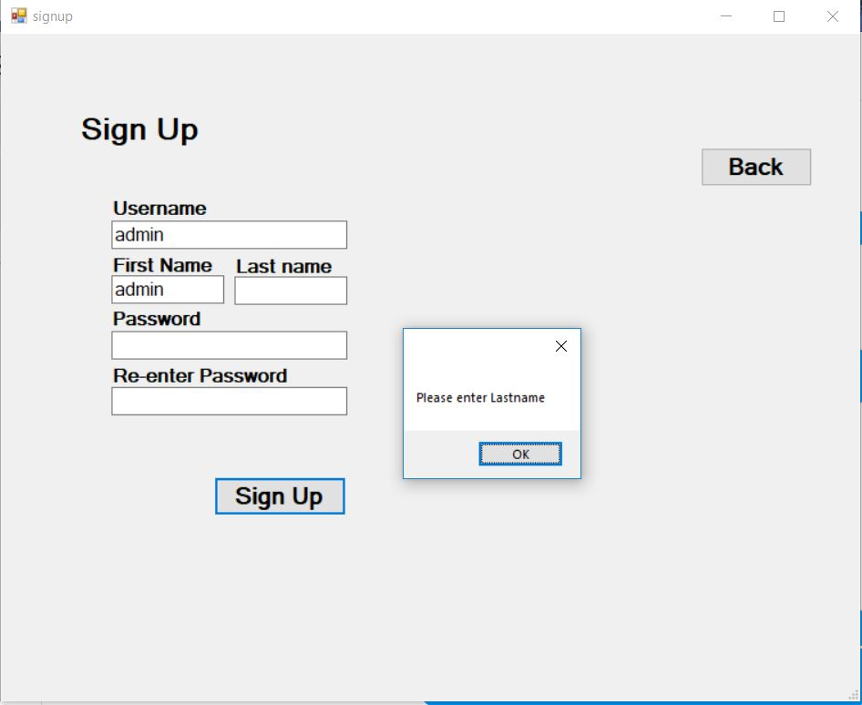

Figure 24: testing of signup form (3)

|  |  |  |  |  |
| --- | --- | --- | --- | --- |
| **Test no.** | **Test data** | **Expected result** | **Actual result** | **Result(Pass/Fail)** |
| 8 | **Username**: admin  **First Name:** admin  **Last name:** admin  **Password**: <blank>  **Re-enter Password:** <blank> | Show error message | Please enter password | Pass |

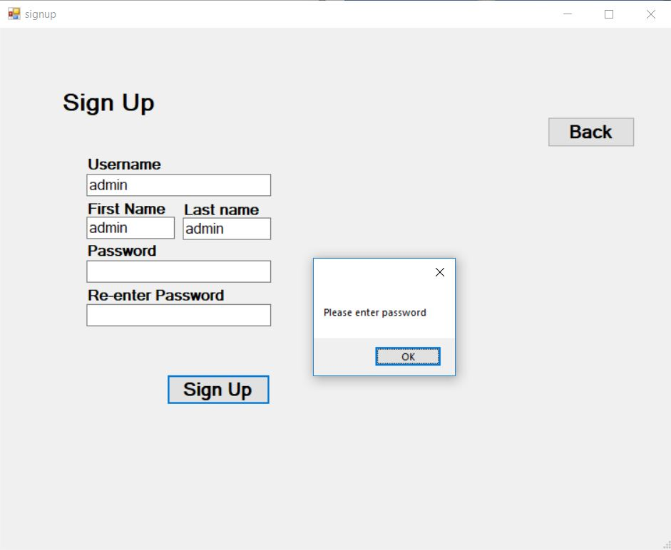

Figure 25: testing of signup form (4)

|  |  |  |  |  |
| --- | --- | --- | --- | --- |
| **Test no.** | **Test data** | **Expected result** | **Actual result** | **Result(Pass/Fail)** |
| 9 | **Username**: admin  **First Name:** admin  **Last name:** admin  **Password**: admin  **Re-enter Password:** <blank> | Show error message | Please enter re-password | Pass |

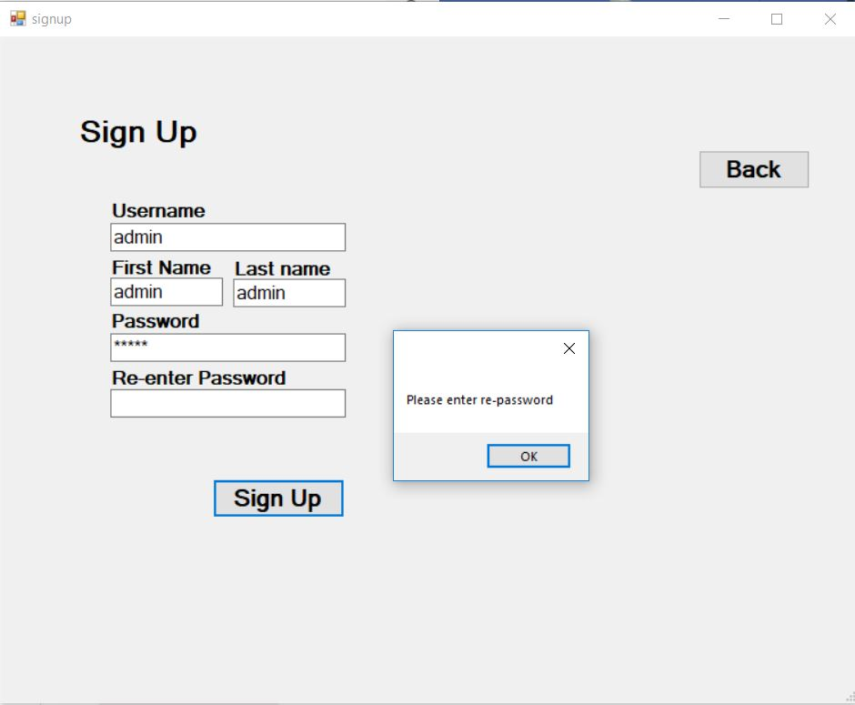

Figure 26: testing of signup form (5)

|  |  |  |  |  |
| --- | --- | --- | --- | --- |
| **Test no.** | **Test data** | **Expected result** | **Actual result** | **Result(Pass/Fail)** |
| 10 | **Username**: admin  **First Name:** admin  **Last name:** admin  **Password**: admin  **Re-enter Password:** a | Show error message | Password and re-password does not match | Pass |

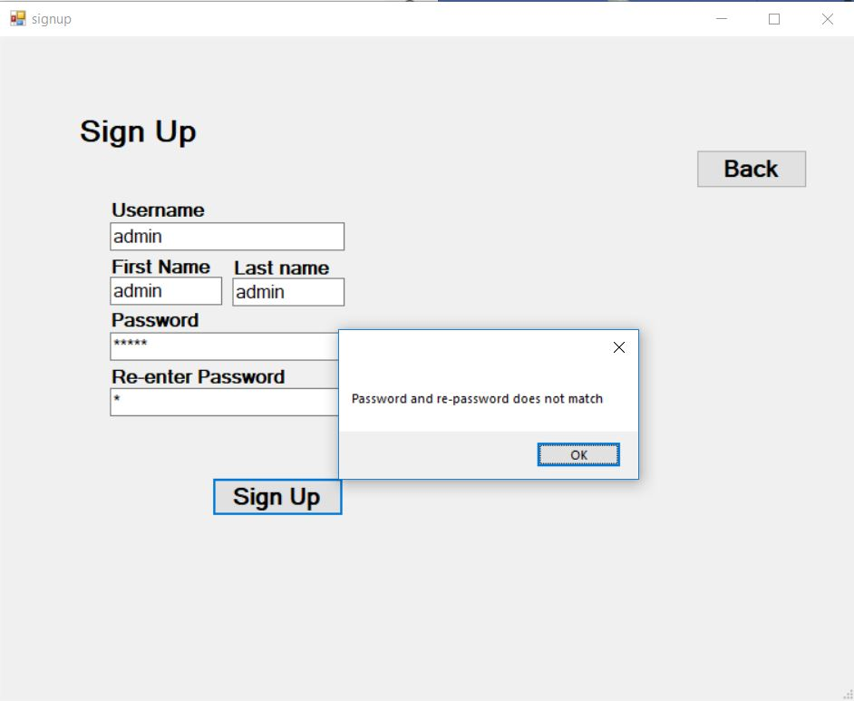

Figure 27: testing of signup form (6)

|  |  |  |  |  |
| --- | --- | --- | --- | --- |
| **Test no.** | **Test data** | **Expected result** | **Actual result** | **Result(Pass/Fail)** |
| 11 | **Username**: admin  **First Name:** admin  **Last name:** admin  **Password**: admin  **Re-enter Password:** admin | Show error message | This username is already taken | Pass |

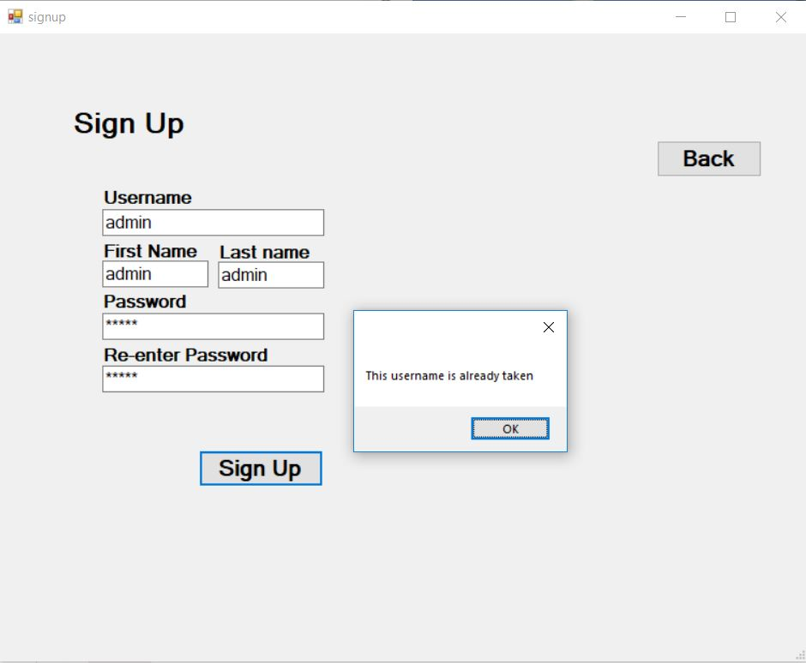

Figure 28: testing of signup form (7)

|  |  |  |  |  |
| --- | --- | --- | --- | --- |
| **Test no.** | **Test data** | **Expected result** | **Actual result** | **Result(Pass/Fail)** |
| 12 | **Username**: admin  **First Name:** admin  **Last name:** admin  **Password**: admin  **Re-enter Password:** admin | Show error message | Registration successful!! | Pass |

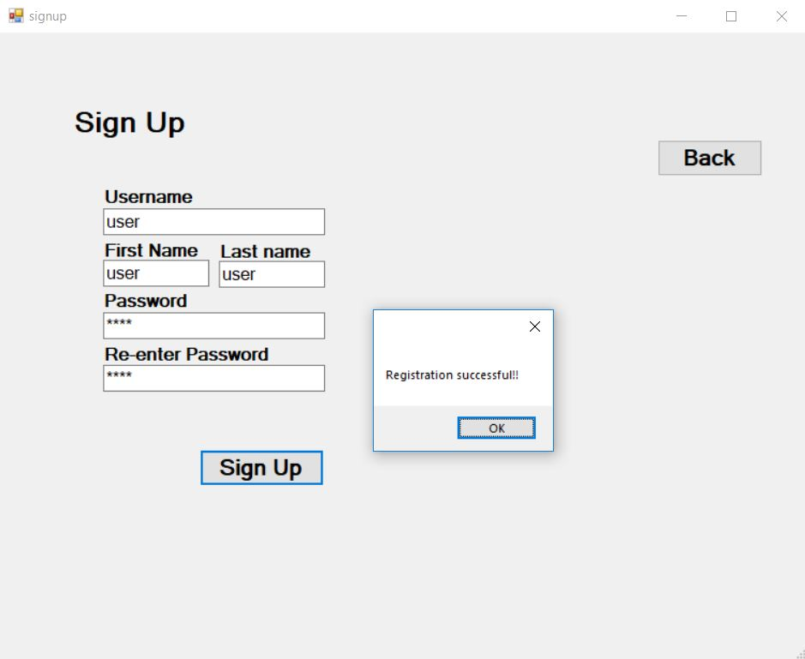

Figure 29: testing of signup form (8)

|  |  |  |  |  |
| --- | --- | --- | --- | --- |
| **Test no.** | **Test data** | **Expected result** | **Actual result** | **Result(Pass/Fail)** |
| 13 | **Category Name:** <blank>  **Description:** <blank>  **Category Type:** Income | Show error message | Please enter Name | Pass |

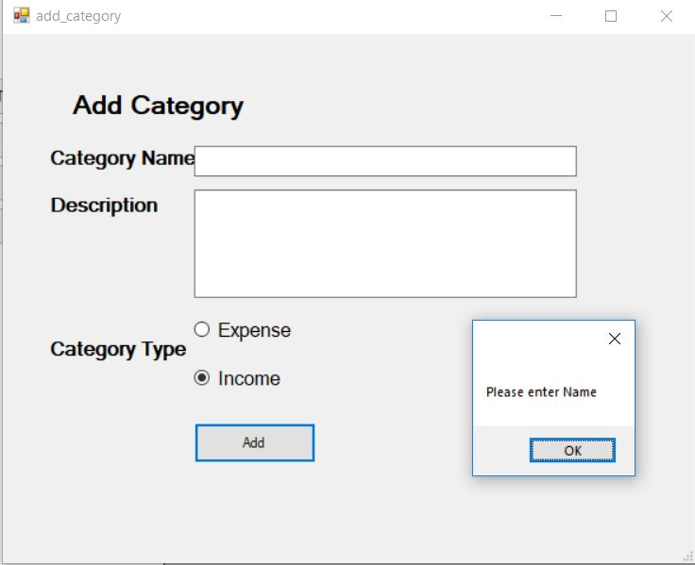

Figure 30: testing of add category

|  |  |  |  |  |
| --- | --- | --- | --- | --- |
| **Test no.** | **Test data** | **Expected result** | **Actual result** | **Result(Pass/Fail)** |
| 14 | **Category Name:** salary  **Description:** <blank>  **Category Type:** Income | Show error message | Value added successfully | Pass |

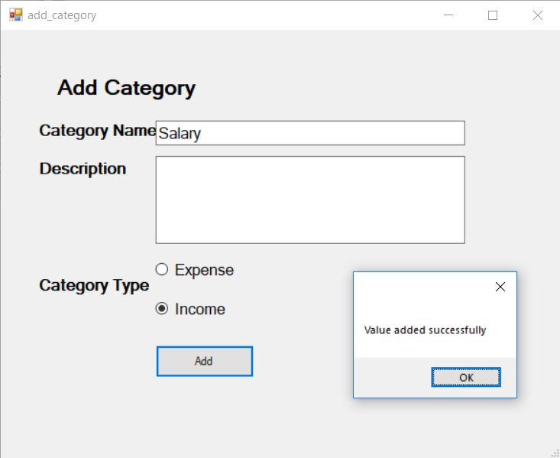

Figure 31: testing of add category (2)

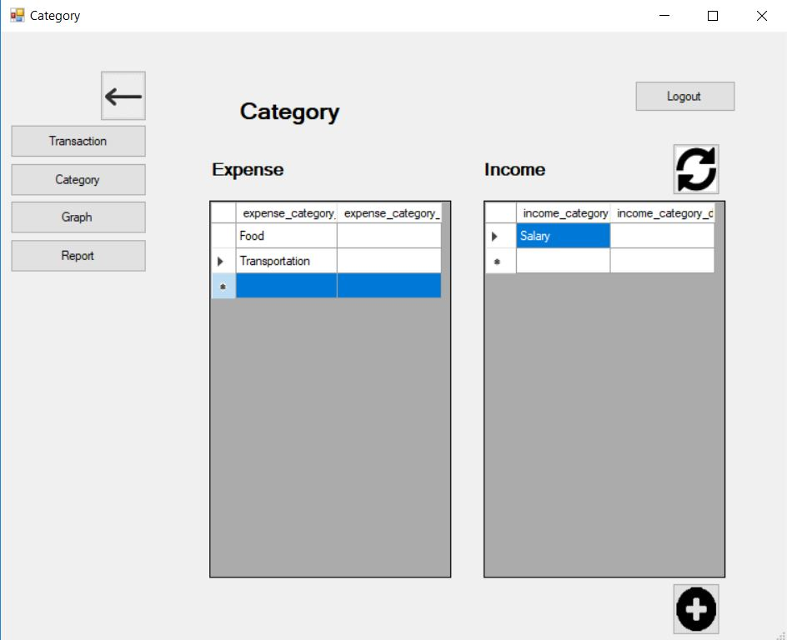

Figure 32: testing of add category (3)

|  |  |  |  |  |
| --- | --- | --- | --- | --- |
| **Test no.** | **Test data** | **Expected result** | **Actual result** | **Result(Pass/Fail)** |
| 15 | **Add:** Income  **Amount:** 5  **Date:** 9/30/2019  **Category:** salary  **Description:** <blank> | Show error message | Value added successfully | Pass |

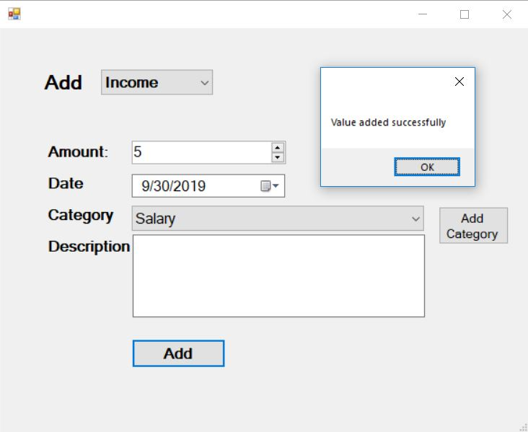

Figure 33: testing of add transaction

|  |  |  |  |  |
| --- | --- | --- | --- | --- |
| **Test no.** | **Test data** | **Expected result** | **Actual result** | **Result(Pass/Fail)** |
| 16 | **Add:** <blank>  **Amount:** 0  **Date:** 9/30/2019  **Category:** <blank>  **Description:** <blank> | Show error message | Please enter Type | Pass |

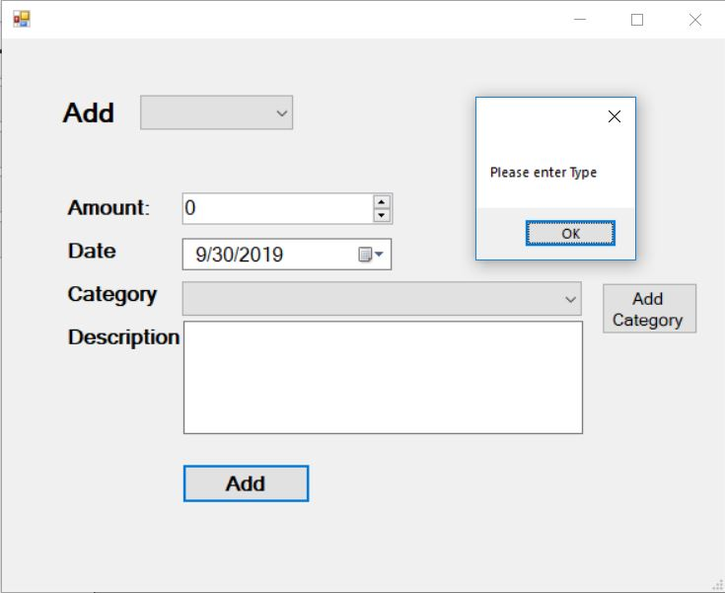

Figure 34: testing of add transaction (2)

|  |  |  |  |  |
| --- | --- | --- | --- | --- |
| **Test no.** | **Test data** | **Expected result** | **Actual result** | **Result(Pass/Fail)** |
| 17 | **Add:** Income  **Amount:** 0  **Date:** 9/30/2019  **Category:** <blank>  **Description:** <blank> | Show error message | Please enter Category | Pass |

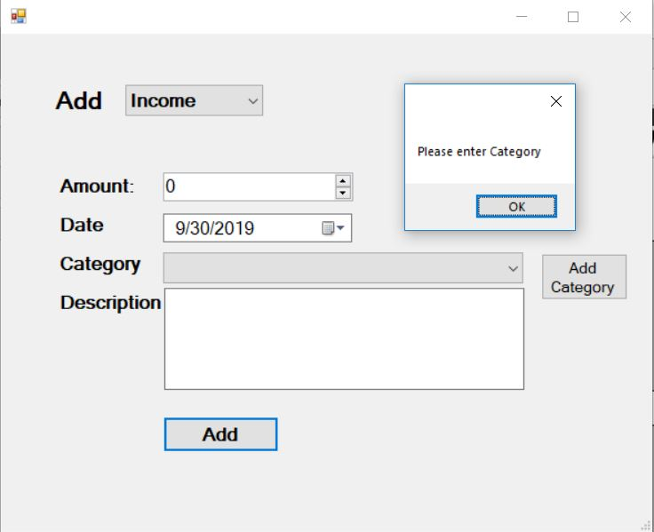

Figure 35: testing of add transaction (3)

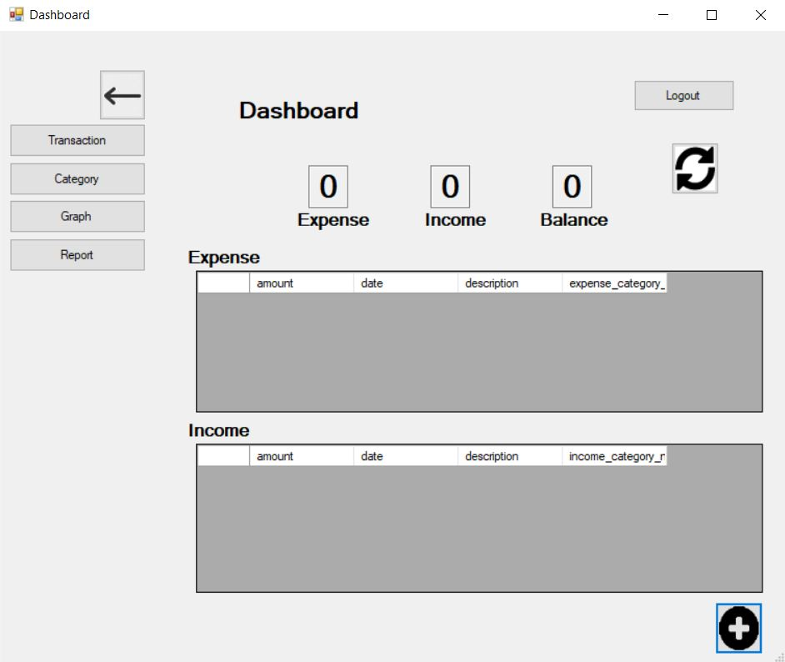

Figure 36: testing of add transaction (4)

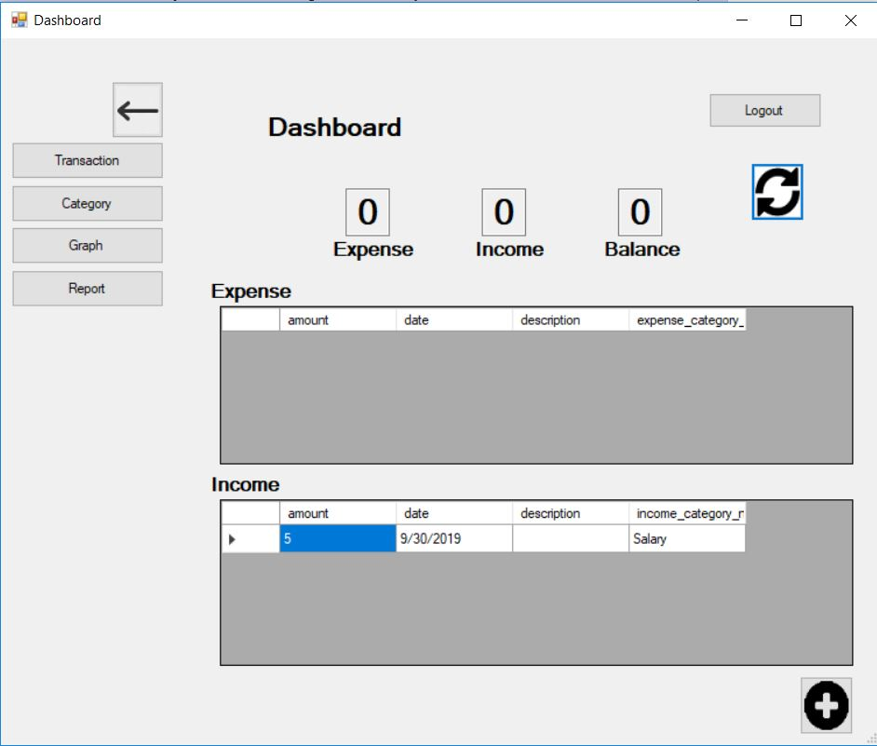

Figure 37: testing of add transaction (5)

## Unit Testing

1. Test for login fail

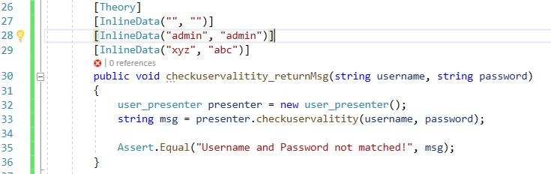

Figure 38: unit test code for login

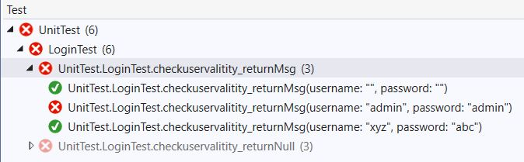

Figure 39: unit test result for login fail

1. Test for login pass

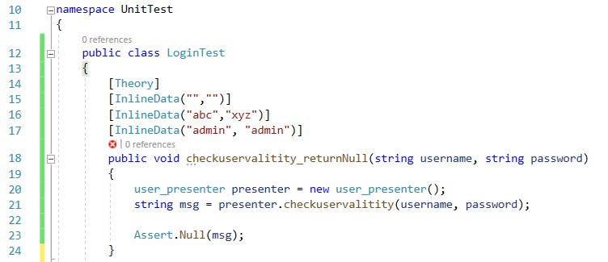

Figure 40: unit test code for login pass

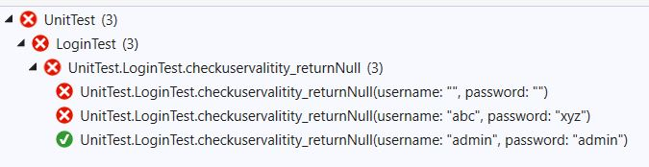

Figure 41: unit test result for login pass

1. Test for validation fail

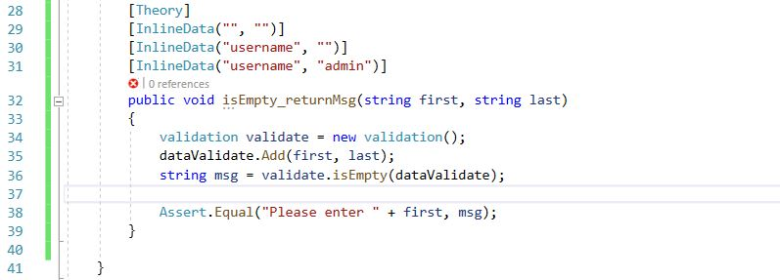

Figure 42: unit test code for validation fail

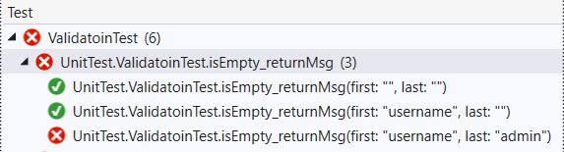

Figure 43: unit test result for validation fail

1. Test for validation pass

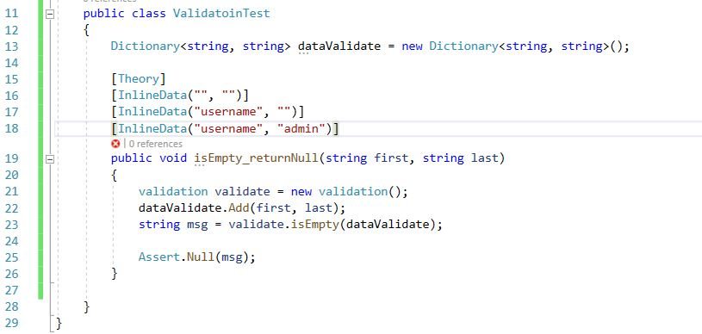

Figure 44: unit test code for validation pass

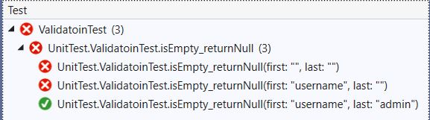

Figure 45: unit test result for validation pass