SupportSense
AI-Powered Customer Support Ticket Intelligence System
NLP Project Report
Course: Natural Language Processing
Team members:
Aman (Enrollment No. 230065)
Shashwat (Enrollment No. 230127)
Date: [Submission date]

Abstract
Companies receive large volumes of customer support messages every day. Reading, categorising and prioritising them by hand is slow, and urgent issues can be overlooked. SupportSense is an NLP system that analyses each support message automatically. It predicts the category of the problem with a TF-IDF + Logistic Regression classifier trained on the Bitext customer support dataset (99.6% accuracy, 0.997 macro F1 on 4,756 unseen messages). It detects sentiment with the pre-trained VADER analyser, and assigns urgency (High / Medium / Low) with explainable business rules. Predictions with low confidence are flagged for manual review. Results are shown in a Streamlit dashboard that lists tickets with the most urgent first.

1. Introduction
Customer support teams handle tickets from email, websites and feedback forms. Each ticket must be read, assigned to the right team and prioritised. Done manually, this:
- delays the first response,
- depends on the agent's judgement, which may be inconsistent,
- risks missing urgent issues such as fraud or double payments when queues are long.
Natural Language Processing can do this first triage automatically, so agents spend their time solving problems instead of sorting them.

2. Problem Statement
Given a customer support message in English, automatically determine:
- What the issue is about (category),
- How the customer feels (sentiment),
- How urgently it needs attention (urgency),
and present all tickets in a dashboard that support teams can filter and sort.

3. Objectives
- Build a supervised text classifier for ticket category.
- Add sentiment analysis and urgency detection.
- Evaluate each part with suitable metrics.
- Build an easy-to-use dashboard that integrates all three.
- Keep the system simple and explainable.
Out of scope: chatbots and automatic replies, email integration, user login, automatic agent assignment.

4. Dataset

4.1 Selection
Two public datasets were compared:
 | Bitext Customer Support (chosen) | Tobi-Bueck Customer Support Tickets
Source | Hugging Face | Hugging Face
Size | 26,872 English messages | 61,765 (only 28,261 English)
Labels | 11 categories, 27 intents | department, priority, type
Missing values | None | 3,639 missing subjects
Baseline accuracy | 99.7% | 52% (department), 62% (priority)

*TF-IDF + Logistic Regression, quick test.
The Tobi-Bueck labels were noisy. For example, "Urgent Help Needed for Possible Data Breach" is labelled medium priority. Bitext was chosen because it is clean, English-only, and its categories match real support teams.

4.2 Bitext dataset description
Column | Description | Used
instruction | Customer message | Input
category | Ticket category | Target label
intent, response, flags | Sub-intent, agent reply, style tags | Not used

- Messages are short: 8.7 words on average (range 1–16).
- They contain realistic noise: typos ("rtying"), slang ("wanna") and placeholders ({{Order Number}}).
- Category distribution (before cleaning):
Category | Count | Category | Count
ACCOUNT | 5,986 | PAYMENT | 1,998
ORDER | 3,988 | FEEDBACK | 1,997
REFUND | 2,992 | DELIVERY | 1,994
INVOICE | 1,999 | SHIPPING | 1,970
CONTACT | 1,999 | SUBSCRIPTION | 999
 |  | CANCEL | 950

The data is imbalanced: ACCOUNT has 6× as many examples as CANCEL.
Note on label meaning: in Bitext, CANCEL covers questions about cancellation fees, while cancelling an order is in ORDER. SUBSCRIPTION means the newsletter, not a paid plan.

4.3 Missing labels
Bitext has no sentiment or urgency labels. Supervised models for these could not be trained without manually labelling thousands of messages. So sentiment uses a pre-trained model and urgency uses rules (Section 5).

5. Methodology

5.1 Text preprocessing
A single function, clean_text(), is used at both training and prediction time, so new messages are cleaned exactly like training data.
Step | Example
Lowercase | "Refund" → "refund"
Remove placeholders | "cancel order {{Order Number}}" → "cancel order"
Remove numbers | "invoice #12588" → "invoice"
Collapse whitespace

Deliberately not done:
- Stop-word removal: it would delete negations ("not", "can't") that change meaning.
- Spelling correction: typos are realistic, and the model learns them.
- Stemming/lemmatisation: unnecessary for short messages with word-pair features.

5.2 Data preparation
Step | Rows
Loaded | 26,872
Empty after cleaning | 0 removed
Same text with conflicting labels | 0 removed
Duplicates removed | 3,096 removed → 23,776
Stratified 80/20 split (random_state=42) | Train 19,020 · Test 4,756

Duplicates were removed so the same sentence cannot appear in both train and test (data leakage). Stratification keeps each category's share equal in both sets (e.g. ACCOUNT 21.5% / 21.5%).

5.3 Category classification: TF-IDF + Logistic Regression
TF-IDF (Term Frequency–Inverse Document Frequency) converts each message into a vector of word scores:
TF-IDF(word, message) = TF(word, message) × log(N / DF(word))
A word scores high when it is frequent in the message but rare across all messages ("refund"), and low when it appears everywhere ("the").
Settings:
- ngram_range=(1,2): single words and word pairs ("payment methods").
- min_df=2: ignore terms seen in only one message.
- sublinear_tf=True: dampen repeated words.
- Result: 4,823 features.
Logistic Regression (multinomial) learns a weight per feature per category and outputs a probability for each category (softmax). class_weight="balanced" compensates for class imbalance.
Both steps are combined in a scikit-learn Pipeline, so TF-IDF is fitted on training data only, and the model is saved as one file (category_model.joblib).

5.4 Confidence check
The highest class probability is used as a confidence score. If it is below 50%, the ticket is marked "Needs manual review". This catches messages unlike the training data, such as "I was charged twice" (22% confidence) or non-English text.

5.5 Sentiment analysis: VADER
VADER (Valence Aware Dictionary and sEntiment Reasoner) is a pre-trained, lexicon- and rule-based sentiment analyser for short informal text. It scores ~7,500 words and applies rules for negation, intensifiers, capitals and exclamation marks, producing a compound score from −1 to +1.
Compound score | Label
≥ 0.5 | Positive
≤ −0.05 | Negative
otherwise | Neutral

The Positive threshold is higher than VADER's default (0.05) because polite support requests ("Please tell me how to…", +0.32) are not genuinely positive.

5.6 Urgency detection: business rules
Rules are checked in order; the first match wins, and the matching reason is shown:
# | Rule | Urgency
1 | Security (hacked, fraud, unauthorized, without my permission…), money (charged twice, overcharged…), legal (lawyer, sue…) or urgency words (urgent, asap, immediately…) | High
2 | Very negative sentiment (compound ≤ −0.7) | High
3 | Problem words (not working, can't, error, broken, missing, delayed…) | Medium
4 | Any negative sentiment | Medium
5 | Otherwise | Low

Combining keywords with sentiment covers both calm-but-serious tickets ("I need access urgently") and angry tickets without a keyword. The very-negative threshold was raised from −0.6 to −0.7 after dashboard testing, because "I chose a wrong address by mistake" (−0.67) was wrongly marked High.

6. System Architecture
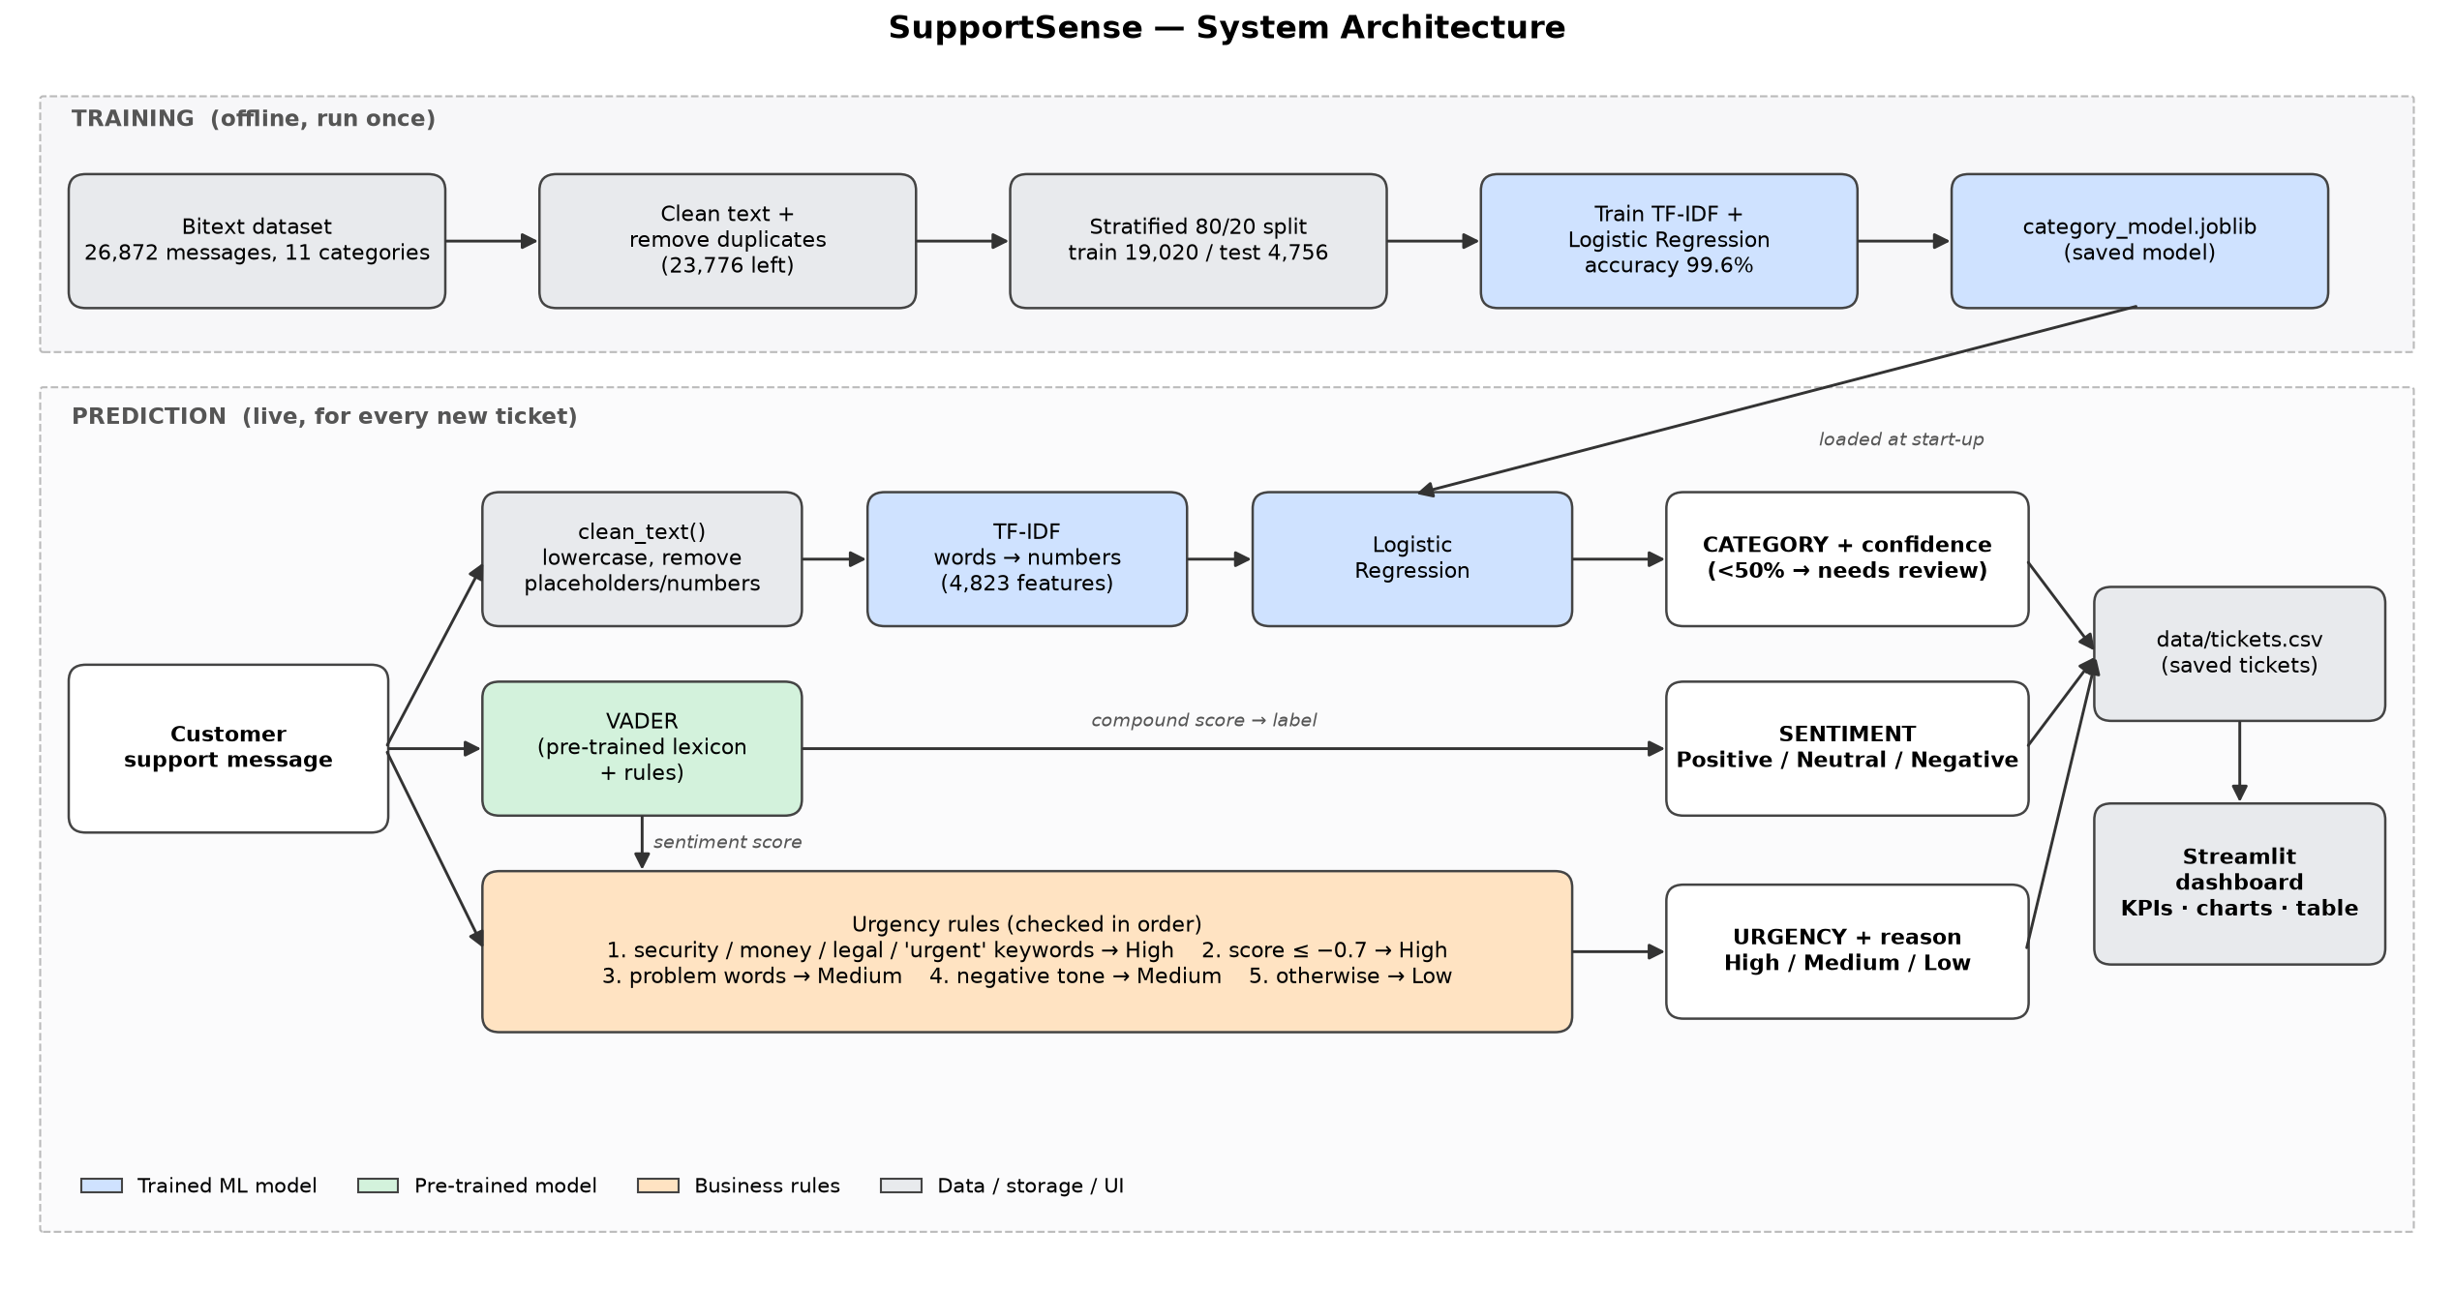
Figure 1: SupportSense architecture
Training (offline): dataset → cleaning and de-duplication → stratified split → TF-IDF + Logistic Regression → saved model.
Prediction (live): each message goes through three parallel branches:
- clean_text → TF-IDF → Logistic Regression → category and confidence
- VADER → sentiment
- Urgency rules (using the VADER score) → urgency and reason
VADER and the urgency rules use the raw text, because capitals, punctuation and placeholders carry tone. The result is saved to data/tickets.csv and displayed in the Streamlit dashboard.

7. Implementation

7.1 Tools
Component | Technology
Language | Python 3
Data handling | Pandas
Feature extraction, model, metrics | scikit-learn
Sentiment | vaderSentiment
Dashboard | Streamlit
Storage | CSV
Plots | Matplotlib

7.2 Code structure
File | Purpose
src/preprocessing.py | clean_text()
src/predict.py | Loads model, predicts category + confidence
src/sentiment.py | VADER wrapper
src/urgency.py | Urgency rules
src/analyzer.py | analyze_ticket(): combines all three, validates input
src/storage.py | Save/load tickets
streamlit_app.py | Dashboard
notebooks/01–06 | Reproducible step-by-step scripts

8. Results

8.1 Category classification (4,756 unseen test messages)
Model | Accuracy | Macro F1
Logistic Regression (selected) | 0.996 | 0.997
Linear SVM | 0.998 | 0.998

Per-class results (Logistic Regression):
Category | Precision | Recall | F1 | Support
ACCOUNT | 0.995 | 0.999 | 0.997 | 1,023
CANCEL | 1.000 | 1.000 | 1.000 | 188
CONTACT | 1.000 | 0.997 | 0.999 | 393
DELIVERY | 0.994 | 0.994 | 0.994 | 326
FEEDBACK | 1.000 | 1.000 | 1.000 | 398
INVOICE | 0.994 | 0.997 | 0.995 | 324
ORDER | 0.993 | 0.992 | 0.993 | 604
PAYMENT | 1.000 | 0.987 | 0.994 | 397
REFUND | 0.992 | 0.998 | 0.995 | 514
SHIPPING | 1.000 | 1.000 | 1.000 | 390
SUBSCRIPTION | 1.000 | 0.995 | 0.997 | 199

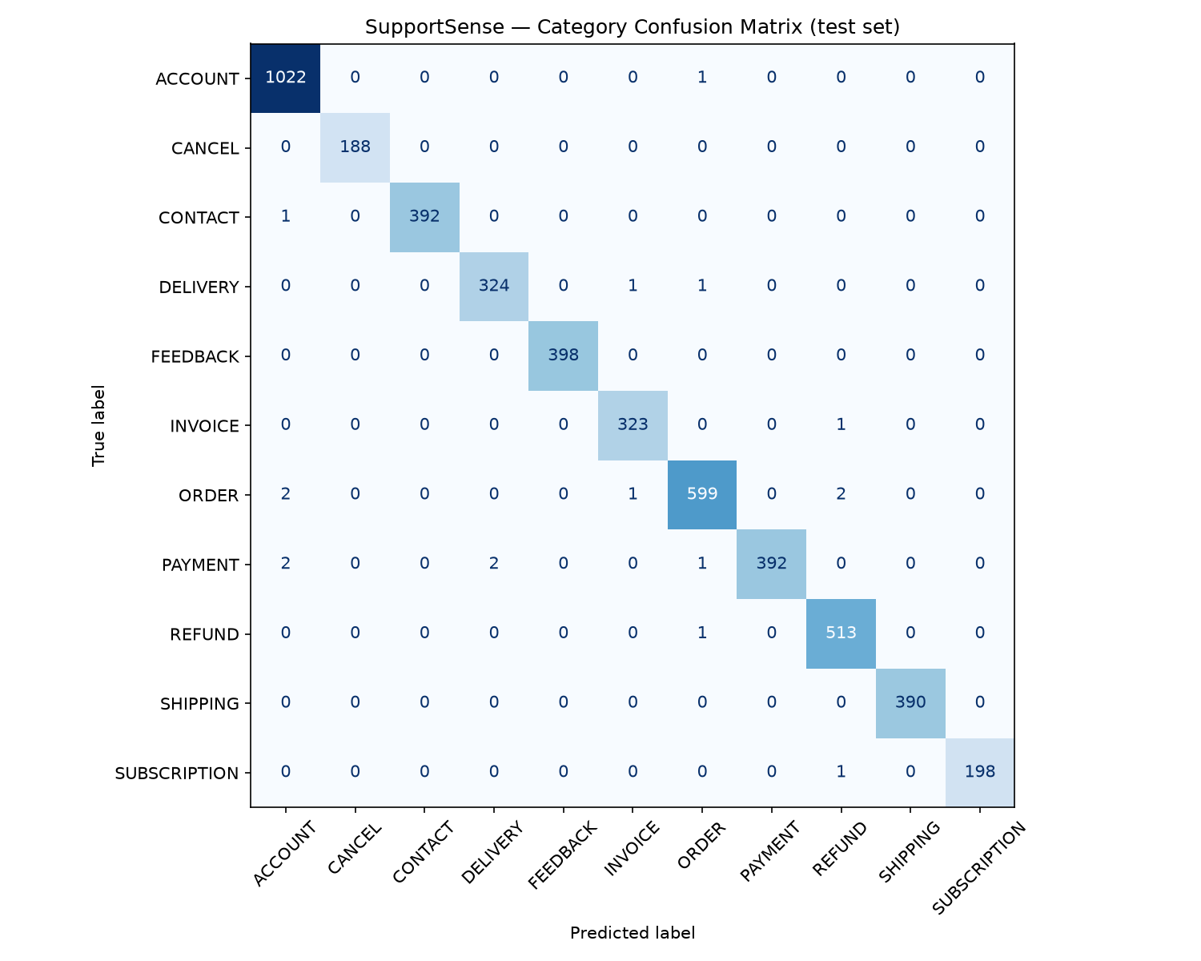
Figure 2: Confusion matrix
- 17 errors out of 4,756. Most involve heavy typos ("paymdnt", "invooce", "contactingassistant").
- Why Logistic Regression over SVM: the SVM is 0.2% more accurate (about 10 messages), but it does not give probabilities, which the confidence check needs.
- Most important words learned per category are sensible, e.g. REFUND: refund, reimbursement, money, rebate; CONTACT: customer, agent, person, speak.
- Confidence check: 74 test tickets (1.6%) fall below 50% confidence. Accuracy is 99.9% on confident tickets and 82.4% on flagged ones, so flagging separates reliable from unreliable predictions.

8.2 Sentiment and urgency (36 hand-labelled messages)
Feature | Accuracy | Notes
Sentiment | 94% | Errors: "overcharged" (not in VADER's lexicon) and "Please refund me immediately…" ("please" offsets the threat)
Urgency | 100% | High recall 100%: no urgent ticket missed

On the Bitext test set, the system labels 82% of messages Neutral, 16% Negative and 2% Positive. It labels 80% Low urgency, 20% Medium and 0.1% High. This matches the dataset, which is mostly calm "how do I…" questions.

8.3 Robustness (edge cases)
Input | Behaviour
Empty, spaces, one word, None | Rejected with "Please enter at least 2 words"
"MY ACCOUNT HAS BEEN HACKED!!! HELP" | ACCOUNT · High (security: hacked)
Emoji: "Still no refund 😡😡 this is ridiculous" | REFUND · Negative · Medium
Numbers only, Spanish text, "hello there" | Low confidence → flagged for review
HTML: <script>…</script> where is my invoice | INVOICE, no crash
600-word message | Works
Typos: "i cnat acess my acount pls hlep" | ACCOUNT (correct); urgency Low (keywords missed)
"Someone else is using my account without my permission" | ACCOUNT · High (security)

0 crashes in 18 edge-case tests.

9. Dashboard
The Streamlit dashboard provides:
- Ticket analysis: text box with example buttons. It shows the category with a confidence bar, urgency with its reason, sentiment with its score, and a "Needs manual review" warning.
- KPI cards: total tickets, High priority count, % negative, needs-review count.
- Charts: tickets by category, urgency and sentiment.
- Ticket table: sorted High urgency first, then newest, with coloured badges. It can be filtered by urgency, sentiment, category, text search and review status, and downloaded as CSV.
[Insert dashboard screenshots here]

10. Limitations
- Synthetic training data: Bitext is template-generated, so its wording is very consistent. Accuracy on real tickets would be lower. Example: "My package hasn't arrived yet and it has been 10 days" is predicted ACCOUNT (28% confidence, flagged).
- One category per ticket: "I need a refund and also want to change my shipping address" gets only SHIPPING.
- Small, self-written sentiment/urgency test set: 36 messages, written alongside the rules, so the reported scores are optimistic.
- Keyword rules are literal:
  - Negation is missed: "I was not charged twice" → High.
  - Context is missed: "my issue is resolved" → Medium.
  - Typos are missed: "cnat" is not matched as "can't".
- VADER limitations: it misses sarcasm ("Great, another late delivery" → Positive) and support jargon ("overcharged", "chargeback").
- English only.
- CSV storage is not suitable for many simultaneous users.

11. Future Work
- Train and test on real labelled tickets from a company.
- Train a supervised urgency classifier from agent-assigned priorities collected over time.
- Fine-tune a transformer (e.g. DistilBERT) if real data is noisier and TF-IDF performance drops.
- Multi-label classification for tickets with several issues.
- Add negation handling to the urgency rules.
- Replace CSV with SQLite/PostgreSQL. Add automatic team assignment and email integration.

12. Conclusion
SupportSense shows that a simple, explainable NLP pipeline can automate the first triage of customer support tickets. TF-IDF with Logistic Regression achieves 99.6% accuracy on category prediction, and the confidence check flags messages the model is unsure about. Pre-trained sentiment analysis and transparent urgency rules add the information support teams need to prioritise. The dashboard ensures urgent issues such as fraud and double charges are seen first. The main limitation is the synthetic training data. The modular design allows each component to be replaced with a stronger model when real labelled tickets become available.

References
- Bitext. Bitext Customer Support LLM Chatbot Training Dataset. Hugging Face. https://huggingface.co/datasets/bitext/Bitext-customer-support-llm-chatbot-training-dataset
- Bueck, T. Customer Support Tickets. Hugging Face. https://huggingface.co/datasets/Tobi-Bueck/customer-support-tickets
- Hutto, C. J., & Gilbert, E. (2014). VADER: A Parsimonious Rule-based Model for Sentiment Analysis of Social Media Text. Proceedings of ICWSM.
- Pedregosa, F. et al. (2011). Scikit-learn: Machine Learning in Python. Journal of Machine Learning Research, 12, 2825–2830.
- Salton, G., & Buckley, C. (1988). Term-weighting approaches in automatic text retrieval. Information Processing & Management, 24(5), 513–523.
- Streamlit documentation. https://docs.streamlit.io

