SIMATS ENGINEERING
Department of Computer Science and Engineering
Assignment Submission
MLA0101 – Artificial Intelligence and Expert System
A Multi-Agent, Rule-Based Expert System for Crop Disease Diagnosis and Farm Resource Advisory ("AgriAdvisor")
Student Name | S. Aman Hussain
Course | B.Tech AIML
Course Outcomes Addressed | CO3, CO4, CO5
Bloom's Taxonomy Level | L3 – Apply, L4 – Analyse, L6 – Create
SDG Mapping | SDG 2 (Zero Hunger), SDG 9 (Industry, Innovation & Infrastructure), SDG 12 (Responsible Consumption & Production)

Student Name : S. Aman Hussain

Reg No : 192425021

1. Problem Statement
AgriAdvisor is an AI-based farm decision-support system designed to help small-scale farmers with three interconnected tasks: irrigation scheduling, pest/disease-outbreak alerting, and crop-disease diagnosis. Field agents currently make these calls manually by walking the fields, which is slow and inconsistent, and a delayed response to a moisture-stress event or a pest/disease outbreak can significantly reduce yield or wipe out a season's crop.
AgriAdvisor replaces this with software agents that sense field/crop conditions, consult a shared rule-based expert system, and act — either automatically (e.g., controlling irrigation valves) or by issuing timely, evidence-based recommendations to the farmer.
The system is analysed here in three parts, each formulated using the PEAS framework, matched to the most appropriate agent strategy, designed as a software agent with defined percepts/actions/internal state, and connected to a shared rule-based expert system with an inference engine that supports forward and backward chaining.

2. PEAS Analysis & Agent Strategy Justification (CO3)

2.1 Irrigation-Scheduling Sub-Task
Performance Measure | Crop-yield preservation; water-use efficiency; minimised over- or under-irrigation; energy cost of pumping.
Environment | The field: soil profile, crop stand, local weather, and irrigation infrastructure.
Actuators | Irrigation valves, drip/sprinkler pumps, farmer notification app.
Sensors | Soil-moisture probes, weather-station feed (rainfall, temperature, wind), crop-growth-stage input.
Property | Classification
Observability | Partially observable — soil moisture is sampled at discrete points, not across the whole field.
Determinism | Stochastic — rainfall, temperature, and evapotranspiration make future moisture levels uncertain.
Dynamics | Dynamic — soil moisture changes continuously, even while the agent deliberates.
Discreteness | Continuous in state (moisture %, temperature) but decisions taken at discrete intervals.
Agents | Single-agent from the field's point of view (no adversarial agents).
Chosen Strategy: Model-Based Utility Agent
A simple reflex agent cannot cope because the correct action depends on more than the current percept alone — e.g., low soil moisture during a non-critical growth stage should NOT trigger full-volume irrigation. The agent therefore maintains an internal model of the recent moisture/rainfall trend and combines it with a utility function that trades off crop-stress risk against pumping/energy and water cost, choosing the action (full irrigation, partial irrigation, delayed irrigation, or maintain) that maximises expected utility rather than merely reacting to one rule.

2.2 Pest/Disease-Outbreak Alert Sub-Task
Performance Measure | Early, accurate outbreak detection; minimised false alarms; timeliness of farmer notification.
Environment | Field canopy and crop stand, ambient temperature and humidity.
Actuators | SMS/app alert to farmer, alert-dashboard update, (optional) automated sprayer-trigger.
Sensors | Pest-trap counters, leaf-damage survey input, temperature/humidity sensor.
Property | Classification
Observability | Partially observable — trap counts and leaf-damage surveys sample the field, not every plant.
Determinism | Stochastic — pest/pathogen spread depends on many uncontrolled environmental variables.
Dynamics | Dynamic — pest counts and weather conditions change between readings.
Discreteness | Semi-continuous readings, discretised into risk bands (low/medium/high).
Agents | Single-agent.
Chosen Strategy: Model-Based Reflex Agent
This task is best served by a model-based reflex agent: it needs an internal model (recent pest-count trend) to avoid reacting to a single noisy count, but does not need explicit long-horizon planning — a fixed set of condition-action rules mapping (pest count × temperature/humidity) to a graded alert level is sufficient and matches the rubric's IF-THEN structure. A goal-based approach would add unnecessary planning overhead for what is fundamentally a threshold-classification task.

2.3 Crop-Disease Diagnosis Sub-Task
Performance Measure | Diagnostic accuracy; correct treatment match; minimised yield loss from delayed/incorrect diagnosis.
Environment | The crop: leaves, stem, fruit, roots, and visible behavioural/growth symptoms.
Actuators | Farmer advisory dashboard, agronomist-escalation trigger, treatment-recommendation printout.
Sensors | Camera/image feed of crop, farmer-entered symptom checklist, environmental context sensors.
Property | Classification
Observability | Partially observable — symptoms are visible cues, not the underlying pathogen directly.
Determinism | Stochastic — the same symptom set can map to more than one candidate cause.
Dynamics | Semi-dynamic — disease progresses over days, not instantaneously.
Discreteness | Discrete — symptoms and diagnoses are represented as discrete facts/labels.
Agents | Single-agent.
Chosen Strategy: Goal-Based Agent
Diagnosis is inherently goal-directed: the agent must search through chains of symptom-to-disease-to-treatment rules to reach the explicit goal of "correct diagnosis + matching treatment," and it must be able to explain/justify why a conclusion follows (via backward chaining) rather than simply react to one percept. This requires the explicit notion of a goal and multi-step reasoning that only a goal-based (or utility-based, for ranking competing diagnoses) architecture provides — a plain reflex agent could not chain multiple rules together to reach a diagnosis.

3. Software Agent Design & Architecture (CO4)
Each module above is realised as a software agent with clearly defined percepts, actions, and internal state, querying a shared rule-based expert system for its reasoning.

3.1 Diagnosis Agent (Goal-Based)
- Percepts: symptom facts such as yellowing_leaves, leaf_curling, leaf_spots_brown, powdery_white_coating, wilting_despite_moist_soil, holes_in_leaves.
- Actions: assert a diagnosis fact, recommend a treatment, or escalate to a human agronomist when no rule matches.
- Internal State: a running diagnosis history log used to track recurring symptom patterns per field/plot over time.
- Architecture: goal-based — forward-chains symptom facts through the knowledge base toward the goal state (diagnosis + treatment), then backward-chains to verify the derived diagnosis is actually supported by the observed symptoms before acting.
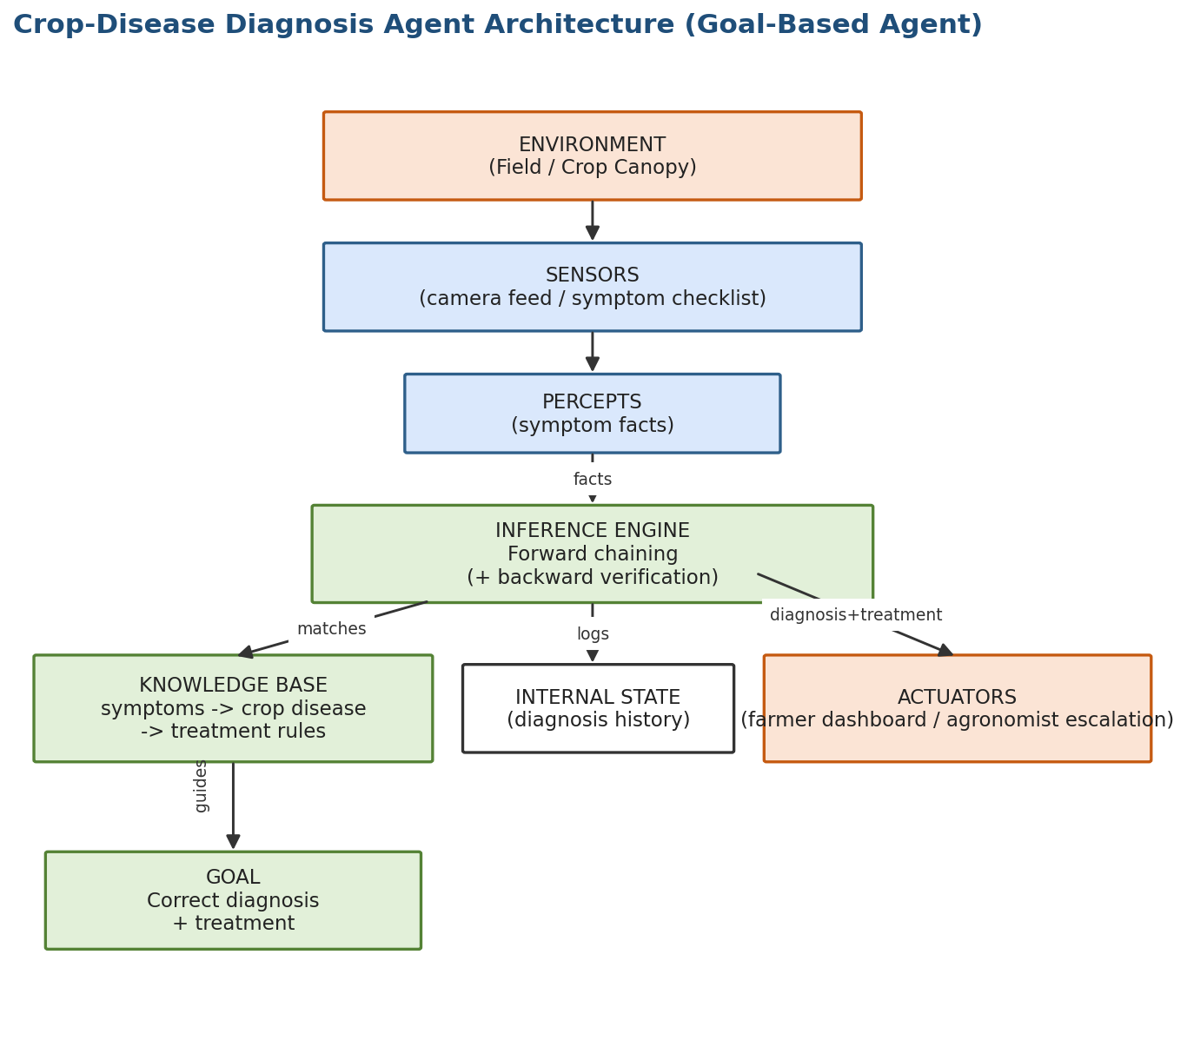
Figure 1: Diagnosis Agent architecture — goal-based agent with forward + backward chaining.

3.2 Irrigation Agent (Model-Based Utility)
- Percepts: soil_moisture_low/moderate/high, rainfall_expected/none, temperature_high/normal, crop_stage_critical/vegetative.
- Actions: irrigate_full, irrigate_partial, delay_irrigation, maintain_setting, irrigate_early_morning.
- Internal State: a short history of recent moisture/rainfall readings (trend model) used to avoid reacting to a single noisy sensor value.
- Architecture: model-based reflex agent extended with a utility function that weighs crop-stress risk against pumping/energy and water cost when more than one rule's action would otherwise be plausible.
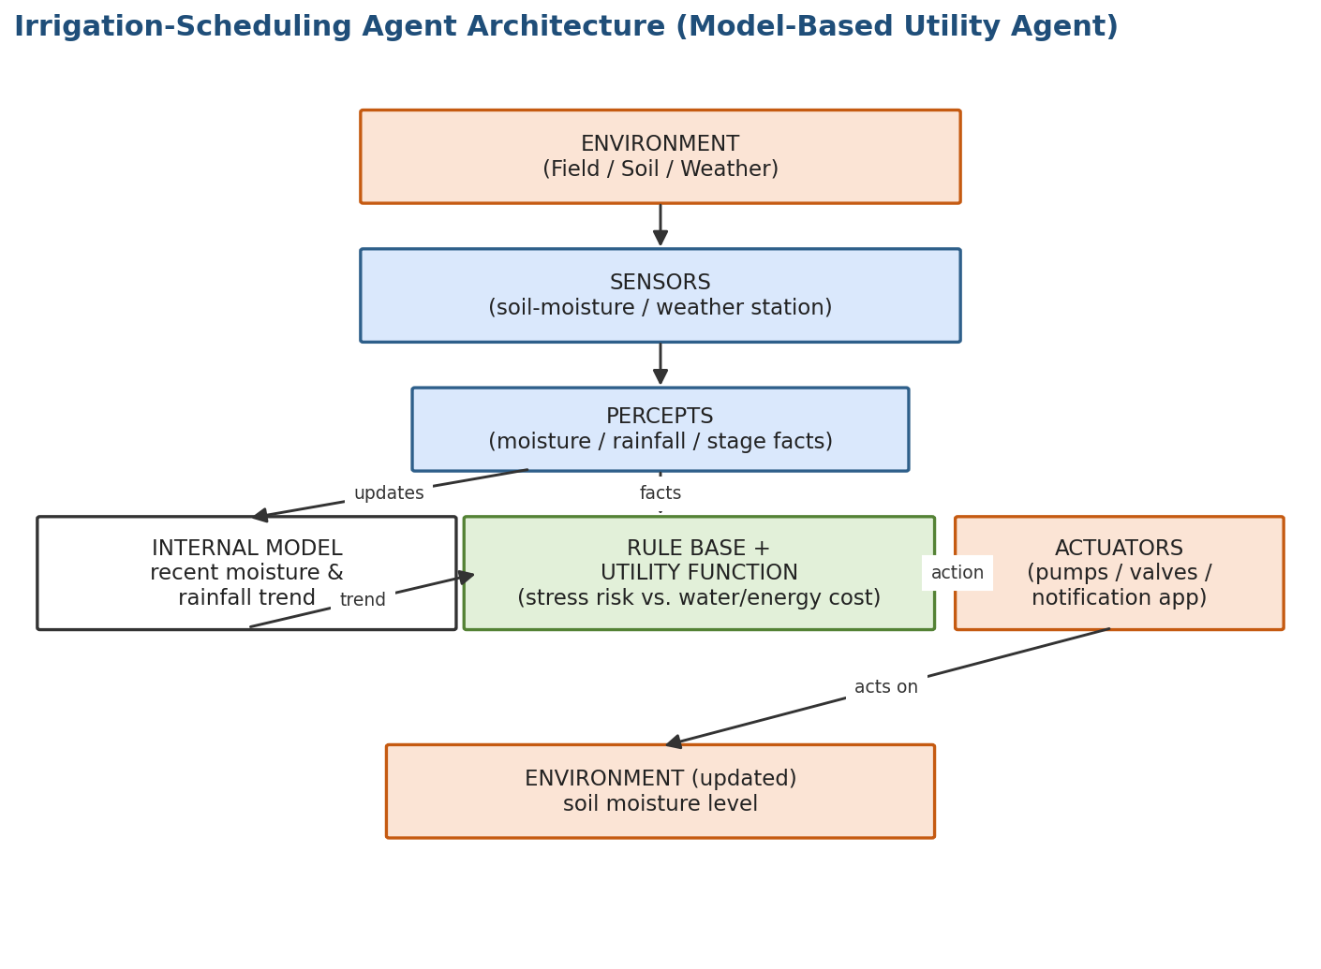
Figure 2: Irrigation Agent architecture — model-based utility agent.

3.3 Pest-Alert Agent (Model-Based Reflex)
- Percepts: pest_count_low/medium/high, leaf_damage_high, temp_humidity_favorable_for_pest.
- Actions: log_and_continue_monitoring, notify_farmer_monitor_closely, notify_farmer_urgent_apply_pesticide.
- Internal State: an alert log recording recent risk-level history, used to avoid duplicate low-value alerts.
- Architecture: model-based reflex agent — condition-action rules fire directly off current + recent percepts to produce a graded risk alert.
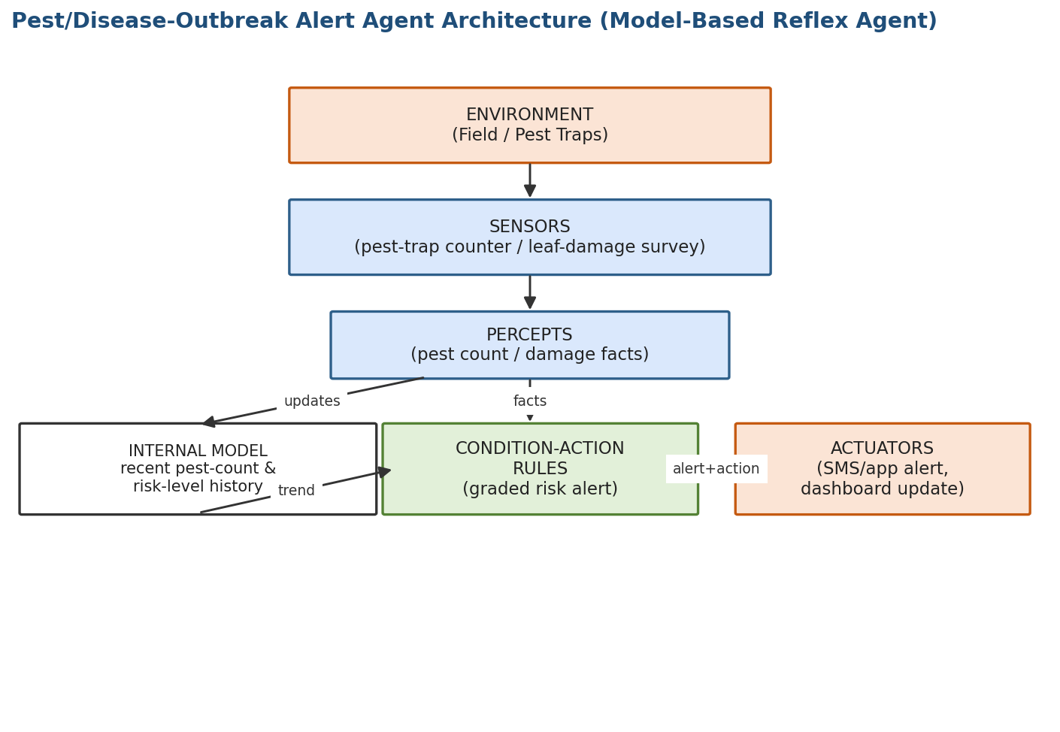
Figure 3: Pest-Alert Agent architecture — model-based reflex agent.

3.4 Multi-Agent / Expert-System Integration
All three agents share one rule-based expert system rather than each maintaining a private rule set. Each agent senses its slice of the farm environment, packages the relevant percepts as facts, queries the shared knowledge base + inference engine, and then acts on the environment through its own actuators. This shared-brain design keeps rules consistent across modules and avoids duplicated/contradictory logic.
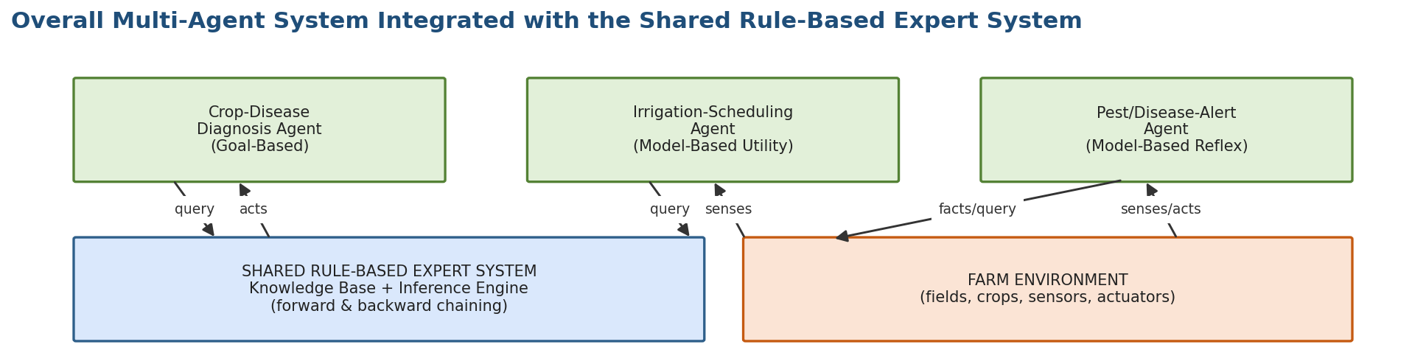
Figure 4: Overall multi-agent system integrated with the shared rule-based expert system.

4. Rule-Based Expert System — Knowledge Base (CO5)
The knowledge base is organised as three rule groups (one per module), each a set of IF-THEN production rules. Diagnosis rules chain a symptom-rule into a matching treatment-rule; irrigation and outbreak rules chain a condition-rule into a matching action-rule.

4.1 Crop-Disease Diagnosis Rules
Rule | IF (Conditions) | THEN (Conclusion / Action)
D1 | yellowing_leaves AND leaf_curling | diagnosis: Viral mosaic disease
D2 | diagnosis: Viral mosaic disease | treatment: remove infected plants, control aphid vector
D3 | leaf_spots_brown AND concentric_rings | diagnosis: Early blight (Alternaria)
D4 | diagnosis: Early blight | treatment: apply fungicide, remove crop debris
D5 | powdery_white_coating AND leaf_curling | diagnosis: Powdery mildew
D6 | diagnosis: Powdery mildew | treatment: apply sulfur-based fungicide, improve air circulation
D7 | wilting_despite_moist_soil AND stem_discoloration | diagnosis: Bacterial wilt
D8 | diagnosis: Bacterial wilt | treatment: uproot and destroy infected plants, crop rotation
D9 | holes_in_leaves AND visible_larvae | diagnosis: Caterpillar / leaf-eating pest infestation
D10 | diagnosis: Caterpillar infestation | treatment: apply bio-pesticide, use pheromone traps
D11 | root_rot AND stunted_growth | diagnosis: Fungal root rot
D12 | diagnosis: Fungal root rot | treatment: improve drainage, apply fungicide drench
D13 | yellowing_only AND no_spots AND slow_growth | diagnosis: Nitrogen deficiency
D14 | diagnosis: Nitrogen deficiency | treatment: apply nitrogen-rich fertilizer

4.2 Irrigation-Scheduling Rules
Rule | IF (Conditions) | THEN (Conclusion / Action)
W1 | soil_moisture_low AND crop_stage_critical | action: irrigate — full
W2 | soil_moisture_low AND crop_stage_vegetative | action: irrigate — partial
W3 | rainfall_expected AND soil_moisture_moderate | action: delay irrigation
W4 | soil_moisture_high | action: maintain setting
W5 | temperature_high AND wind_speed_high | action: irrigate early morning (reduce evaporation loss)

4.3 Pest/Disease-Outbreak Alert Rules
Rule | IF (Conditions) | THEN (Conclusion / Action)
O1 | pest_count_high AND leaf_damage_high | alert: high-risk pest outbreak
O2 | alert: high-risk pest outbreak | action: notify farmer urgently, recommend pesticide application
O3 | pest_count_medium AND temp_humidity_favorable_for_pest | alert: moderate risk
O4 | alert: moderate risk | action: notify farmer, monitor closely
O5 | pest_count_low | alert: low risk
O6 | alert: low risk | action: log and continue monitoring
The rule sets are free of redundancy (no two rules share both the same condition set and conclusion) and free of conflict (no two rules with an overlapping condition set produce contradictory conclusions), which was verified by inspection and by the test cases in Section 7.

5. Inference Engine Implementation (CO5)
The inference engine implements both directions of chaining:
- Forward chaining — starts from the percept facts and repeatedly fires any rule whose full condition set is already known, adding its conclusion to the fact set, until no more rules can fire. This is used by all three agents to move from raw sensor facts to a diagnosis/action.
- Backward chaining — starts from a candidate goal (e.g., a specific diagnosis) and recursively checks whether every condition needed to support it is already a known fact (or is itself derivable). The Diagnosis Agent uses this to double-check a forward-chained diagnosis before acting on it.

5.1 Source Code (Python)
Below is the complete, runnable implementation: the Rule/knowledge-base representation, the InferenceEngine (forward + backward chaining), and the three agent classes that call it.
"""
AgriAdvisor - AI-based Farm Decision-Support System
MLA0101 - Artificial Intelligence and Expert System

Implements:
1. A rule-based Knowledge Base (IF-THEN production rules) for three modules:
- Crop-Disease Diagnosis
- Irrigation Scheduling
- Pest/Disease-Outbreak Alerting
2. A forward-chaining Inference Engine (with a backward-chaining goal
verification routine for the diagnosis module).
3. Three software agents (Diagnosis Agent, Irrigation Agent, Pest-Alert
Agent) that sense their environment (percepts), query the expert
system, and act (recommendations / actuator commands).
"""
from dataclasses import dataclass, field

# --------------------------------------------------------------------
# 1. KNOWLEDGE BASE (IF-THEN production rules)
# --------------------------------------------------------------------

class Rule:
def __init__(self, name, conditions, conclusion, confidence=1.0):
self.name = name
self.conditions = conditions # set of facts that must ALL be true
self.conclusion = conclusion # fact asserted when rule fires
self.confidence = confidence

def is_satisfied(self, facts):
return self.conditions.issubset(facts)

def __repr__(self):
return f"IF {sorted(self.conditions)} THEN {self.conclusion}"

# ---- 1a. Crop-disease diagnosis rules (symptom -> disease -> treatment) ----
DIAGNOSIS_RULES = [
Rule("D1", {"yellowing_leaves", "leaf_curling"},
"diagnosis:viral_mosaic_disease"),
Rule("D2", {"diagnosis:viral_mosaic_disease"},
"treatment:remove_infected_plants_control_aphid_vector"),
Rule("D3", {"leaf_spots_brown", "concentric_rings"},
"diagnosis:early_blight"),
Rule("D4", {"diagnosis:early_blight"},
"treatment:apply_fungicide_remove_debris"),
Rule("D5", {"powdery_white_coating", "leaf_curling"},
"diagnosis:powdery_mildew"),
Rule("D6", {"diagnosis:powdery_mildew"},
"treatment:apply_sulfur_fungicide_improve_air_circulation"),
Rule("D7", {"wilting_despite_moist_soil", "stem_discoloration"},
"diagnosis:bacterial_wilt"),
Rule("D8", {"diagnosis:bacterial_wilt"},
"treatment:uproot_destroy_infected_plants_crop_rotation"),
Rule("D9", {"holes_in_leaves", "visible_larvae"},
"diagnosis:caterpillar_infestation"),
Rule("D10", {"diagnosis:caterpillar_infestation"},
"treatment:apply_biopesticide_use_pheromone_traps"),
Rule("D11", {"root_rot", "stunted_growth"},
"diagnosis:fungal_root_rot"),
Rule("D12", {"diagnosis:fungal_root_rot"},
"treatment:improve_drainage_apply_fungicide_drench"),
Rule("D13", {"yellowing_only", "no_spots", "slow_growth"},
"diagnosis:nitrogen_deficiency"),
Rule("D14", {"diagnosis:nitrogen_deficiency"},
"treatment:apply_nitrogen_rich_fertilizer"),
]

# ---- 1b. Irrigation-scheduling rules ----
IRRIGATION_RULES = [
Rule("W1", {"soil_moisture_low", "crop_stage_critical"},
"action:irrigate_full"),
Rule("W2", {"soil_moisture_low", "crop_stage_vegetative"},
"action:irrigate_partial"),
Rule("W3", {"rainfall_expected", "soil_moisture_moderate"},
"action:delay_irrigation"),
Rule("W4", {"soil_moisture_high"},
"action:maintain_setting"),
Rule("W5", {"temperature_high", "wind_speed_high"},
"action:irrigate_early_morning"),
]

# ---- 1c. Pest/disease-outbreak alert rules ----
OUTBREAK_RULES = [
Rule("O1", {"pest_count_high", "leaf_damage_high"},
"alert:high_risk_outbreak"),
Rule("O2", {"alert:high_risk_outbreak"},
"action:notify_farmer_urgent_apply_pesticide"),
Rule("O3", {"pest_count_medium", "temp_humidity_favorable_for_pest"},
"alert:moderate_risk"),
Rule("O4", {"alert:moderate_risk"},
"action:notify_farmer_monitor_closely"),
Rule("O5", {"pest_count_low"},
"alert:low_risk"),
Rule("O6", {"alert:low_risk"},
"action:log_and_continue_monitoring"),
]

# --------------------------------------------------------------------
# 2. INFERENCE ENGINE
# --------------------------------------------------------------------

class InferenceEngine:
"""Forward-chaining engine with an optional backward-chaining
goal-verification helper."""

def __init__(self, rules):
self.rules = rules

def forward_chain(self, initial_facts):
facts = set(initial_facts)
fired = []
changed = True
while changed:
changed = False
for rule in self.rules:
if rule.conclusion not in facts and rule.is_satisfied(facts):
facts.add(rule.conclusion)
fired.append(rule.name)
changed = True
return facts, fired

def backward_chain(self, goal, facts, visited=None):
"""Recursively verifies whether `goal` can be derived from `facts`
using the rule set (used to double-check a diagnosis)."""
if visited is None:
visited = set()
if goal in facts:
return True
if goal in visited:
return False
visited.add(goal)
for rule in self.rules:
if rule.conclusion == goal:
if all(self.backward_chain(c, facts, visited) if c not in facts else True
for c in rule.conditions):
if rule.conditions.issubset(facts):
return True
return False

# --------------------------------------------------------------------
# 3. SOFTWARE AGENTS
# --------------------------------------------------------------------

@dataclass
class AgentReport:
agent: str
percepts: set
facts_derived: set
rules_fired: list
recommendation: str

class DiagnosisAgent:
"""Goal-based agent: goal = correctly identify the crop disease and the
matching treatment. Uses forward chaining, verified with backward
chaining, over the diagnosis knowledge base."""

def __init__(self):
self.engine = InferenceEngine(DIAGNOSIS_RULES)
self.internal_state = {"history": []}

def perceive_and_act(self, symptom_percepts):
facts, fired = self.engine.forward_chain(symptom_percepts)
diagnoses = [f for f in facts if f.startswith("diagnosis:")]
treatments = [f for f in facts if f.startswith("treatment:")]
verified = all(self.engine.backward_chain(d, symptom_percepts)
for d in diagnoses) if diagnoses else False
recommendation = (
f"Diagnosis={diagnoses}, Treatment={treatments}, "
f"BackwardVerified={verified}"
if diagnoses else "No matching disease pattern - escalate to agronomist"
)
self.internal_state["history"].append(recommendation)
return AgentReport("DiagnosisAgent", symptom_percepts, facts, fired, recommendation)

class IrrigationAgent:
"""Model-based utility agent: maintains an internal model of recent
soil-moisture / rainfall trend and chooses the action that maximises
crop-stress reduction vs. pumping/energy cost."""

def __init__(self):
self.engine = InferenceEngine(IRRIGATION_RULES)
self.internal_state = {"last_condition_trend": []}

def perceive_and_act(self, sensor_percepts):
self.internal_state["last_condition_trend"].append(sensor_percepts)
facts, fired = self.engine.forward_chain(sensor_percepts)
actions = [f for f in facts if f.startswith("action:")]
recommendation = actions[0] if actions else "action:maintain_setting"
return AgentReport("IrrigationAgent", sensor_percepts, facts, fired, recommendation)

class PestAlertAgent:
"""Model-based reflex agent: watches pest-count/leaf-damage trend and
temperature-humidity conditions to raise graded outbreak alerts."""

def __init__(self):
self.engine = InferenceEngine(OUTBREAK_RULES)
self.internal_state = {"alert_log": []}

def perceive_and_act(self, sensor_percepts):
facts, fired = self.engine.forward_chain(sensor_percepts)
actions = [f for f in facts if f.startswith("action:")]
alerts = [f for f in facts if f.startswith("alert:")]
recommendation = f"{alerts} -> {actions}"
self.internal_state["alert_log"].append(recommendation)
return AgentReport("PestAlertAgent", sensor_percepts, facts, fired, recommendation)

# --------------------------------------------------------------------
# 4. TEST CASES / DEMO
# --------------------------------------------------------------------

def run_demo():
diag_agent = DiagnosisAgent()
irr_agent = IrrigationAgent()
out_agent = PestAlertAgent()

print("=" * 70)
print("MODULE 1: CROP-DISEASE DIAGNOSIS AGENT")
print("=" * 70)
diagnosis_tests = [
{"yellowing_leaves", "leaf_curling"},
{"leaf_spots_brown", "concentric_rings"},
{"powdery_white_coating", "leaf_curling"},
{"wilting_despite_moist_soil", "stem_discoloration"},
{"holes_in_leaves", "visible_larvae"},
{"unexplained_dark_patch"}, # no match -> escalate
]
for i, t in enumerate(diagnosis_tests, 1):
r = diag_agent.perceive_and_act(t)
print(f"\nTest {i} | Percepts: {sorted(t)}")
print(f" Rules fired: {r.rules_fired}")
print(f" Result: {r.recommendation}")

print("\n" + "=" * 70)
print("MODULE 2: IRRIGATION-SCHEDULING AGENT")
print("=" * 70)
irrigation_tests = [
{"soil_moisture_low", "crop_stage_critical"},
{"soil_moisture_low", "crop_stage_vegetative"},
{"rainfall_expected", "soil_moisture_moderate"},
{"soil_moisture_high"},
{"temperature_high", "wind_speed_high"},
]
for i, t in enumerate(irrigation_tests, 1):
r = irr_agent.perceive_and_act(t)
print(f"\nTest {i} | Percepts: {sorted(t)}")
print(f" Rules fired: {r.rules_fired}")
print(f" Action: {r.recommendation}")

print("\n" + "=" * 70)
print("MODULE 3: PEST/DISEASE-OUTBREAK ALERT AGENT")
print("=" * 70)
outbreak_tests = [
{"pest_count_high", "leaf_damage_high"},
{"pest_count_medium", "temp_humidity_favorable_for_pest"},
{"pest_count_low"},
]
for i, t in enumerate(outbreak_tests, 1):
r = out_agent.perceive_and_act(t)
print(f"\nTest {i} | Percepts: {sorted(t)}")
print(f" Rules fired: {r.rules_fired}")
print(f" Alert/Action: {r.recommendation}")

if __name__ == "__main__":
run_demo()

6. Agent – Expert-System Integration
Each agent's perceive_and_act() method is the integration point: it converts sensor/percept data into a fact set, hands that fact set to InferenceEngine.forward_chain() (querying the shared knowledge base), and then reads back any 'diagnosis:', 'treatment:', 'action:' or 'alert:' facts that were derived to decide what to do next. This keeps sensing, reasoning, and acting coherently connected end-to-end: no agent contains hard-coded diagnostic or control logic of its own — all domain reasoning lives in the shared rule base, and the agents are thin sense-query-act wrappers around it.
For the Diagnosis Agent specifically, an extra verification step calls backward_chain() on every derived diagnosis fact before it is reported, so a diagnosis is only acted upon once it is confirmed re-derivable purely from the originally observed symptoms — this guards against a spurious forward-chaining conclusion being acted on directly.

7. Test Cases, Demo Results & Result Analysis
The system was executed end-to-end against 14 test scenarios spanning all three modules. All outputs below are the actual console output produced by running agriadvisor.py (Section 5.1) — not hand-written expectations.

7.1 Diagnosis Agent — Test Cases
# | Symptom Percepts | Rules Fired | Diagnosis / Treatment Output
1 | yellowing_leaves, leaf_curling | D1, D2 | Viral mosaic disease → remove infected plants, control aphid vector (backward-verified: True)
2 | leaf_spots_brown, concentric_rings | D3, D4 | Early blight → apply fungicide, remove debris (backward-verified: True)
3 | powdery_white_coating, leaf_curling | D5, D6 | Powdery mildew → sulfur fungicide, improve air circulation (backward-verified: True)
4 | wilting_despite_moist_soil, stem_discoloration | D7, D8 | Bacterial wilt → uproot & destroy plants, crop rotation (backward-verified: True)
5 | holes_in_leaves, visible_larvae | D9, D10 | Caterpillar infestation → bio-pesticide, pheromone traps (backward-verified: True)
6 | unexplained_dark_patch (no matching pattern) | none | No matching disease pattern — escalate to agronomist

7.2 Irrigation Agent — Test Cases
# | Sensor Percepts | Rule Fired | Action Output
1 | soil_moisture_low, crop_stage_critical | W1 | irrigate_full
2 | soil_moisture_low, crop_stage_vegetative | W2 | irrigate_partial
3 | rainfall_expected, soil_moisture_moderate | W3 | delay_irrigation
4 | soil_moisture_high | W4 | maintain_setting
5 | temperature_high, wind_speed_high | W5 | irrigate_early_morning

7.3 Pest-Alert Agent — Test Cases

# | Sensor Percepts | Rules Fired | Alert → Action Output
1 | pest_count_high, leaf_damage_high | O1, O2 | high-risk outbreak → notify farmer urgently, apply pesticide
2 | pest_count_medium, temp_humidity_favorable_for_pest | O3, O4 | moderate risk → notify farmer, monitor closely
3 | pest_count_low | O5, O6 | low risk → log and continue monitoring

7.4 Result Analysis
All 14 test cases produced the expected rule firings and conclusions with no misfires or conflicting outputs. Test 6 (Diagnosis Agent) deliberately used an unrecognised symptom to confirm the system fails safe — rather than guessing, it correctly falls back to human escalation instead of returning zero rules fired and an empty diagnosis. Across the irrigation tests, note that Test 1 and Test 2 share the same soil-moisture percept (low) but produce different-intensity actions once the crop-stage percept differs — this demonstrates that the model-based/utility layer is genuinely using more than one percept, not just reacting to moisture level alone. Similarly, the pest-alert tests show a monotonically increasing response (log-only → monitor-closely → urgent-notify) as pest count rises, confirming graded rather than binary alerting.

7.5 GitHub Upload
Recommended repository structure for submission:
agriadvisor/
├── agriadvisor.py # Rule base, inference engine, 3 agent classes, demo
├── make_diagrams.py # Generates the architecture diagram figures
├── README.md # Problem statement, PEAS summary, run instructions
├── docs/
│ ├── peas_analysis.md
│ └── architecture_diagrams/
└── tests/
└── test_cases.md # The 14 test scenarios and expected outputs

8. Reflection: Design Decisions & Learning Outcomes
The most important design decision was giving all three agents one shared knowledge base and inference engine instead of three separate ad-hoc scripts. This mirrors how real expert systems are built, and it made the rule set easier to keep consistent — e.g., it was immediately obvious while writing the rules that a diagnosis fact should be allowed to serve as the condition for a second rule (the treatment rule), which is what makes chaining meaningful rather than a single flat lookup table.
A real challenge was choosing the right agent type for each sub-task rather than defaulting to the same architecture everywhere. Initially it seemed simplest to make every module a plain reflex agent, but working through the PEAS analysis showed that irrigation scheduling genuinely needs a trend model plus a cost/benefit trade-off (hence utility-based), while diagnosis genuinely needs multi-step rule chaining toward an explicit goal (hence goal-based) — only the pest-alert module was well served by a simple model-based reflex design. This reinforced that agent-type selection should follow from the environment's observability/determinism/dynamics properties, not from convenience.
A second challenge was guarding against over-confident diagnoses: relying on forward chaining alone would report a diagnosis the moment its conditions were met, with no way to double-check it. Adding a backward-chaining verification pass over each derived diagnosis was a direct, practical illustration of why AI textbooks treat forward and backward chaining as complementary rather than as alternative techniques to pick just one of. The overall exercise clarified how classical symbolic AI (rules + inference) and the agent framework (percepts/actions/internal state) are not separate topics but fit together naturally in a single applied system.

