**Steps for Pagination in Laravel- Livewire 8**

**Watch video stepbystepcode :-** [Laravel 8 tutorial in Hindi - Pagination with Database - YouTube](https://www.youtube.com/watch?v=D4eSS7pOEBU&t=88s)

**Pagination in livewire**

1. Import in component

use Livewire\WithPagination;

1. Write 3 line in function

class SubCategoryComponent extends Component

{

    use WithPagination;

3.in render function

$allproducts = Product::paginate(4);

        // this is used when pagination apply on form

Product is a Modal name

**Pagination in laravel**

**Youtube :** [#Laravel8](https://www.youtube.com/hashtag/laravel8) [#SearchFunction](https://www.youtube.com/hashtag/searchfunction) [#Laravel2021](https://www.youtube.com/hashtag/laravel2021)

# Search Function in Laravel | Implement Search Function | Laravel 8 Tutorial #26

[https://yt3.ggpht.com/ytc/AMLnZu87mBunCwnqTgrQ8Em_rNCkWYn9Ahnh9o987-ByVA=s48-c-k-c0x00ffffff-no-rj](https://www.youtube.com/c/wscubetechjodhpur)

[WsCube Tech](https://www.youtube.com/c/wscubetechjodhpur)

1. Open index function in controller where we view the page
2. public function index()
3. {
4. // $allcategory = Category::all();
5. $allcategory = Category::paginate(2);
6. return view('admin.category.viewcategory', ['contacts' => $allcategory]);
7. }

Category::all() di jaga paginate(4); likhna

2.

 </tbody>

            {{$contacts->links()}}

        </table>

    </div>

    <style>

        .w-5{

            display: none;

        }

    </style>

1. Add style according to need

1….. search text box with search button and also pagination

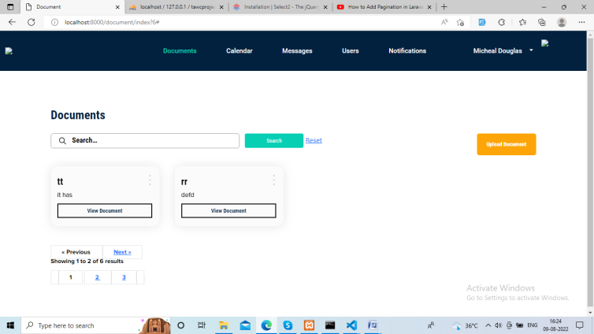

1…  <form class="search document-search">

                    <div class="row">

                        <div class="col-md-6">

                            <input type="search" name= "search" placeholder="Search…">

                        </div>

                        <div class="col-md-6 Search-btn">

                            <input type="submit" value="Search">

                            <a href= "{{route('doc.index')}}"> Reset </a>

                        </div>

                    </div>

                </form>

2.

 public function index(request $request)

    {

        $search = $request['search']?? "";

        if($search != ""){

            $userDetails = AdminDocument::where('title', 'LIKE', "%$search%")

            ->orWhere('description', 'LIKE', "%$search%")->get();

        }else {

            $userDetails = AdminDocument::paginate(2);

        }

        return view('admin.admin-document', compact('userDetails' , 'search'));

    }

3.

 <div class="pagenation">

                      {{$userDetails->links()}}

                </div>

1. <style>
2. .w-5{
3. display: none;
4. }
5. </style>

**For search and pagination in livewire**

[Laravel 8 Tutorial - Livewire Search With Pagination - YouTube](https://www.youtube.com/watch?v=qvxSEov0UhY)

[Surfside Media](https://www.youtube.com/c/SurfsideMedia)

18.5K subscribers

-----------------------

Q1. In laravel search box without search button ?

Use ajax