## CREATING AND CONFIGURING THE NAVBAR

### **Getting started with the navbar**

To start creating your own navbar, add an HTML5 **nav** element to your page, and add the **navbar** class to it. Alternatively, you could use a **div** or **span** element, however, best practice is to add the **role='navigation'**element for accessibility.

Next, adding the **navbar-default** class will enable the default color scheme for navbars; **navbar-inverse** will use the reverse color scheme.

Finally, content, like content for your page, is placed into one of two containers: container, for a fixed-width**container**, or **container-fluid**, which will take up the entire width of the page.

-- code

### **Positioning the navbar**

You have three options when placing the navbar on your page.

The first option is to have it appear at the top of the page as a normal element, scrolling, and disappearing off the top of the browser window, along with the rest of the content. This is achieved by adding the **navbar-static-top** class.

-- code

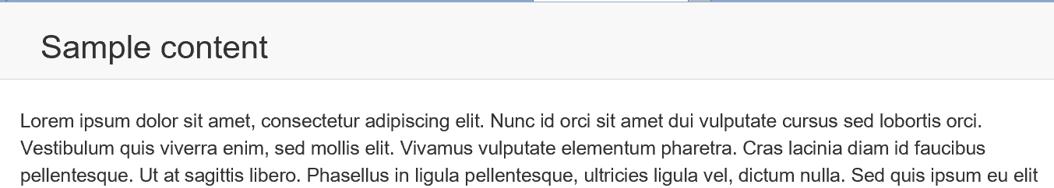

The second option is affix it to the top of the page, so it will not disappear when the user scrolls, but rather stay in place. This is achieved by adding the **navbar-fixed-top** class.

Finally, you can have the navbar use the same behavior on the bottom of the page with **navbar-fixed-bottom**.

**If you are using either fixed option**, you are required to add padding to the top (for **navbar-fixed-top**), or bottom (for **navbar-fixed-bottom**) to the **body** element. If you forget to add this in, the navbar will overlap the content on the page. If you see the sample above, you'll notice the navbar is above the content, and the content starts with "Lorem ipsum dolor sit amet..." The image below shows the result of adding fixed, but not adding in the padding.

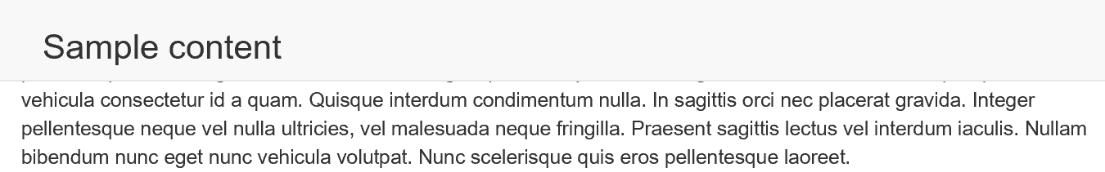

The proper HTML and CSS for a **navbar-fixed-top** is displayed below, with the padding. Remember that the padding must be set after the Bootstrap.min.css file is applied if you are using a seperate external stylesheet.

-- code

Scrollspy

ACCORDION

Carousel

carousel caption