1. Create a MongoDB Atlas account.
2. Set up a database(cluster). Select the cloud provider, region, tier, etc.
3. Have to configure the cluster so that we can connect to it.

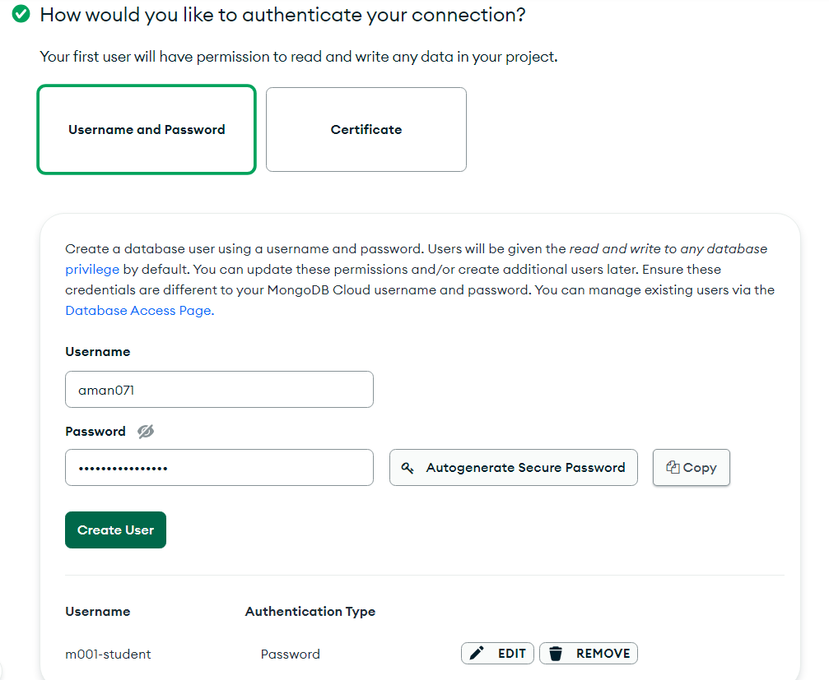

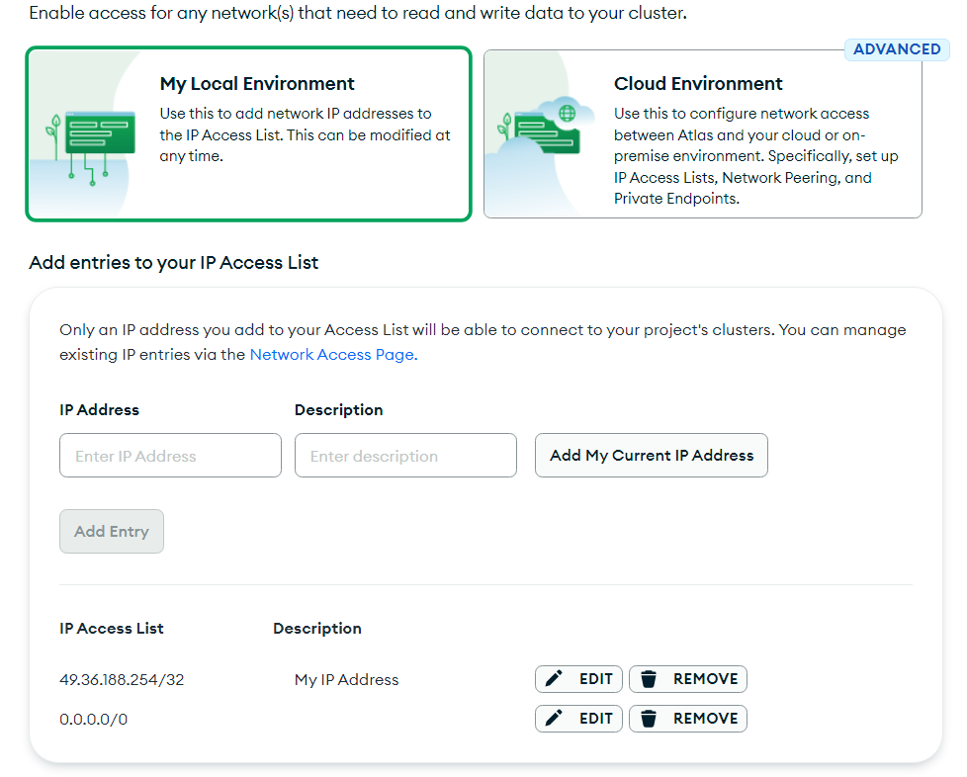

We can also connect our cluster to cloud providers directly if we want to manage our cluster through those cloud provider rather than code or the Atlas interface.

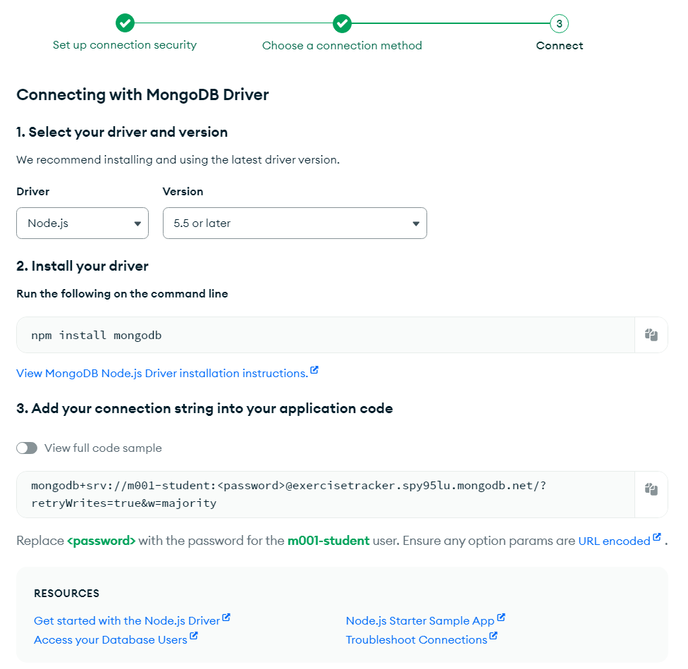

Next, to connect to our cluster instance we need to set up a driver. Whichever platform we are going to code on, we would need a driver for that platform. Since our platform is in Nodejs we will choose NodeJS. And note down the connection string. This is the only string that will let us connect to our mongodb cluster in our nodejs application.

1. Add data to our database. MongoDB offers the facility to add sample data.  
     
   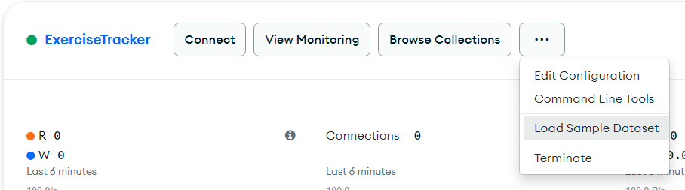  
     
     
     
   We can look at the sample data. (Different tables in MongoDB are called Collections). Every Collections has rows called Documents.  
   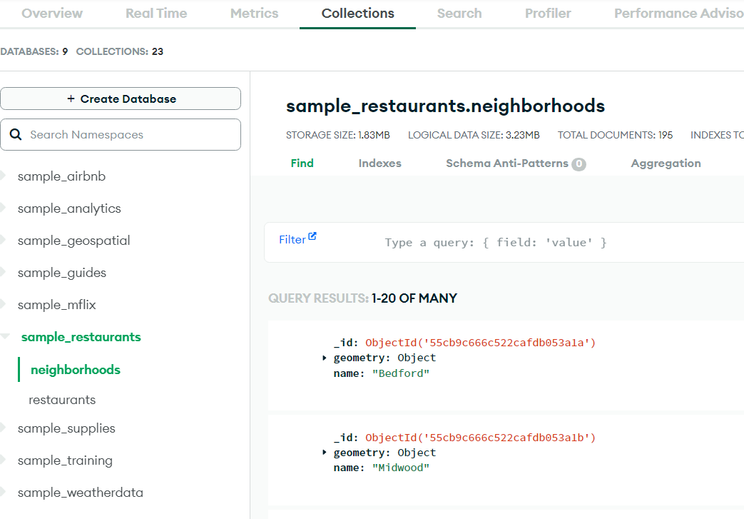

We can create indices on various fields directly from Atlas. Can then use it to query from our backend.

