1.Welcome Page
import pandas as pd
def menu():

print()
print('BANK MANAGEMENT SYSTEM' )
print()
print ('0. Know about the Project')
print( '1. Reading file Bank')
print( '2. Reading file Bank without Index')
print( '3. Add Details of New Account Holder')
print( '4. Delete Account if it is closed' )
print( '5. Balance Enquiry')
print( '6. Arrange details in Ascending Order by Name of Accounts')
print( '7. Maximum Balance from all accounts in Bank')
print( '8. Reading file Account')
print( '9. Deposit in Account')
print( '10. Withdrawl from Account')
print()

print('***************')

menu()

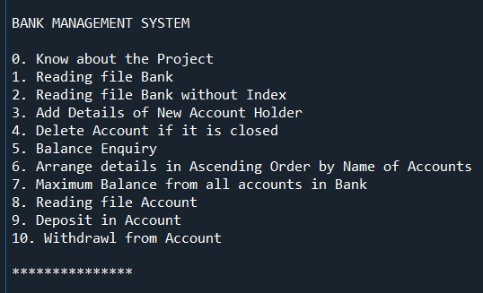

2.When Choice is: 0
menu()

def about():
print('This project contains the Bank Management System. It has 2 tables with 10 options. ')

3. When Choice is: 1
…displaying bank table
def bankcsv():
print('Reading file bank')
print()
print()
df=pd.read_csv("C:\\Users\\USER\Desktop\CSV\Bank Table.csv")
print(df)

