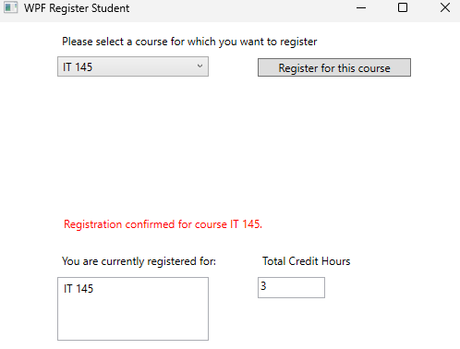

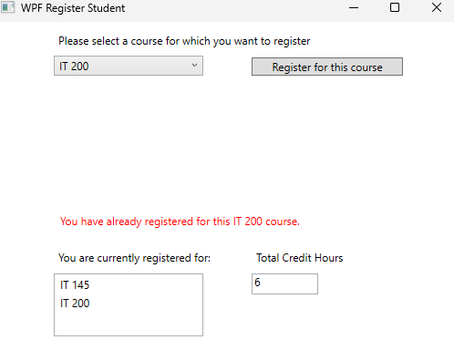

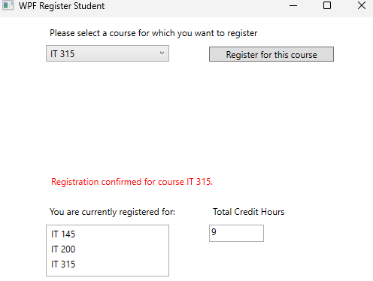

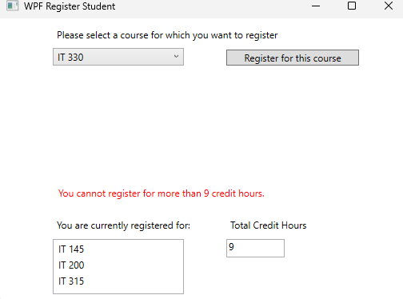

using System;

using System.Collections.Generic;

using System.Linq;

using System.Text;

using System.Threading.Tasks;

using System.Windows;

using System.Windows.Controls;

using System.Windows.Data;

using System.Windows.Documents;

using System.Windows.Input;

using System.Windows.Media;

using System.Windows.Media.Imaging;

using System.Windows.Navigation;

using System.Windows.Shapes;

namespace WPFRegisterStudent

{

/// <summary>

/// Interaction logic for MainWindow.xaml

/// </summary>

public partial class MainWindow : Window

{

Course choice;

private int creditHours = 0; // Tracks the total number of credit hours the student has registered for. Starts at 0 and increases as courses are added.

public MainWindow()

{

InitializeComponent();

}

private void Window_Loaded(object sender, RoutedEventArgs e)

{

Course course1 = new Course("IT 145");

Course course2 = new Course("IT 200");

Course course3 = new Course("IT 201");

Course course4 = new Course("IT 270");

Course course5 = new Course("IT 315");

Course course6 = new Course("IT 328");

Course course7 = new Course("IT 330");

this.comboBox.Items.Add(course1);

this.comboBox.Items.Add(course2);

this.comboBox.Items.Add(course3);

this.comboBox.Items.Add(course4);

this.comboBox.Items.Add(course5);

this.comboBox.Items.Add(course6);

this.comboBox.Items.Add(course7);

this.textBox.Text = "";

}

private void button_Click(object sender, RoutedEventArgs e)

{

choice = (Course)(this.comboBox.SelectedItem); // Get the currently selected course from the ComboBox and cast it to Course

if (this.listBox.Items.Contains(choice) && choice.IsRegisteredAlready()) // Check if the selected course is already in the ListBox AND if the course has been registered already

{

this.textBlock1.Text = "You have already registered for this " + choice.ToString() + " course."; // Inform the user that they are trying to register for a course they already registered

}

else if (creditHours < 9) // Check if the student is under the 9 credit hour limit

{

this.listBox.Items.Add(choice); // Add the selected course to the ListBox

choice.SetToRegistered(); // Mark the course as registered

creditHours += 3; // Increment total credit hours by 3 (assuming each course is 3 credits)

this.textBox.Text = Convert.ToString(creditHours); // Update the TextBox showing the current total credit hours

this.textBlock1.Text = "Registration confirmed for course " + choice.ToString() + "."; // Confirm registration to the user

}

else

this.textBlock1.Text = "You cannot register for more than 9 credit hours."; // User has reached the 9 credit hour limit

}

private void comboBox_SelectionChanged(object sender, SelectionChangedEventArgs e) // Event handler for when the ComboBox selection changes

{

}

private void listBox_SelectionChanged(object sender, SelectionChangedEventArgs e) // Event handler for when the ListBox selection changes

{

}

private void textBox_TextChanged(object sender, TextChangedEventArgs e) // Event handler for when the TextBox content changes

{

}

}

}