Report
Of
Python Developer Internship

Submitted
To
School of Computer Science and Engineering
IILM University, Greater Noida, U.P.
In partial fulfilment of the requirement of degree of
B.Tech CSE

By
Roll Number of Student: 25SCS1003004670
Name of Student: AMANDEEP DIXIT
Batch: 2025-29
2026-27

CANDIDATE’S DECLARATION

I, Amandeep Dixit do hereby declare that the internship report titled “Python Developer Internship” has been completed by me to fulfil the requirement for the award of the degree of Bachelor of Technology in CSE. All the references have been quoted and I have not taken as such any material from any other source. I affirm to you that this report is my own and has not been submitted to any other institute for any degree/diploma requirement and further I shall be solely responsible for any kind of copyright violation in this regard.

Signature
Student Name: Amandeep Dixit
Roll No.: 25SCS1003004670

ACKNOWLEDGEMENT

I am using this opportunity to express my gratitude to everyone who supported me throughout the Internship Program. I am thankful for their aspiring guidance, invaluably constructive criticism and friendly advice during this work. I am sincerely grateful to them for sharing their truthful and illuminating views on a number of issues related to this work.
I express my gratitude to my parents for their blessings.

Signature
Student Name: Amandeep Dixit
Roll No.: 25SCS1003004670

Chapter No. | Chapter Name | Page Nos.
 | Cover Page | ----
1. | Candidate’s Declaration | i
2. | Acknowledgment | ii
3. | Internship Completion Certificate | ----
4. | Project Description  4.1 Introduction  4.2 Organization Profile  4.3 Problem Statement  4.4 Project Objectives  4.5 Scope of the Project  4.6 Technologies and Tools Used  4.7 System Architecture  4.8 Methodology  4.9 Expected Outcomes  4.10 Certificates of completion and other communication mail proof | 1  1  2  2  3  3  4  4  5  6
5. | Bibliography/References

3. INTERNSHIP COMPLETION CERTIFICATE
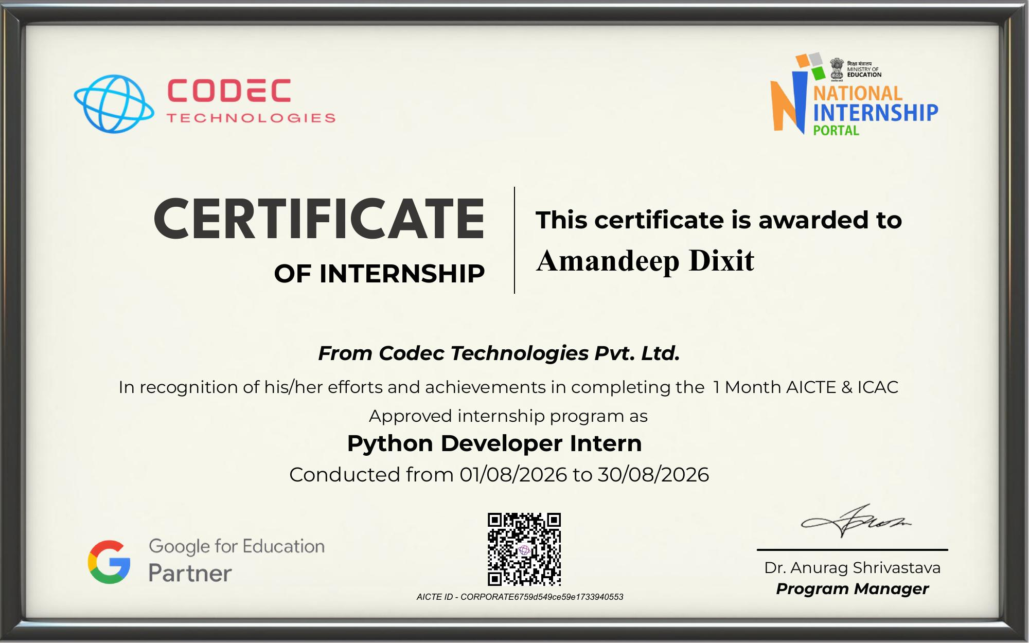

4. PROJECT DESCRIPTION
4.1 Introduction
During this internship, I worked on developing robust, enterprise-ready Python back-end and command-line application components. The primary focus was mastering Object-Oriented Programming (OOP) paradigms, automated testing suites, asynchronous web frameworks, and database persistence layers. Through practical implementation, I successfully built and tested a structured Python Command-Line Interface (CLI) application adhering to modular architecture standards.
4.2 Organization Profile
- Organization Name: Codec Technologies Pvt. Ltd.
- Platform Domain: EdTech / Skill Development & Practical Training
- Overview: Codec Technologies is an AICTE & ICAC approved internship platform designed to bridge the gap between academic education and industry requirements. It provides hands-on development projects, structured curricula, and practical evaluation pipelines in software engineering domains including Python, Web Development, and System Design.
4.3 Problem Statement
Modern software engineering requires codebases to be modular, scalable, maintainable, and thoroughly tested. Beginners often write monolithic Python scripts lacking structural organization, database integration, or automated tests. The challenge was to design and implement a structured Python project using strict Object-Oriented principles, dynamic command handling, unit testing via pytest, and persistent data handling.
4.4 Project Objectives
- Design a clean, modular Python CLI application using advanced Object-Oriented Programming concepts (inheritance, encapsulation, model hierarchies).
- Implement automated testing suites using pytest to ensure high code quality and test coverage.
- Handle File I/O operations and database persistence for structured data manipulation.
- Apply industry-standard directory structures and virtual environment isolation practices.
4.5 Scope of the Project
The project encompasses back-end execution logic, unit test validation, command parsing, and persistence models. It provides a foundation for extending application functionalities into full RESTful APIs using frameworks like FastAPI and ORMs like SQLAlchemy.
4.6 Technologies and Tools Used
- Programming Language: Python 3.x
- Frameworks & Libraries: FastAPI, Pydantic, SQLAlchemy, pytest
- Database & File Formats: SQLite (app.db), JSON (data.json), CSV (output.csv)
- Version Control & Management: Git, GitHub, Virtual Environments (venv)
- Development Environment: VS Code / Terminal
4.7 System Architecture
The application follows a standard modular architecture:
- Application Core (main.py): Contains model class definitions, business logic execution, data serialization, and input parsing routines.
- Testing Suite (test_main.py): Contains explicit unit test functions executing automated test assertions against main.py models and outputs.
- Data Layer: Interacts with local databases (app.db) and static storage files (data.json, output.csv) for persistent state handling.
4.8 Methodology
- Environment Setup: Virtual environment initialization and dependency resolution.
- OOP Modeling: Defining data hierarchies, constraint validation using Pydantic, and database schemas via SQLAlchemy.
- Core Development: Writing main business logic within structured scripts (main.py).
- Test-Driven Verification: Writing and executing unit tests (test_main.py) using pytest to ensure error handling and function validity.
- Deployment & Documentation: Publishing code repository to GitHub and generating verified execution logs.
4.9 Expected Outcomes
- Fully functional and error-free Python CLI application code execution.
- Complete pass results across all pytest automated test suites.
- Clean version-controlled repository structured according to PEP 8 standards.
4.10 Certificates of Completion and Communication Proof
The Internship Completion Certificate presented in Section 3 was issued by Codec Technologies Pvt. Ltd. in association with the National Internship Portal (Ministry of Education) and Google for Education, confirming successful completion of the Python Developer Internship (AICTE & ICAC approved) conducted from 01/08/2026 to 30/08/2026.
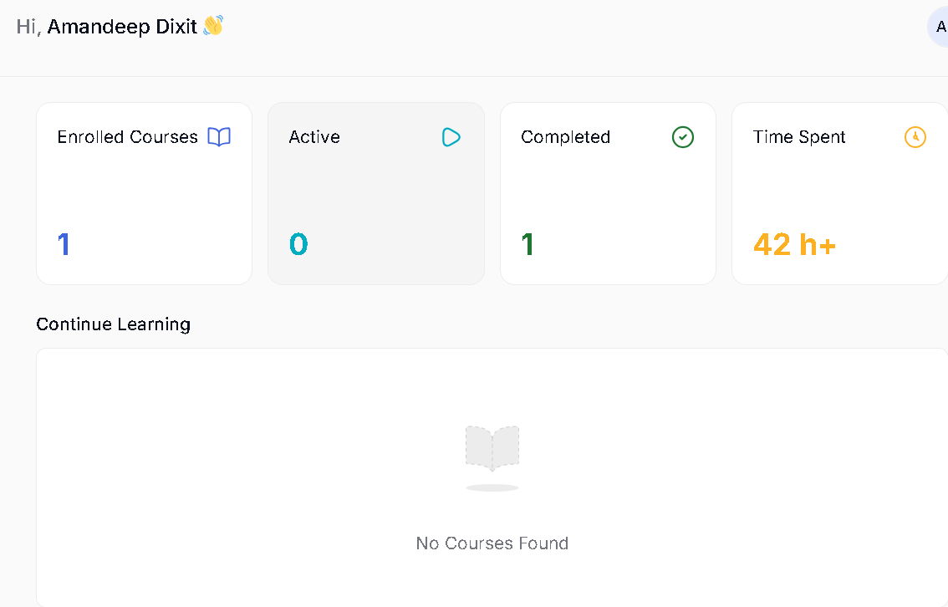
Fig 4.1: Learning Portal Dashboard – Course Completion Proof

5. BIBLIOGRAPHY / REFERENCES
- Python Software Foundation. Python Documentation (v3.10+). Available at: https://docs.python.org/3/
- Pytest Developers. pytest: helps you write better programs. Available at: https://docs.pytest.org/
- FastAPI Documentation. FastAPI Framework for building APIs. Available at: https://fastapi.tiangolo.com/
- Codec Technologies Curriculum Guidelines. Python Developer Track.

