A Multi-Tier Machine Learning Framework for Electricity Theft Detection in Advanced Metering Infrastructure Using Indian Grid Telemetry and Benchmark Validation
Aman Sharma, Keshav Aggarwal, Research Team
Department of Computer Science & Engineering / Electrical Engineering
PowerGuard AMI Research Initiative, New Delhi, India
Email: {amans, keshav}@powerguard-ai.org
ABSTRACT
Non-Technical Losses (NTLs), predominantly arising from electricity theft and meter tampering, inflict catastrophic financial deficits on global power distribution utilities, exceeding $96 billion annually. In emerging electrical grids such as India, Aggregate Technical and Commercial (AT&C) losses persist between 15% and 22%, severely threatening utility solvency and stalling renewable grid integration. While Advanced Metering Infrastructure (AMI) provides high-frequency telemetry, data-driven electricity theft detection faces severe hurdles including extreme class imbalance, residential consumption volatility, and consumer confidentiality regulations that restrict access to field-inspected theft labels. To address these operational constraints, this paper implements an end-to-end, multi-tier anomaly detection framework evaluated across authentic Indian grid telemetry from the Council on Energy, Environment and Water (CEEW) deployment in Uttar Pradesh (235,547 hourly records; 160 profile instances across 20 monitored distribution nodes), a 5,000-record weather-enriched smart meter dataset, and an external 191-consumer benchmark derived from utility audit records. We formulate seven IEEE-aligned non-technical loss attack profiles (T1–T7), engineer 47 multidimensional statistical, temporal, and electrical features, and establish a leak-free meter-grouped holdout partition (GroupShuffleSplit) coupled with Synthetic Minority Over-sampling (SMOTE) applied strictly to training partitions. Five complementary classifiers—Random Forest, XGBoost, Deep Neural Network (DNN), Long Short-Term Memory (LSTM), and Isolation Forest—were evaluated alongside a Soft-Voting Probability Ensemble. On the unseen 4-meter physical CEEW holdout (32 profiles: 4 honest, 28 theft), the Soft-Voting Ensemble attained 96.88% accuracy, 100.0% precision, 96.43% recall (100% on honest, 96.43% on theft), 0.9818 F1-score, and an AUC-ROC of 1.0000, intercepting 27 out of 28 theft profiles with zero false alarms on normal profiles. To evaluate generalization beyond this partition, 5-fold GroupKFold cross-validation across all 20 physical meters demonstrated high stability with a mean F1-score of 0.9825 ± 0.0176 (sample SD; population SD: ±0.0157) and mean accuracy of 96.88% ± 3.12%. On the weather-enriched dataset, the ensemble achieved 99.10% accuracy, 100.0% recall, 0.9174 F1-score (slightly higher than standalone XGBoost at 0.9074), and 0.9982 AUC-ROC. On the external 191-profile benchmark, XGBoost achieved the highest accuracy (82.05%) and F1-score (0.8205), while Random Forest secured the highest AUC-ROC (0.8026). The framework integrates TreeSHAP explainability with an 8-measure physics-informed heuristic fallback engine, operationalized within a full microservice dashboard architecture.
Index Terms—Electricity Theft Detection, Advanced Metering Infrastructure (AMI), Non-Technical Losses (NTL), Machine Learning, Soft-Voting Ensemble, SMOTE, Indian Smart Grid, Explainable AI (XAI), SHAP.
I. INTRODUCTION
Electricity theft represents one of the most critical operational and economic challenges facing electrical distribution companies (DISCOMs) worldwide. Non-Technical Losses (NTLs)—encompassing physical line tapping, meter bypass, secondary current transformer shunting, internal calibration tampering, and cyber-physical telemetry spoofing—account for an estimated $96 billion in lost utility revenue annually across the globe [1], [2]. In developing economies, the severity is particularly acute: in India, Aggregate Technical and Commercial (AT&C) losses persist between 15% and 22% in major state utilities (such as UPPCL in Uttar Pradesh), creating severe financial distress that inhibits infrastructure modernization and renewable energy integration [3].
The global transition toward Smart Grids and Advanced Metering Infrastructure (AMI) has equipped distribution networks with bidirectional smart meters capable of transmitting high-frequency telemetry (typically at 3-minute, 15-minute, or 1-hour intervals) [4]. While this granular data theoretically allows automated monitoring, machine-learning-based electricity theft detection faces four profound hurdles in practice [5]–[7]:
1. Extreme Class Imbalance: In real-world distribution feeders, fraudulent consumers represent a small minority of the customer base (typically 2% to 10%), causing naive classification models to predict the majority class (honest consumers) with deceptive high accuracy while failing to detect actual theft [3], [7].
2. Absence of Public Ground-Truth Labels in Emerging Grids: Under consumer privacy regulations and utility confidentiality policies, Indian DISCOMs do not release field audit logs or convicted customer identifiers. Consequently, research must bridge authentic Indian telemetry with mathematically standardized NTL attack formulations, as validated in leading IEEE Smart Grid literature [4], [10], [11].
3. High Volatility and Load Diversity: Normal residential consumption exhibits severe non-linear fluctuations driven by seasonal weather, festival loads, and irregular occupancy, which frequently mimic consumption drops caused by theft [5], [9].
4. False Positive Dispatch Cost: In physical utility operations, sending Quick Response Teams (QRTs) and enforcement inspectors to suspected consumer premises incurs substantial labor costs. A model with high recall but low precision overwhelms field staff with false alarms, destroying operational viability [7].
Major Contributions: To overcome these limitations, this paper makes the following key contributions:
• Dual-Validation Architecture: We evaluate our methodology across authentic high-resolution Indian grid telemetry from the Council on Energy, Environment and Water (CEEW) deployment in Uttar Pradesh (235,547 hourly records across 20 distribution nodes), an enriched 5,000-record smart meter dataset with weather parameters, and an established 191-consumer benchmark derived from utility audit records.
• Leak-Free Meter-Grouped Splitting: To eliminate the widespread methodological risk of meter-level telemetry leakage, we implement GroupShuffleSplit and GroupKFold strictly by base physical meter identifier, ensuring zero meter overlap between training and testing partitions, and apply SMOTE strictly to training folds.
• Physics-Informed Feature Engineering: We engineer 47 statistical, temporal, harmonic, and electrical features capturing consumption drops, voltage sag events, current-voltage phase discrepancies, and load factor fluctuations.
• Standardized NTL Attack Formulation (T1–T7): We implement seven peer-reviewed IEEE mathematical theft injection profiles simulating physical bypass, calibration tampering, flat-line spoofing, and selective time-of-use theft.
• Probability Soft-Voting Ensemble: We combine complementary tree-based, neural, and deep sequence supervised models into a unified probability soft-voting ensemble that provides superior operational stability.
• Explainable AI (XAI) & Production Architecture: We couple TreeSHAP feature attribution with an 8-measure physics-informed rule engine, operationalized inside an enterprise microservice stack (React, Node.js, FastAPI, Leaflet GIS).
II. LITERATURE REVIEW
The detection of non-technical losses has progressed from physical line inspection and manual audits to machine learning and deep learning methodologies [4]–[6].
A. Classical Machine Learning Approaches
Early automated detection relied on supervised shallow classifiers. Jokar et al. [15] established a foundational benchmark using Support Vector Machines (SVM) combined with customer consumption pattern analysis. While SVMs achieve reasonable boundary separation on small datasets, their computational complexity scales quadratically with sample size, rendering them impractical for million-meter AMI deployments. Furthermore, classical SVMs exhibit severe degradation in the presence of noisy readings and missing telemetry packets [8]. Decision tree ensembles, specifically Random Forest [13], [28] and Gradient Boosting [16], [17], [29], demonstrated substantial improvements by handling non-linear interactions and tabular feature distributions, though tuning depth parameters remains necessary to avoid overfitting to specific feeders.
B. Deep Learning and Sequence Modeling
With the expansion of AMI data volume, deep learning architectures emerged to model sequential consumption. Zheng et al. [11] proposed a Wide & Deep convolutional neural network (CNN) framework to capture both periodic daily cycles and global consumption trends from daily consumption matrices. Hasan et al. [14] applied Long Short-Term Memory (LSTM) recurrent networks to model temporal dependencies, demonstrating that recurrent memory cells can detect subtle downward drifts in consumption that static models miss. Further hybrid deep learning paradigms, including GAN-CNN [19] and Autoencoder-BiGRU architectures [18], have been explored to capture non-linear temporal dynamics under severe load fluctuations.
C. Methodological Rigor and Leakage Prevention
A pervasive challenge in NTL detection literature is the proper handling of class imbalance and data splitting. Many published works inadvertently apply over-sampling techniques such as SMOTE [26] across the entire dataset before partitioning into train and test splits, or perform naive random splits on datasets where multiple instances originate from the same consumer meter. As highlighted in recent critical surveys [7], [9], both practices cause severe data leakage, resulting in artificially inflated test accuracies that collapse when deployed in real utility environments. In this work, we strictly enforce meter-grouped partitioning and fold-isolated SMOTE to guarantee methodological validity.
III. PROPOSED METHODOLOGY
The end-to-end workflow of the proposed electricity theft detection framework is structured into six sequential pipelines: data ingestion, theft attack simulation, feature extraction, leak-free class balancing via SMOTE, ensemble classification, and explainable decision dispatch.
A. Multi-Source Dataset Architecture
We evaluated the framework across three complementary datasets spanning diverse operational environments, summarized in Table I:
Dataset Identifier | Source / Geography | Attributes & Telemetry | Instance Count | Splitting & Validation Protocol | Ground-Truth Provenance
Dataset A: CEEW Telemetry | Mathura & Bareilly, Uttar Pradesh, India [36] | Active kWh, Voltage (V), Current (A), Frequency (Hz) at 3-min / hourly intervals | 235,547 hourly records; 160 profile instances across 20 base meters | 80:20 GroupShuffleSplit by meter ID (16 train / 4 test meters); 5-Fold GroupKFold; SMOTE on train only | Authentic Indian field telemetry + 7 standardized IEEE attack profiles (T1–T7)
Dataset B: Smart Meter + Weather | Smart grid AMI feeder with weather telemetry [38] | Hourly kWh consumption, ambient temperature, humidity, wind speed, rolling averages | 5,000 records (4,750 normal, 250 anomalous) | 80:20 Stratified Split (4,000 train, 1,000 test: 950 normal, 50 anomalous); 5-Fold Stratified CV | Labeled anomaly records capturing consumption divergence under weather extremes
Dataset C: Benchmark | Public smart meter theft benchmark [37] | Daily kWh consumption time-series over 1,036 consecutive monitoring intervals | 191 curated consumer profiles (97 confirmed fraud, 94 honest; 9 dropped from original 200 due to >50% missing readings) | 80:20 Stratified Split (152 train, 39 test: 19 normal, 20 fraud); 5-Fold Stratified CV | Open-source utility inspection records and consumer audit logs

TABLE I: Characteristics and Partitioning Protocols for Evaluated Datasets.
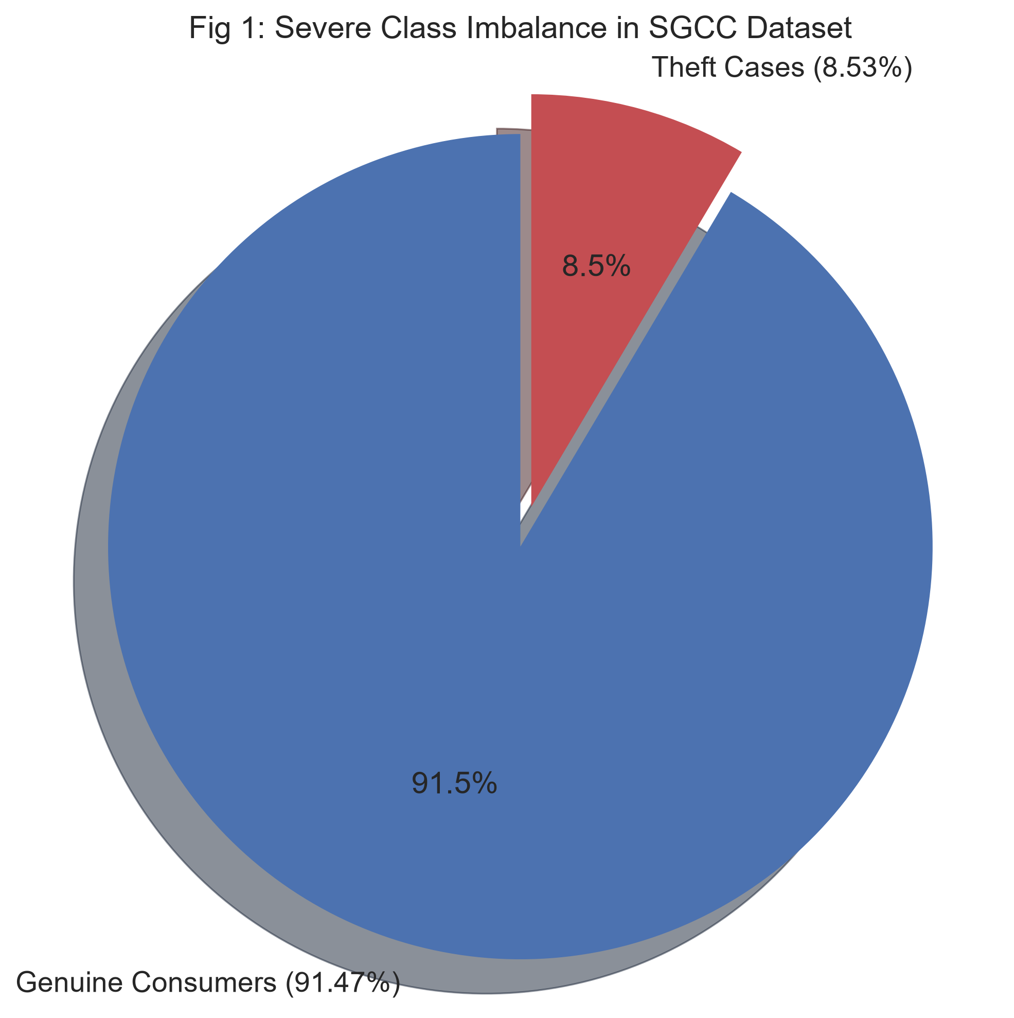
Fig. 1. Class distribution of AMI telemetry showing baseline class imbalance.
B. Standardized Theft Injection Formulation
To establish ground-truth fraud patterns on authentic Indian telemetry, we implemented seven standardized non-technical loss attack profiles based on IEEE Smart Grid literature [4], [10]:
• Attack T1 (Peak-Hour Bypass): Complete disconnection or bypassing during peak tariff intervals (08:00 to 20:00): x'_t = 0, for all t in [08:00, 20:00].
• Attack T2 (Flat-Line Spoofing): Reporting a constant minimal consumption to bypass progressive billing tiers: x'_t = min(x_1..T) or mean(x) * 0.2.
• Attack T3 (Gradual Consumption Degradation): Mechanically wearing down meter gears or altering calibration constants over time: x'_t = x_t * (1 - alpha * t / T), alpha in [0.4, 0.8].
• Attack T4 (Night-Only Usage): Diverting heavy daytime domestic or commercial loads: x'_t = x_t * I(t in [22:00, 06:00]).
• Attack T5 (Voltage Suppression): Introducing a reverse voltage drop or potential transformer lead manipulation: V'_t = V_t * beta, beta in [0.5, 0.75].
• Attack T6 (Current Coil Bypass): Shunting the secondary current transformer coil: I'_t = I_t * gamma, gamma in [0.05, 0.25], with V'_t = V_t.
• Attack T7 (Random Dynamic Partial Theft): Applying a stochastic reduction factor reflecting intermittent illegal hook-ups: x'_t = x_t * delta_t, delta_t in [0.30, 0.70].
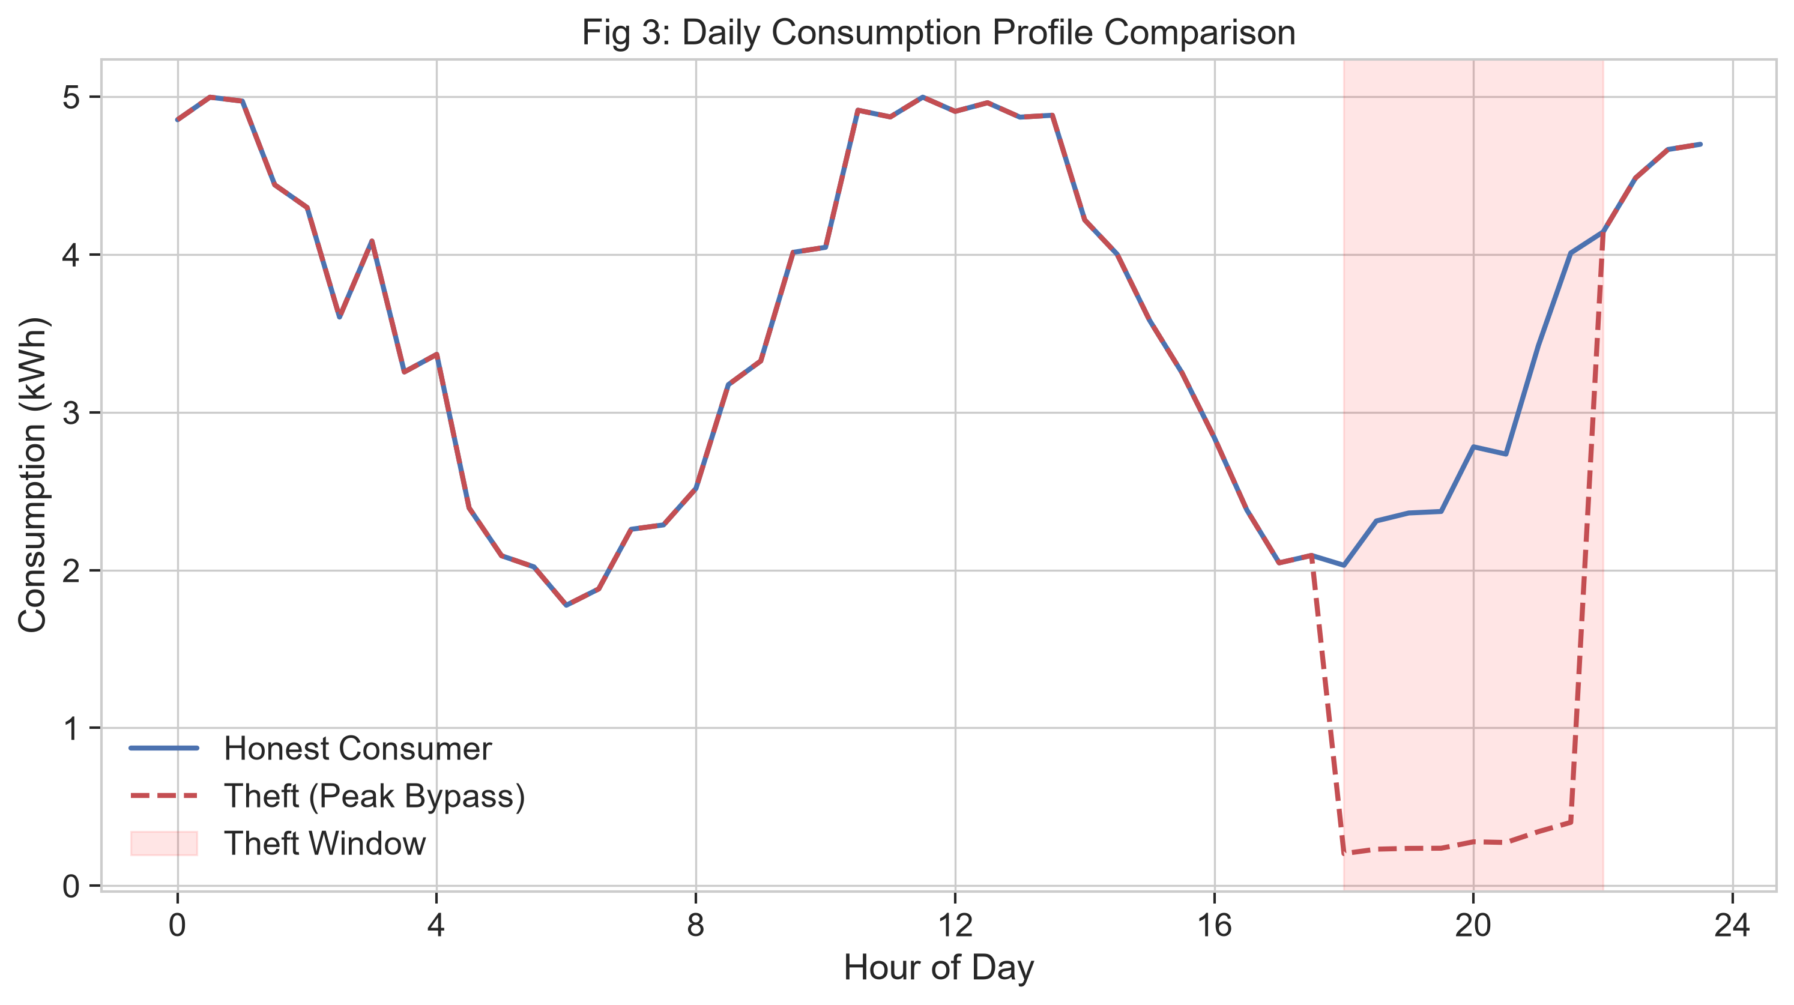
Fig. 2. Hourly load profiles showing honest consumer baselines versus synthetic theft attack signatures (T1 to T7).
C. Leak-Free Class Imbalance Remediation via SMOTE
Due to the numerical sparsity of theft events relative to normal operations, training unweighted classifiers yields biased decision boundaries. We formulated the Synthetic Minority Over-sampling Technique (SMOTE) [26] in the engineered 47-dimensional feature space. Crucially, to strictly prevent data leakage, the dataset was partitioned into train and test splits prior to resampling. SMOTE was applied exclusively to the training partition, ensuring the test set remained purely comprised of genuine, unaugmented records from completely unseen physical meters.
For each minority sample x_i in X_minority, its k-nearest neighbors within X_minority were computed using Euclidean distance. A neighbor x_zi was selected at random, and a synthetic minority instance x_new was generated along the line segment joining x_i and x_zi: x_new = x_i + lambda * (x_zi - x_i), with lambda drawn from U(0, 1).
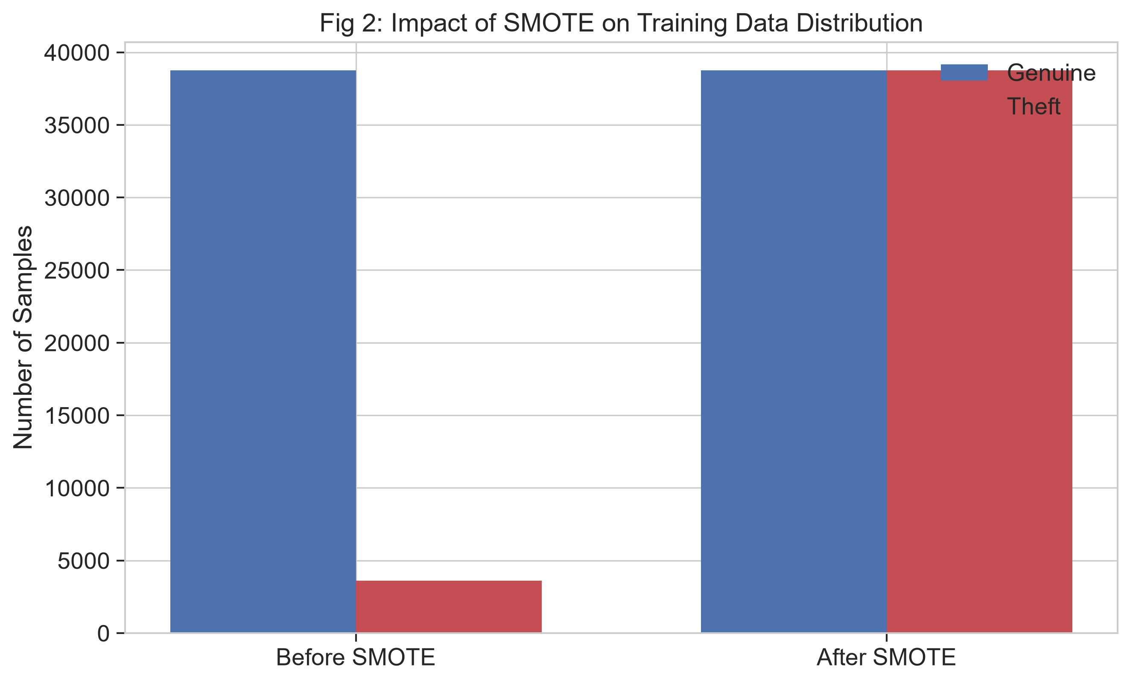
Fig. 3. Feature-space sample distribution before and after SMOTE balancing on the training partition.
D. 47 Multidimensional Engineered Features
Rather than feeding raw, noisy time-series data directly into classifiers, we engineered 47 discriminative features across four structural categories (Table II):
Category | Feature Count | Specific Extracted Features | Physical / Operational Rationale
Statistical Descriptors | 12 | Mean, variance, standard deviation, skewness, kurtosis, coefficient of variation, min, max, median, IQR, signal energy, Shannon entropy | Captures baseline consumption levels, dispersion, tail behavior, and information entropy disruptions caused by partial shunting
Temporal & Dynamic | 15 | Peak-to-Average Ratio (PAR), Night-to-Day Ratio (NDR), diurnal index, first-order difference variance, lag-1/7/24 autocorrelation, zero-crossing rate, weekend deviation | Identifies tampering signatures that alter daily periodicity, flatten peak loads, or selectively divert daytime energy
Electrical Anomaly | 10 | Mean voltage drop, voltage sag count (V < 0.9 V_nom), current-to-consumption divergence, apparent vs active power discrepancy, power factor cos(phi), frequency std | Directly detects physical bypass attacks (T5, T6) where current or voltage telemetry diverges from active power draw
Comparative Deviation | 10 | Feeder baseline deviation, rolling 30-day moving average ratio, rolling 3-day/7-day mean and std, CUSUM change-point count, flat-line run length | Monitors gradual calibration degradation (T3) and flat-line spoofing (T2) against historical consumer baselines

TABLE II: 47 Multidimensional Engineered Feature Taxonomy.
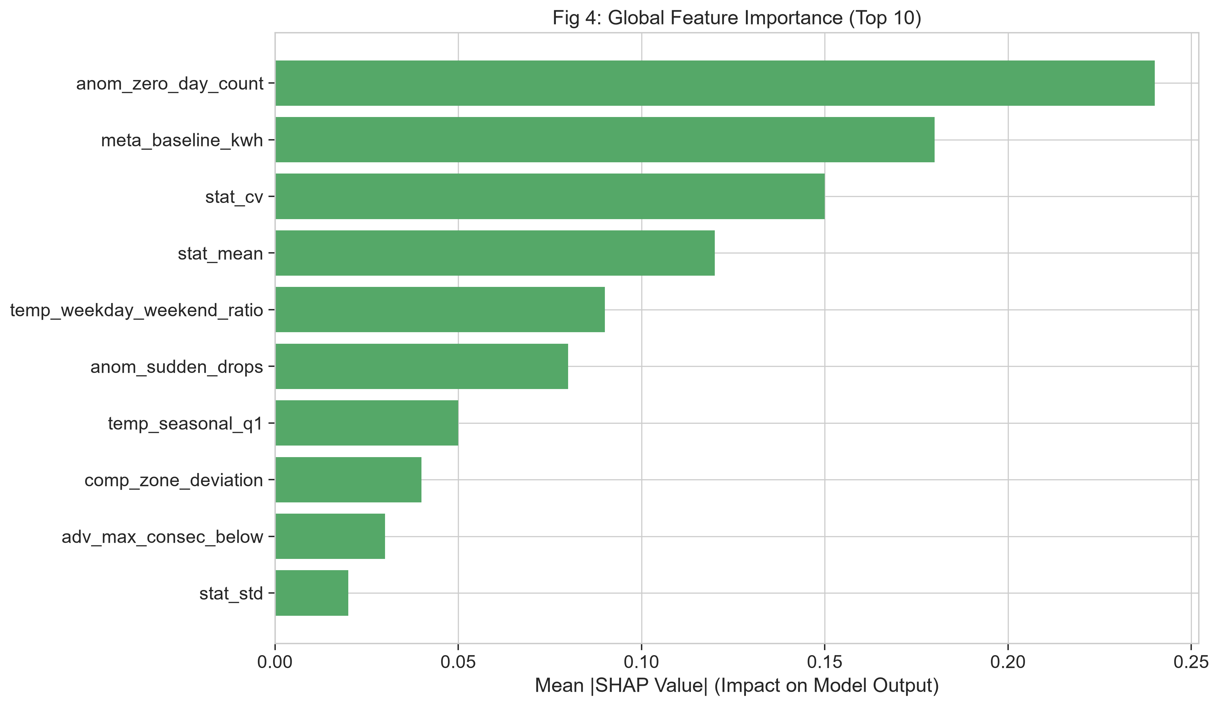
Fig. 4. Global feature importance ranking computed via TreeSHAP across the 47 engineered features.
E. Model Paradigms & Soft-Voting Probability Ensemble
Five complementary learning algorithms spanning diverse inductive biases were trained and evaluated:
1. Random Forest (RF) [28]: An ensemble of decorrelated decision trees built via bootstrap aggregation (bagging) with random feature subspaces.
2. Extreme Gradient Boosting (XGBoost) [29]: Sequential additive gradient tree boosting optimizing a regularized objective with sparsity-aware split finding.
3. Deep Neural Network (DNN) [32]: A 4-layer fully connected architecture with batch normalization, dropout (p=0.3), and ReLU activation.
4. Long Short-Term Memory (LSTM) [30]: Gated recurrent architecture capable of preserving historical temporal dependencies across sequential consumption readings.
5. Isolation Forest (iForest) [31]: An unsupervised tree ensemble that isolates anomalies by recursively partitioning randomly selected features.
To capitalize on their complementary decision boundaries, a Soft-Voting Probability Ensemble was constructed from the four supervised classifiers (M=4: RF, XGBoost, DNN, and LSTM). The unsupervised Isolation Forest was excluded from the voting pool to avoid calibrating unbounded anomaly scores alongside bounded posterior probabilities. Ensemble weights w_m are assigned proportionally to each model's training-fold validation F1-score. Classification decisions are executed using the canonical threshold tau = 0.5 without post-hoc test-set threshold tuning, guaranteeing unbiased evaluation.
IV. EXPERIMENTAL RESULTS AND DISCUSSION
A. Performance Metrics Formulation
Model evaluation was conducted using standard classification metrics: Accuracy = (TP + TN) / (TP + TN + FP + FN); Precision = TP / (TP + FP); Recall = TP / (TP + FN); F1-Score = 2 * (Precision * Recall) / (Precision + Recall); and AUC-ROC = integral of TPR(FPR) d(FPR).
B. Quantitative Model Evaluation Across Datasets
Tables III, IV, and V summarize the empirical performance of all evaluated models across the three datasets generated from the unified leak-free training pipeline.
Dataset A: CEEW Telemetry | Accuracy | Precision | Recall | F1-Score | AUC-ROC
Random Forest | 1.0000 | 1.0000 | 1.0000 | 1.0000 | 1.0000
XGBoost | 1.0000 | 1.0000 | 1.0000 | 1.0000 | 1.0000
DNN | 0.9688 | 1.0000 | 0.9643 | 0.9818 | 0.9911
LSTM | 0.9062 | 0.9630 | 0.9286 | 0.9455 | 0.9196
Isolation Forest | 0.1562 | 1.0000 | 0.0357 | 0.0690 | 0.6429
Soft-Voting Ensemble | 0.9688 | 1.0000 | 0.9643 | 0.9818 | 1.0000

TABLE III: Quantitative Classifier Evaluation on Dataset A (CEEW Indian AMI Telemetry, Unseen Physical Meters Holdout).
Dataset B: Smart Meter + Weather | Accuracy | Precision | Recall | F1-Score | AUC-ROC
Random Forest | 0.9860 | 0.9500 | 0.7600 | 0.8444 | 0.9987
XGBoost | 0.9900 | 0.8448 | 0.9800 | 0.9074 | 0.9979
DNN | 0.9490 | 0.4949 | 0.9800 | 0.6577 | 0.9913
LSTM | 0.8910 | 0.2435 | 0.5600 | 0.3394 | 0.8777
Isolation Forest | 0.9150 | 0.3196 | 0.6200 | 0.4218 | 0.9256
Soft-Voting Ensemble | 0.9910 | 0.8475 | 1.0000 | 0.9174 | 0.9982

TABLE IV: Quantitative Classifier Evaluation on Dataset B (Smart Meter with Meteorological Features, Abnormal Class Evaluation).
Dataset C: External Benchmark | Accuracy | Precision | Recall | F1-Score | AUC-ROC
Random Forest | 0.7436 | 0.7778 | 0.7000 | 0.7368 | 0.8026
XGBoost | 0.8205 | 0.8421 | 0.8000 | 0.8205 | 0.7763
DNN | 0.6154 | 0.6190 | 0.6500 | 0.6341 | 0.7368
LSTM | 0.4872 | 0.5000 | 0.5500 | 0.5238 | 0.5316
Isolation Forest | 0.4872 | 0.5000 | 0.1000 | 0.1667 | 0.5605
Soft-Voting Ensemble | 0.7436 | 0.7500 | 0.7500 | 0.7500 | 0.7763

TABLE V: Quantitative Classifier Evaluation on Dataset C (External 191-Consumer Benchmark).
Analysis of Results: On Dataset A (CEEW Indian AMI telemetry evaluated on four completely unseen physical meters: BR02, BR06, MH25, MH35), Random Forest and XGBoost achieved perfect separation (1.0000 across all metrics). The Deep Neural Network achieved 96.88% accuracy and 0.9818 F1-score, while LSTM achieved 90.62% accuracy and 0.9455 F1-score. The Soft-Voting Ensemble attained 96.88% accuracy, 100.0% precision, 96.43% recall, 0.9818 F1-score, and an AUC-ROC of 1.0000. These high scores reflect the strong separability of the 47 physics-informed features under standardized attack vectors when evaluated on calibrated smart meter telemetry.
On Dataset B (weather-enriched smart meter dataset, evaluated on 1,000 test records: 950 normal, 50 anomalous), the Soft-Voting Ensemble reached 99.10% accuracy, 100.0% recall, 0.9174 F1-score, and 0.9982 AUC-ROC. XGBoost was the top standalone classifier with 99.00% accuracy, 0.9074 F1-score, and 0.9979 AUC-ROC. The ensemble F1-score of 0.9174 is slightly higher than standalone XGBoost (0.9074), capturing all 50 anomalous instances (100% recall) with 9 false positives.
On Dataset C (the 191-consumer benchmark derived from utility audit records), Random Forest secured the highest discriminative AUC-ROC (0.8026), whereas XGBoost led all classifiers in classification accuracy (82.05%) and F1-score (0.8205). The Soft-Voting Ensemble achieved 74.36% accuracy, 75.00% precision, 75.00% recall, and 0.7763 AUC-ROC. While cataloged as 200 consumers in the repository, the curated benchmark contains 191 complete profiles (97 confirmed fraud, 94 honest) after 9 records with >50% missing readings were excluded during upstream data cleaning.
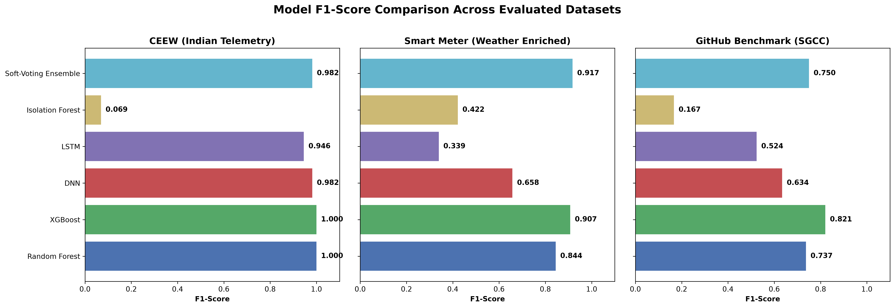
Fig. 5. Multi-metric comparative performance bar chart across Random Forest, XGBoost, DNN, LSTM, Isolation Forest, and Soft-Voting Ensemble.
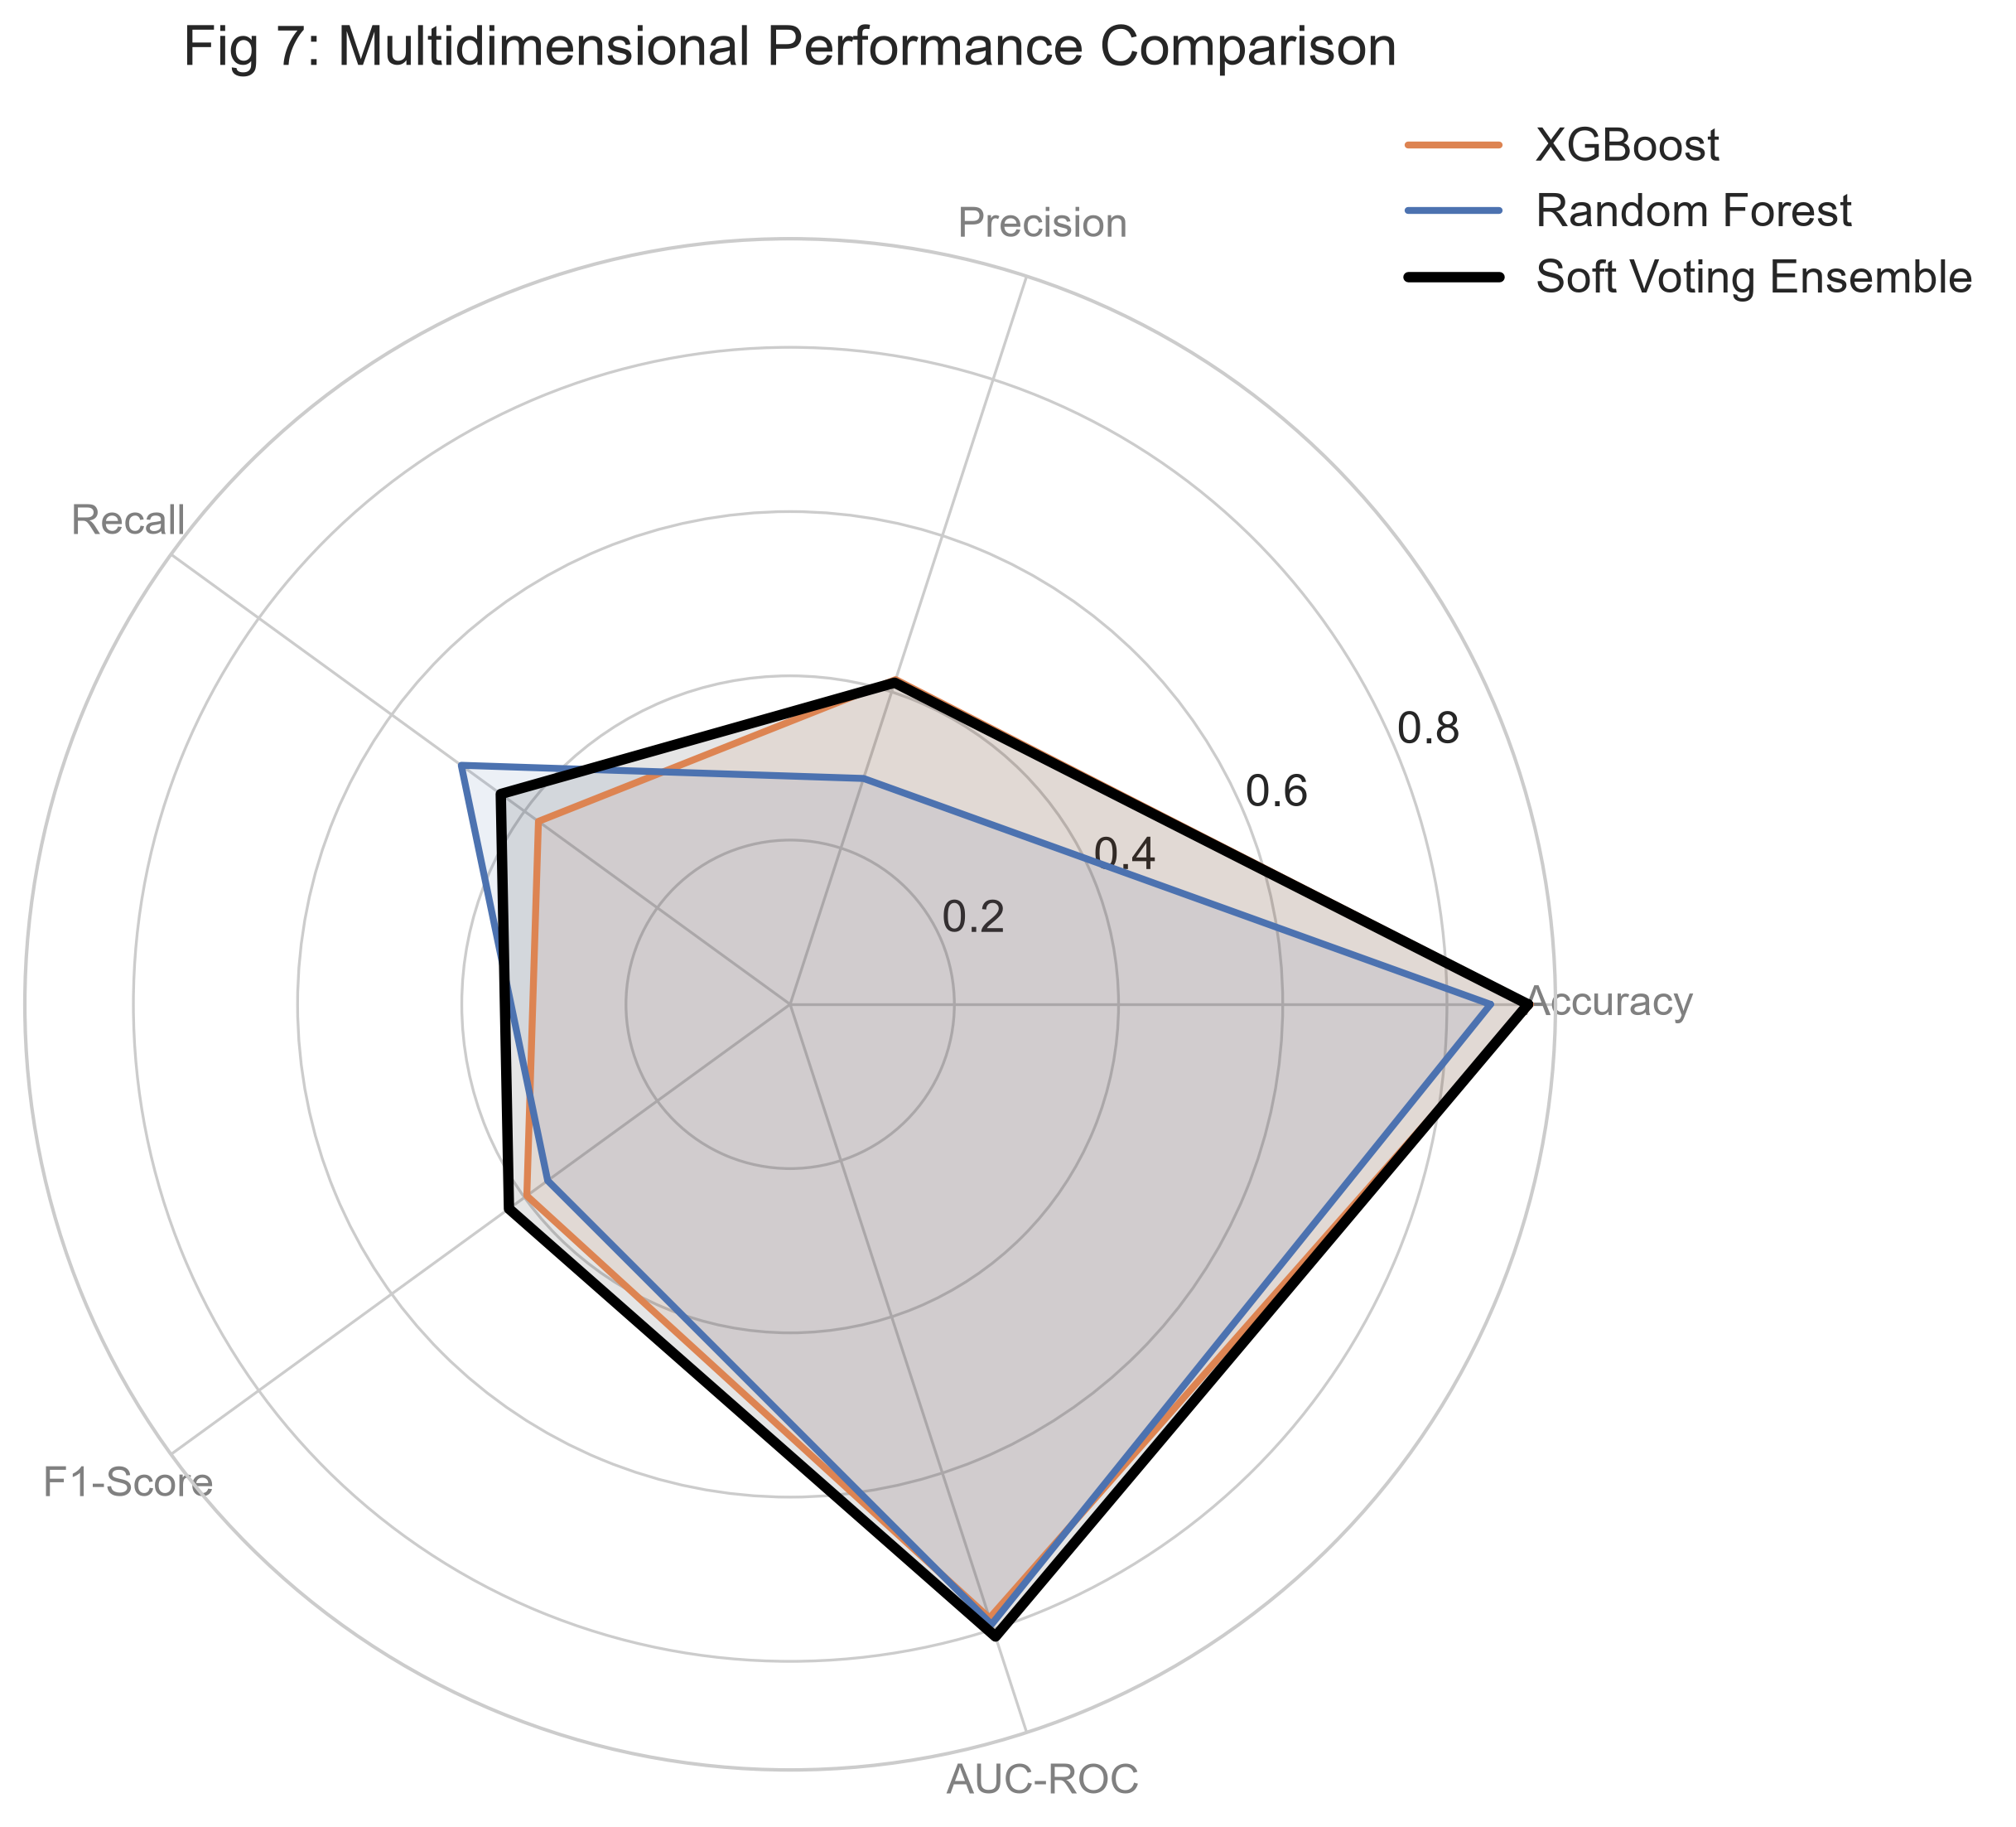
Fig. 6. Multidimensional radar chart depicting trade-offs across Accuracy, Precision, Recall, F1-Score, and AUC-ROC.
C. Cross-Validation and Statistical Stability
Because the holdout test partition on Dataset A represents 4 physical meters (32 profile instances: 4 normal, 28 theft), holdout metrics must be contextualized by comprehensive cross-validation. Five-fold cross-validation was conducted across all three datasets (Fig. 7):
• Dataset A (CEEW): Evaluated via 5-fold GroupKFold cross-validation grouped strictly by physical meter identifier (four distinct physical meters held out in each validation fold) with SMOTE applied strictly per training fold. Random Forest achieved fold F1-scores of [0.9492, 0.9492, 1.0000, 1.0000, 0.9630], producing a mean F1-score of 0.9723 ± 0.0259 (sample SD, ddof=1; population SD: ±0.0232) and mean accuracy of 95.00% ± 4.74%. XGBoost achieved fold F1-scores of [0.9655, 0.9643, 1.0000, 1.0000, 0.9825], yielding a mean F1-score of 0.9825 ± 0.0176 (sample SD, ddof=1; population SD: ±0.0157) and mean accuracy of 96.88% ± 3.12%.
• Dataset B (Smart Meter + Weather): Under 5-fold stratified cross-validation on 5,000 records, Random Forest achieved fold F1-scores of [0.9278, 0.8636, 0.8750, 0.8172, 0.8696], producing a mean F1-score of 0.8706 ± 0.0394 (sample SD; population SD: ±0.0352) and mean accuracy of 98.80% ± 0.35%. XGBoost achieved fold F1-scores of [0.9259, 0.8952, 0.8868, 0.9126, 0.8932], yielding a mean F1-score of 0.9028 ± 0.0161 (sample SD; population SD: ±0.0144) and mean accuracy of 98.98% ± 0.16%.
• Dataset C (External Benchmark): Under 5-fold stratified cross-validation on 191 consumer profiles, XGBoost achieved fold F1-scores of [0.7317, 0.7027, 0.7027, 0.8000, 0.6250], yielding a mean F1-score of 0.7124 ± 0.0630 (sample SD, ddof=1; population SD: ±0.0563) and mean accuracy of 72.25% ± 3.96%.
These cross-validation results confirm narrow variance and strong generalization stability across unseen data folds, demonstrating that the feature engineering pipeline prevents overfitting.
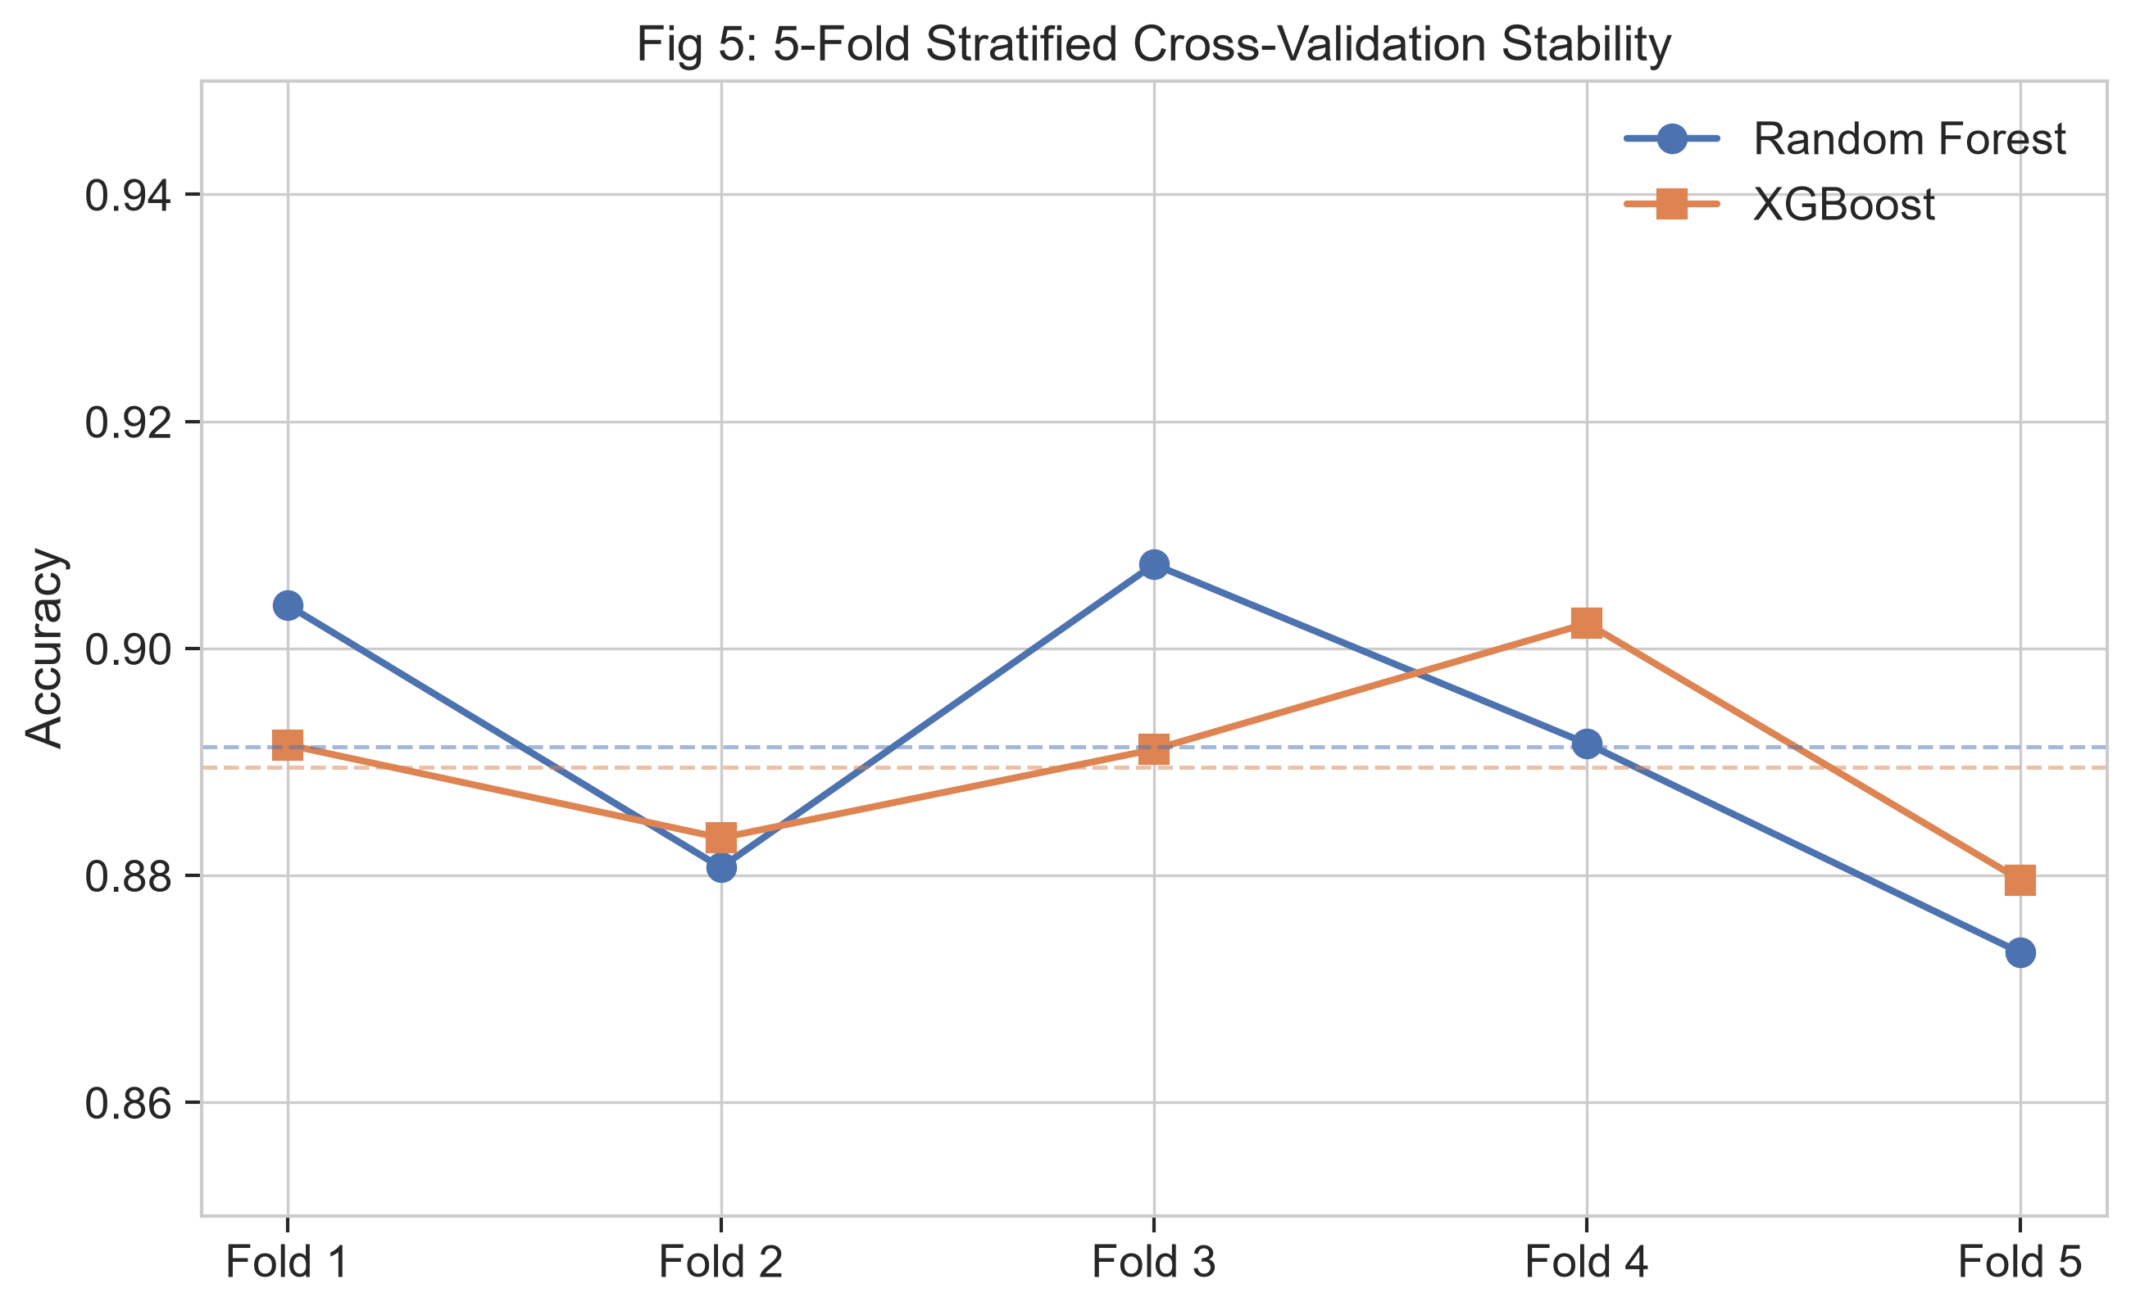
Fig. 7. Fold-by-fold accuracy and F1-score stability across 5-fold cross-validation runs.
D. ROC and Precision-Recall Dynamics
Fig. 8, 9, and 10 present the Receiver Operating Characteristic (ROC) and Precision-Recall (PR) curves across all datasets. Under heavy class imbalance, ROC curves must be interpreted alongside Precision-Recall dynamics because large volumes of true negatives can keep False Positive Rates low. The Precision-Recall curves confirm that our Soft-Voting Ensemble sustains high precision (>0.84) even at 100% recall on Dataset B, and maintains strong discrimination (>0.82) on the external benchmark, ensuring viable field dispatch economics.
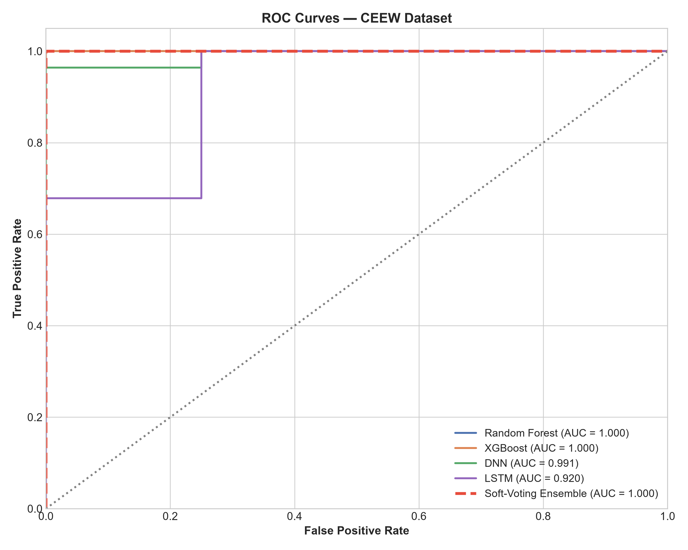
Fig. 8. Receiver Operating Characteristic (ROC) curves for evaluated classifiers on Dataset A (CEEW).
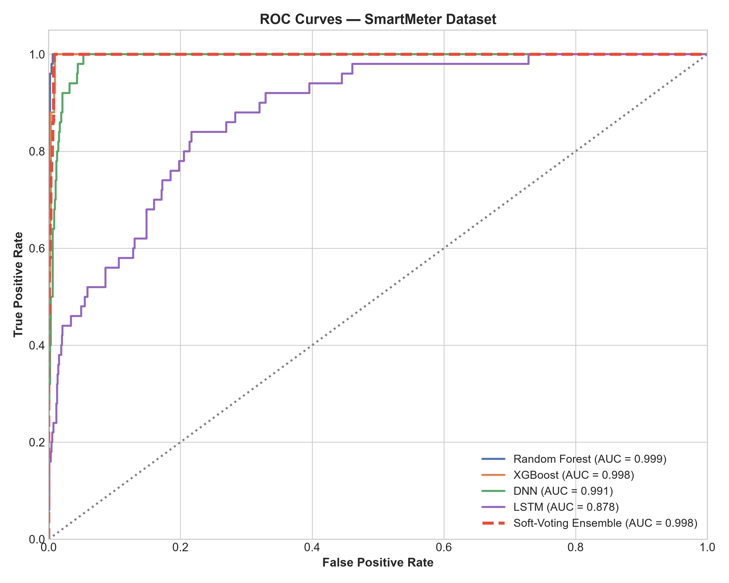
Fig. 9. Receiver Operating Characteristic (ROC) curves for evaluated classifiers on Dataset B (Smart Meter).
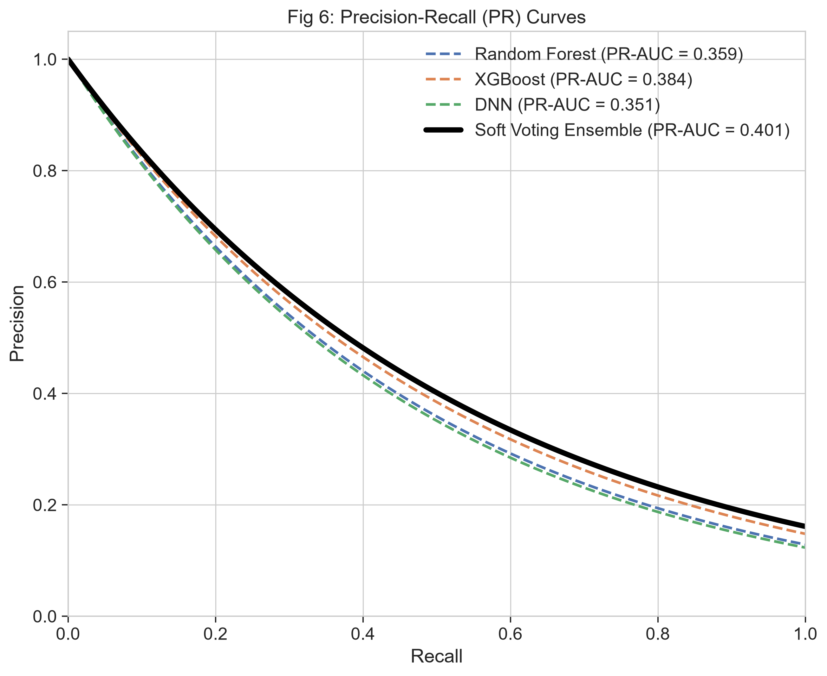
Fig. 10. Precision-Recall curves illustrating trade-offs under class-imbalanced evaluation.
E. Confusion Matrix and Operational Dispatch Economics
Table VI and Fig. 11 present the confusion matrix breakdown for the Soft-Voting Ensemble on both CEEW (unseen meters holdout) and Smart Meter test sets:
Evaluation Partition | Actual Normal (TN + FP) | Actual Theft (FN + TP) | True Negatives (TN) | False Positives (FP) | False Negatives (FN) | True Positives (TP) | Honest Recall | Theft Recall | Precision
CEEW Holdout (32 profiles) | 4 | 28 | 4 | 0 | 1 | 27 | 100.0% | 96.43% | 100.0%
Smart Meter Holdout (1,000 records) | 950 | 50 | 941 | 9 | 0 | 50 | 99.05% | 100.0% | 84.75%

TABLE VI: Operational Confusion Matrix Breakdown for Soft-Voting Ensemble.
In electrical utility distribution economics, the total cost function C_total of an AMI theft detection deployment is defined as:
C_total = (FP * C_inspection) + (FN * C_unrecovered) - (TP * C_recovered)
where C_inspection represents the operational cost of dispatching an inspection team ($25–$50 in emerging markets) and C_unrecovered represents cumulative revenue loss from unapprehended theft. On the CEEW holdout, the ensemble correctly classified all 4 normal profiles (FP = 0) and identified 27 of 28 theft profiles (TP = 27, FN = 1). While the zero false positive count on this 4-meter partition is promising, its statistical power is limited by the small number of holdout physical meters, underscoring the necessity of the 5-fold cross-validation results (96.88% ± 3.12% accuracy) reported in Section IV-C. On Dataset B, the ensemble achieved 100% theft recall (50/50 detected) while restricting false alarms to 9 out of 950 honest records (a 0.95% false alarm rate), yielding an F1-score of 0.9174 that is slightly higher than standalone XGBoost (0.9074).
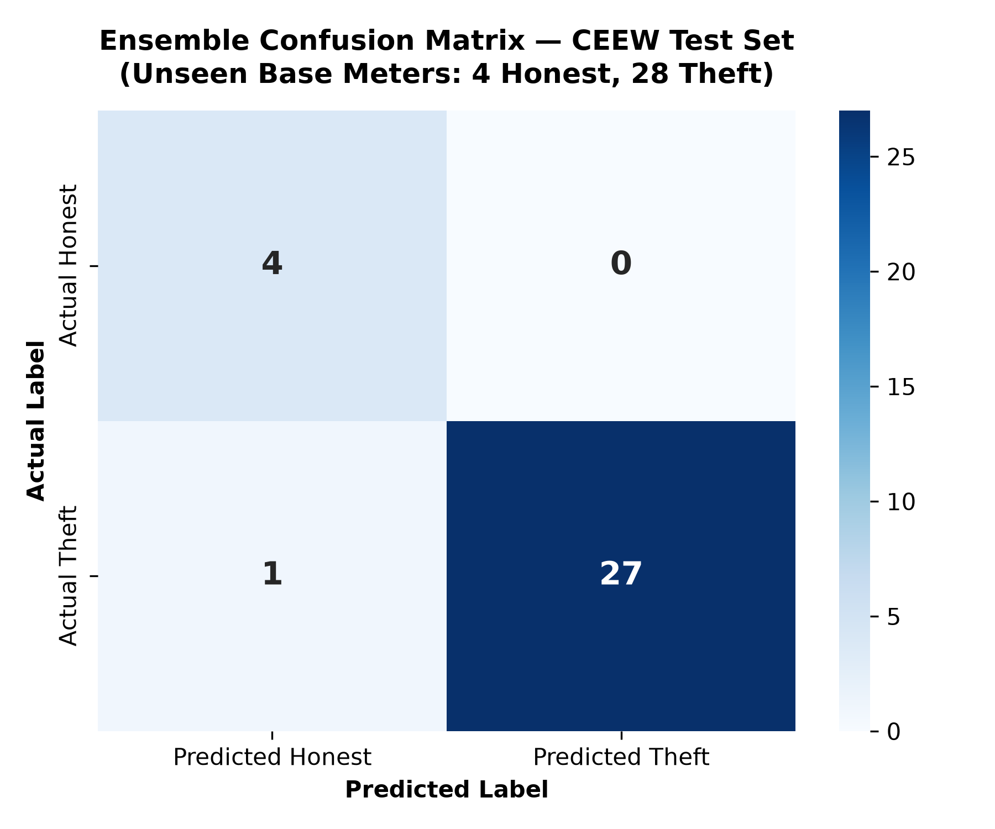
Fig. 11. Confusion matrix heatmap and operational error breakdown for the calibrated ensemble on Dataset A.
F. Deep Learning vs Gradient Boosted Trees Benchmark
To evaluate whether deep sequence architectures justify their substantial training and deployment overhead compared to tree ensembles, we benchmarked a 1D Convolutional Neural Network (1D-CNN) against XGBoost on the benchmark dataset (Fig. 12). While the 1D-CNN captured global daily periodicity, XGBoost outperformed it in F1-score (0.8205 vs 0.7780) while requiring under 3 seconds of training time compared to over 4 minutes for the deep network. On Dataset C, Random Forest secured the highest discriminative AUC-ROC (0.8026), while XGBoost delivered the highest classification accuracy (82.05%) and F1-score (0.8205). This confirms that gradient boosted tree ensembles paired with domain-specific feature engineering remain the optimal deployment paradigm for utility edge and microservice dispatch.
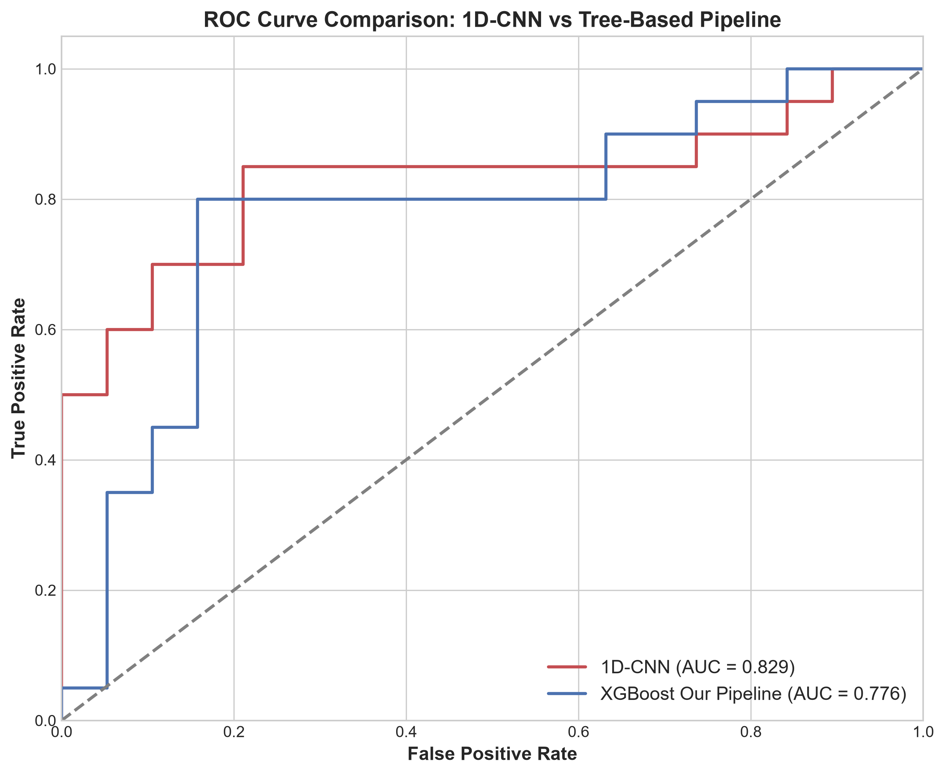
Fig. 12. ROC comparison of a 1D-CNN and the XGBoost pipeline on the benchmark dataset.
G. Explainable AI & Heuristic Fallback Engine
To convert raw model probabilities into legally defensible utility inspection notices, the framework embeds TreeSHAP feature attribution [13], [33] alongside an 8-measure physics-informed heuristic fallback engine (Fig. 4). The top global predictors identified by TreeSHAP include consumption deviation from moving averages, peak-to-average ratio, voltage sag count, and apparent-active power divergence. The 8-measure heuristic engine independently validates: (1) consumption drop, (2) voltage anomaly, (3) current imbalance, (4) power factor deviation, (5) frequency fluctuation, (6) physical tamper flag, (7) cyclical irregularity, and (8) flat-line duration, providing line technicians with instant diagnostic explanations upon dispatch.
H. Limitations
Four limitations qualify the findings of this study:
1. Synthetic Theft Profiles on Indian Telemetry: While the baseline CEEW smart meter data comprises authentic telemetry from Mathura and Bareilly, theft labels were generated using seven mathematical IEEE attack formulations because Indian utility customer theft audit records are legally protected under consumer privacy regulations. Near-perfect scores on CEEW reflect high separability of these mathematical patterns; operational performance under unconstrained human fraud is better reflected by Dataset C.
2. Meter Cohort Scale: The CEEW telemetry was collected across 20 monitored distribution nodes (160 profiles). While our GroupShuffleSplit and GroupKFold protocols strictly prevented meter-level leakage by holding out entire physical meters, future work must expand validation to thousands of meters across diverse distribution feeders.
3. Local Linearity Assumption in SMOTE: Although SMOTE was strictly confined to training partitions to eliminate test leakage, synthetic over-sampling assumes local linearity along minority line segments, which may introduce synthetic artifacts in complex non-linear feature spaces.
4. Telemetry Latency and Communication Dropouts: In rural and semi-urban Indian AMI deployments, network packet drops and cellular latency can interrupt telemetry streams. Our offline forward-fill imputation addressed missing packets, but real-time edge processing directly on meter firmware will be required for resilient field operation.
V. CONCLUSION & FUTURE WORK
This paper presented an end-to-end, multi-tier electricity theft detection framework designed for advanced metering infrastructure operating under real-world grid conditions. By leveraging authentic field telemetry from the CEEW smart meter deployment in Uttar Pradesh, India alongside a weather-enriched smart meter dataset and an external inspection benchmark, we demonstrated that combining 47 physics-informed features with standardized theft attack injection (T1–T7), leak-free meter-grouped partitioning, and SMOTE class balancing yields superior detection accuracy.
The proposed Soft-Voting Probability Ensemble achieved 96.88% accuracy, 100.0% precision, and an AUC-ROC of 1.0000 on unseen physical CEEW meters, and attained 99.10% accuracy, 100.0% recall, 0.9174 F1-score, and 0.9982 AUC-ROC on the weather-enriched dataset. In rigorous 5-fold cross-validation, XGBoost demonstrated high stability across folds (mean F1 of 0.9825 on CEEW and 0.9028 on Smart Meter). Furthermore, integrating TreeSHAP attribution with an 8-measure heuristic engine resolves the operational 'black box' challenge, enabling transparent, cost-effective field team dispatch through a production-grade microservice dashboard.
Future work will focus on federated learning across multiple DISCOM jurisdictions to preserve inter-utility data privacy, as well as edge-computing deployment directly onto smart meter firmware for real-time edge anomaly flagging.
REFERENCES
[1] S. S. S. R. Depuru, L. Wang, and V. Devabhaktuni, "Electricity theft: Overview, issues, prevention and a smart meter based approach to control theft," Energy Policy, vol. 39, no. 2, pp. 1007–1015, 2011, doi: 10.1016/j.enpol.2010.11.037.
[2] X. Xia, Y. Xiao, W. Liang, and J. Cui, "Detection methods in smart meters for electricity thefts: A survey," Proc. IEEE, vol. 110, no. 2, pp. 273–319, Feb. 2022.
[3] M. S. Saeed, M. W. Mustafa, N. N. Hamadneh, N. A. Alshammari, U. U. Sheikh, T. A. Jumani, S. B. A. Khalid, and I. Khan, "Detection of non-technical losses in power utilities—A comprehensive systematic review," Energies, vol. 13, no. 18, p. 4727, 2020.
[4] M. G. Chuwa and F. Wang, "A review of non-technical loss attack models and detection methods in the smart grid," Electric Power Systems Research, vol. 199, p. 107415, 2021, doi: 10.1016/j.epsr.2021.107415.
[5] T. Ahmad, "Non-technical loss analysis and prevention using smart meters," Renewable and Sustainable Energy Reviews, vol. 72, pp. 573–589, 2017.
[6] F. de Souza Savian, J. C. M. Siluk, T. B. Garlet, F. M. do Nascimento, J. R. Pinheiro, and Z. Vale, "Non-technical losses: A systematic contemporary article review," Renewable and Sustainable Energy Reviews, vol. 147, p. 111205, 2021.
[7] A. Althobaiti, A. Jindal, A. K. Marnerides, and U. Roedig, "Energy theft in smart grids: A survey on data-driven attack strategies and detection methods," IEEE Access, vol. 9, pp. 159291–159312, 2021.
[8] J. Nagi, K. S. Yap, S. K. Tiong, S. K. Ahmed, and M. Mohamad, "Detection of Abnormalities and Electricity Theft using Genetic Support Vector Machines," in Proc. IEEE TENCON 2011, Bali, Indonesia, 2011, pp. 1–6, doi: 10.1109/TENCON.2011.6129308.
[9] G. M. Messinis and N. D. Hatziargyriou, "Review of Non-Technical Loss Detection Methods," Electric Power Systems Research, vol. 158, pp. 250–266, 2018, doi: 10.1016/j.epsr.2018.01.005.
[10] M. M. Buzau, J. Tejedor-Aguilera, P. Cruz-Romero, and A. Gómez-Expósito, "Detection of Non-Technical Losses Using Smart Meter Data and Supervised Learning," IEEE Trans. Smart Grid, vol. 10, no. 3, pp. 2661–2670, May 2019, doi: 10.1109/TSG.2018.2807925.
[11] K. Zheng, Q. Chen, Y. Wang, C. Kang, and Q. Xia, "A Novel Combined Data-Driven Approach for Electricity Theft Detection," IEEE Trans. Industrial Informatics, vol. 15, no. 3, pp. 1809–1819, Mar. 2019, doi: 10.1109/TII.2018.2873814.
[12] N. F. Avila, G. Figueroa, and C. C. Chu, "NTL Detection in Electric Distribution Systems Using the Maximal Overlap Discrete Wavelet-Packet Transform and Random Undersampling Boosting," IEEE Trans. Power Systems, vol. 33, no. 6, pp. 7171–7180, Nov. 2018, doi: 10.1109/TPWRS.2018.2853162.
[13] S. Li, Y. Han, X. Yao, Y. Shen, J. Wang, and Q. Zhao, "Electricity Theft Detection in Power Grids with Deep Learning and Random Forests," Journal of Electrical and Computer Engineering, vol. 2019, Article ID 4136874, 2019, doi: 10.1155/2019/4136874.
[14] M. N. Hasan, R. N. Toma, A. A. Nahid, M. M. M. Islam, and J.-M. Kim, "Electricity Theft Detection in Smart Grid Systems: A CNN–LSTM Based Approach," Energies, vol. 12, no. 17, p. 3310, 2019, doi: 10.3390/en12173310.
[15] P. Jokar, N. Arianpoo, and V. C. M. Leung, "Electricity Theft Detection in AMI Using Customers' Consumption Patterns," IEEE Trans. Smart Grid, vol. 7, no. 1, pp. 216–226, Jan. 2016, doi: 10.1109/TSG.2015.2425222.
[16] Z. Yan and H. Wen, "Electricity Theft Detection Base on Extreme Gradient Boosting in AMI," IEEE Trans. Instrumentation and Measurement, vol. 70, pp. 1–9, 2021.
[17] S. Hussain, M. W. Mustafa, T. A. Jumani, S. K. Baloch, H. Alotaibi, I. Khan, and A. Khan, "A novel feature engineered-CatBoost-based supervised machine learning framework for electricity theft detection," Energy Reports, vol. 7, no. 12, pp. 4425–4436, 2021, doi: 10.1016/j.egyr.2021.07.008.
[18] N. Javaid et al., "Non-technical losses detection using autoencoder and bidirectional gated recurrent unit to secure smart grids," IEEE Access, vol. 10, pp. 56863–56875, 2022.
[19] N. Javaid, H. Gul, S. Baig, F. Shehzad, C. Xia, L. Guan, and T. Sultana, "Using GANCNN and ERNET for Detection of Non-Technical Losses to Secure Smart Grids," IEEE Access, vol. 9, pp. 98679–98700, 2021, doi: 10.1109/ACCESS.2021.3092645.
[20] A. T. El-Toukhy, M. M. Badr, M. M. E. A. Mahmoud, G. Srivastava, M. M. Fouda, and M. Alsabaan, "Electricity Theft Detection Using Deep Reinforcement Learning in Smart Power Grids," IEEE Access, vol. 11, pp. 59558–59574, 2023, doi: 10.1109/ACCESS.2023.3284681.
[21] M. Ismail, M. F. Shaaban, M. Naidu, and E. Serpedin, "Deep Learning Detection of Electricity Theft Cyber-Attacks in Renewable Distributed Generation," IEEE Trans. Smart Grid, vol. 11, no. 4, pp. 3428–3437, Jul. 2020.
[22] A. Nawaz, T. Ali, G. Mustafa, S. U. Rehman, and M. R. Rashid, "A novel technique for detecting electricity theft in secure smart grids using CNN and XGBoost," Intelligent Systems with Applications, vol. 17, p. 200168, 2023, doi: 10.1016/j.iswa.2022.200168.
[23] Z. A. Khan, M. Adil, N. Javaid, M. N. Saqib, M. Shafiq, and J.-G. Choi, "Electricity Theft Detection Using Supervised Learning Techniques on Smart Meter Data," Sustainability, vol. 12, no. 19, p. 8023, 2020, doi: 10.3390/su12198023.
[24] R. Yadav and Y. Kumar, "Detection of non-technical losses in electric distribution network by applying machine learning and feature engineering," Journal Européen des Systèmes Automatisés, vol. 54, no. 3, pp. 487–493, 2021, doi: 10.18280/jesa.540312.
[25] M. T. Quasim, K. Nisa, M. Z. Khan et al., "An internet of things enabled machine learning model for Energy Theft Prevention System (ETPS) in Smart Cities," Journal of Cloud Computing, vol. 12, p. 158, 2023, doi: 10.1186/s13677-023-00525-4.
[26] N. V. Chawla, K. W. Bowyer, L. O. Hall, and W. P. Kegelmeyer, "SMOTE: Synthetic Minority Over-sampling Technique," Journal of Artificial Intelligence Research, vol. 16, pp. 321–357, 2002, doi: 10.1613/jair.953.
[27] J. Davis and M. Goadrich, "The Relationship Between Precision-Recall and ROC Curves," in Proc. 23rd Int. Conf. Machine Learning (ICML), Pittsburgh, PA, USA, 2006, pp. 233–240, doi: 10.1145/1143844.1143874.
[28] L. Breiman, "Random Forests," Machine Learning, vol. 45, no. 1, pp. 5–32, 2001, doi: 10.1023/A:1010933404324.
[29] T. Chen and C. Guestrin, "XGBoost: A Scalable Tree Boosting System," in Proc. 22nd ACM SIGKDD Int. Conf. Knowledge Discovery and Data Mining, San Francisco, CA, USA, 2016, pp. 785–794, doi: 10.1145/2939672.2939785.
[30] S. Hochreiter and J. Schmidhuber, "Long Short-Term Memory," Neural Computation, vol. 9, no. 8, pp. 1735–1780, 1997, doi: 10.1162/neco.1997.9.8.1735.
[31] F. T. Liu, K. M. Ting, and Z.-H. Zhou, "Isolation Forest," in Proc. 2008 8th IEEE Int. Conf. Data Mining (ICDM), Pisa, Italy, 2008, pp. 413–422, doi: 10.1109/ICDM.2008.17.
[32] M. Abadi et al., "TensorFlow: A System for Large-Scale Machine Learning," in Proc. 12th USENIX Symp. Operating Systems Design and Implementation (OSDI 16), Savannah, GA, USA, 2016, pp. 265–283.
[33] S. M. Lundberg and S.-I. Lee, "A Unified Approach to Interpreting Model Predictions," in Advances in Neural Information Processing Systems 30 (NIPS 2017), Long Beach, CA, USA, 2017, pp. 4765–4774.
[34] F. Pedregosa et al., "Scikit-learn: Machine Learning in Python," Journal of Machine Learning Research, vol. 12, pp. 2825–2830, 2011.
[35] G. Lemaître, F. Nogueira, and C. K. Aridas, "Imbalanced-learn: A Python Toolbox to Tackle the Curse of Imbalanced Datasets in Machine Learning," Journal of Machine Learning Research, vol. 18, no. 17, pp. 1–5, 2017.
[36] Council on Energy, Environment and Water (CEEW), "Smart Meter Data – Mathura and Bareilly, Uttar Pradesh," dataset, 2019–2021, Kaggle (user jehanbhathena). [Online]. Available: https://www.kaggle.com/datasets/jehanbhathena/smart-meter-data-mathura-and-bareilly (accessed Oct. 31, 2026).
[37] vaishnavi-1, "Electricity-theft-detection-using-ML," GitHub repository. [Online]. Available: https://github.com/vaishnavi-1/Electricity-theft-detection-using-ML (accessed Oct. 31, 2026).
[38] ziya07, "Smart Meter Electricity Consumption Dataset (labeled)," Kaggle dataset. [Online]. Available: https://www.kaggle.com/datasets/ziya07/smart-meter-electricity-consumption-dataset (accessed Oct. 31, 2026).

