Real-Time Log Monitoring System
Project Report
Author: Aman Dubey

1. Introduction
This project implements an end-to-end real-time log monitoring platform using Apache Kafka, Apache Spark Structured Streaming, PostgreSQL, Grafana, Docker, and Apache Airflow. Nginx access logs are streamed through Kafka, processed in Spark, stored in PostgreSQL, visualized in Grafana, and scheduled jobs are managed using Airflow.

2. Objectives
- Process logs in real time
- Detect HTTP errors
- Generate operational analytics
- Store processed data
- Visualize metrics
- Automate daily reporting

3. Technology Stack
Python, Apache Kafka, Apache Spark Structured Streaming, PostgreSQL, Grafana, Apache Airflow, Docker, Nginx

4. Database Design
Tables:
- access_logs
- error_logs
- top_ips
- top_endpoints
- requests_per_minute
- errors_per_minute
- alerts
- daily_summary

5. Architecture
Flow:
Nginx -> Python Producer -> Kafka -> Spark Structured Streaming -> Transformations & Alerts -> PostgreSQL -> Grafana
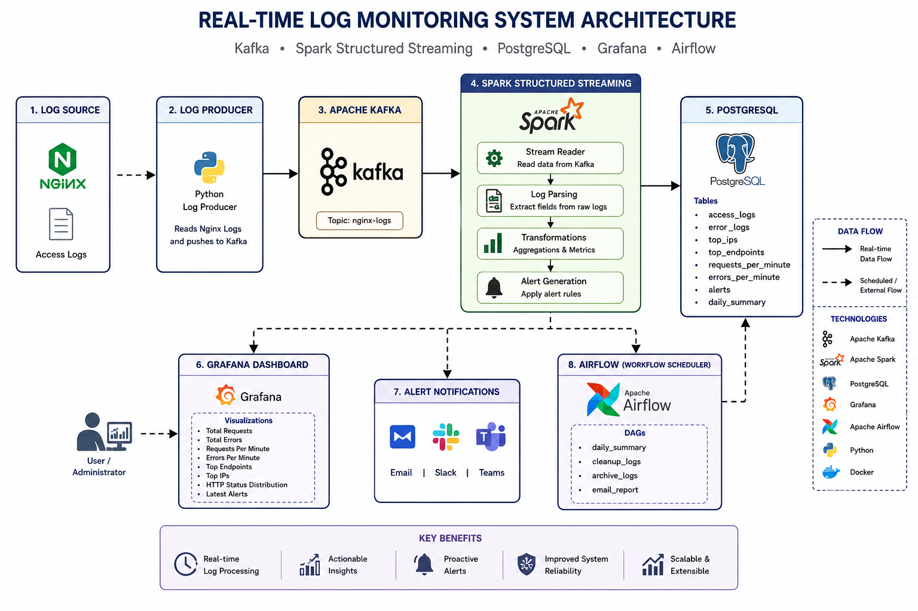

Airflow performs scheduled jobs such as daily summaries, cleanup, archive and reporting.

6. Spark Processing
Spark consumes Kafka messages, parses Nginx logs, extracts fields (IP, timestamp, endpoint, method, status, bytes, referer, user agent), performs aggregations, detects errors and writes results to PostgreSQL.

7. Analytics
Top IPs
Top Endpoints
Requests Per Minute
Errors Per Minute
HTTP Error Analysis
Alert Generation

8. Grafana Dashboard
Dashboard panels include Total Requests, Total Errors, Active Alerts, Top IPs, Top Endpoints, Requests/Minute, Errors/Minute and Latest Alerts.

9. Airflow
DAGs:
- daily_summary
- cleanup_logs
- archive_logs
- email_report
These execute scheduled batch operations while Spark Streaming continues running independently.

10. Challenges
- Kafka networking
- Spark Kafka connector
- Docker networking
- PostgreSQL connectivity
- Structured Streaming checkpoints
- Airflow connectivity

11. Future Enhancements
- Slack/Teams notifications
- ELK integration
- Prometheus metrics
- Kubernetes deployment
- AWS deployment
- ML anomaly detection

12. Conclusion
The project demonstrates a complete streaming data engineering pipeline using industry-standard tools. It showcases ingestion, processing, storage, visualization, and orchestration suitable for production-inspired monitoring systems.

