LINUX EXERCISE

1.
a. echo “hello world”
Sol:- echo "helloworld"

b.List all the files(hidden included) present in the current directory in long format
displaying files in reverse order , sorted based on the modification time .
Sol:- ls -a

c. Change your current password.
Sol:- passwd

d. How to get the current date
Sol:- date

e. How to get the current logged in user
Sol:- whoami

f. How to get the current working directory.
Sol:- pwd

g. How to get the list of all commands that you have typed so far
Sol:- history

h. To get the information on the tcp ports
Sol:- netstat

i. To get the information about the running processes.
Sol:- ps aux

j. Search for a word in a file. (Hint grep)
Sol:- grep "aman" filename , where grep is command name,aman is a word to be search and file name is a name of file in which we do search that word..

k. Search for a specific process. (Hint use | with ps )
Sol:- ps ax | grep terminal

2. Create a directory “exercises” inside your home directory . ​ cd​ to this new directory.
Sol:- mkdir exercise
cd exercise

3. Create 3 empty files , file1.txt,file2.txt,file3.txt in current directory (exercises).
Sol:- touch file1, vi file1
touch file2,vi file2
touch file3,vi file3

4. Add some text to file1.txt and copy this to ~/exercises/files
Sol:- cp file.txt files ,where file1.txt is copying into files folder.

5. Copy the entire exercise directory to this files
directory.
Sol:- cp -r exercise file

6. Create a symlink “testlink” in your home directory that points to this file1.txt i.e.
~/exercises/files/file1.txt.
Sol:- ln -s file1.txt testlink

7. Try creating a hard link in your home directory that points to “files” directory .
Sol:-

8. Difference between soft and hard link.
Sol:- Hard link vs. Soft link in Linux or UNIX
- Hard links cannot link directories.
- Cannot cross file system boundaries.
Soft or symbolic links are just like hard links. It allows to associate multiple filenames with a single file. However, symbolic links allows:
- To create links between directories.
- Can cross file system boundaries.
These links behave differently when the source of the link is moved or removed.
- Symbolic links are not updated.
Hard links always refer to the source, even if moved or removed.

9. Change permissions for files directory such that nobody other than the user who created the directory, can write/update anything in that directory.
Sol:- chmod 744 files

10:- Create a new user “test”.
Sol:- sudo adduser test

11:- Change the owner of file1.txt to test
Sol:-

12. create following directory structure with single command -
home
|-john
| -work
|-scripts
|-bash

Assume that you are currently in ‘home’ directory.
Sol:- mkdir -p ~/john/work/scripts/bash

13. Try deleting the ~/exercises/files/exercises directory. See what happens.
Sol:-
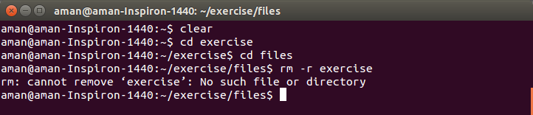

14:- A file named employees.odt has a mode of rw-r--r-- If John is not the file's owner but
is a member of the group that owns this file, what can he do with it?
Sol:- John can read this file only.

15:- Create an alias for clearing the screen.
Sol:- alias cls=clear, where cls is a new alias name of clear command.

16:- Create a tar archive of all the files in the current directory.
Sol:- tar -cvf exer.tar /home/aman/exercise

17:-How to find if a jar file contains a particular class file?
Sol:-

18:- How to find all jars with given classname.
Sol:-

19:- How to find files greater than a certain size
Sol:- find ~ -size +20M

20:- How do u add and remove a variable in the shell environment.
Sol:-

21:-Install openssh-server on your system
Sol:- sudo apt-get install openssh-server

