

|  |
| --- |
| CAPSTONE MODULE-2  D |
| Dr. Uzair Ahmad |
| October 263,2020  Credit Risk Analysis  Submitted by: Mohammed Imran (100805394)   Aman Verma (100799391) |

Contents

1. Problem Statement 3

2. Data Acquisition 3

3. Exploratory Data Analysis 4

4. Model Selection 8

5. Summary 8

## Problem Statement

Many people struggle to get loans due to insufficient or non-existent credit histories. And, unfortunately, this population is often taken advantage of by untrustworthy lenders.



Home Credit strives to broaden financial inclusion for the unbanked population by providing a positive and safe borrowing experience. In order to make sure this underserved population has a positive loan experience; Home Credit makes use of a variety of alternative data--including telco and transactional information--to predict their clients' repayment abilities.

## Data Acquisition

The below dataset is being used to create a model which has been acquired from Kaggle.

2.1 Data Requirements

Application and previous history is required for model building. The labels are included in the training data and train a model to predict the labels from the features. Details of the data required are as follows

2.2 Data Preparation

Application Data {train test):

Static data for all applications. One row represents one loan in our data sample.

Bureau:

All client's previous credits history from credit

Transaction and Balances:

Customer credit transaction details from various channels like POS, cash Loans, and Credit cards.

Credit Card Balances:

Credit card monthly balances. Previous applications:

All previous applications for Credit loans of clients who have loans in our sample.

Repayment history:

For the previously disbursed credits in Credit related to the loans in our sample.

**note that all of the above have multiple features in file.

## 3. Exploratory Data Analysis

Exploratory Data Analysis (EDA) is an open-ended process where we calculate statistics and make figures to find trends, anomalies, patterns, or relationships within the data. The goal of EDA is to learn what our data can tell us. It generally starts out with a high-level overview, then narrows in to specific areas as we find intriguing areas of the data. The findings may be interesting in their own right, or they can be used to inform our modeling choices, such as by helping us decide which features to use.

## 3.1 Approach

The steps to be conducted for the EDA are: -

* To get an overview of the summary statistics of the data first need to retrieve the data.
* Examine the Distribution of the Target Column; The target is what we are asked to predict: either a 0 for the loan was repaid on time, or a 1 indicating the client had payment difficulties. We can first examine the number of loans falling into each category.
* Examine Missing Values; we can look at the number and percentage of missing values in each column. When it comes time to build our machine learning models, we will have to fill in these missing values (known as imputation).
* Column Types; Let's look at the number of columns of each data type; int64 and float64 are numeric variables (which can be either discrete or continuous). object columns contain strings and are categorical features.
* Encoding Categorical Variables; Before we go any further, we need to deal with pesky categorical variables. A machine learning model unfortunately cannot deal with categorical variables (except for some models such as LightGBM). Therefore, we have to find a way to encode (represent) these variables as numbers before handing them off to the model. There are two main ways to carry out this process:

## 3.2 Dataset – insights and cleaning

3.2.1 Numbers of feature in Train and Test dataset

app_train.shape

(307511, 122)

app_test.shape

(48744, 121)

### 3.2.2 Target Column Distribution¶

0 282686

1 24825

Name: TARGET, dtype: int64

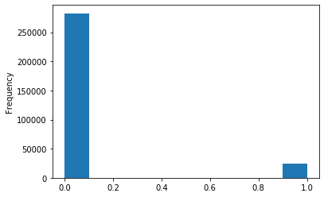

*Observation: Dataset is imbalance*

3.2.3 Missing – Null values

AMT_REQ_CREDIT_BUREAU_DAY 12.409732

AMT_REQ_CREDIT_BUREAU_WEEK 12.409732

AMT_REQ_CREDIT_BUREAU_MON 12.409732

AMT_REQ_CREDIT_BUREAU_QRT 12.409732

AMT_REQ_CREDIT_BUREAU_YEAR 12.409732

*Observations: 12 – 13 values are missing in some of the features in train and test set.*

3.2.4 Column Types

float64 65

int64 41

object 16

dtype: int64

*Observations: 16 column are object type , those have non number data set.*

3.2.5 Categorical feature and distinct classes in each feature

NAME_CONTRACT_TYPE 2

CODE_GENDER 3

FLAG_OWN_CAR 2

FLAG_OWN_REALTY 2

NAME_TYPE_SUITE 7

NAME_INCOME_TYPE 8

NAME_EDUCATION_TYPE 5

NAME_FAMILY_STATUS 6

NAME_HOUSING_TYPE 6

OCCUPATION_TYPE 18

WEEKDAY_APPR_PROCESS_START 7

ORGANIZATION_TYPE 58

FONDKAPREMONT_MODE 4

HOUSETYPE_MODE 3

WALLSMATERIAL_MODE 7

EMERGENCYSTATE_MODE 2

dtype: int64

## 3.3 Encoding

1. Label encoding: assign each unique category in a categorical variable with an integer. No new columns are created. An example is shown below

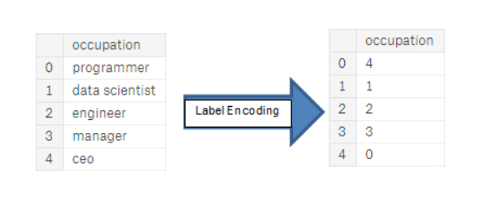

1. One-hot encoding: create a new column for each unique category in a categorical variable. Each observation receives a 1 in the column for its corresponding category and a 0 in all other new columns.

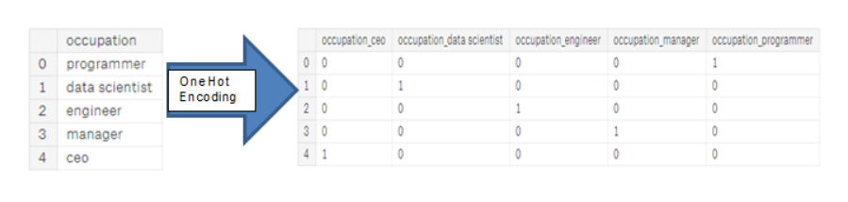

### Frequency Encoding : we will used frequency encoding as One hot is not suitable for Decision trees and Random Forest

## **3.**4 Anomalies

## 

### *Observations : Employed for 365243 days , too many year!!**¶*

*Feature engineering the employment days , 365243 = 0*

count 252137.000000

mean -2384.169325

std 2338.360162

min -17912.000000

25% -3175.000000

50% -1648.000000

75% -767.000000

max 0.000000

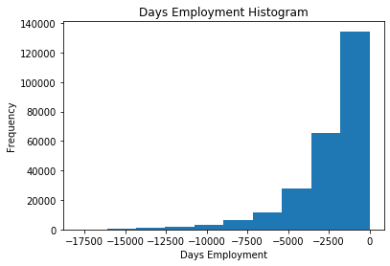

** - ve count backwards from current date

## 3.5 Feature Selection / Importance with Target

### 3.5.1 Correlations¶

Correlation give a general idea about target variable relationship with other features.

Most Positive Correlations:

OCCUPATION_TYPE_Laborers 0.043019

FLAG_DOCUMENT_3 0.044346

REG_CITY_NOT_LIVE_CITY 0.044395

FLAG_EMP_PHONE 0.045982

NAME_EDUCATION_TYPE_Secondary / secondary special 0.049824

REG_CITY_NOT_WORK_CITY 0.050994

DAYS_ID_PUBLISH 0.051457

CODE_GENDER_M 0.054713

DAYS_LAST_PHONE_CHANGE 0.055218

NAME_INCOME_TYPE_Working 0.057481

REGION_RATING_CLIENT 0.058899

REGION_RATING_CLIENT_W_CITY 0.060893

DAYS_EMPLOYED 0.074958

DAYS_BIRTH 0.078239

TARGET 1.000000

Name: TARGET, dtype: float64

Most Negative Correlations:

EXT_SOURCE_3 -0.178919

EXT_SOURCE_2 -0.160472

EXT_SOURCE_1 -0.155317

NAME_EDUCATION_TYPE_Higher education -0.056593

CODE_GENDER_F -0.054704

NAME_INCOME_TYPE_Pensioner -0.046209

DAYS_EMPLOYED_ANOM -0.045987

ORGANIZATION_TYPE_XNA -0.045987

FLOORSMAX_AVG -0.044003

FLOORSMAX_MEDI -0.043768

FLOORSMAX_MODE -0.043226

EMERGENCYSTATE_MODE_No -0.042201

HOUSETYPE_MODE_block of flats -0.040594

AMT_GOODS_PRICE -0.039645

REGION_POPULATION_RELATIVE -0.037227

Name: TARGET, dtype: float64

*Observation: there is no strong correlation between features and target*

3.5.2 Effect of Age feature on target repayment

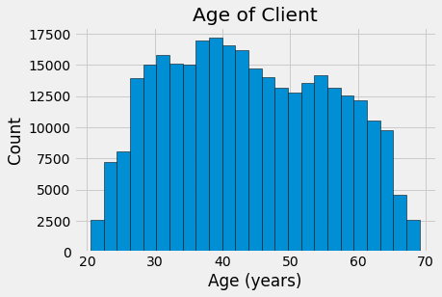

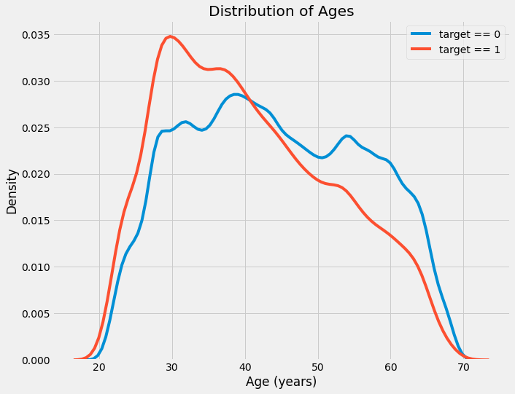Age distribution in dataset

*Observation: Kernel density plot showing trend that younger are mote likely NOT to repay.*

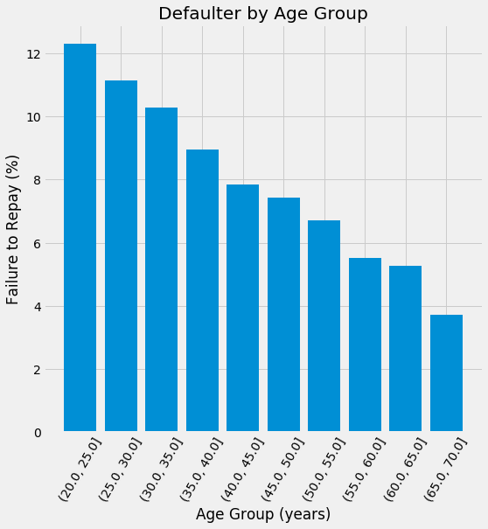

*Observation: Bin – 5 years : showing same trend more clearly*

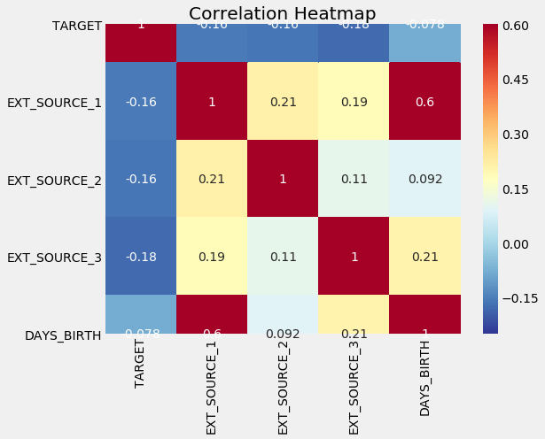

#### Observation : Moderate positive linear relationship between the EXT_SOURCE_1 and the DAYS_BIRTH¶

3.5 Feature Engineering: Polynomial Features

3.5.1 Correlation between newly created polynomial feature and Target

EXT_SOURCE_2 EXT_SOURCE_3 -0.193939

EXT_SOURCE_1 EXT_SOURCE_2 EXT_SOURCE_3 -0.189605

EXT_SOURCE_2 EXT_SOURCE_3 DAYS_BIRTH -0.181283

EXT_SOURCE_2^2 EXT_SOURCE_3 -0.176428

EXT_SOURCE_2 EXT_SOURCE_3^2 -0.172282

EXT_SOURCE_1 EXT_SOURCE_2 -0.166625

EXT_SOURCE_1 EXT_SOURCE_3 -0.164065

EXT_SOURCE_2 -0.160295

EXT_SOURCE_2 DAYS_BIRTH -0.156873

EXT_SOURCE_1 EXT_SOURCE_2^2 -0.156867

Name: TARGET, dtype: float64

DAYS_BIRTH -0.078239

DAYS_BIRTH^2 -0.076672

DAYS_BIRTH^3 -0.074273

TARGET 1.000000

1 NaN

Name: TARGET, dtype: float64

*Observation: no significant correlation found between polynomial feature and target*

4: Model Selection

* ****logistic regression baseline score around 0.671****
* ****Random Forest model score 0.678.****

# Light Gradient Boosting Machine model scores about 0.754

5: Summary

* *Dataset is highly imbalance, less then 10% of the values are 1*
* *ONE HOT ENCODING increased number of features, we would use ***count of frequency encoding*
* *Age is important as younger people are more likely to default*
* *Ext_source_1 feature is important as it has strong correlation with age*
* *Credit perios , Income and credit to income is also important.*
* *Number of days in employment has anomalies , its -ve and showing too many days for some rows.*
* *There are missing values found in some columns, will use imputation to balance data. Even polynomial feature engineering is not able to provide some strong correlation.*
* *Next step to merge all data sets and will find relationship " TARGET PERMUTATION "*