**DBMS**

**Name :- Aman**

**Course: - B.SC(H) COMPUTER SCIENCE**

**RollNo.: - 20221406**

**Examination Roll No.-22020570024**

* **Creating Database student_society**

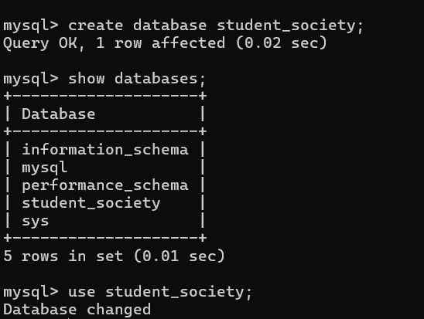

* **Creating Student Table**

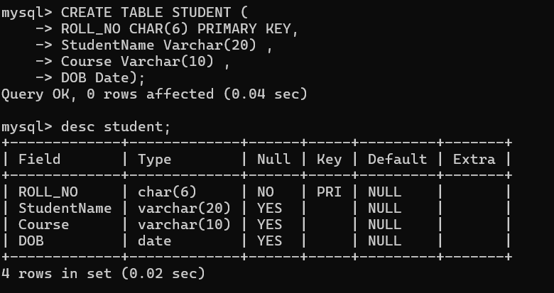

* **Creating Society Table**

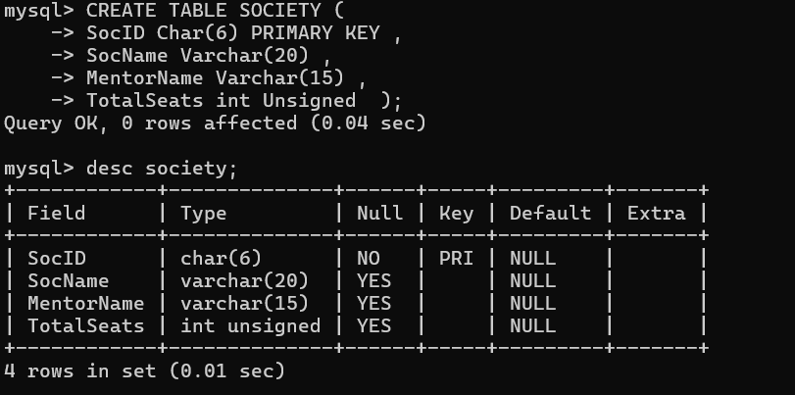

* **Creating Enrollment Table**

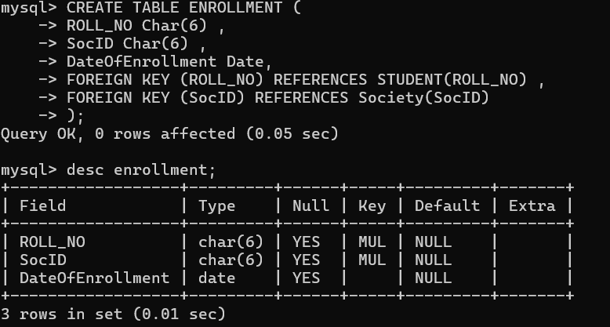

* **Inserting Value in student table**

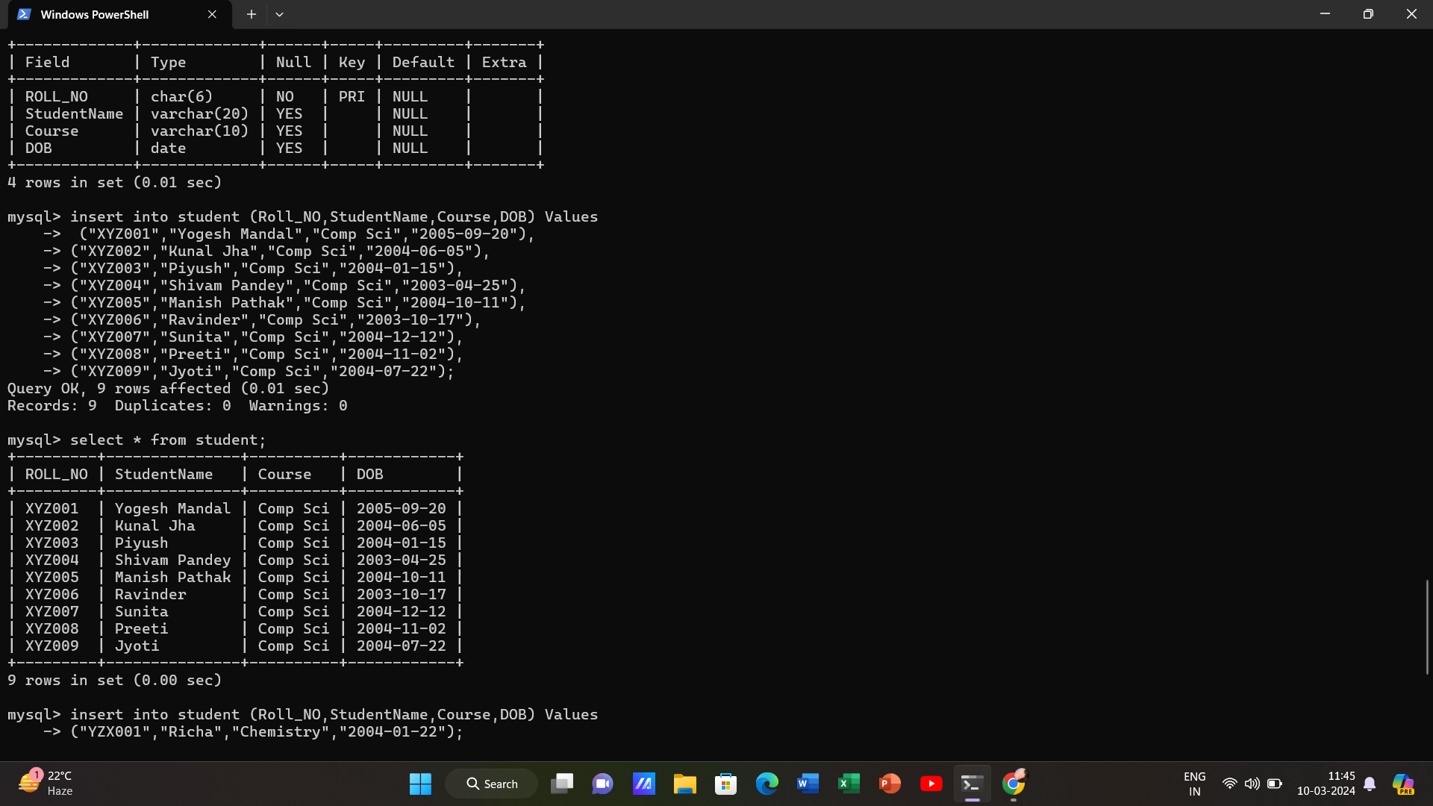

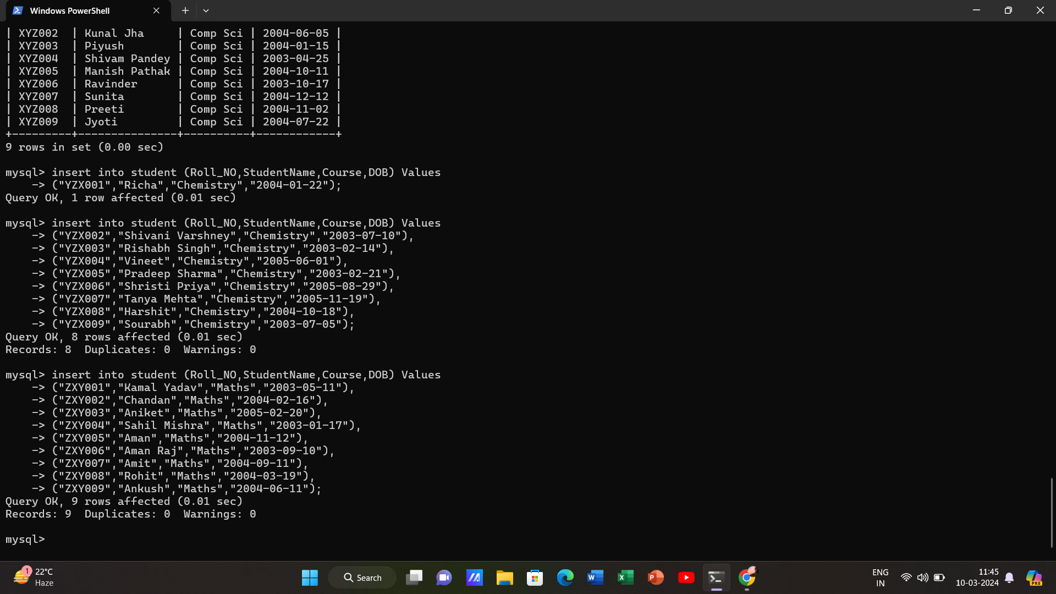

* **Student Table Details**

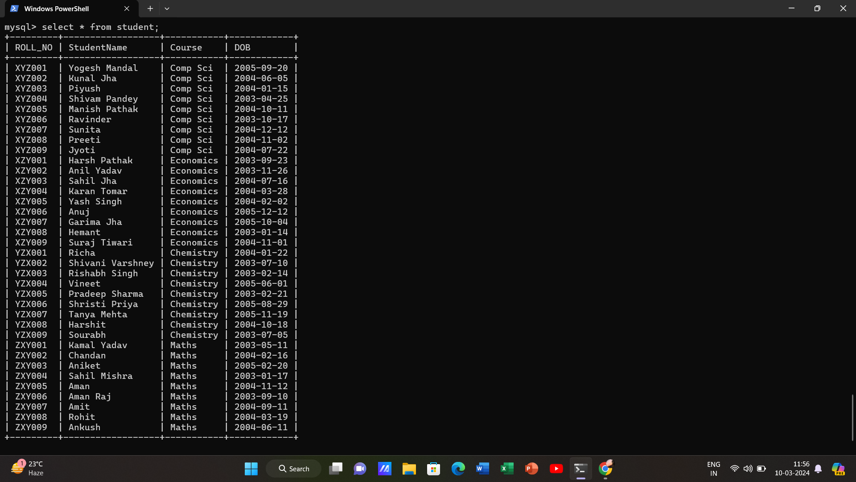

* **Inserting value in Society table and its Details.**

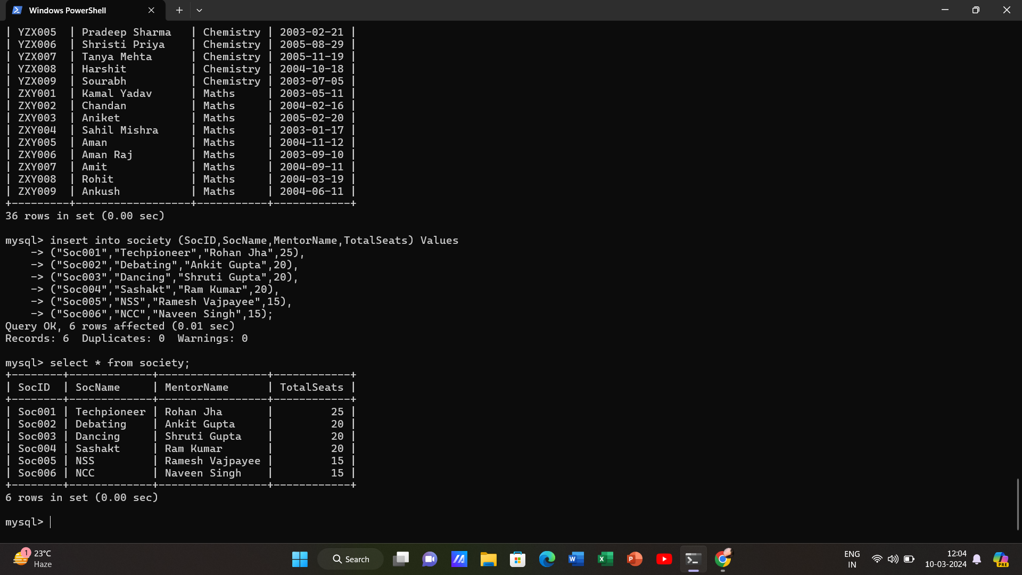

* **Enrollment Table Details**

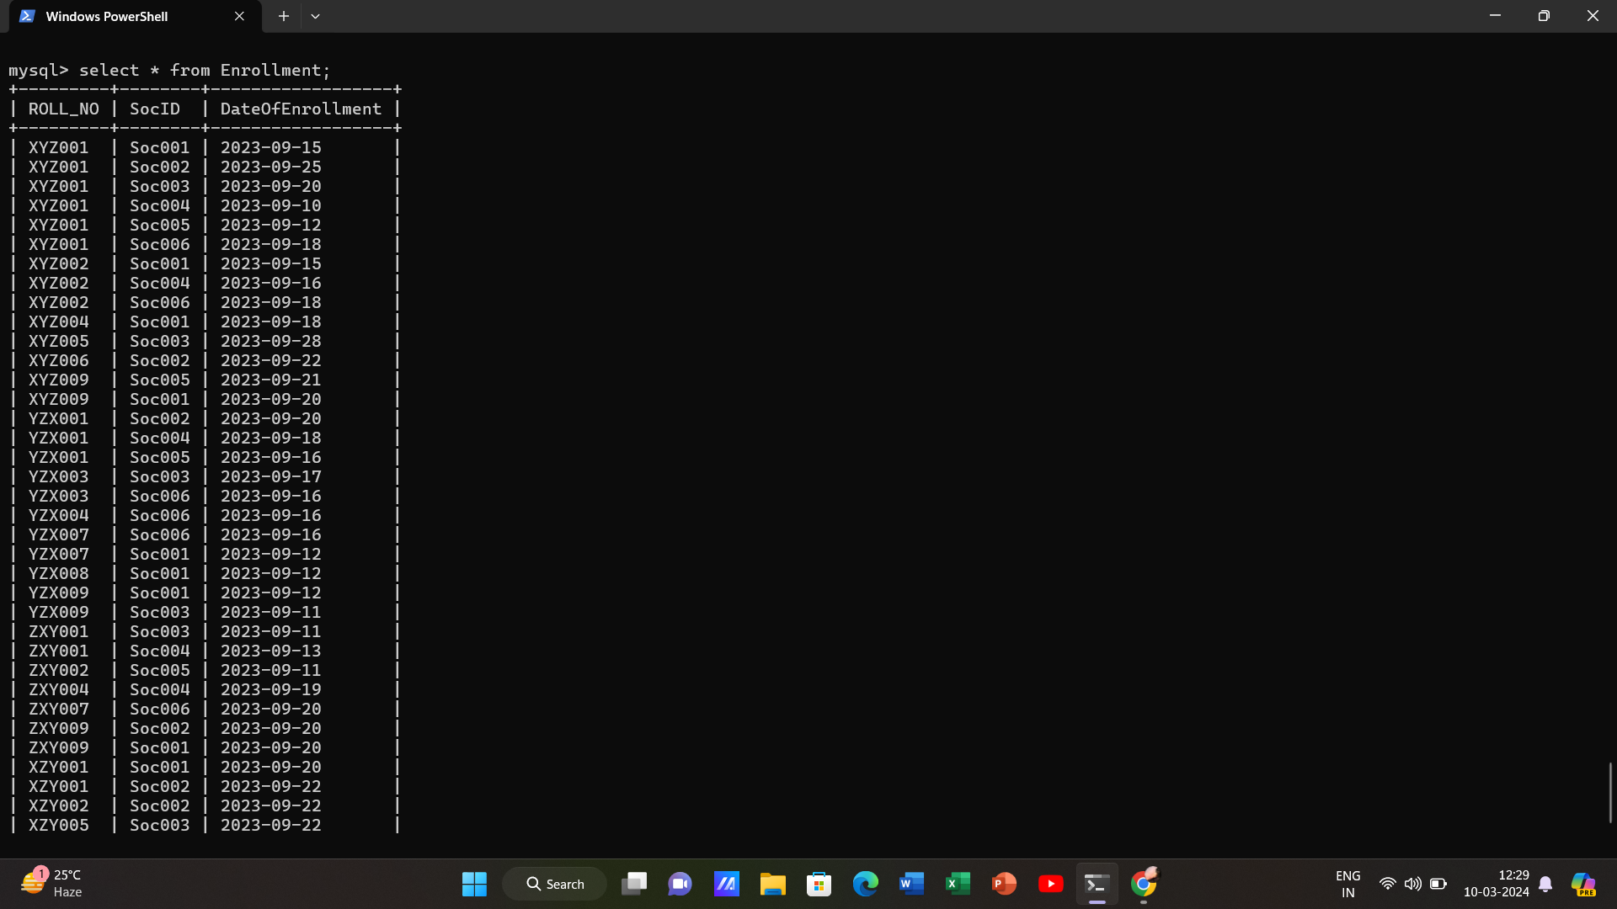

**Q1. Retrieve names of students enrolled in any society.**

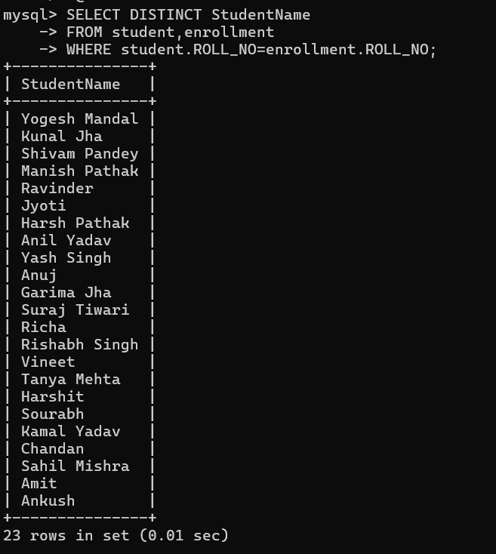

**Q2. Retrieve all society names.**

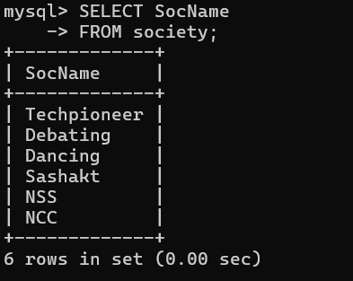

**Q3. Retrieve students' names starting with letter ‘A’.**

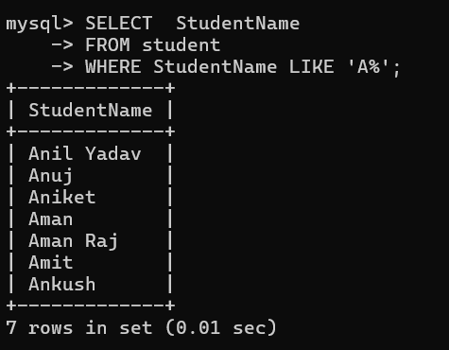

**Q4. Retrieve students' details studying in courses ‘computer science’ or ‘chemistry’.**

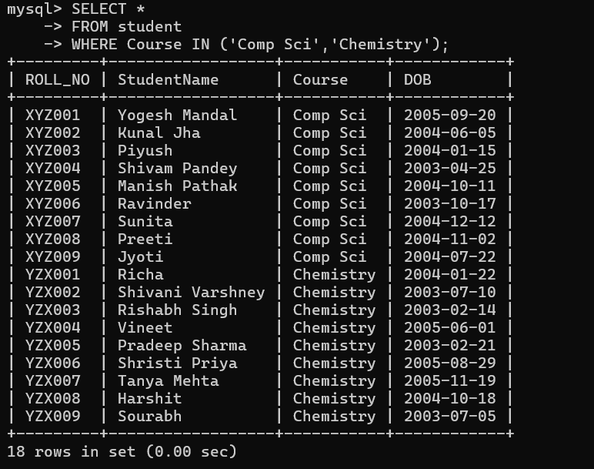

**Q5. Retrieve students’ names whose roll no either starts with ‘X’ or ‘Z’ and ends with ‘9’**

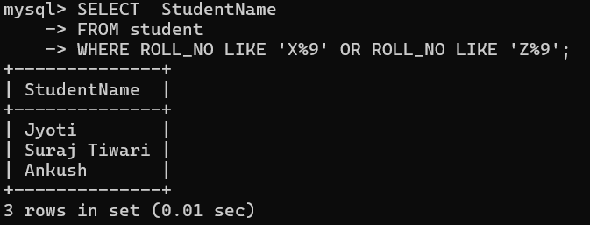

**Q6. Find society details with more than N TotalSeats where N is to be input by the user.**

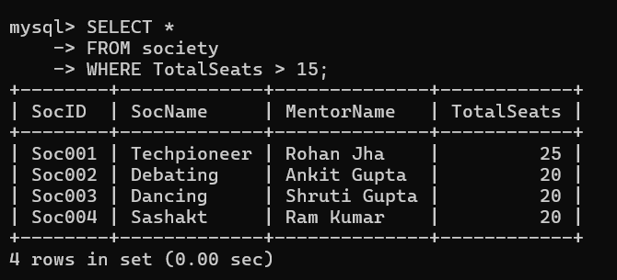

**Q7. Update society table for mentor name of a specific society.**

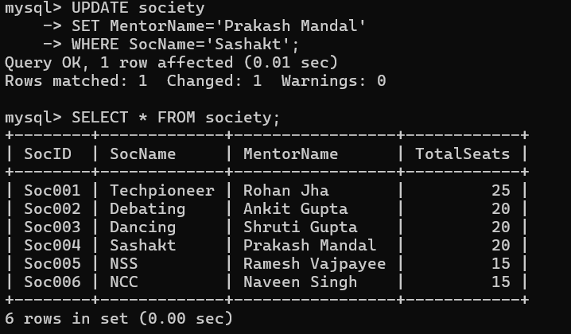

**Q8. Find society names in which more than five students have enrolled.**

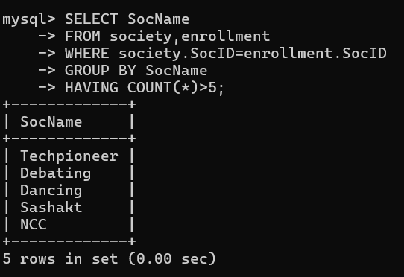

**Q9. Find the name of the youngest student enrolled in society ‘NSS’.**

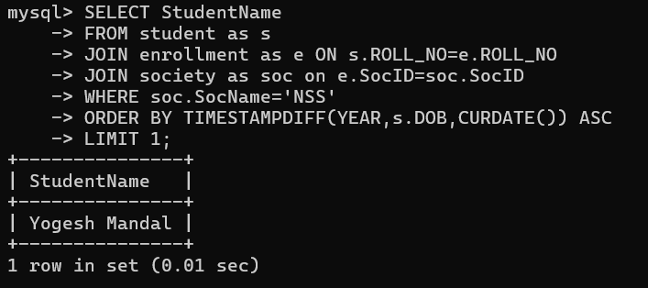

**Q10. Find the name of the most popular society (on the basis of enrolled students).**

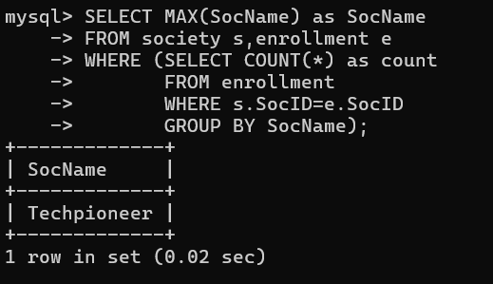

**Q11. Find the name of two least popular societies (on the basis of enrolled students)**

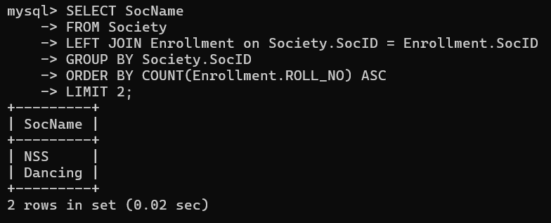

**Q12. Find the student names who are not enrolled in any society**

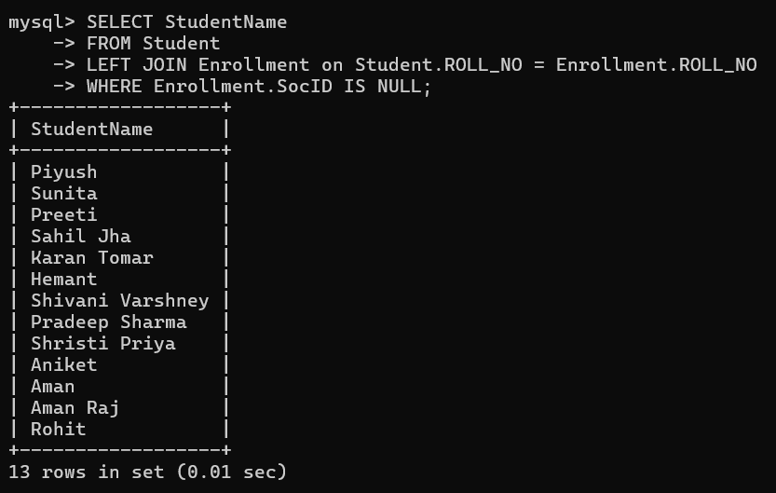

**Q13. Find the student names enrolled in at least two societies**

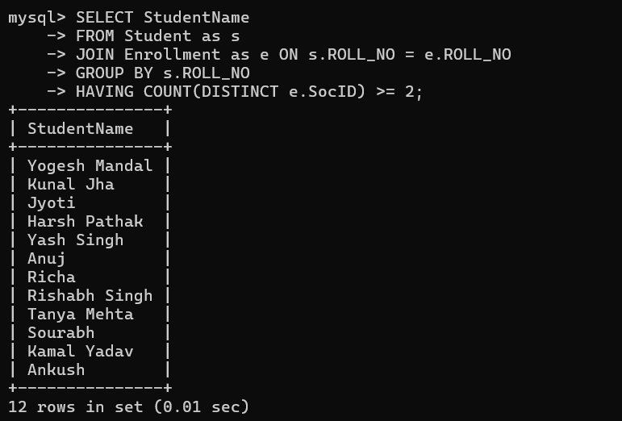

**Q14. Find society names in which maximum students are enrolled**

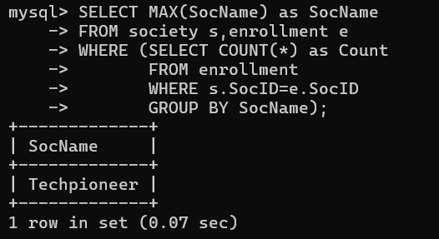

**Q15. Find names of all students who have enrolled in any society and society names in which at least one student has enrolled**

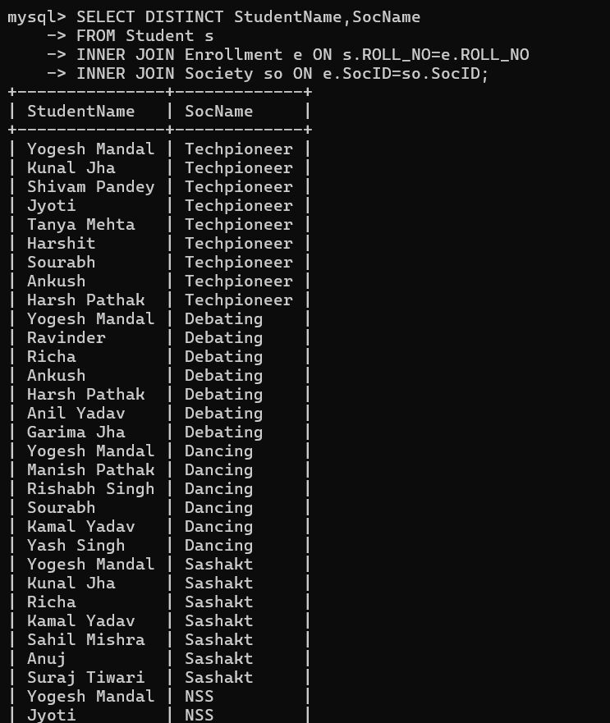

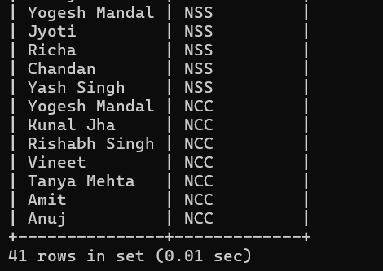

**Q16. Find names of students who are enrolled in any of the three societies ‘Debating’,‘Dancing’ and ‘Sashakt’.**

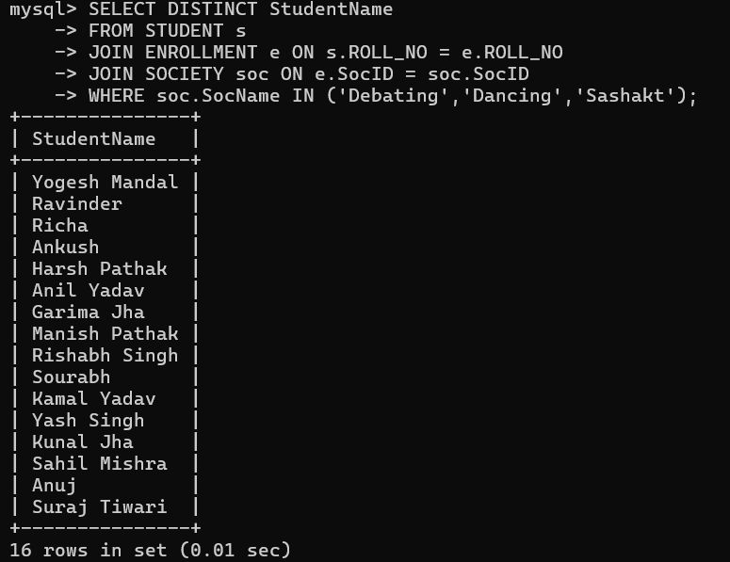

**Q17. Find society names such that its mentor has a name with ‘Gupta’ in it.**

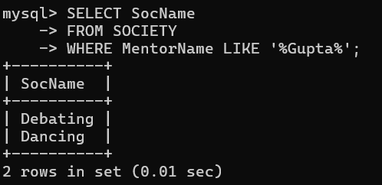

**Q18. Find the society names in which the number of enrolled students is only 10% of its capacity.**

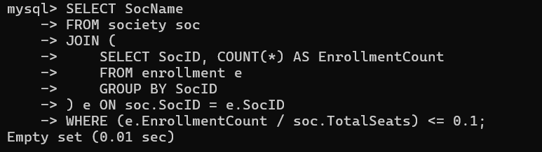

**Q19. Display the vacant seats for each society.**

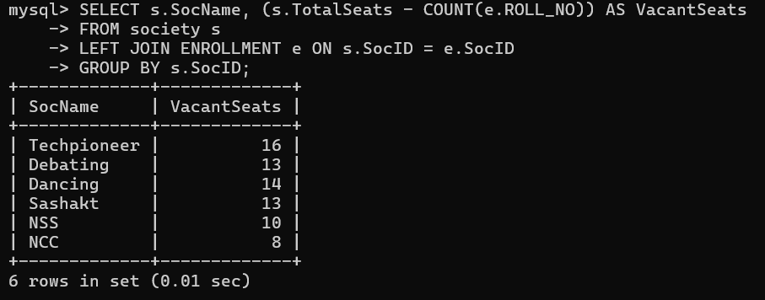

**Q20. Increment Total Seats of each society by 10%.**

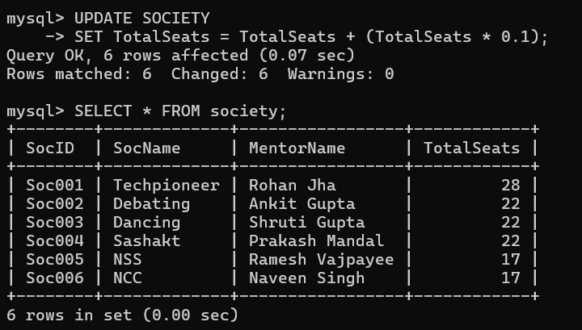

**Q21. Add the enrollment fees paid (‘yes’/’No’) field in the enrollment table.**

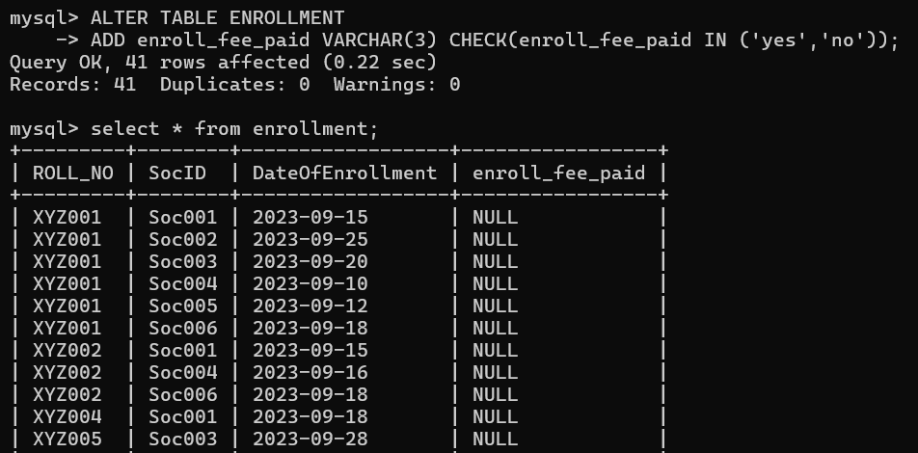

**Q22. Update date of enrollment of society id ‘s1’ to ‘2018-01-15’, ‘s2’ to current date and ‘s3’ to ‘2018-01-02’.**

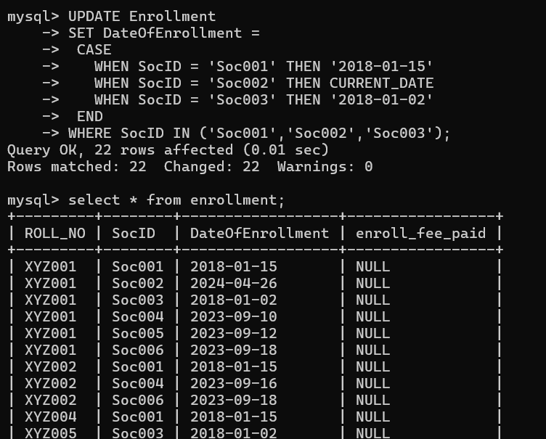

**Q23. Create a view to keep track of society names with the total number of students enrolled in it.**

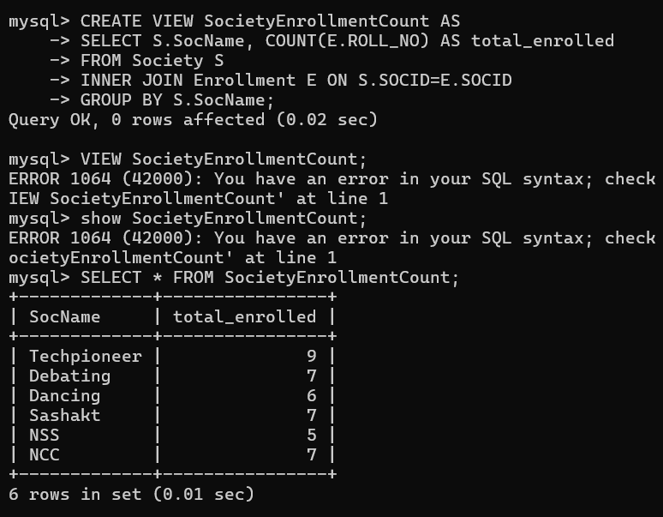

**Q24. Find student names enrolled in all the societies.**

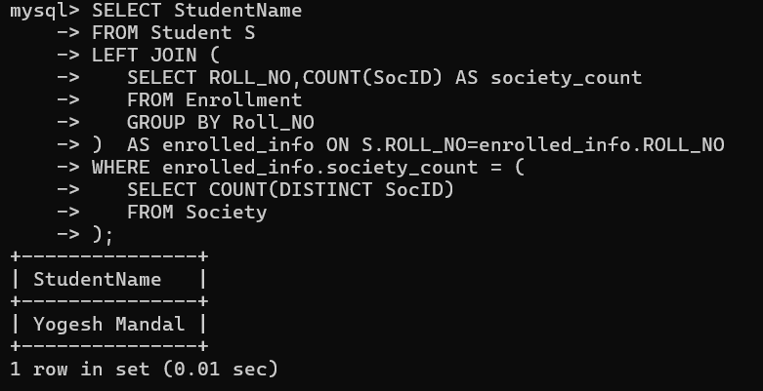

**Q25. Count the number of societies with more than 5 students enrolled in it.**

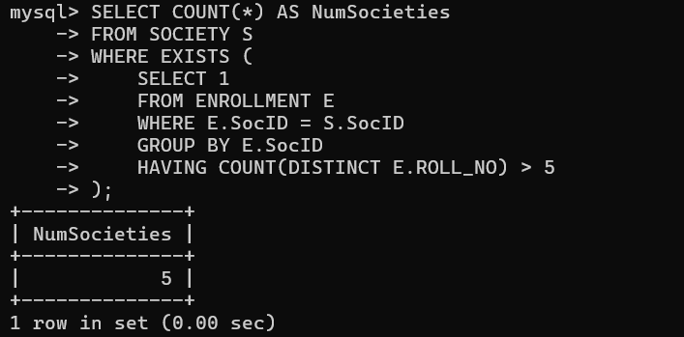

**Q26. Add column Mobile number in student table with default value ‘9999999999’.**

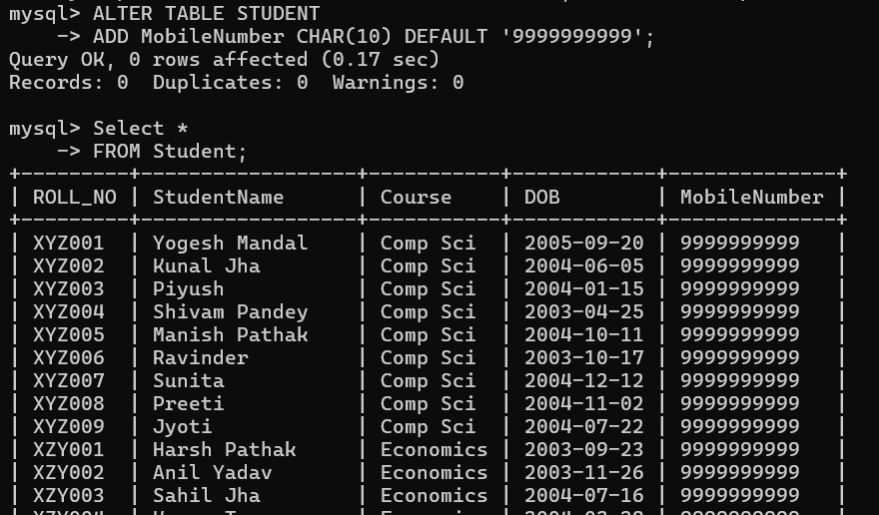

**Q27. Find the total number of students whose age is > 20 years.**

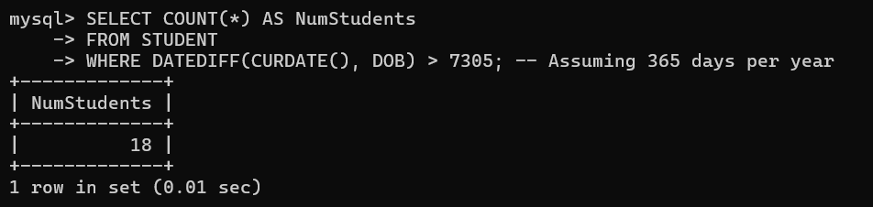

**Q28. Find names of students who are born in 2001 and are enrolled in at least one society.**

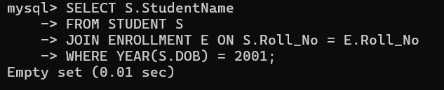

**Q29. Count all societies whose name starts with ‘S’ and ends with ‘t’ and at least 5 students are enrolled in the society.**

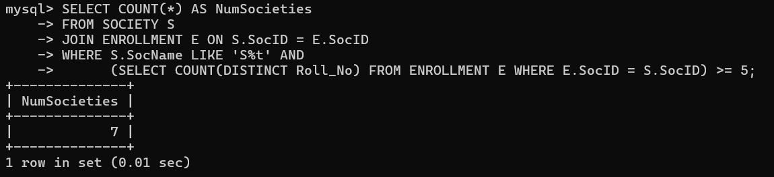

**30. Display the following information: Society name,Mentor name, Total Capacity, Total Enrolled , Unfilled Seats.**

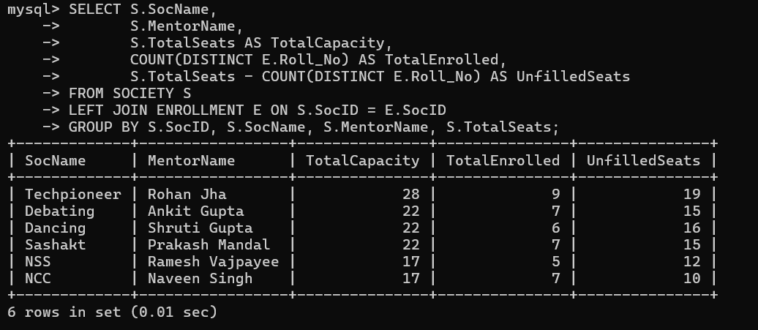

**II. Do the following database administration commands:**

**create user, create role, grant privileges to a role, revoke privileges from a role, create index.**

**Ans: -**

Connect to your MySQL with this command and enter your password: -

* mysql -u root -p

1. Create user: -

* CREATE USER 'myuser'@'localhost' IDENTIFIED BY 'password';

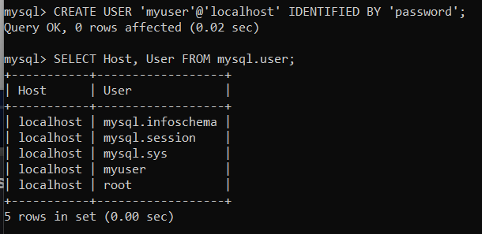

2.Grant Privileges: -

* GRANT SELECT, INSERT, UPDATE ON mysql.engine_cost TO 'myuser'@'localhost';



3.Revoke Privileges: -

* REVOKE INSERT ON mysql.engine_cost FROM 'myuser'@'localhost';



4.Create Index: -

* CREATE INDEX engine_cost ON engine_cost(cost_name);

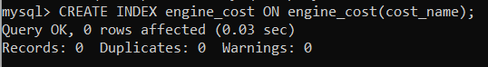

III. **Execute queries given in part I through a high-level language using ODBC connection.**

**Code: - Create Table: - (CREATE)**

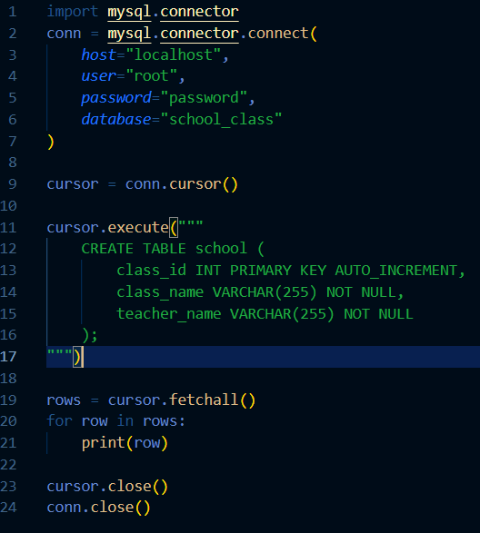

Result: -

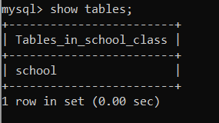

**Code :- Insert values in a table (INSERT)**

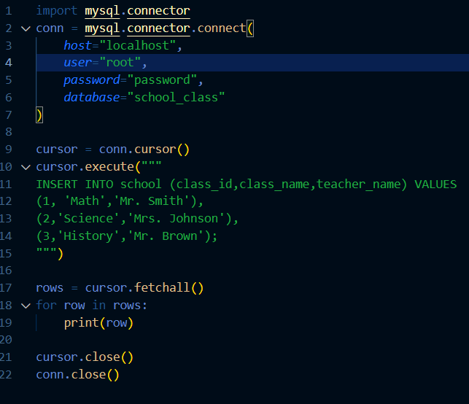

Result: -

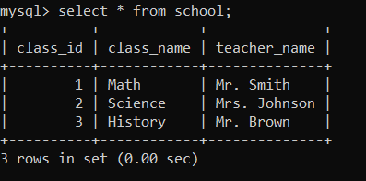

**Code: - Output in Terminal (SELECT)**

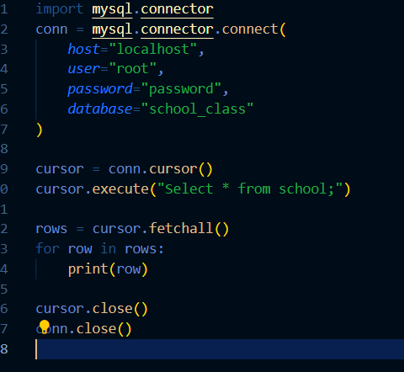

Output: -

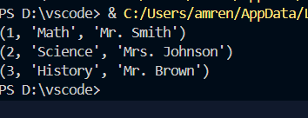

**Code: - Update any data entry (UPDATE)**

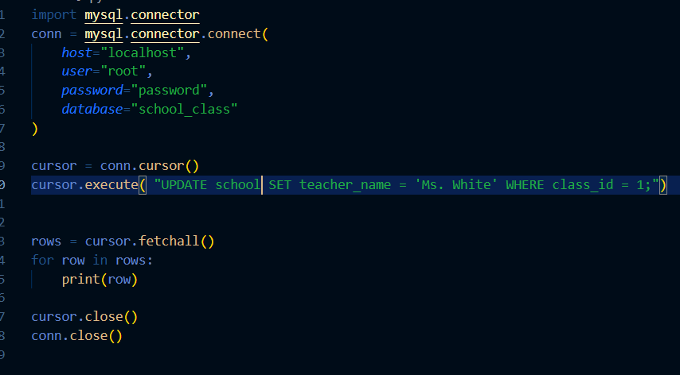

**Output: -**



