Report
Of
Python Fullstack Developer Virtual Internship
Submitted
To
School of Computer Science and Engineering
IILM University, Greater Noida, U.P.
In partial fulfilment of the requirement of degree of
B.Tech CSE
By
Roll Number of Student: 2410030293
Name of Student: AMAN KUMAR SINGH
Batch: 2024-28

CANDIDATE'S DECLARATION
I, Aman Kumar Singh, do hereby declare that the internship report titled “Python Fullstack Developer Virtual Internship” has been completed by me to fulfil the requirement for the award of the degree of Bachelor of Technology in CSE. All the references have been quoted and I have not taken as such any material from any other source. I affirm to you that this report is my own and has not been submitted to any other institute for any degree/diploma requirement and further I shall be solely responsible for any kind of copyright violation in this regard.
Student Name: AMAN KUMAR SINGH
Roll No: 2410030293

ACKNOWLEDGEMENT
I am using this opportunity to express my gratitude to everyone who supported me throughout the Internship Program. I am thankful for their aspiring guidance, invaluably constructive criticism and friendly advice during this work. I am sincerely grateful to them for sharing their truthful and illuminating views on a number of issues related to this work.
I would like to sincerely thank EduSkills Academy, in association with AICTE and the National Internship Portal, Ministry of Education, for providing me the opportunity to undertake the 8-week Python Fullstack Developer Virtual Internship, and for the structured curriculum, mentorship, and real-world projects that helped me build practical skills in full stack web development. I also thank the faculty of the School of Computer Science and Engineering, IILM University, Greater Noida, for their continuous support and encouragement throughout this internship.
Student Name: AMAN KUMAR SINGH
Roll No: 2410030293

TABLE OF CONTENTS
Table 1: Report Structure and Page Numbers
Chapter No. | Chapter Name | Page Nos.
 | Cover Page | ----
1. | Candidate's Declaration | i
2. | Acknowledgment | ii
3. | Internship Completion Certificate | iii
4. | Project Description | 1
 | 4.1 Introduction | 1
 | 4.2 Organization Profile | 1
 | 4.3 Problem Statement | 1
 | 4.4 Project Objectives | 2
 | 4.5 Scope of the Project | 2
 | 4.6 Technologies and Tools Used | 2
 | 4.7 System Architecture | 2
 | 4.8 Methodology | 3
 | 4.9 Expected Outcomes | 3
 | 4.10 Certificate of Completion | 4
5. | Bibliography/References | 4

INTERNSHIP COMPLETION CERTIFICATE
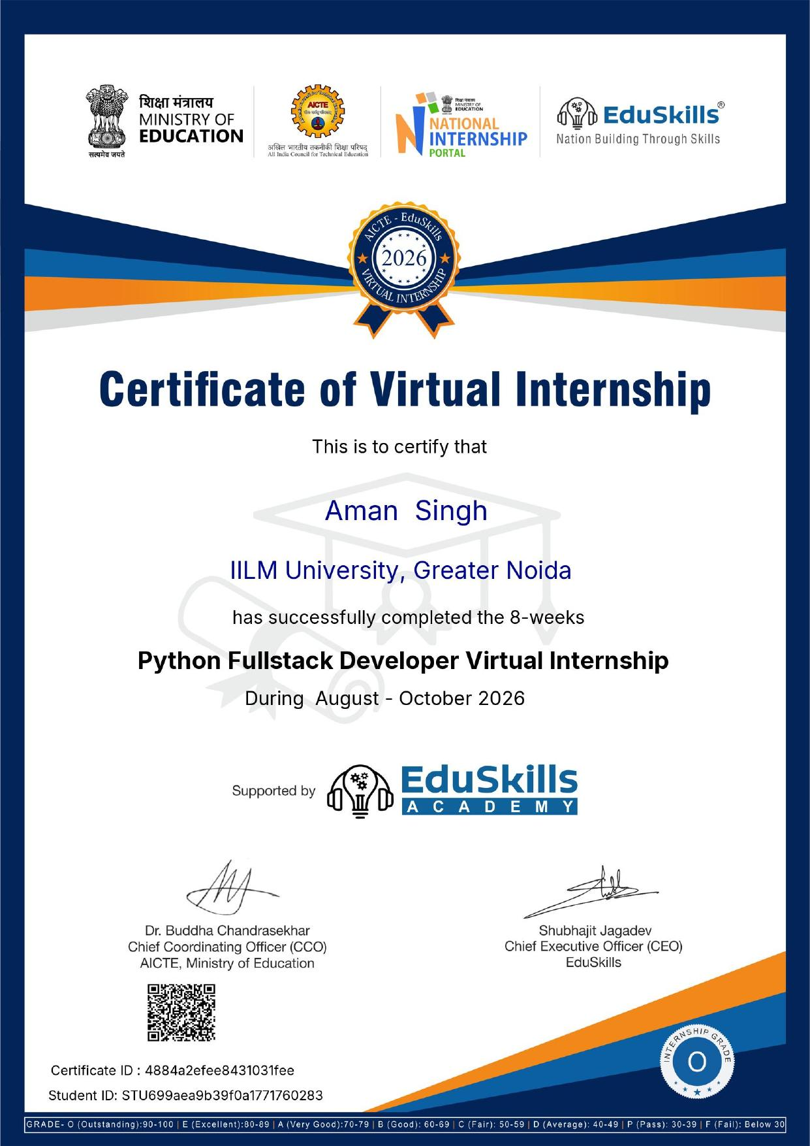

CHAPTER 4: PROJECT DESCRIPTION

4.1 Introduction
This report presents an account of the 8-week Python Fullstack Developer Virtual Internship undertaken under the aegis of EduSkills Academy, in association with AICTE and the National Internship Portal, Ministry of Education, Government of India, during August–October 2026. Full stack web development has become a core skill for the modern software industry, requiring proficiency across front-end technologies, back-end programming, databases, and deployment practices. The internship was designed to provide a hands-on, project-based understanding of building complete web applications using Python-based technologies, from front-end markup and styling to server-side logic, database integration, and final deployment. The certificate of completion for this internship (Certificate ID: 4884a2efee8431031fee, Student ID: STU699aea9b39f0a1771760283) has been awarded with Grade ‘O’ (Outstanding) and is attached in Chapter 3 of this report.

4.2 Organization Profile
EduSkills Academy is a skilling and industry-academia collaboration initiative that works to prepare a digitally skilled, Industry 4.0-ready workforce among students in India. Operating in association with the All India Council for Technical Education (AICTE) and the National Internship Portal of the Ministry of Education, it partners with academic institutions to deliver structured, certification-based virtual internship programs across emerging technology domains such as full stack development, data analytics, cloud computing, and cybersecurity, with the objective of bridging the gap between classroom learning and industry requirements.

4.3 Problem Statement
Modern businesses require web applications that are dynamic, data-driven, and scalable, yet many students graduate with only a fragmented understanding of either the front-end or the back-end of web development, rarely both. This gap leaves them unprepared to build or maintain complete, end-to-end software solutions. The internship addressed this problem by training interns to design and develop full stack web applications using Python as the primary back-end language, combined with standard front-end technologies, relational databases, and RESTful APIs, thereby enabling them to independently build and deploy functional, real-world web applications.

4.4 Project Objectives
- To understand the fundamentals of full stack web development and the roles of front-end and back-end components.
- To build responsive and structured web pages using HTML5, CSS3, and JavaScript.
- To learn core and advanced Python programming concepts for back-end development.
- To design and implement server-side logic using Python web frameworks.
- To integrate relational databases and perform CRUD operations through SQL.
- To design and consume RESTful APIs for communication between front-end and back-end.
- To apply the above skills to a real-world style project and deploy a complete full stack application.

4.5 Scope of the Project
The scope of the internship covered the complete lifecycle of a full stack web application: environment setup, front-end development using HTML, CSS, and JavaScript, core Python programming, back-end development using a Python web framework, database design and integration, RESTful API development, and finally deployment of the completed application. The internship concluded with a capstone project in which a fully functional full stack web application was designed, developed, tested, and deployed, consolidating all the skills learned over the eight weeks.

4.6 Technologies and Tools Used
- Front-End: HTML5, CSS3, JavaScript
- Programming Language: Python
- Back-End Framework: Python web framework (Flask/Django) for server-side development
- Database: SQL-based relational database for data storage and CRUD operations
- API Development: RESTful APIs for front-end–back-end communication
- Version Control & Deployment: Git and cloud/hosting platforms for deployment

4.7 System Architecture
The application followed a standard three-tier full stack architecture. The presentation layer consisted of web pages built using HTML, CSS, and JavaScript, providing the user interface. The application/back-end layer, built using Python, handled business logic, routing, and request processing through a web framework. The data layer used a relational database to store and manage persistent application data, accessed by the back-end through SQL queries. Communication between the front-end and back-end was handled through RESTful API endpoints, and the completed application was deployed to a hosting environment for end-to-end access.

4.8 Methodology
The internship followed a structured, week-wise curriculum in which theoretical concepts were reinforced through hands-on exercises and progressively complex projects, culminating in a capstone full stack application. The week-wise breakup of topics covered is summarized below:
Table 4.1: Week-wise Breakup of Topics Covered
Week | Topics Covered
Week 1 | Introduction to Full Stack Development; Environment Setup; HTML5 & CSS3 Fundamentals
Week 2 | JavaScript Fundamentals & DOM Manipulation; Responsive Web Design
Week 3 | Core Python Programming for Web Development; Object-Oriented Concepts in Python
Week 4 | Python Web Frameworks – Basics; Routing, Templates & Views
Week 5 | Database Design & SQL Integration; CRUD Operations with Python
Week 6 | RESTful API Development; Front-End & Back-End Integration
Week 7 | Real-World Project: Building a Full Stack Web Application; Testing & Debugging
Week 8 | Capstone Project: Deployment of Full Stack Application; Best Practices & Project Workflow
This methodology ensured that foundational concepts (HTML, CSS, JavaScript, and core Python) were established first, followed by back-end development and database integration, and finally applied through a real-world capstone project that simulated the development and deployment of an actual full stack web application.

4.9 Expected Outcomes
- Ability to independently design and build responsive front-end interfaces using HTML, CSS, and JavaScript.
- Proficiency in core Python programming for back-end web development.
- Capability to build and manage server-side logic using a Python web framework.
- Practical experience in designing databases and performing SQL-based CRUD operations.
- Skill in developing and consuming RESTful APIs for front-end–back-end communication.
- A completed and deployed capstone full stack web application, demonstrating end-to-end development competency.

4.10 Certificate of Completion and Other Communication Proof
The Certificate of Virtual Internship issued by EduSkills Academy, in association with AICTE and the National Internship Portal, Ministry of Education (Certificate ID: 4884a2efee8431031fee, Student ID: STU699aea9b39f0a1771760283, Internship Grade: O – Outstanding, signed by Dr. Buddha Chandrasekhar, Chief Coordinating Officer, AICTE, and Shubhajit Jagadev, Chief Executive Officer, EduSkills), has been attached in Chapter 3 of this report as proof of successful completion of the internship requirements.

CHAPTER 5: BIBLIOGRAPHY/REFERENCES
1. EduSkills Academy, “Python Fullstack Developer Virtual Internship” Certification Program, AICTE – National Internship Portal, Ministry of Education, 2026.
2. Python Software Foundation, Python 3 Documentation, https://docs.python.org/3/
3. Mozilla Developer Network, HTML, CSS & JavaScript Documentation, https://developer.mozilla.org/
4. Flask Documentation, https://flask.palletsprojects.com/
5. Django Software Foundation, Django Documentation, https://docs.djangoproject.com/
6. Certificate of Virtual Internship, Certificate ID: 4884a2efee8431031fee, EduSkills Academy, AICTE – Ministry of Education, 2026.

