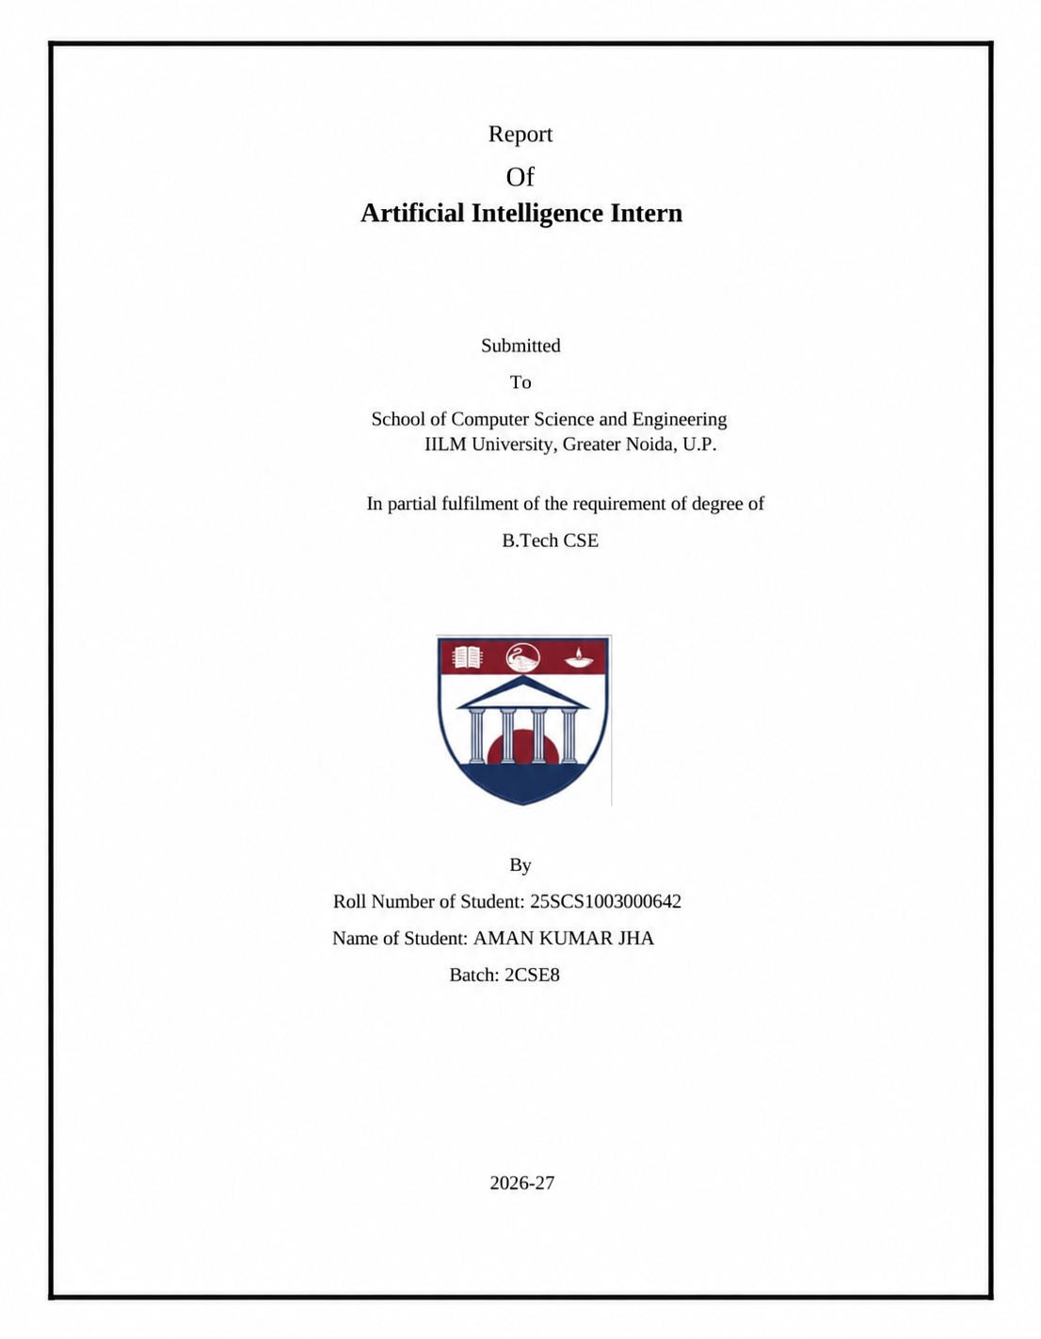

CERTIFICATE
This is to certify that [YOUR NAME], student of [COLLEGE / UNIVERSITY NAME], has completed the project titled “Customer Support Chatbot Agent” as part of the internship/project requirements. The project demonstrates the development of a Python-based chatbot for handling common customer-support queries.

DECLARATION
I hereby declare that this project report titled “Customer Support Chatbot Agent” is my project work completed for academic and internship purposes. The project helped me understand Python programming, basic natural language processing, JSON data handling, Streamlit, testing, and documentation.

ACKNOWLEDGEMENT
I would like to thank my teachers, project guide, and internship mentors for their guidance and support. Their suggestions helped me understand how a simple programming idea can be converted into a useful customer-support application. I am also thankful for the opportunity to improve my Python and problem-solving skills through this project.

ABSTRACT
Customer-support teams receive many repeated questions about orders, delivery, returns, refunds, payments, cancellations, and account access. Answering these questions manually can take time. To address this problem, this project develops a Customer Support Chatbot Agent using Python and Streamlit.
The chatbot provides a simple web-based conversation interface. It reads a customer's message, cleans the text, checks important words against a structured FAQ knowledge base, and returns the most relevant response. If it cannot identify the query, it provides a helpful fallback message. The FAQ information is stored separately in a JSON file, making the system easy to update.
The current version does not require an external AI API. It demonstrates the basic idea of conversational automation and provides a foundation for future LLM, database, and API integration.

1. INTRODUCTION
Customer service is an important part of almost every online business. Customers often ask similar questions such as “Where is my order?”, “How long will delivery take?”, “Can I return this product?” and “When will I receive my refund?”. A support team can answer these questions, but handling repeated queries can consume time.
This project introduces a simple Customer Support Chatbot Agent that can answer common questions automatically. The application is built in Python and uses Streamlit to provide a browser-based interface. The chatbot communicates in a friendly and easy-to-understand way.

2. PROBLEM STATEMENT
Customer-support teams spend a lot of time answering repetitive questions. Customers may also have to wait for a human agent even when their question is simple.
The proposed solution is a chatbot that can immediately respond to common support questions using a prepared knowledge base. The system should be easy to use, easy to update, and simple enough to run without a complicated setup.

3. OBJECTIVES
- • Develop a customer-support chatbot using Python.
- • Provide a friendly conversational interface.
- • Answer common questions about orders, delivery, returns, refunds, payments, cancellations, and accounts.
- • Store support information in a separate JSON knowledge base.
- • Provide a fallback response for unknown queries.
- • Create a foundation that can later be extended with an LLM, database, and business APIs.

4. SCOPE OF THE PROJECT
The current project focuses on common customer-support conversations. It is suitable as a learning and internship project and demonstrates the basic workflow of a conversational support application.
The current version does not connect to a real company order database or payment system. Therefore, it provides informational responses rather than checking a real customer's order. Real APIs and databases can be connected in a production version.

5. TECHNOLOGIES USED
Python – used for chatbot logic and application programming.
Streamlit – used to create the web-based chat interface directly from Python.
JSON – used to store FAQ keywords and customer-support answers.
Regular Expressions – used for basic text cleaning.
Git and GitHub – used for version control and project sharing.

6. SYSTEM REQUIREMENTS
- Hardware:
- • Basic computer or laptop.
- • At least 4 GB RAM recommended.
- • Internet connection for installing packages.
- Software:
- • Python 3.10 or newer.
- • Visual Studio Code.
- • Streamlit Python package.
- • Chrome, Edge, or another modern browser.
The project is lightweight and does not require a GPU.

7. SYSTEM DESIGN AND WORKING
The chatbot follows this simple process:
Customer Message → Text Cleaning → Keyword Matching → FAQ Selection → Response
First, the customer enters a message in the Streamlit chat box. Python sends the message to the CustomerSupportBot class. The chatbot converts the message to lowercase and removes unnecessary special characters.
Next, the cleaned message is compared with keywords stored in faqs.json. For every FAQ entry, the chatbot counts matching keywords. The entry with the highest score is selected.
If a relevant keyword is found, the chatbot returns the related answer. If no match is found, it gives a fallback response asking the customer to rephrase the question or contact human support.
The chatbot also handles simple greetings, thank-you messages, and goodbye messages.

8. PROJECT STRUCTURE
customer-chatbot-agent/
├── app.py
├── chatbot.py
├── requirements.txt
├── README.md
├── PROJECT_EXPLANATION.md
├── .gitignore
└── data/
└── faqs.json
The user interface, chatbot logic, documentation, and FAQ data are kept separate so the project is easier to understand and maintain.

9. MODULE DESCRIPTION
app.py:
The main application file. It creates the Streamlit page, displays conversation messages, accepts customer input, and shows the chatbot response.
chatbot.py:
Contains the CustomerSupportBot class. It loads the FAQ file, cleans input, handles basic conversation, matches keywords, and returns a response.
data/faqs.json:
The knowledge base containing support topics, keywords, and answers. New FAQs can be added easily.
requirements.txt:
Lists the Python package required to run the project.
README.md:
Contains setup instructions and technical documentation.
PROJECT_EXPLANATION.md:
Contains a simple explanation for learning, presentation, and interview preparation.

10. IMPLEMENTATION
The implementation starts by loading FAQ information from the JSON file. The chatbot receives the customer's message and processes it.
For example, when the customer writes “Where is my order?”, words related to order tracking are found and the order-tracking response is returned.
Messages containing “return” or “replacement” are matched with the return response. Messages containing “refund” are matched with refund information. The Streamlit interface keeps the current conversation visible using session state.

11. TESTING AND RESULTS
The chatbot was tested with several customer questions.
Test 1: “Hello” → Friendly greeting → Passed.
Test 2: “Where is my order?” → Order tracking information → Passed.
Test 3: “How long does delivery take?” → Delivery information → Passed.
Test 4: “I want to return my product” → Return information → Passed.
Test 5: “When will I get my refund?” → Refund information → Passed.
Test 6: “What payment methods do you accept?” → Payment information → Passed.
Test 7: Unknown question → Fallback response → Passed.
The application was successfully run locally through Streamlit at localhost:8501.

12. ADVANTAGES
- • Quick responses to common questions.
- • Simple and easy customer interface.
- • Reduces repetitive work for support staff.
- • FAQ information can be updated easily.
- • Lightweight and beginner-friendly.
- • No external AI API is required for the current version.
- • Can be expanded into a larger support platform.

13. LIMITATIONS
- • The current chatbot uses keyword matching rather than a full language model.
- • It cannot check real-time order information.
- • It cannot access real customer accounts or payment systems.
- • Some differently worded questions may not match the intended FAQ.
- • Responses are limited to the information stored in the knowledge base.

14. FUTURE SCOPE
The project can be improved by integrating an LLM for better natural-language understanding. A database can be added for customer profiles, orders, and chat history. Real order-tracking and payment APIs can provide live information.
Other improvements include customer authentication, voice support, multilingual conversations, sentiment analysis, analytics, automatic human-agent escalation, and cloud deployment.

15. CONCLUSION
The Customer Support Chatbot Agent successfully demonstrates how Python can be used to automate common customer-support conversations. The project combines Python, basic text processing, a JSON knowledge base, and Streamlit to create a working browser-based application.
Although the current implementation uses keyword matching, its modular structure provides a strong foundation for adding an AI/LLM, database, real-time APIs, authentication, and other production features in the future.

16. REFERENCES
- • Python documentation and learning resources.
- • Streamlit documentation.
- • JSON documentation.
- • Git and GitHub documentation.
- • Basic concepts of natural language processing and conversational systems.

