- Launch the Window Powershell from the below location:
Location : C:\Users\Aman Kumar\langflow-project\langflow-env

Or Change the path as below:
PS C:\Users\Aman Kumar> cd langflow-project\langflow-env

2. Now run the below command
.\Scripts\activate

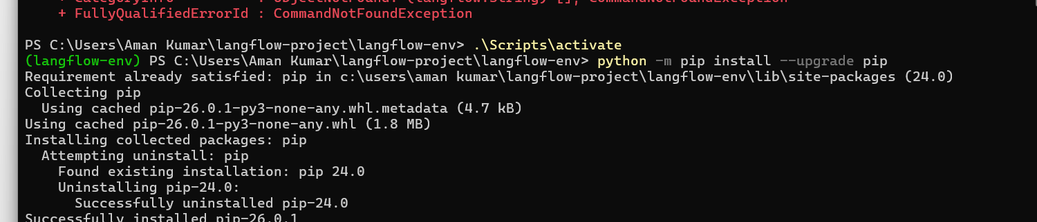

3. Check the version:
pip show langflow
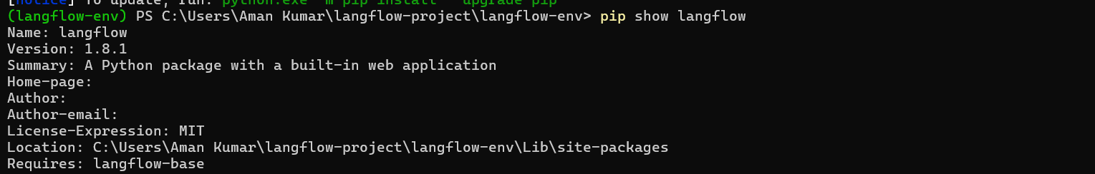

4. Run the lang flow from below location
Location: PS C:\Users\Aman Kumar\langflow-project\langflow-env>
Run Command : python -m langflow run

5. 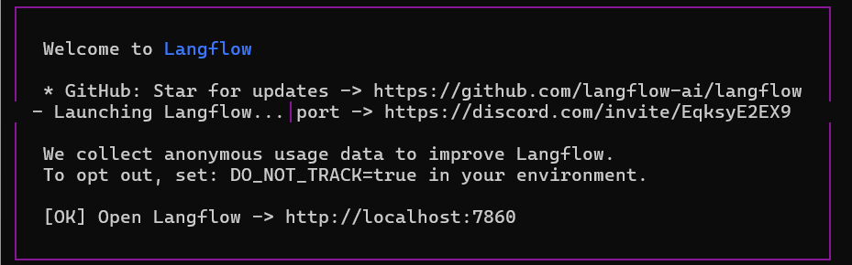

Show the version

