VISVESVARAYA TECHNOLOGICAL UNIVERSITY

“JNANA SANGAMA”, BELAGAVI-**590018.**

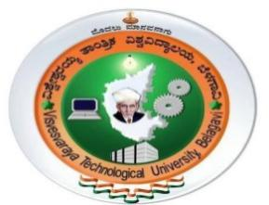

**A**

**Mini Project Report**

**On**

**Police Database System**

**SUBMITTED IN FULFILLMENT OF THE REQUIREMENT IN**

**5TH SEMESTER DATABASE MANAGEMENT SYSTEM MINI PROJECT WORK OF BACHELOR OF ENGINEERING**

**IN**

COMPUTER SCIENCE AND ENGINEERING

**By**

**Aman Prakash [1JB17CS013]**

**Ambuj Dubey [1JB17CS014]**

**UNDER THE GUIDANCE OF**

**Savitri Kulkarni**

**Assistant Professor**

**Dept. of CSE**

**Dr. Gopalakrishna M T**

**Professor**

**Dept. of CSE**



**DEPARTMENT OF COMPUTER SCIENCE AND ENGINEERING**

### SJB INSTITUTE OF TECHNOLOGY

**#67,BGS HEALTH AND EDUCATION CITY, Dr Vishnuvardhan Road,Kengeri, Bangalore-560060.**

**2019-2020**

||Jai Sri Gurudev||

Sri Adichunchanagiri Shikshana Trust ®

### SJB INSTITUTE OF TECHNOLOGY

### #67,BGS Health & Education City, Dr Vishnuvardhan Road, Kengeri, Bangalore-560060.

**DEPARTMENT OF COMPUTER SCIENCE AND ENGINEERING**



**CERTIFICATE**

This is to certify that the mini project entitled *“*Police Database System” is a bonafide work carried out by Aman Prakash [1JB17CS013] and Ambuj Dubey [1JB17CS014] in partial fulfillment of mini project of 5th semester Database Management System Laboratory (17CSL58) in COMPUTER SCIENCE AND ENGINEERING of VISVESVARAYA TECHNOLOGICAL UNIVERSITY, BELAGAVI, during the academic year 2019-2020. It is certified that all corrections/suggestions have been incorporated in the report deposited in the department library. The mini project report has been approved as it satisfies the academic requirements.

___________________

Signature of the HOD

**Dr. Krishna A N**

**Professor & Head**

**Dept. of CSE**

___________________

Signature of the Guide

**Savitri Kulkarni**

**Assistant Professor**

**Dept. of CSE**

___________________

Signature of the Guide

**Dr. Gopalakrishna M T**

**Professor**

**Dept. of CSE**

**EXTERNAL VIVA**

**Name of the Examiners Signature with Date**

**1. _________________________ ____________________**

**2.__________________________ ____________________**

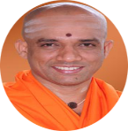

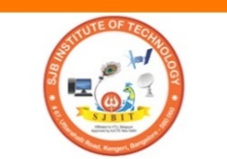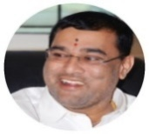

**ACKNOWLEDGEMENT**

We would like to express our profound gratefulness to His Divine Soul **Jagadguru Padmabhushan Sri Sri Sri Dr. Balagangadharanatha Maha Swamiji** and His Holiness **Jagadguru Sri Sri Sri Dr. Nirmalanandanatha Maha Swamiji** for providing me with an opportunity to study in this esteemed Institution.

We would like to express our profound thanks to **Revered Sri Sri Dr. Prakashnath Swamiji,** Managing Director, SJB Institute of Technology, for his continuous support in providing amenities to carry out this mini project in this admired institution.

We express my gratitude to **Dr. Puttaraju**, Principal, SJB Institute of Technology, for providing us with excellent facilities and academic ambience; which have helped me in satisfactory completion of this mini project.

We extend our sincere thanks to **Dr. Krishna A N,** Head of the Department of Computer Science and Engineering, for providing me with invaluable support throughout the period of my mini project.

We wish to express my heartfelt gratitude to my guides**, Dr. Gopalakrishna M T**, Professor and **Mrs. Savitri Kulkarni**, Assistant Professorfor their valuable guidance, suggestions and cheerful encouragement during the entire period of this mini project work.

Finally, we take this opportunity to extend my earnest gratitude and respect to my parents, teaching & non-teaching staffs of the department, the library staff and all my friends, who have directly or indirectly supported me during the period of my mini project work.

Regards,

**Aman Prakash [1JB17CS013]**

**Ambuj Dubey [1JB17CS014]**