**How To Install Apache Cloud Stack Management Server on Ubuntu 22.04**

Step 1: **ip a**

1: lo: <LOOPBACK,UP,LOWER_UP> mtu 65536 qdisc noqueue state UNKNOWN group default qlen 1000

link/loopback 00:00:00:00:00:00 brd 00:00:00:00:00:00

inet 127.0.0.1/8 scope host lo

valid_lft forever preferred_lft forever

inet6 ::1/128 scope host

valid_lft forever preferred_lft forever

2: ens33: <BROADCAST,MULTICAST,UP,LOWER_UP> mtu 1500 qdisc fq_codel state UP group default qlen 1000

link/ether 00:0c:29:c8:e9:be brd ff:ff:ff:ff:ff:ff

altname enp2s1

inet 192.168.11.159/24 brd 192.168.11.255 scope global dynamic noprefixroute ens33

valid_lft 1544sec preferred_lft 1544sec

inet6 fe80::686a:b2ab:96f3:77b1/64 scope link noprefixroute

valid_lft forever preferred_lft forever

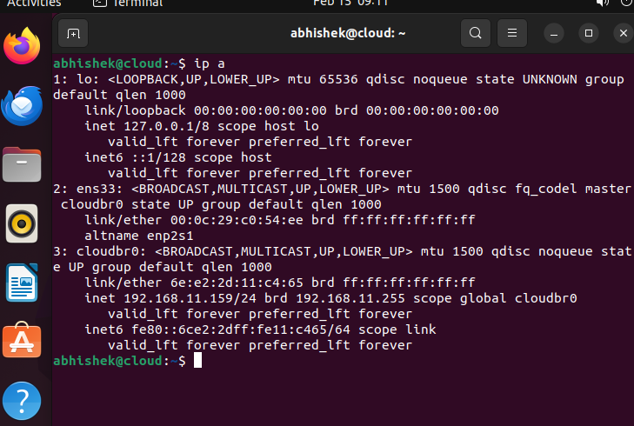

Step 2: **ip r**

default via 192.168.11.2 dev ens33 proto dhcp metric 100

169.254.0.0/16 dev ens33 scope link metric 1000

192.168.11.0/24 dev ens33 proto kernel scope link src 192.168.11.156 metric 100

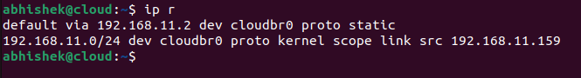

Step 3: **cd /etc/netplan/**

**ls**

**cat /etc/netplan/01-network-manager-all.yaml** (chaing the ip to static)

Step 4: sudo nano /etc/netplan/01-network-manager-all.yaml

For reference go to this link-- (https://www.freecodecamp.org/news/setting-a-static-ip-in-ubuntu-linux-ip-address-tutorial/)

network:

version: 2

renderer: NetworkManager

ethernets:

ens33:

dhcp4: no

addresses: [192.168.11.159/24]

gateway4: 192.168.11.2

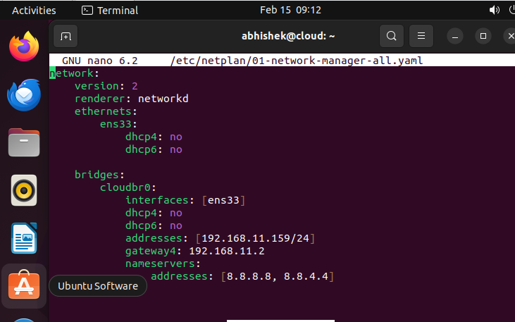

Step 5: **sudo netplan apply**

Step 6: **sudo systemctl restart NetworkManager**

Step 7: **hostname --fqdn**

Step 8: **sudo nano /etc/hosts**

127.0.0.1 localhost

127.0.1.1 ubuntu

**192.168.11.159 apache.cloud.u1 cloud**

# The following lines are desirable for IPv6 capable hosts

::1 ip6-localhost ip6-loopback

fe00::0 ip6-localnet

ff00::0 ip6-mcastprefix

ff02::1 ip6-allnodes

ff02::2 ip6-allrouters

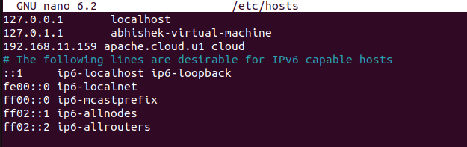

Step 9: **sudo hostnamectl set-hostname cloud**

Step 10: **hostname --fqdn**

apache.cloud.u1

Step 11: **sudo apt install bridge-utils**

Step 12: **sudo brctl addbr cloudbr0**

Step 13: **sudo brctl addif cloudbr0 ens33**

Step 14: **sudo nano /etc/netplan/01-network-manager-all.yaml**

For reference go to this link-- https://www.inf.ufpr.br/jwvflauzino/vines/installation-guide/ubuntu-18.04-all-in-one.html

network:

version: 2

renderer: networkd

ethernets:

ens33:

dhcp4: no

dhcp6: no

bridges:

cloudbr0:

interfaces: [ens33]

dhcp4: no

dhcp6: no

addresses: [192.168.11.159/24]

gateway4: 192.168.11.2

nameservers:

addresses: [8.8.8.8, 8.8.4.4]

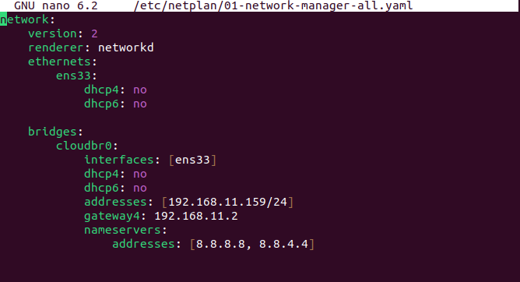

Step 15: **sudo netplan apply**

Step 16: **sudo systemctl restart NetworkManager**

Step 17: **sudo apt install ntp**

Step 18: **sudo systemctl enable ntp**

Step 19: **sudo systemctl start ntp**

Step 20: **sudo apt install chrony**

Step 21: **sudo apt install openjdk-11-jdk**

Step 22: **sudo nano /etc/apt/sources.list.d/cloudstack.list**

For reference go to this link-- https://docs.cloudstack.apache.org/en/latest/installguide/management-server/

Open the file and add: deb https://download.cloudstack.org/ubuntu focal 4.18

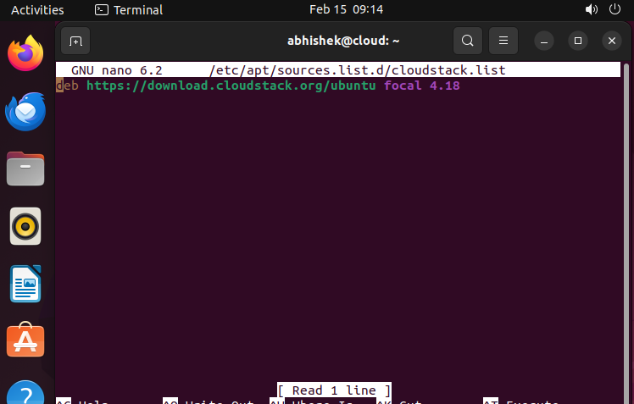

Step 23: add public key to the trusted keys

**wget -O - https://download.cloudstack.org/release.asc |sudo tee/etc/apt/trusted.gpg.d/cloudstack.asc**

[sudo] password for abhishek:

--2024-01-23 11:14:29-- https://download.cloudstack.org/release.asc

Resolving download.cloudstack.org (download.cloudstack.org)... 89.187.162.133, 143.244.33.156,

89.187.163.84, ...

Connecting to download.cloudstack.org (download.cloudstack.org)|89.187.162.133|:443... connected.

HTTP request sent, awaiting response... 200 OK

Length: 1649 (1.6K) [application/pgp-keys]

Saving to: ‘STDOUT’

- 0%[ ] 0 --.-KB/s -----BEGIN PGP PUBLIC KEY

BLOCK-----

Version: GnuPG v1

mQINBFyVI1kBEACedYxvfQzPTGnQ0g7fWqvuijiQ958laj7S1a2a5qzR3FIZ2sCd

1NLeBKDVdkwfNKbRryAOhTI38duZrsYZ+/Kpv12emcWVv0HofEL2bGBQakz3yn2l

qhioqC4nNOPYAH+opxCAFngvTl9ZBOZCQrHPI0+P2MSn7DPnlq+tsGhz1ChlpFwf

Nbkbzwb69PVA3kQPSsr1Gb6Bu06mjtFKwOzwpDv0Qk1eJ0IUjDm0Z+RVGlbp1jQg

HSGQ3KmLwV6WfAxWqiaCl38CfjESkb46eclB8GKq4/ma8Zl2SmFZSJeyTXq3SNXm

oRjYD3yz37HjY+7+zqABkGTGXFrtLDqlv1AoaTUTm9mzm6bBEzydnINjE1eRXuzN

Pw7yeKSX/IRd88wlwJrEuwPHhdjNSGQ995wGrUyyDufasfRa634ZapAnrKEwvbls

SlA2TmUQBXnhIxsUwOkto8agTzsgNKG+CEOAaXpohxgVvO40ZRoBz+5aZe3XDELR

edjsyVBv7bJd2m9DAVdADjv3JSdlJgntkTE/c1V5GJrtECSkZ3jmAraA6bX8+jWu

BQD+Ym5iRtYydsdN1P09C/qnhf0OeTkYcd4wkII6CztCCOndTX3c2d5eOoQwZsqp

1NUTU9N7nHALx3flIXBqRMBCA8Xa7AE4oCqG8HeY0C3In/LofoemqazEhwARAQAB

tC1BcGFjaGUgQ2xvdWRTdGFjayA8ZGV2QGNsb3Vkc3RhY2suYXBhY2hlLm9yZz6J

AjgEEwECACIFAlyVI1kCGy8GCwkIBwMCBhUIAgkKCwQWAgMBAh4BAheAAAoJED1i

uDfxAOdY+NsP/37BRSVx+uxc8NoA88BQ2Ol6sWrHZ5AoQA3OPnV/SUJ8nuEETJ4b

Pp3+vuT2hWTEV6qQX0pirtCbRkFG5626j1P4/F3sDJTtHoOTeOKdOcI/mUw4LHNH

bunh6WrfLyOWJObDrGuso/87kZK1e6SNwD6YxthCTpAX0Ziq5INzsA+ViP7F5U/N

2mXRRcKThIWktyQxmI/jp3MFFmSLg2ds8++HWLCkRp91JHn3xwSZxARLuuiqPRaS

ER2Hmdh30y/bleQnOZN/MAEgBgid2YfKTa58IrUPTibI7LFg9G60iEosnQfuY+Ez

jj2Q1KGPBIADQFZfAsGXMu8PBWuap+3UN6jqlwNlXmKbv4mSic0NRoNhooqWSX1G

uTACBcW9NjGysWaKMPOWx6lSyJ+cmgnmOk+v1U6mgSPQr1P36pWSAbdSdQR0TnHM

qwce2xBm2DgNroiIfoaUKKh+VNnDXSPP/ldua4Fk6vZVLYEIGSrUXmGDu/7LJuE9

oez2/bOxJ38pwvXO+cTxxdiHmn37Km2OHwiq03hmryiek7OYvqPPlyW+YrKEefsS

LQosKiELe3X2kl5AdNxJC+S5V2RD3Qp5PwDGGpb9VN7IITxGcOw30kgzr9qNeP8e

uknsiiyrOjMXNOTSPWoRnJD85LI13xlSng1ELUHtV09XqP62XNrE3Jmj

=ORlq

-----END PGP PUBLIC KEY BLOCK-----

- 100%[==================================================>] 1.61K --.-

KB/s in 0s

2024-01-23 11:14:30 (114 MB/s) - written to stdout [1649/1649

Step 24: update local apt cache: **sudo apt update**

Get:1 http://security.ubuntu.com/ubuntu focal-security InRelease [114 kB]

Hit:2 http://us.archive.ubuntu.com/ubuntu focal InRelease

Ign:3 https://download.cloudstack.org/ubuntu focal InRelease

Get:4 http://us.archive.ubuntu.com/ubuntu focal-updates InRelease [114 kB]

Err:5 https://download.cloudstack.org/ubuntu focal Release

Certificate verification failed: The certificate is NOT trusted. The certificate chain uses expired certificate. Could

not handshake: Error in the certificate verification. [IP: 143.244.33.157 443]

Get:6 http://security.ubuntu.com/ubuntu focal-security/main amd64 Packages [2,648 kB]

Hit:7 http://us.archive.ubuntu.com/ubuntu focal-backports InRelease

Get:8 http://us.archive.ubuntu.com/ubuntu focal-updates/main i386 Packages [920 kB]

Get:9 http://us.archive.ubuntu.com/ubuntu focal-updates/main amd64 Packages [3,030 kB]

Get:10 http://security.ubuntu.com/ubuntu focal-security/main i386 Packages [694 kB]

Get:11 http://security.ubuntu.com/ubuntu focal-security/main Translation-en [406 kB]

Get:12 http://security.ubuntu.com/ubuntu focal-security/restricted i386 Packages [35.5 kB]

Get:13 http://security.ubuntu.com/ubuntu focal-security/restricted amd64 Packages [2,462 kB]

Get:14 http://security.ubuntu.com/ubuntu focal-security/restricted Translation-en [343 kB]

Get:15 http://security.ubuntu.com/ubuntu focal-security/universe amd64 Packages [929 kB]

Get:16 http://security.ubuntu.com/ubuntu focal-security/universe i386 Packages [640 kB]

Get:17 http://security.ubuntu.com/ubuntu focal-security/universe Translation-en [196 kB]

Get:18 http://security.ubuntu.com/ubuntu focal-security/multiverse amd64 Packages [23.9 kB]

Get:19 http://us.archive.ubuntu.com/ubuntu focal-updates/restricted amd64 Packages [2,585 kB]

Ign:19 http://us.archive.ubuntu.com/ubuntu focal-updates/restricted amd64 Packages

Get:20 http://us.archive.ubuntu.com/ubuntu focal-updates/restricted i386 Packages [36.9 kB]

Get:21 http://us.archive.ubuntu.com/ubuntu focal-updates/restricted Translation-en [360 kB]

Get:22 http://us.archive.ubuntu.com/ubuntu focal-updates/universe i386 Packages [768 kB]

Get:23 http://us.archive.ubuntu.com/ubuntu focal-updates/universe amd64 Packages [1,155 kB]

Get:24 http://us.archive.ubuntu.com/ubuntu focal-updates/multiverse i386 Packages [8,456 B]

Get:25 http://us.archive.ubuntu.com/ubuntu focal-updates/multiverse amd64 Packages [26.1 kB]

Get:19 http://us.archive.ubuntu.com/ubuntu focal-updates/restricted amd64 Packages [2,585 kB]

Reading package lists... Done

E: The repository 'https://download.cloudstack.org/ubuntu focal Release' does not have a Release file.

N: Updating from such a repository can't be done securely, and is therefore disabled by default.

N: See apt-secure(8) manage for repository creation and user configuration details.

Error coming: use below commands

sudo apt install --only-upgrade ca-certificates

[trusted = yes]

Step 25: **sudo apt install cloudstack-management**

Step 26: **sudo apt install mysql-server**

Step 27: open file **/etc/mysql/my.cnf**

**sudo nano /etc/mysql/my.cnf**

add the below lines at the bottom:

[mysqld]

server-id=1

innodb_rollback_on_timeout=1

innodb_lock_wait_timeout=600

max_connections=350

log-bin=mysql-bin

binlog-format = 'ROW'

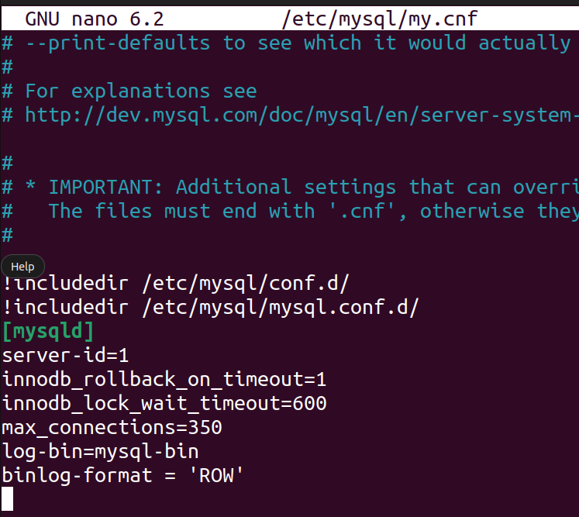

Step 28: **sudo systemctl restart mysql**

Step 29: **sudo mysql_secure_installation**

securing the MySQL server deployment.

Connecting to MySQL using a blank password.

VALIDATE PASSWORD COMPONENT can be used to test passwords

and improve security. It checks the strength of password

and allows the users to set only those passwords which are

secure enough. Would you like to setup VALIDATE PASSWORD component?

Press y|Y for Yes, any other key for No: y

There are three levels of password validation policy:

LOW Length >= 8

MEDIUM Length >= 8, numeric, mixed case, and special characters

STRONG Length >= 8, numeric, mixed case, special characters and dictionary file

Please enter 0 = LOW, 1 = MEDIUM and 2 = STRONG: 0

Skipping password set for root as authentication with auth_socket is used by default.

If you would like to use password authentication instead, this can be done with the "ALTER_USER" command.

See https://dev.mysql.com/doc/refman/8.0/en/alter-user.html#alter-user-password-management for more

information.

By default, a MySQL installation has an anonymous user,

allowing anyone to log into MySQL without having to have

a user account created for them. This is intended only for

testing, and to make the installation go a bit smoother.

You should remove them before moving into a production

environment.

Remove anonymous users? (Press y|Y for Yes, any other key for No) : y

Success.

Normally, root should only be allowed to connect from

'localhost'. This ensures that someone cannot guess at

the root password from the network.

Disallow root login remotely? (Press y|Y for Yes, any other key for No) : y

Success.

By default, MySQL comes with a database named 'test' that

anyone can access. This is also intended only for testing,

and should be removed before moving into a production

environment.

Remove test database and access to it? (Press y|Y for Yes, any other key for No) : y

- Dropping test database...

Success.

- Removing privileges on test database...

Success.

Reloading the privilege tables will ensure that all changes

made so far will take effect immediately.

Reload privilege tables now? (Press y|Y for Yes, any other key for No) : y

Success.

All done!

Step 30: **sudo mysql**

-- Create the cloud and cloud_usage databases

CREATE DATABASE `cloud`;

CREATE DATABASE `cloud_usage`;

-- Create the cloud user

CREATE USER cloud@`localhost` identified by '<password>';

CREATE USER cloud@'localhost' identified by '123@Msql';

CREATE USER cloud@`%` identified by '<password>';

CREATE USER cloud@'%' identified by '1234@Sql';

-- Grant all privileges to the cloud user on the databases

GRANT ALL ON cloud.* to cloud@`localhost`;

GRANT ALL ON cloud.* to cloud@`%`;

GRANT ALL ON cloud_usage.* to cloud@`localhost`;

GRANT ALL ON cloud_usage.* to cloud@`%`;

-- Grant process list privilege for all other databases

GRANT process ON *.* TO cloud@`localhost`;

GRANT process ON *.* TO cloud@`%`;

Exit

Step 31: **sudo cloudstack-setup-databases cloud:password@localhost --deploy-as=root**

Mysql user name:cloud [ OK ]

Mysql user password:****** [ OK ]

Mysql server ip:localhost [ OK ]

Mysql server port:3306 [ OK ]

Mysql root user name:root [ OK ]

Mysql root user password:****** [ OK ]

Checking Cloud database files ... [ OK ]

Checking local machine hostname ... [ OK ]

Checking SELinux setup ... [ OK ]

Detected local IP address as 192.168.145.132, will use as cluster management server node IP[ OK ]

Preparing /etc/cloudstack/management/db.properties [ OK ]

Applying /usr/share/cloudstack-management/setup/create-database.sql [ OK ]

Applying /usr/share/cloudstack-management/setup/create-schema.sql [ OK ]

Applying /usr/share/cloudstack-management/setup/create-database-premium.sql [ OK ]

Applying /usr/share/cloudstack-management/setup/create-schema-premium.sql [ OK ]

Applying /usr/share/cloudstack-management/setup/server-setup.sql [ OK ]

Applying /usr/share/cloudstack-management/setup/templates.sql [ OK ]

Processing encryption ... [ OK ]

Finalizing setup ... [ OK ]

CloudStack has successfully initialized database, you can check your database configuration in

/etc/cloudstack/management/db.properties

Step 32: **sudo cloudstack-setup-management**

Starting to configure CloudStack Management Server:

Configure CloudStack Management Server ...[OK]

CloudStack Management Server setup is Done!

Please ensure ports 8080, 8250, 8443, and 9090 are opened and not firewalled for the management server

and not in use by other processes on this host.

Step 33: **sudo ufw allow mysql**

Rules updated

Rules updated (v6)

Step 34: **sudo mkdir -p /export/primary**

Step 35: **sudo mkdir -p /export/secondary**

Step 36: **sudo nano /etc/exports**

Insert the line: /export *(rw,async,no_root_squash,no_subtree_check)

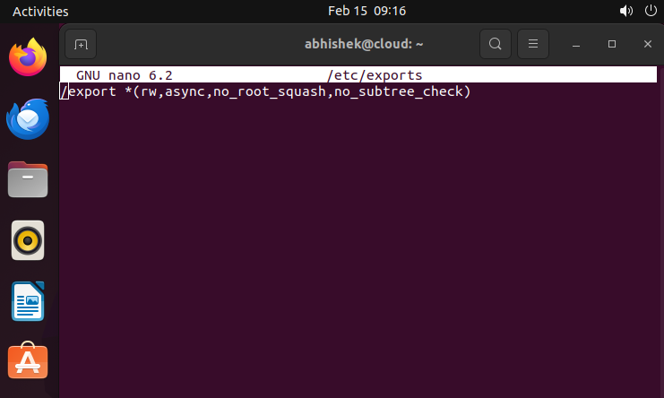

Step 37: **sudo apt install nfs-kernel-server**

Reading package lists... Done

Building dependency tree

Reading state information... Done

The following packages were automatically installed and are no longer required:

gir1.2-goa-1.0 libfwupdplugin1 libopts25 libxmlb1 sntp

Use 'sudo apt autoremove' to remove them.

The following NEW packages will be installed:

nfs-kernel-server

0 upgraded, 1 newly installed, 0 to remove and 3 not upgraded.

Need to get 98.8 kB of archives.

After this operation, 420 kB of additional disk space will be used.

Get:1 http://us.archive.ubuntu.com/ubuntu focal-updates/main amd64 nfs-kernel-server amd64 1:1.3.4-

2.5ubuntu3.5 [98.8 kB]

Fetched 98.8 kB in 4s (27.2 kB/s)

Selecting previously unselected package nfs-kernel-server.

(Reading database ... 170053 files and directories currently installed.)

Preparing to unpack .../nfs-kernel-server_1%3a1.3.4-2.5ubuntu3.5_amd64.deb ...

Unpacking nfs-kernel-server (1:1.3.4-2.5ubuntu3.5) ...

Setting up nfs-kernel-server (1:1.3.4-2.5ubuntu3.5) ...

Created symlink /etc/systemd/system/multi-user.target.wants/nfs-server.service →

/lib/systemd/system/nfs-server.service.

Creating config file /etc/default/nfs-kernel-server with new version

Processing triggers for man-db (2.9.1-1) ...

Processing triggers for systemd (245.4-4ubuntu3.23) ...

Step 36: **sudo exportfs -a**

Step 37: **service nfs-kernel-server restart**

--I got problem--

(

First step: sudo apt remove nfs-common

Then: sudo apt install nfs-kernel-server

)

Step 38: **sudo mkdir -p /mnt/primary /mnt/secondary**

Step 39: **sudo echo "192.168.11.159:/export/primary /mnt/primary nfs rsize=8192,wsize=8192,timeo=14,intr,vers=3,noauto 0 2" >> /etc/fstab**

bash: /etc/fstab: Permission denied

Step 40: **sudo chmod 777 /etc/fstab**

Step 41: **sudo echo "192.168.11.159:/export/primary /mnt/primary nfs rsize=8192,wsize=8192,timeo=14,intr,vers=3,noauto 0 2" >> /etc/fstab**

Step 42: **sudo echo "192.168.11.159:/export/secondary /mnt/secondary nfs rsize=8192,wsize=8192,timeo=14,intr,vers=3,noauto 0 2" >> /etc/fstab**

Step 43: **sudo mount /mnt/primary**

Step 44: **sudo mount /mnt/secondary**

Step 45: Open the Browser and type the url: http://192.168.11.159:8080/

The following Page will open:

Step 46: Provide the default Credentials:

Username: admin, Password: password

The following Page will open

Screenshots--

