Project Report on

Online Charity Management

at

U. V. Patel College of Engineering



Guide : | Prepared By:
Prof. Ritesh Upadhyay
Malvika Oza (19012011027)
Aman Panchal (19012011029)

B.Tech Semester VII
(Computer Engineering)

Submitted to,
Department of Computer Engineeiring
U.V. Patel College of Engineering
Ganpat University, Kherva - 384 012

ACKNOWLEDGEMENT

This satisfaction that successful completion of any task would be incomplete without the mention of people whose ceaseless cooperation it made it possible, whose constant guidance and encouragement crown all efforts with success. We are grateful to our guide Mr. Ritesh Upadhyay for the guidance, inspiration and constructive suggestions that helpful us in the preparation of this project. We also thank our colleagues who have helped in successful completion of the project.

ABSTRACT

This Project is to develop for Charity to raise funds online, Online appointment feature for birthday party or any other activities, Online Children adaption service and many more. Even if any food item remains in any function people can send request to charity. Charity employees can check all kinds of reports after the login.

- Introduction:

This document is the Software Requirements Specifications for Online Charity. The following document which provides the complete Software Requirements Specification (SRS) for “Online Charity”.

  - Purpose:

The purpose of this document is to present a detailed description of the Online Chartiy. It will explain the purpose and features of the system, the interfaces of the system, what the system will do, the constraints under which it must operate and how the system will react to external stimuli. This document is intended for both the stakeholders and the developers of the system.

Hope for Hopeless is the non-profit organization which helps old people, poor people, Mentally challenging peoples which is situated in Mehsana, Gujarat.

The main purpose of this project is to develop for Hope for Hopeless charity which helps to raise funds online, Online appointment feature for birthday party or any other activities, Online Children adaption service and many more. Even if any food item remains in any function people can send request to charity. Charity employees can check all kinds of reports after the login.

  - Overview:

The remainder of this document includes three chapters and appendixes. The second one provides an overview of the system functionality and system interaction with other systems. This chapter also explains the system constraints and assumptions about the product. The third chapter provides the requirements specification in detailed terms and a description of the different system interfaces. Different specification techniques are used in order to specify the requirements more precisely for different audiences.

  - Objective:

Hope for Hopeless is the non-profit organization which helps Old people, Poor people, Mentally Challenging peoples which is situated in Mehsana, Gujarat.

The main objectives of this project is to develop the Hope for Hopeless charity which helps to raise funds through online, Online appointment feature for birthday celebration or any other activities ,Online Children adaption service and many more. Even if any food item remains in any function people can send request to charity. Charity employees can check all kinds of reports after the login.

This project helps charities to increase operational efficiencies and reduce costs by eliminating much manual paperwork.

Donors and charity Managements can see donor names, donation amounts, payment date time and transaction details.

Donors or public visitors can view all the information about charity through online.

  - Tools and Technology:

Tools | Platform
Front End | PHP
Back End | MySQL Server

Hardware Requirements:

• System-Windows XP/Windows 7

• Operating Processor-Intel dual core

• RAM-1GB

• Hard Disk-Minimum 40 GB

• Keyboard, monitor and mouse

Software Requirements:

• IDE: Visual Studio

• XMAPP Server

• Apache PHP

• MYSQL database Server

- Functional Requirements

  - The project has following modules:

- Donor module: This module is for donors to make an online donation. Donors need to register their profile before donation. They can login and they can check donations records and other reports.
Sub modules are:
- Donor Register module
- Donor Login module
- Donor profile module
- Change password module

- Donation module: This module provides the key functions to automate and streamline the process of donation including printing and issuing receipts. Donors can make payment through online.
Sub modules are:
- Make donation
- View paid donation report
- Generate receipt

- Fund Raiser module: Fundraising is the process of seeking and gathering voluntary financial contributions by engaging, businesses, charitable foundations, or governmental agencies. This module allows charity to raise fund request in need to the various registered donor. Donors can view and donate in the fund raiser module. Management can view reports of previous fund raiser details and donation report.
Sub modules are:
- Create fund raiser request
- View fund raiser request
- Pay fund raiser

- Food donors module: The mission of this modules is to end food waste and hunger to make “Hunger Free”. This module recovers surplus food from weddings, parties and functions and donate it to charity members. Donors can send request to charity people for food.
Sub modules are:
- Send Request
- View Requests

- Online appointment module: Donor needs to take appointment before visiting Charity. Admin or management has rights to Approve or Reject donors visiting request. Donors can view appointment approvals after login.
Sub modules are:
- Send Appointment request
- View Appointment Requests
- Approve/Reject Appointments

- Child adaption service module: This module has Online Parent Registration for child adoption. User can search database of children available for adoption using any criteria. The adaption process will complete after legal process.

Sub modules are:
- View children
- Online Parent Registration form
- View adaption

- Members record module: This module shows members who stay in Charity. Donors can view members profile details through online
Sub modules are:
- Add members
- View members

- Photo Gallery module: This module stores Photo album and gallery records.
Sub modules are:
- Create Gallery
- View gallery
- Upload photos
- View photos

- Employee account module: This module has two types of users. One is admin and another is employee. Admin is having full authority of the website. Admin or employees can login using credentials.
Sub modules are:
- Dashboard module
- Add employee
- View employees
- Change password
- Update profile

- Report module: Admin or employees can generate and download reports related to donors, fund raiser, received donation, food donations, etc. This report includes donors profile, history of donations, members record and many more.
Sub modules are:
- Donors report
- Donation report
- Fund raiser report
- Food Donors report
- Others

  - Other non-functional requirements:

- Performance Requirements:
This section lists the performance requirements expected from this Project:
- The users shall be able to add any records fewer than 5 seconds.
- The users shall be able to view any records fewer than 10 seconds.
- The navigation between pages shall take fewer than 5 seconds.

- Safety Requirements:
- No safety requirements have been identified.
- Security Requirements:
- Users shall be required to log in to the System for all operations except viewing a items.
- The system shall permit only staff members who are on the list of authorized Menu Managers to create or edit items.
- Software Quality Attributes:
- If the connection between the user and the system is broken prior to payment being either confirmed or canceled, the System shall enable the user to recover an incomplete payment.

- System Design:

  - Context Flow Diagram:
Context flow diagram is a top level data flow diagram. It only contains one process node that generalises the function of the entire system in relationship to external entities. In context diagram the entire system is treated as a single process and all its inputs, outputs, sinks and sources are identified and shown.

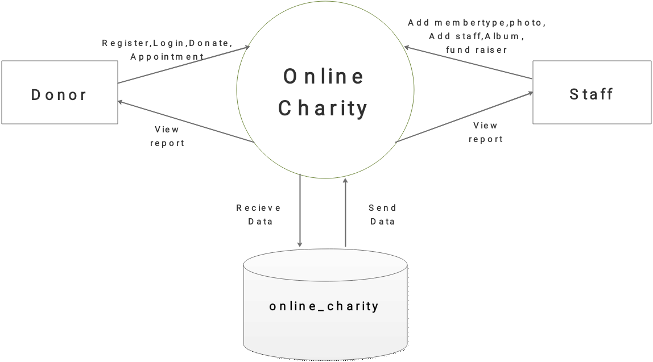
Context Flow Diagram (Level 0):

  - Entity-Relationship Diagram:
An entity-relationship (ER) diagram is a specialized graphic that illustrates the relationships between entities in a database. ER diagrams often use symbols to represent three different types of information. Boxes are commonly used to represent entities. Diamonds are normally used to represent relationships and ovals are used to represent attributes.

ER Diagram:

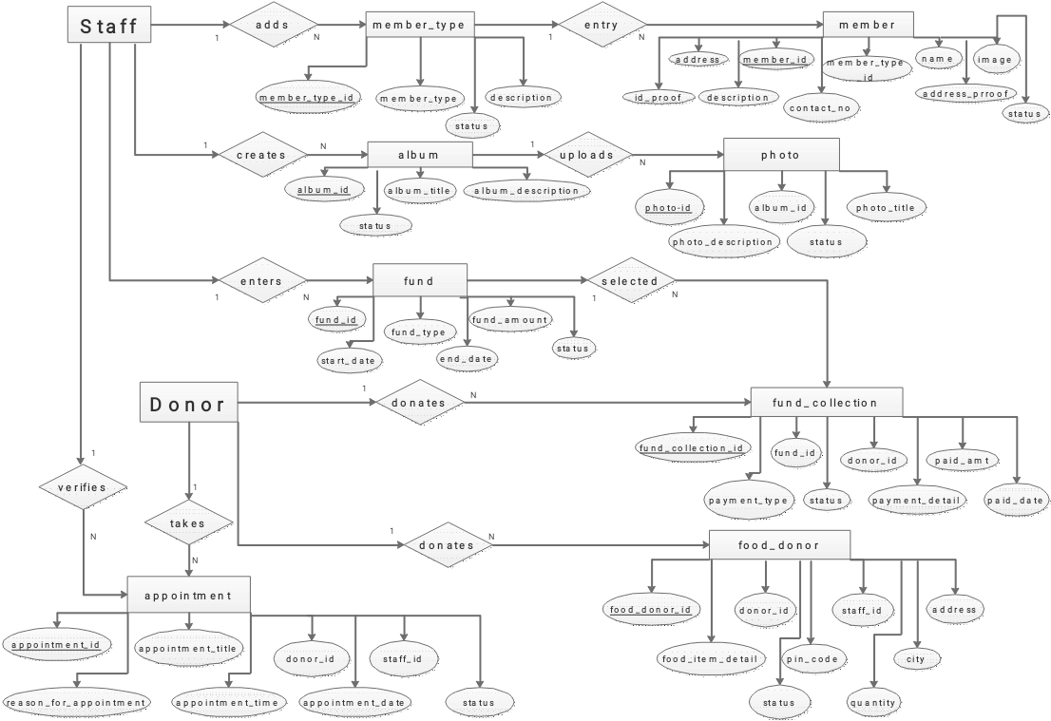

  - Activity Diagram:

  - Data Flow Diagram :

A data flow diagram is a graphical representation of the flow of data through an information system. A data flow diagram can also be used for the visualization of the data processing. It is common practice for a designer to draw a context level DFD. It shows the interaction between the system and the outside entities. This context level DFD, is then exploded to show more detail of the system being modelled.

A DFD represents flow of data through a system. Data flow diagrams are commonly used during problem analysis. It views a system as a function that performs the input into the desired output. A DFD shows movement of data through the different transformations or processes in the system.

Data Flow diagrams can be used to provide the end users with the physical idea of where the data they input ultimately has an effect upon the structure of whole system from order to dispatch to restock how any system is developed can be determined through data flow diagram. The appropriate register saved in database and maintained by appropriate authorities.

Notations in the DFD :






    - Top Level DFD-Level-1:
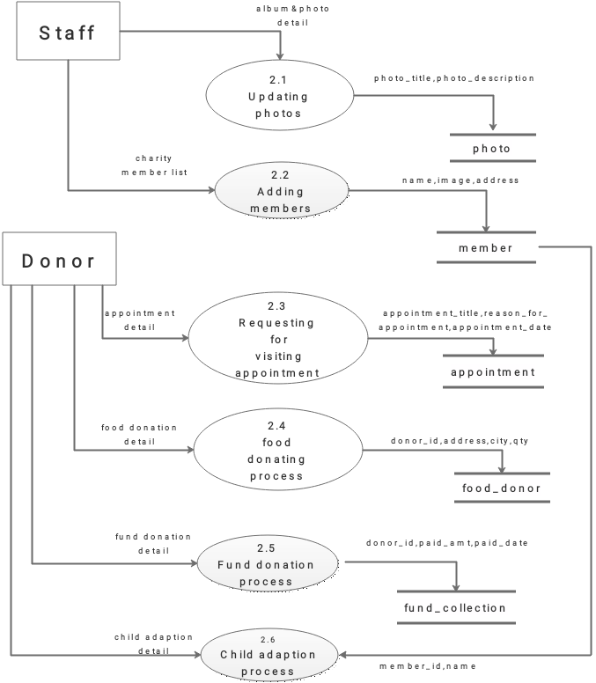

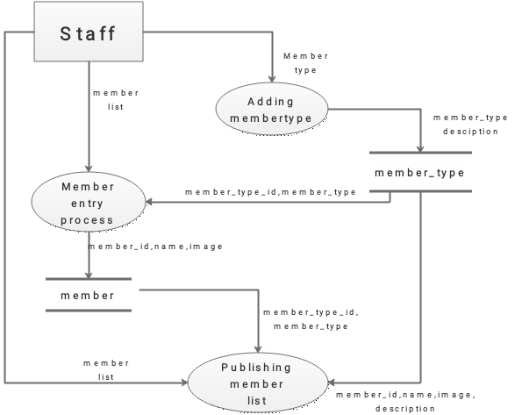
    - DFD Level 2.2:

    - DFD Level 2.3:
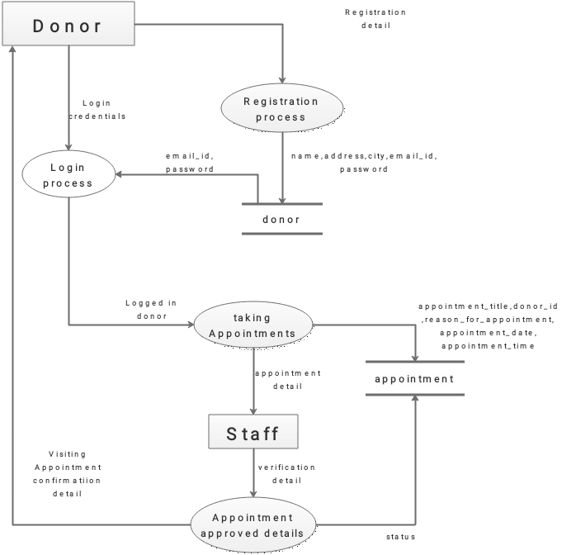

    - DFD Level 2.4:

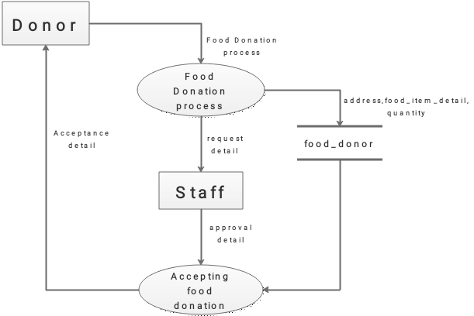

    - DFD Level 2.5:
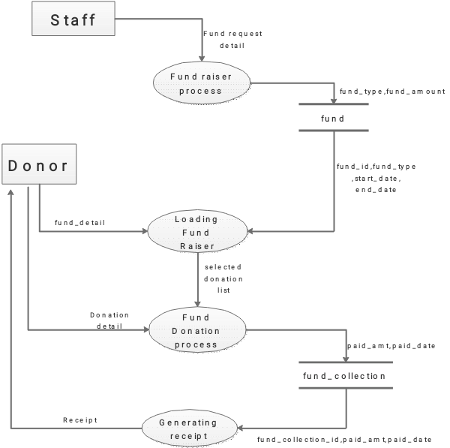

    - DFD Level 2.6:

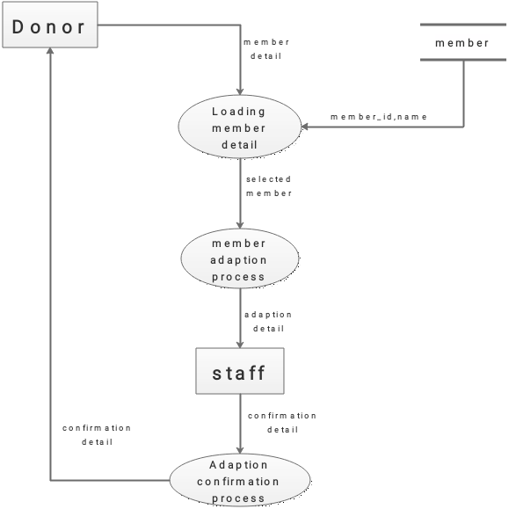

- Data Base Design:
The database is physically implemented using MySQL.
The database online_charity for is organized into 10 tables:
- Donor
- Fund
- Fund collection
- member
- member type
- staff
- appointment
- album
- photo
- food donor

