MAIN OUTPUT WHICH STATE THAT UP IS POLLUTED GROUPED MEAN

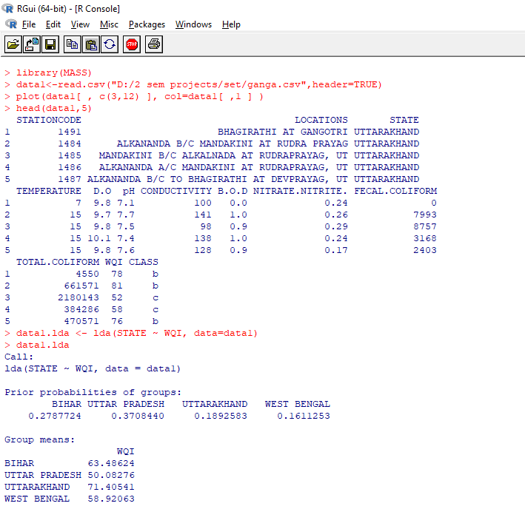

BOX PLOT DIAGRAM FOR WATER QUALITY INDEX AND STATE

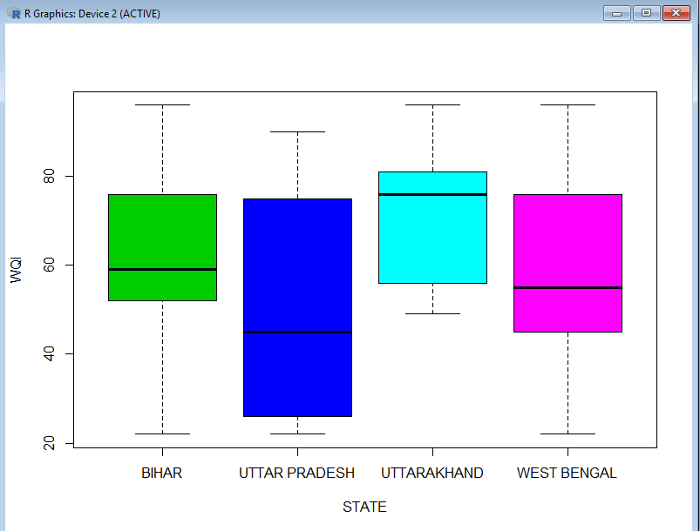

Handling N\A values

C:\Users\Aman\Pictures\na values code.PNG

Q values

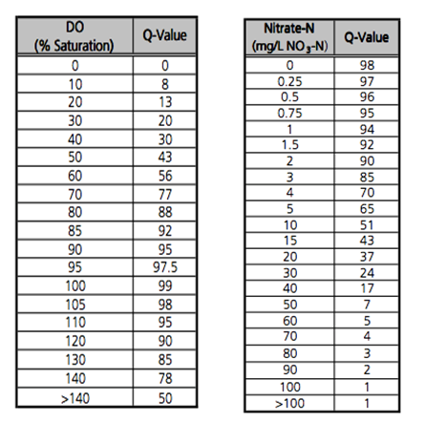

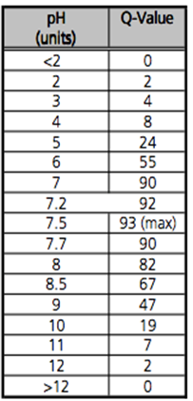

EXAMPLE

