*A project report on*

**Location and Healthcare Monitoring of Deployed Troop**

*Submitted in partial fulfilment for the award of the degree of*

**Master’s in Computer Application (MCA)**

*By*

**AMAN VERMA 17MCA0241**



**School of Information Technology & Engineering [SITE]**

April, 2019

**ABSTRACT**

In this proposed work, we are envisioning a military wellbeing administration (MHS) stage which depends on progressive IoT design. We propose a semantic Edge based system display which assumes a noteworthy job for conveying strategic and non-strategic snippet of data over the system. Further, the trading of data and resulting information investigation on the MHS makes the framework keen and smart. The soldier Health and Position Tracking System enables military to follow the present GPS position of soldier and furthermore checks the wellbeing status including temperature of body and beats of soldier. The System will likewise comprises of an additional component with the assistance of that soldier can request help physically or send a trouble flag to military if he is in need. The GPS modem sends the latitude and longitude position with association plan with the help of that military can pursue the present position of the soldier. The framework might be exceptionally useful for getting wellbeing status data of soldier and giving them moment help. Information will be sent to cloud legitimately from where we can download as csv and can apply data mining for examination.

The IoT makes the whole checking procedure quick, effective and the choices can be taken in less measure of time. So by utilizing these types of gear we are attempting to execute the essential life guarding framework for soldier in minimal effort and high dependability

**Chapter-1**

**INTRODUCTION**

**1.1 Introduction**

In this day and age the reliability of country is based on soldier fighting thus the wellbeing of the soldiers is considered as fundamental job in it. Concerning the soldiers wellbeing there are numerous instruments to look upon their wellbeing status just as ammo on the soldiers. In soldiers security, bio-sensors frameworks gives diverse sorts of little physiological sensors, biomedical sensor, transmission modules and preparing capacities, and would thus have the way to motivate minimal effort wearable unpretentious answers for wellbeing checking. GPS used to log the longitude and latitude so that direction can be known easily. These gadgets are being added to weapons, guns, and militaries, for example, the Israeli an Army which are investigating the likelihood of installing GPS gadgets into soldier’s vests and outfits with the objective that field leaders can follow their soldier's developments continuously. IOT module can be utilized for viable scope of rapid transmission, short-range and soldier-to-soldier remote interchanges that will be required to hand-off data on situational mindfulness, strategic directions, and secret observation related information amid exceptional tasks surveillance and different missions. .So by using these equipment’s we are trying to implement the basic lifeguarding system for soldier in low cost and high reliability.

**1.2 Overview**

The soldier Health and Position Tracking System enables military to follow the present GPS position of soldier and furthermore checks the wellbeing status including body temperature and heart pulses. There is a need to build up a wearable innovation which isn't massive and disseminates next to no power in the safeguard area so the area and indispensable wellbeing parameters of the soldiers can be followed continuously when he is on the front line. Utilizing this soldier route framework, main station can control the soldier to attain the ideal goal. So this paper centre around following location soldier from GPS, which is helpful for control room station to know the precise area of soldier and appropriately they with guide them. The biosensor comprise of temperature and heartbeat sensor. The primary quintessence of this undertaking is that it is a task based on IoT . IoT frameworks are frameworks that comprise of interrelated machines (mechanical or advanced), processing gadgets, creatures, people groups and different items which have one of a kind functionalities. Utilizing the IoT, they can be spoted without the PC to PC and human to PC intercession. The pertinence of IoT in Soldier Navigation and Health Observation framework is ongoing area and wellbeing parameters of soldiers on front are observed by the base station without the soldier contributing anything. The IoT convert whole checking procedure quick, effective and the choices can be taken in less measure of time.

**1.3 Scope of the Project**

This framework empowers GPS (Global situating frameworks) following of these soldiers. A sensor tolerant observing framework to gauge heartbeat and temperature of the patient by utilizing installed arrange. Simply interfacing the temperature sensor and heartbeat sensor creating the wellbeing condition subtleties. The gadget cautions when heartbeat and temperature surpass the edge esteem. This limit esteem is characterized by the developer at the season of programming the smaller scale controller. The framework might be exceptionally useful for getting wellbeing status data of soldier and giving them moment help.

Information will be sent to cloud legitimately from where we can download as csv and can apply AI calculations for examination.

**1.4 Objective**

So this paper center around following the area of soldier from GPS, which is helpful for control room station to know the accurate area of soldier and in like manner they with guide them. The biosensor comprise of temperature sensor and heart beat sensor. The primary pith of this task is that it is an Internet of Things (IoT) based undertaking.

**Chapter- 2**

**Literature Survey**

**[1]** In this paper they are giving security to the wellbeing tracker framework in the medical clinic of VIP's and area by utilizing a RFID framework to give a security. The Health Tracker framework joins remote sensor systems, existing RFID and Vital Sign Monitoring innovation to all the while screen crucial signs while monitoring the clients' area. The remotely screen indispensable indications of clients progressively and inform medicinal staff and relatives promptly in the event of crises and expected to improve the social insurance framework.

**[2]** In this paper they associated sensors to gauge parameters like body temperature, heart beat rate. A smaller scale controller board is utilized for investigating the contributions from the patient and any variation from the norm felt by the patient makes the observing framework give an alert. Medical clinics are keeping up the patient's subtleties. All the patient's outcomes are demonstrating a framework utilizing implanted sensor. As indicated by accessibility of sensors or advancement in biomedical pattern more parameter can be sense and screen which will radically improve the proficiency of the remote checking framework in biomedical field.

**[3]** In this paper studies progresses in IoT-based medicinal services advancements and audits the cutting edge organize structures/stages, applications, and modern solutions. It investigations unmistakable IoT security and protection highlights, including security prerequisites, risk models, and assault scientific classifications from the social insurance viewpoint. It characterizes how the IOT gives a possibility to medicinal services framework. Sensors, gadgets, web applications, and different innovations have persuaded reasonable social insurance contraptions and associated wellbeing administrations to unimaginably grow the capability of IoT-based human services administrations for further advancement.

**[4]** This paper centre on following the area of trooper from GPS, which is valuable for control room station to know the precise area of warrior and in like manner they with guide them. Fighters can constantly discuss anyplace with the base station utilizing RF, DS-SS, FH-SS which can help warrior to impart among their squad individuals at whatever point in need. Utilization of 328 controller and low power requiring peripherals lessen by and large power use of framework.

**[5]** In this paper they has audited the cutting edge arrange structures/stages, applications, and modern patterns in IoT-based human services arrangements. The paper also breaks down unmistakable IoT security and protection highlights, including security necessities, risk models, and assault scientific classifications from the human services viewpoint. It also talked about how diverse developments can be utilized in a medicinal services setting.

**[6]** This paper highlights the real security prerequisites in BSN-based present day human services framework and a protected IoT-based medicinal services framework utilizing BSN, called BSN-Mind. Data is uploaded in cloud server and android based mobile app is used. Use of Raspberry Pi microcontroller and Wi-Fi module can be seen.

**[7]** In this paper they concentrated on wearable and implantable body zone arrange frameworks for consistent observing of patients. Use of electrodes, sophisticated sensors and biosensors has been done. Radio transceiver is used for communication and ZigBee as communication as communication protocol.

**Chapter-3**

**Data Mining**

**3.1 INTRODUCTION TO DATA MINING AND ITS ARCHITECTURE**

Data mining creates field nowadays in view of the risky advancement of data. Data mining is express task of evacuating captivating (non-immaterial, unquestionable, already dark and conceivably profitable) precedents or gaining from parcel of data. The substitute names that can be sued to the expression "data mining" are:

I. Knowledge revelation (mining) of databases (KDD), learning extraction, data/design examination, data archaic exploration, data digging, data gathering, and business knowledge.

II. Searching for information (intriguing examples) in our data.

The accompanying chart demonstrates the structure of an ordinary data mining

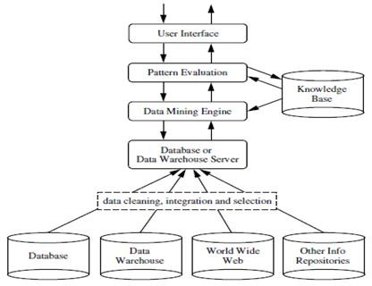

Architecture of a typical data mining system

**Explanation:** Database, data transport centre, "Web", or other data vault imply one or a strategy of databases, data stockrooms, spreadsheets, or different sorts of data annals. Data cleaning and data mix strategy might be performed on the data. The database or data course centre server is responsible for bringing the important data, in light of the client's data mining demand. The data base is utilized to control the intrigue or assess the enamouring idea of coming about points of reference. Data can join considered chains hugeness, used to manage properties or quality respects into various elements of thought. Learning, for example, client sentiments, which can be utilized to think about a model's intriguing quality with regards to light of its astonishing quality, may in like way be joined. Data mining motor contains a strategy of down to business modules for assignments, for instance , delineation, union and relationship examination, depiction, check, bundle examination, exceptional case examination, and improvement examination. Point of reference evaluation show is utilized to center the solicitation toward fascinating models and to channel through found models. The point of reference assessment model might be made with the mining module, subordinate upon the execution of the data mining methodology utilized. For gainful data mining, it is exceedingly supported to push the examination of model intriguing quality as huge as conceivable into the mining system in order to attach the pursuit to just the hypnotizing points of reference. The UI presents among clients and the data mining structure. It engages the client to connect with framework by choosing a data mining solicitation or errand. It offers data to help centre the enthusiasm by performing exploratory data mining in context on the broadly engaging data mining works out as expected. It engages the client to analyse database and data movement center courses of action or data structures, review mined points of reference, and envision the models in various structures.

**3. 2 TERMS RELATED TO DATA MINING**

A few terms that we need to remember for adopting data mining strategies are:

a. Data - Data is only summary of crude statistical data points; it might be a gathering of letters in order, characters, numbers, and digits.

b. Data – When the data is prepared, it offers approach for data and it accomplished when the data is pre-prepared and cleaned. It is the data deprived of repetition and decreased to the base important to portray the data.

Knowledge – Knowledge is coordinated data, including certainties and their relations, which have been seen, found, or learned as our "psychological pictures". Learning can be viewed as data at an unusual condition of consultation and speculation”. If (Headache=No AND Vomiting = Yes

AND Temperature = High) THEN Viral illness = Yes

The above is an example to show how data gets transferred to knowledge.

Decision – After applying suitable analysis and synthesis measures, we can extract decision from the knowledge which helps us in several successful outcomes.

A suitable minimal approach for stepping stone in data mining can be depicted with the help of diagram:

Data

Information

Knowledge

Decision

Basic suitable approach to data mining

**3.3 APPLICATION AREAS OF DATA MINING**

Data mining is intersection of a few orders. It isn't kept to a specific one; it obliges a few utilitarian territories like that of insights, database innovation, perception, design portrayal.

This can be depicted with the help of following diagram:

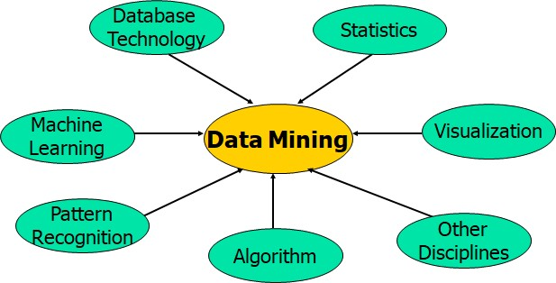

Data mining: a confluence of multiple disciplines

**3.4 USES OF DATA MINING**

The data mining is used each application field and to each application user can be depicted with the diagram:

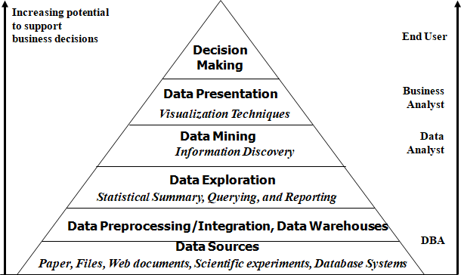

Data mining and business intelligence uses from the lowest to the highest hierarchy in a data mining pyramid.

**3.5 MULTIDIMENSIONAL VIEW OF DATA MINING**

The mined data can be of the going with sorts:

i.Relational – It suggests a database structure, also considered a database the board system (DBMS). DBMS involves between related data, known as database.

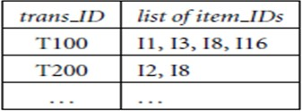ii. Data dispersion focus - It suggests a storage facility of data assembled from various sources, set away under a bound together example, and that regularly abides at a lone site.

**Fig.5** An example of transactional database system

iii. Esteem based – It involves a report where each record addresses a trade. A trade regularly fuses an exceptional trade character number (trans ID) and a summary of the things making up a trade.

iv. Stream – It is the data streaming all through a perception stage progressively.

v. Article arranged – Here every substance is considered as an item. Items that share a typical arrangement of properties can be gathered into an article class, where each item is an occasion of its class.

vi. Worldly, succession and time-arrangement databases – A transient database ordinarily stores social data that incorporate time-related properties. These properties may include timestamps, having distinctive semantics. An arrangement database stores groupings of requested occasions, may or may not a solid idea of time. Precedents incorporate client shopping arrangements, Web click streams, and natural successions. A period arrangement database stores successions of qualities or occasions got over rehashed estimations of time (e.g., hourly, day by day, week by week). Precedents incorporate data gathered from the stock trade, stock control, and the perception of regular wonders (like temperature and wind).

vii. Spatial and spatiotemporal databases – Spatial databases contain spatial-related data and might be spoken to in raster position, comprising of n-dimensional piece maps or pixel maps.

viii. Heterogeneous and inheritance databases – A heterogeneous database comprises of a lot of interconnected, self-ruling part databases. An inheritance database is a gathering of heterogeneous databases that joins various types of data frameworks. The heterogeneous databases in an inheritance database might be associated by intra or between PC systems.

ix. Content and mixed media – Text databases are databases containing word portrayals for objects. Words, sentences or sections (item particulars, blunder or bug reports, cautioning messages, outline reports, notes, or different records). May be profoundly unstructured, for example, some pages on www. Sight and sound databases store picture, sound and video data. It is utilized in applications, for example, picture content-based recovery, voice message frameworks, video-on-request frameworks, the World Wide Web, and discourse based UIs that perceive spoken directions. It can bolster huge articles, since data items, for example, video can require gigabytes of capacity.

x. WWW – It alludes to conveyed data administrations, for example, Yahoo, Google, and AltaVista, give rich, around the world, on-line data administrations, where data objects are combined to encourage intuitive access. Clients looking for data of intrigue cross starting with one article by means of connections then onto the next. It catches client get to designs in such dispersed data conditions is called Web utilization mining (or Weblog mining).

**3.6 DATA MINING ACTIVITY**

Data mining undertakings can be characterized into two kinds:

i. Descriptive

ii. Predictive

Each of the types can be again further classified into sub-classes as follows:

Predictive tasks can be again subdivided into the following types:

i. Classification

ii. Regression

iii. Time series analysis

iv. Prediction

Descriptive tasks can be again further subdivided into the following types:

i. Clustering

ii. Summarization

iii. Association Rules

iv. Sequence discovery

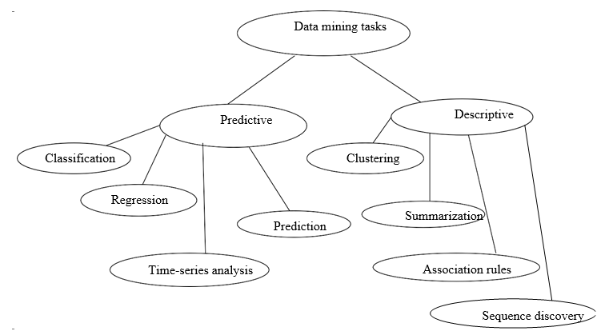This can be presented in form of a figure as follows:

**Chapter-4**

**Hardware and Software requirements**

**4.1 Hardware requirements**

**4.1.1 Temperature sensor:**

Temperature is the most-estimated process variable in mechanical computerization. Most ordinarily, a temperature sensor is used to change the temperature motivator to an electrical regard. Temperature Sensors are the best approach to examine temperatures successfully and to control temperature in industrials applications. A broad refinement can be made between temperature sensor types. Sensors shift a lot in properties, for instance, contact-way, temperature run, adjusting procedure and identifying part. With the help of moulding circuits, the sensor will mirror the difference in natural temperature. Temperature is the most-estimated process variable in modern computerization. Most generally, a temperature sensor is utilized to change over temperature incentive to an electrical esteem. Sensors are the best approach to examine temperatures precisely and to control temperature in industrials applications. /In the temperature reasonable module we made, we use the LM34 course of action of temperature sensors. The LM34 course of action are precision consolidated circuit temperature sensors, whose yield voltage is legitimately relating to the Fahrenheit temperature.

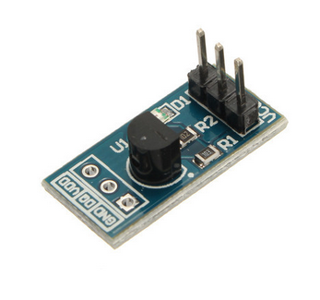

The LM34 therefore has leverage over direct temperature sensors adjusted in degrees Kelvin, as the client isn't required to subtract an extensive consistent voltage from its yield to get advantageous Fahrenheit scaling. The LM34 does not require any outer alignment or cutting to give average correctness’s of ±1.2°F at room temperature and ±11.2°F over a full - 50 to +300°F temperature run. The LM34 is evaluated to work over a -50o to +300o F temperature run.



**Circuit diagram for the LM34 temperature sensor functional module**

It is anything but difficult to incorporate the LM34 arrangement in a temperature estimating application. The yield voltage of LM34 is directly corresponding to the Fahrenheit temperature, it has a Linear +10.0 mV/°F scale factor which implies that you will get n*10.0 mV yield voltage if nature temperature is n°F. The LM34 arrangement is accessible bundled in hermetic TO-46 transistor bundles, while the LM34C, LM34CA and LM34D are likewise accessible in the plastic TO-92 transistor bundle. The LM34D is likewise accessible in a 8-lead surface mount little layout bundle. In our useful module, LM34H in metal can bundle (TO-46) is utilized in the practical module, it is vital to realize that the wiring of sensor ought to be founded on the places of the main sticks in various bundles.

# DESCRIPTION

The temperature sensor practical module has two sections: module box of capacity and head test. The LM34 temperature sensor is scaled on test head. Be mindful so as to ensure that the sensor is appropriately mounted on the test head. - 55°C to +150°C.In reality LM34 and LM35.The wiring of LM 35 is equivalent to that of LM34. If it's not too much trouble allude to the datasheets of LM34 and LM35 for progressively nitty gritty bundling and highlights data.

**4.1.2 Heartbeat sensor**

The task of the board is exceptionally basic. Subsequent to driving the board from a 3-5.5V supply, the Enable (EN) stick must be dismantled high to initiate the IR sensor. Next, place the tip of your index finger tenderly over the sensor all over. Your finger should be still and ought not to press excessively hard on the sensor. Inside a few seconds the circuit settles and you will see the LED blazing synchronously with your heart beat. You can encourage the yield flag (Volt) to either a computerized I/O or an ADC input stick of the microcontroller for estimation of rate of heartbeat in BPM. The yield voltage waveform can likewise be seen on an oscilloscope. I associated Digilent's Analog Discovery device to check the information PPG and the yield waveforms from the two LPF stages.

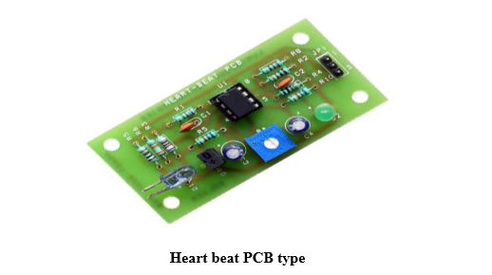

**PRODUCT DESCRIPTION**

Sensor of heartbeat deals with an extremely fundamental standard of optoelectronics. Everything necessary to gauge you pulse is a couple of LED and LDR and a microcontroller. IR drove emanates infrared radiation and surface mirrors the infrared light. Contingent upon reflectivity of exterior measure of light reflected differs this reflected light is made episode on turn around one-sided IR sensor which results backward spillage current. Measure of electron-gap sets produced relies upon power of occurrence IR radiation. Progressively exceptional radiation results in increasingly switch spillage current. This current can be gone through a resistor to get corresponding voltage. In this way as power of occurrence beams fluctuates, voltage crosswise over resistor will differ as needs be.

**How it works**

The heartbeat sensor is dependent on standard of photograph plethysmography. It gauges the adjustment in blood volume through the organ of body which causes an adjustment in the light power through that organ (a vascular district). In the event of utilizations where rate of heartbeat is to be checked, the planning of the beats is increasingly essential. The stream of blood volume is chosen by the rate of heart beats and since light is consumed by blood, the flag beats are equal to beats of heartbeat.

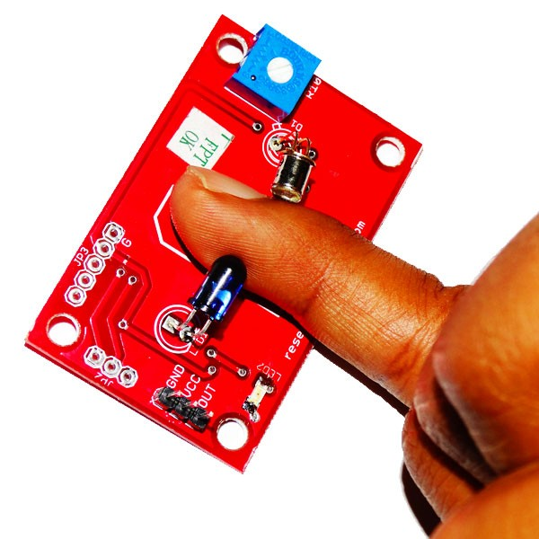

**FEATURES**

• Indication of Heart beat by LED.

• Moment yield advanced flag for legitimately associating with microcontroller.

• Compact Size.

• Working Voltage +5V DC

**APPLICATIONS**

• Navigation systems.

• Environmental control systems.

• Augmentative communication devices.

• Emergency response systems.

**4.1.3 GPS**

The GPS is a space-based satellite course framework that gives zone and time data in every single climate condition, wherever on or close to the Earth where there is an unhindered unmistakable pathway to no under four GPS satellites. The framework gives fundamental abilities to military, typical and business clients around the globe. It is kept up by the US government and is uninhibitedly made accessible to anyone with a GPS authority. GPS is comprised of three sections: somewhere in the range of 24 and 32 satellites circling the Earth, four control and observing stations on Earth, and the GPS collectors claimed by clients. GPS satellites communicate signals through space that are utilized by GPS collectors to give three-dimensional area (scope, longitude, and elevation) in addition to the time.

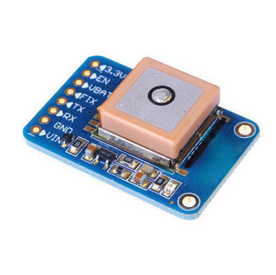

**How it work**

GPS satellites rotate around earth two times every day in an exact circle and transmit flag data to earth. The GPS recipients take this data and triangulation is used to compute the client's definite area. Fundamentally, the GPS gatherer considers the time a banner was transmitted by a satellite with the time it was gotten. The time differentiate tells the GPS authority how far away the satellite is. By and by, with partition estimations from two or three additional satellites, the authority can choose the customer's position and show it on the unit's electronic guide.

A GPS recipient must be bolted on to the flag of somewhere around three satellites to figure a 2D position (scope and longitude) and track development. With something like four satellites in view, the beneficiary can choose the customer's 3D position (degree, longitude and rise). At the point when the customer's position has been settled, the GPS unit can figure other information, for instance, speed, bearing, track, trip discrete, partition to objective, day break and dusk time and nightfall time and that's only the tip of the iceberg.

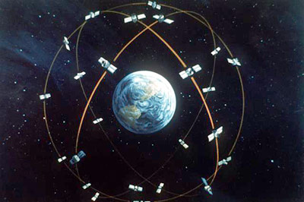

**4.1.4 NODE –MCU**- NodeMCU ESP-12E ESP8266

Complete name: NodeMCU ESP-12E ESP8266 WiFi Lua IoT CH340. The Node Mcu is an open-source firmware and improvement unit that encourages you to model your IoT item with few Lua content lines.The Development Kit dependent on ESP8266, integates GPIO, PWM, IIC, 1-Wire and ADC across the board.

The ESP8266 is the name of a miniaturized scale controller planned by Espressif Systems. The ESP8266 itself is an independent WiFi organizing arrangement offering as a scaffold from existing miniaturized scale controller to WiFi and is likewise equipped for running independent applications.

It is an open source IoT arrange. It joins firmware which continues running on the ESP8266 Wi-Fi SoC from Espressif Systems, and hardware which relies upon the ESP-12 module.The term "NodeMCU" as is normally done implies the firmware rather than the dev packs. The firmware uses the Lua scripting language. It depends on the eLua venture, and based on the Espressif Non-OS SDK for ESP8266. It relies upon the eLua adventure, and dependent on the Espressif Non-OS SDK for ESP8266. It uses many open source adventures, for instance, lua-cjson,and spiffs.

**SCHEMATIC DIAGRAM:**

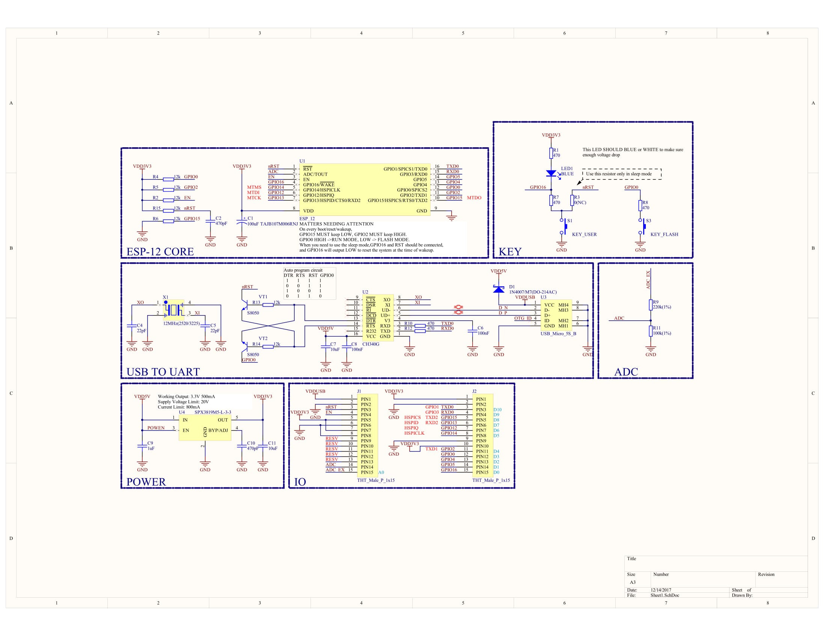

**Features**

* Utilizations CH340G rather than CP2102.
* NodeMCU has worked in USB-TTL sequential with overly solid modern quality CH340G for predominant dependability on every single upheld stage.
* Communication interface voltage: 3.3V.
* Antenna type: Built-in PCB receiving wire is accessible.
* Wireless 802.11 b/g/n standard
* WiFi at 2.4GHz, support WPA/WPA2 security mode
* Support STA/AP/STA + AP three working modes
* Built-in TCP/IP convention stack to help different TCP Client associations (5 MAX)
* D0 ~ D8, SD1 ~ SD3: utilized as GPIO, PWM, IIC, and so forth., port driver capacity 15mA
* AD0: 1 channel ADC
* Power input: 4.5V ~ 9V (10VMAX), USB-controlled
* AD0: 1 channel ADC
* Power input: 4.5V ~ 9V (10VMAX), USB-controlled
* Current: Continuous current transmission=70mA (200mA MAX), standby :<200uA.
* Transfer rate: 110-460800bps
* Support UART/GPIO information correspondence interface
* Remote firmware update (OTA)
* Support Smart Link Smart Networking
* Working temperature: - 40° c ~ + 125° c
* Drive Type: Dual high-control H-connect driver
* ESP8266 has IO Pin
* Don't have to download resetting
* A incredible arrangement of devices to create ESP8266Flash size: 4MByte
* Open-source
* Interactive
* Programmable
* Low cost
* Simple Smart WI-FI enabled

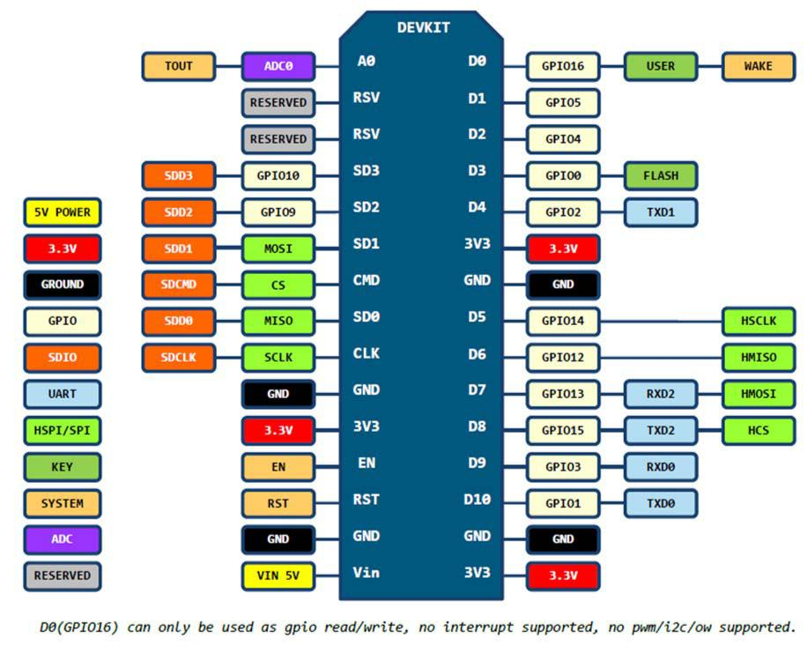**Pin Definition:**

**Starting with node MCU:**

You need to power the board with external power supply. I utilized 5V/GND from Arduino fueled by 12V/1A connector on VIN/G on NodeMCU base left (USB looking down) - in light of the fact that that is the thing that I had promptly accessible around my work area when testing a bunch of tests. A few units may work without outside power, other may not come up as sequential port, some may cycle between sequential port appearing and disappearing. NodeMCU does not have large power draw, but power surges from its own working are most likely resetting the device. Some poeple have had success installing additional electrolytic capacitor on the device.

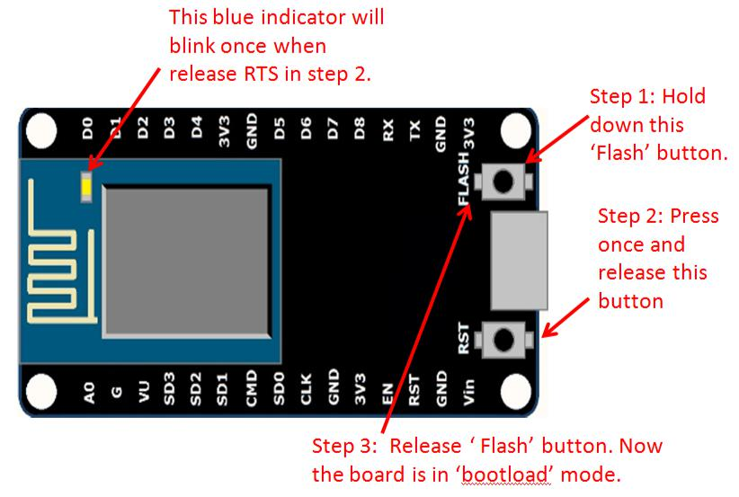

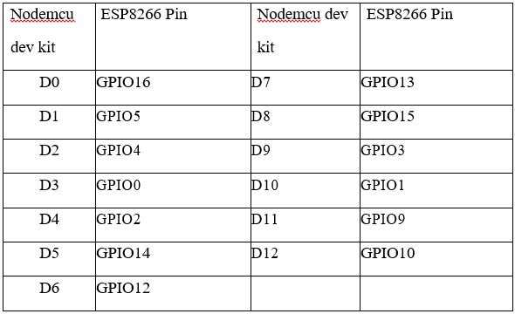

D0 or GPIO16 can be used only as a read and write pin, no other options like PWM/I2C are supported by this pin.

Web Resources:

* + [ESP8266 Lua Nodemcu WIFI Module](http://handsontec.com/index.php/product/esp8266-lua-nodemcu-wifi-board/)
  + [ESP8266 Breadboard Friendly Module](http://handsontec.com/index.php/product/esp8266-module-bread-board-friendly/)
  + [ESP8266 Remote Serial WIFI Module](http://handsontec.com/index.php/product/esp8266-remote-serial-wifi-module/)
  + [PL2303HX USB-UART Converter Cable](http://handsontec.com/index.php/product/pl2303hx-usb-to-rs232-converter-cable/)
    - **4.1.5 Male to Male jumper wire**

A jumper wire is a leading wire used to exchange electrical flags between two focuses in a circuit. The wires can either be utilized to change circuits or to analyze issues inside a circuit.

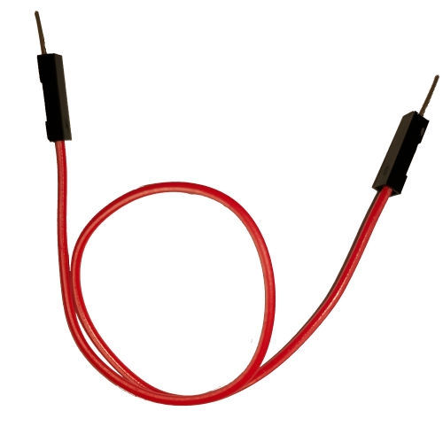

**4.1.6 Male to Female jumper wires**

There is additionally a helpful link that connects to a Sensor Shield toward one side, however has separate female attachments on the opposite end.

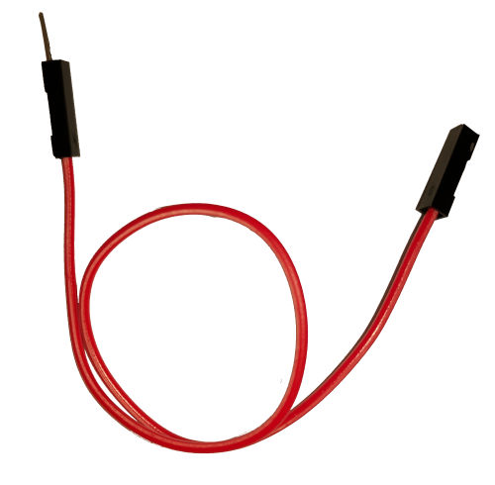

* + - **4.1.7 Female to Female jumper wires**

It is basically used to join or assemble the parts of a breadboard or other model or test circuit, inside or with other gear or segments, without patching.

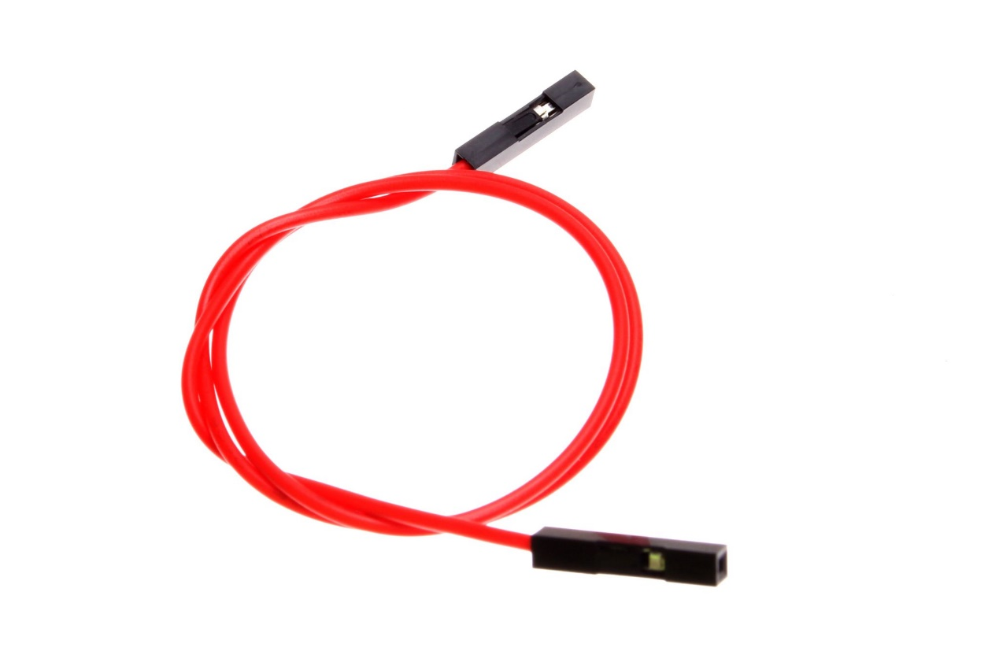

**4.2 Software requirements**

**4.2.1 Arduino.IDE**

A program for Arduino might be written in any programming language for a compiler that produces parallel machine code for the objective processor. The Arduino venture gives the Arduino coordinated advancement condition (IDE), which is a cross-stage application and can be written in any language. It started from the IDE for the dialects Processing and Wiring. It incorporates a code supervisor with highlights, for example, content reordering, looking and supplanting content, programmed indenting, support coordinating, and linguistic structure featuring, and gives basic a single tick instruments to order and transfer projects to an Arduino board. It additionally contains a message zone, a content reassure, a toolbar with catches for basic capacities and a progressive system of activity menus. A program composed with the IDE for Arduino is termed as a sketch. Arduino IDE is an open-source programming program that enables clients to compose and transfer code inside a continuous workplace. The platform is absolutely flexible with any Arduino software board.

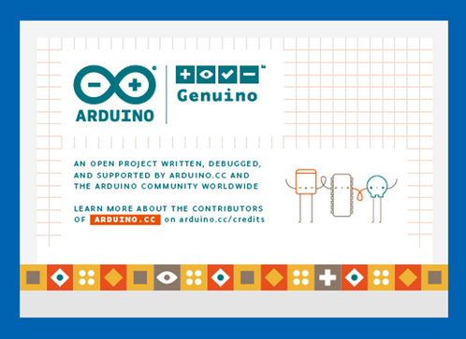

**4.2.2 MQTT**

For creation of a correspondence organize in which different IoT gadgets can speak among each other by means of a MQTT dealer, it is crucial to organise IoT gadgets as MQTT customers. The MQTT is made on the most noteworthy purpose of TCP/IP stack, so the devices must have TCP/IP stack with them on the off chance that that they have to bestow to each other by methods for MQTT specialist. In this instructional exercise, an advanced cell and a work area will be orchestrated as MQTT clients. For making an android Smartphone MQTT customer, MQTT dashboard application which is an android application can be utilized.

. This android application underpins MQTT convention to speak with other MQTT customers. For setting the PC as MQTT customer, MQTT focal point that is a chrome add-on that additionally bolsters MQTT convention can be utilized. When the versatile and PC are set MQTT customers, they can convey through MQTT Broker.

The fundamental favoured angle of using MQTT is it is exceptionally lightweight. So in case you are on an exceptionally moderate system, utilizing Firebase can be a weight since it utilizes HTTP and a generally high data transmission. In case your framework is truly untrustworthy, even a little flag drop can interfere with your correspondence with the IoT gadget. But since MQTT is so lightweight it can convey in most area of these situations and can be in all respects effectively used to transmit your IoT sensor/gadget readings.

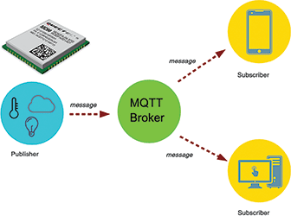

**4.2.3 Python**

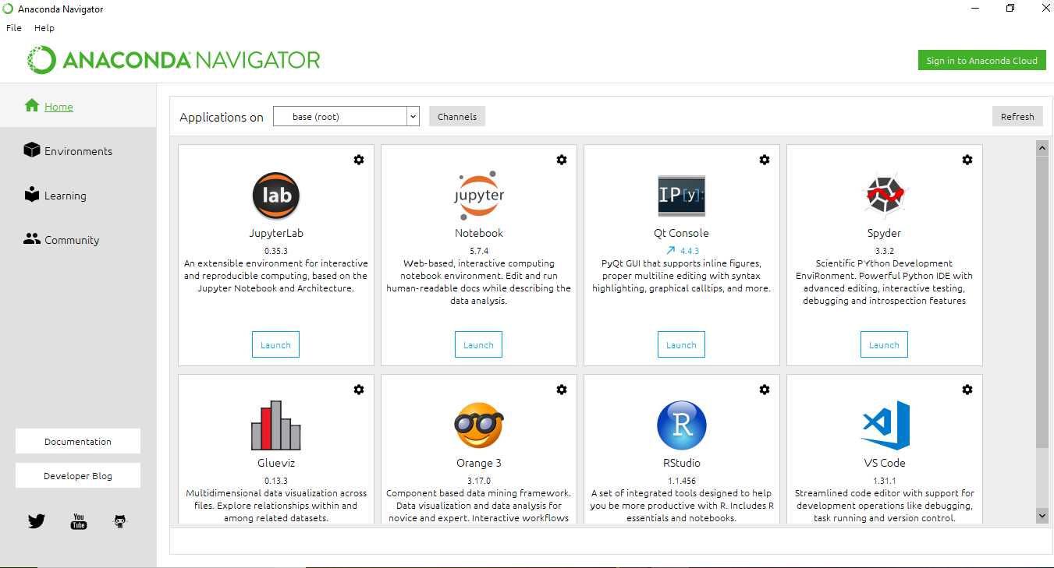Anaconda Navigator is a work area graphical UI incorporated into Anaconda that enables you to dispatch applications and effectively oversee conda bundles, conditions and channels without the need to utilize direction line directions.

UI of Anaconda IDE

There are several ways to run Python code. First let us discuss the various options for development enviroments. There are 3 main types of enviroments:

* Text editor
* Full IDEs(Integrated Development Environment)
* Notebook Environments

**Text editors**

* General editors for any text file i.e. they are general editors for any text file. They are designed in general format which can open any text files, JavaScript files etc.
* Works with a variety of file types.
* Can be customized with plugins and add-ons.
* 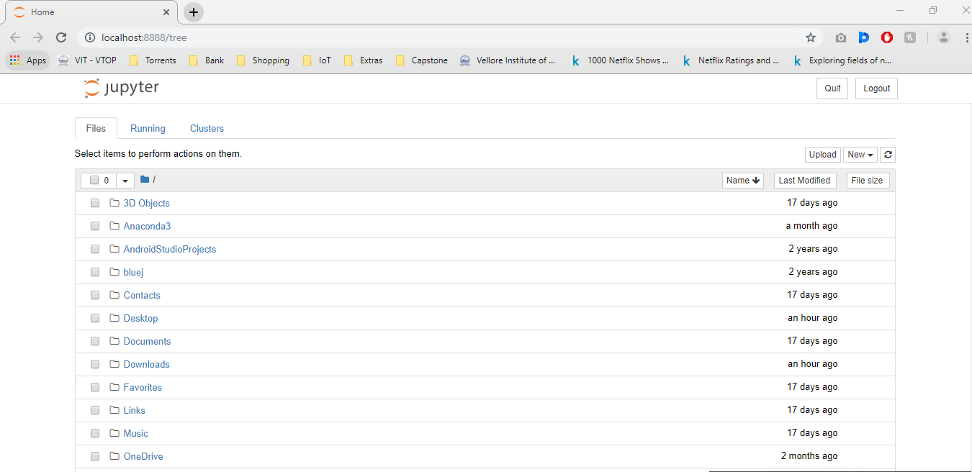Most popular text editors are Sublime Text and Atom.

UI of Jupiter

**For creating a new python file, click on New ->Python 3**

Now let us explore the Jupiter notebook environments and let’s see how what works. Search in computer for Anaconda Navigator, open that, and then launch the Jupiter Notebook. Once you click on that launch button notice that Brower automatically opens up to localhost: 8888 or localhost: 8889.Though Jupiter browser works in your browser, it does not require any internet connection. Everything happens locally. It just happens to open up in your browser as a convenience graphical interface for you’re to program intone you launch, you can see all the files in your computer

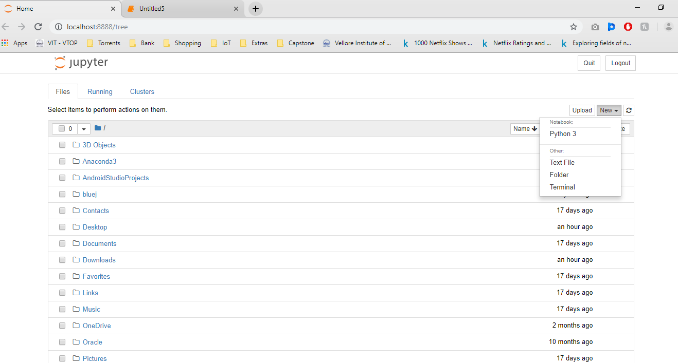

**Fig 13.** Jupiter Screen 2

**Full IDE**

Development Environments designed specifically for python.

Larger programs, larger file size.

Only community editions are free.

Designed specifically for python and lots of functionality.

Most popular are Pycharm and Spyder.

**Notebook Environments**

Great for learning

See input and output next to each other

Support in-line markdown notes, visualisations, videos and more

Special file formats that are not .py

Most popular is Jupyter Notebook

Now let us explore the Jupyter notebook environments and let’s see how what works. Search in computer for Anaconda Navigator, open that, and then launch the Jupyter Notebook. Once you click on that launch button notice that Brower automatically opens up to localhost: 8888 or localhost: 8889.Though Jupyter browser works in your browser, it does not require any internet connection. Everything happens locally. It just happens to open up in your browser as a convenience graphical interface for your to program intone you launch, you can see all the files in your computer.

**Chapter-5**

**Machine Learning**

**5.1 What is Machine learning?**

AI (ML) is the logical investigation of calculations and measurable models that PC frameworks use to successfully play out a particular undertaking without utilizing explicit instructions, depending on examples and inference instead. It is viewed as a subset of AI. AI calculations assemble a numerical model of test information, known as "training data", so as to settle on forecasts or choices without being expressly modified to play out the task. Machine learning calculations are utilized in a wide assortment of utilizations, for example, email sifting, and PC vision, where it is infeasible to build up a calculation of explicit guidelines for playing out the errand. AI is firmly identified with computational insights, which centres on making forecasts utilizing PCs. The investigation of scientific advancement conveys strategies, hypothesis and application spaces to the field of AI. Information mining is a field of concentrate inside AI, and spotlights on exploratory information investigation through unsupervised learning. In its application crosswise over business issues, AI is additionally alluded to as prescient examination.

**5.2 Algorithm Used**

**5.2.1 K-Means**

k-means clustring is a strategy for vector quantization, initially from flag preparing, that is famous for bunch examination in information mining. This outcomes in a dividing of the information space into Voronoi cells.

The issue is computationally hard (NP-hard); nonetheless, effective heuristic calculations combine rapidly to a neighborhood ideal. These are normally like the desire boost calculation for blends of Gaussian dispersions by means of an iterative refinement approach utilized by both k-menas and Gaussian blend demonstrating. They both use group focuses to display the information; be that as it may, k-implies bunching will in general discover bunches of similar spatial degree, while the desire boost system enables bunches to have distinctive shapes.

The calculation has a free relationship to the k-closest neighbor classifier, a well known AI strategy for characterization that is regularly mistaken for k-menas because of the name. Applying the 1-closest neighbor classifier to the group focuses gotten by k-implies arranges new information into the current bunches. This is known as closest centroid classifier or Rocchio calculation.

**5.2.2 Linear Regression**

This is a predictive analysis and is used mostly. According to this technique, dependent variable should be continuous and independent variable may be continuous or discrete and regression line should be linear.

Best fit straight line is fit to know the relation between independent variable and dependent variable.

y = a + bx +e

This is general form of equation where,

y = dependent variable

x = independent variable

a = intercept

b = slope of line

e = error term

The difference between linear and multiple regression is that number of independent variable will be greater than 1 in multiple regression whereas the linear regression gas only one independent variable.

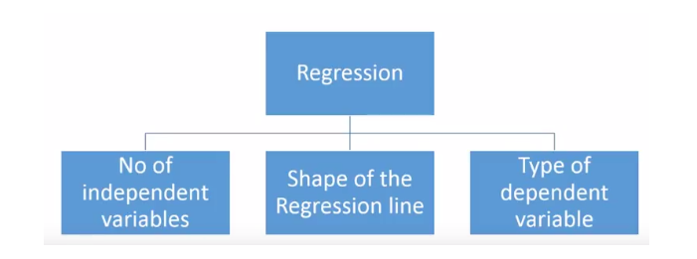

**Application of linear regression**

1. Trend line
2. Epidemiology
3. Finance
4. Economics
5. Environmental Science
6. Machine Learning

**Why linear regression is used**

1. Most common data analysis technique of statistic
2. For predictive analysis

**Advantages of linear regression**

1. Simple method
2. Easy to use and understand
3. Person does not require higher standard of mathematics to use and understand it
4. Works in almost most cases
5. It will tell the relationship between two variables even when it does not fit the data.

**Disadvantage of linear regression**

1. It assume that relationship between variables will be a straight line, which may be wrong in most cases.
2. Outlier influence the linear regression model
3. Another drawback is that on the off chance that we have various parameters than the quantity of tests accessible then the model begins to show the commotion as opposed to the connection between the factors.
4. Over ease real world problem
5. Not recommended for practical approach
6. Limited to linear relationships

**Chapter-6**

**Implementation**

**6.1 MODULE DESCRIPTION:**

**Power Supply Module**

In this module the required power supply of 5V is provided for all the devices with the suitable power source.

**Sensor module:**

Here we are using heart beat sensor to measure the pulse, temperature sensor to measure the temperature, GPS to get the position.

**Microcontroller and wifi module**:

Here we collect all the data from the sensor and process the data, these data’s will be sent to the cloud through wifi module.

**Cloud and android application:**

Here we store the processed data and sent to the respective user through an android application.

**Analysis**

When data is stored in cloud we will download the .CSV file from there and apply two algorithms that is K-means and Linear Regression.

**6.2 Work Flow Diagram**

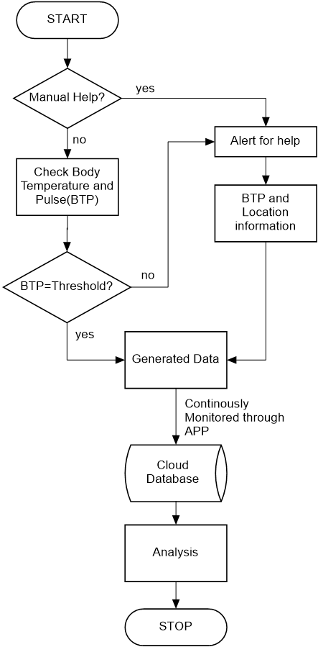

**6.3 Block diagram:**

**Soldier Section**

**IOT module**

**NODE-MCU**

**Heart beat Sensor**

**Power Supply**

**GPS**

**Temperature sensor**

**6.3.1 Connections**

**6.3.1.1 Power Supply: We can use power bank or any 5v battery.**

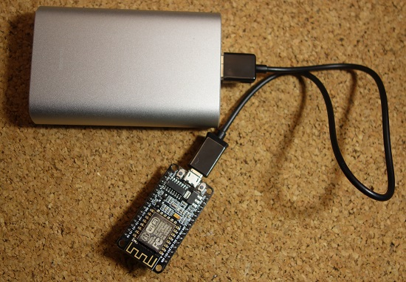

**6.3.1.2 Heart beat sensor:**

It need 3 pins one for power supply and the other two for input and output.

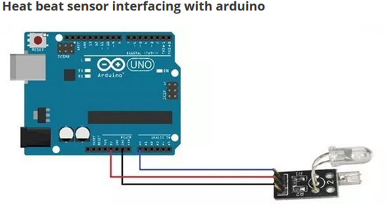

**6.3.1.3 Temperature Sensor**

It need 3 pins one for power supply and the other two for input and output.

1. Connect Arduino Uno GND to LM35 GND
2. Connect Arduino 5V pin to LM35 pin 1
3. Connect Arduino Uno Analog Pin 1 to LM35 pin OUT

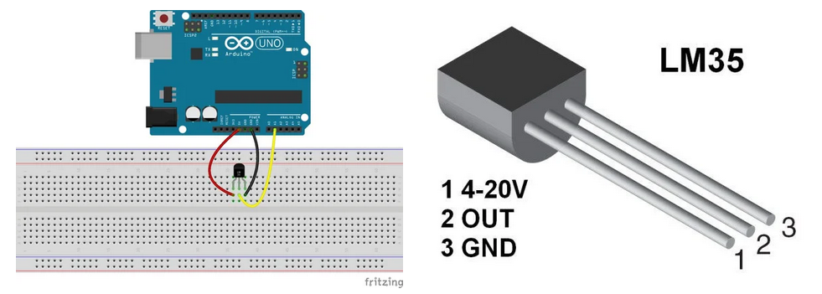

**6.3.1.4 GPS Module Connection**

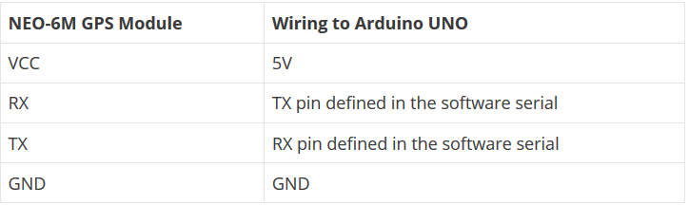

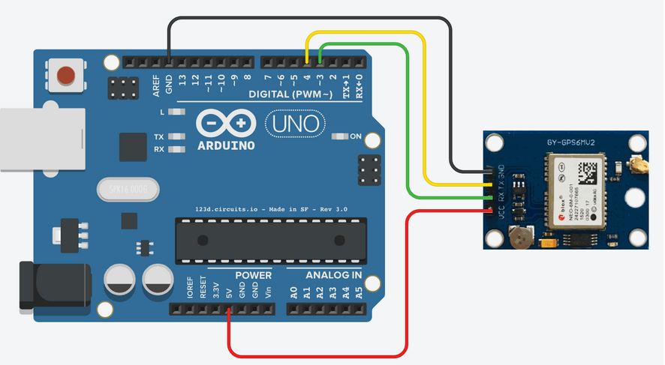

**6.3.2 Monitoring Section:**

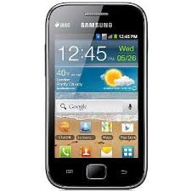

**PC**

For monitoring we can monitor through the mobile app or directly through the pc on serial monitor or MQTT software on laptop

**6.3.2.1 App connection**

* Download MQTT dashboard and install the app. After installation on the android phone, open the app. There will open a dashboard window. In that window, tap the Plus sign.
* There will open a new window for connection establishment.
* In the client ID field, set a unique name (a string) so that when mobile client will connect to the MQTT broker, the MQTT broker can easily identify and send or receive the packet data to that particular client only. The two clients should not have the same name. So, the client name should be unique. The client ID can be maximum 24 bytes.

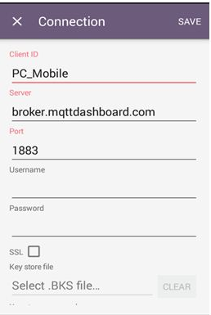

**6.3.2.2 MQTT for laptop connection**

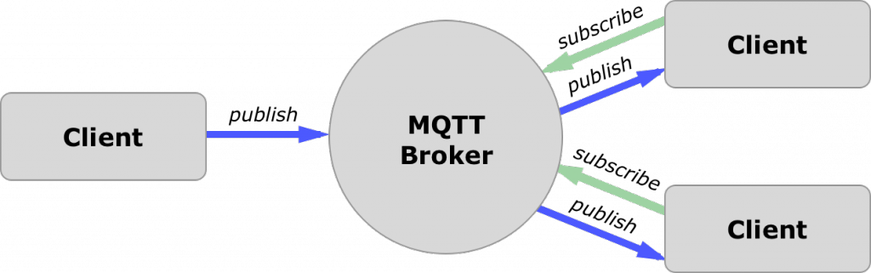

**What MQTT do?**

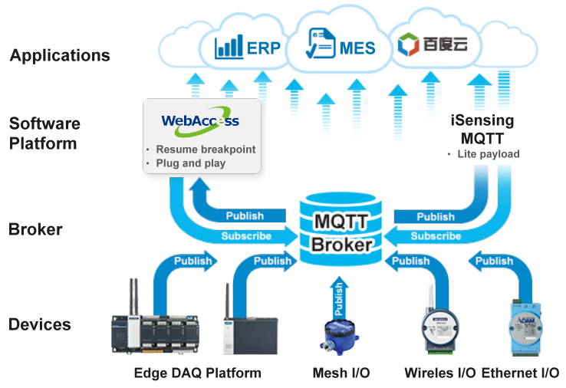

**Connection in MQTT**

* Download MQTT box in laptop.
* Click on create MQTT client.

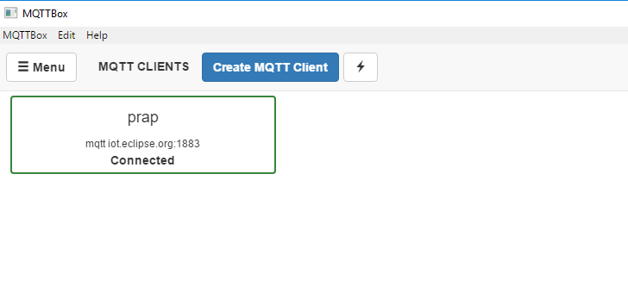

* Fill all the details like Client ID, Client Name, protocol , user name etc

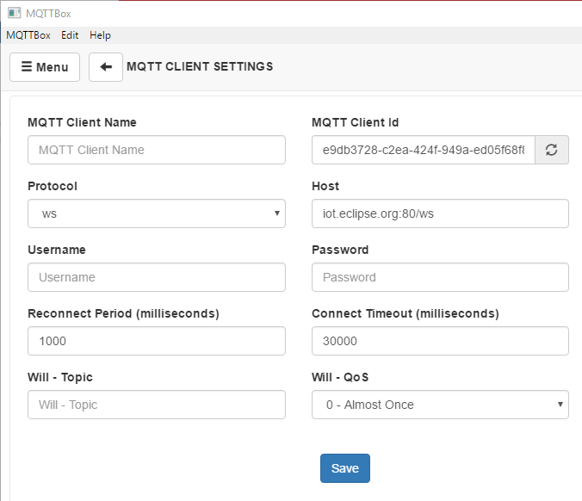

* Click on save and it will start.
* Then click on add subscriber and give the details.

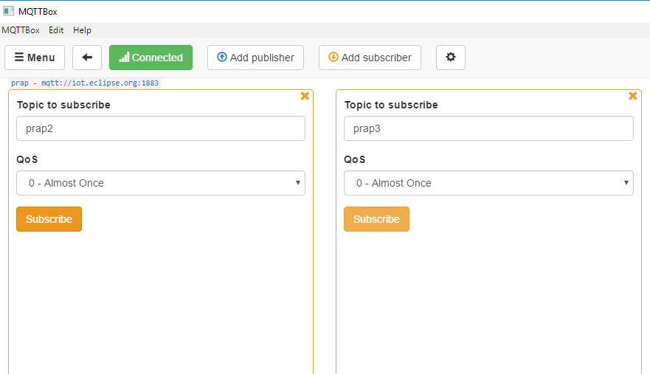

* It is distribute and buy in based (more on this later) very lightweight informing convention.
* Since it is lightweight, it tends to be utilized with associations which have an exceptionally low data transmission (Slow Speeds) or associations which are problematic.

**Chapter-7**

**Result and Conclusion**

**7.1 Working Model**

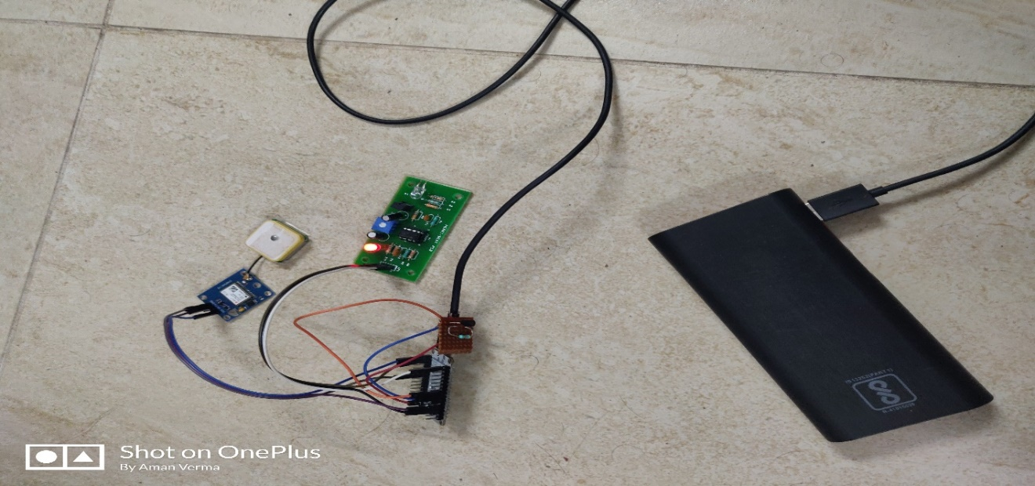

**7.2 Output on Serial Monitor**

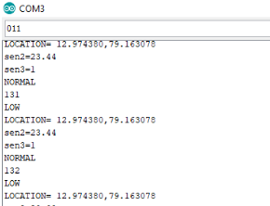

**7.3 Output on MQTT Server**

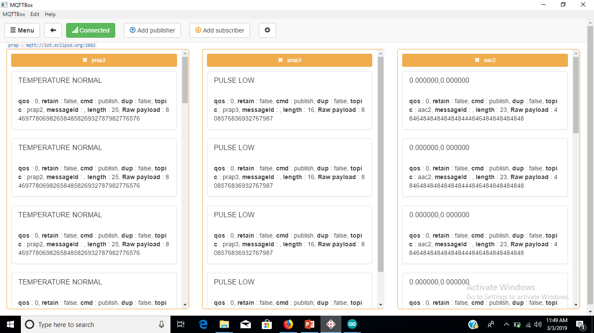

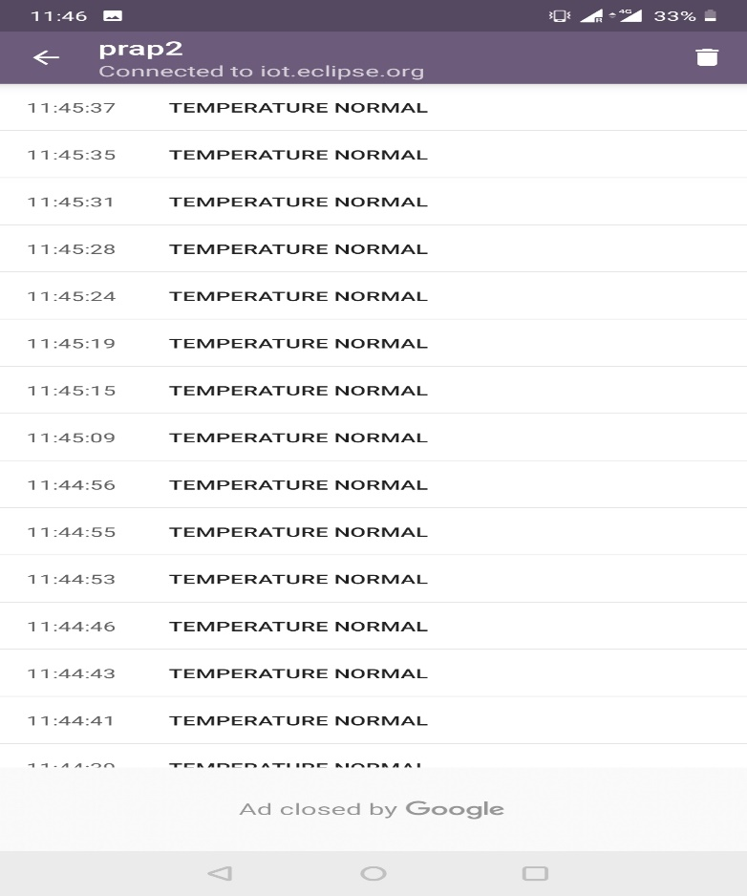**7.4 Output on MQTT dashboard app (for temperature sensor)**

**7.5 Output on MQTT dashboard app (for Heartbeat sensor)**

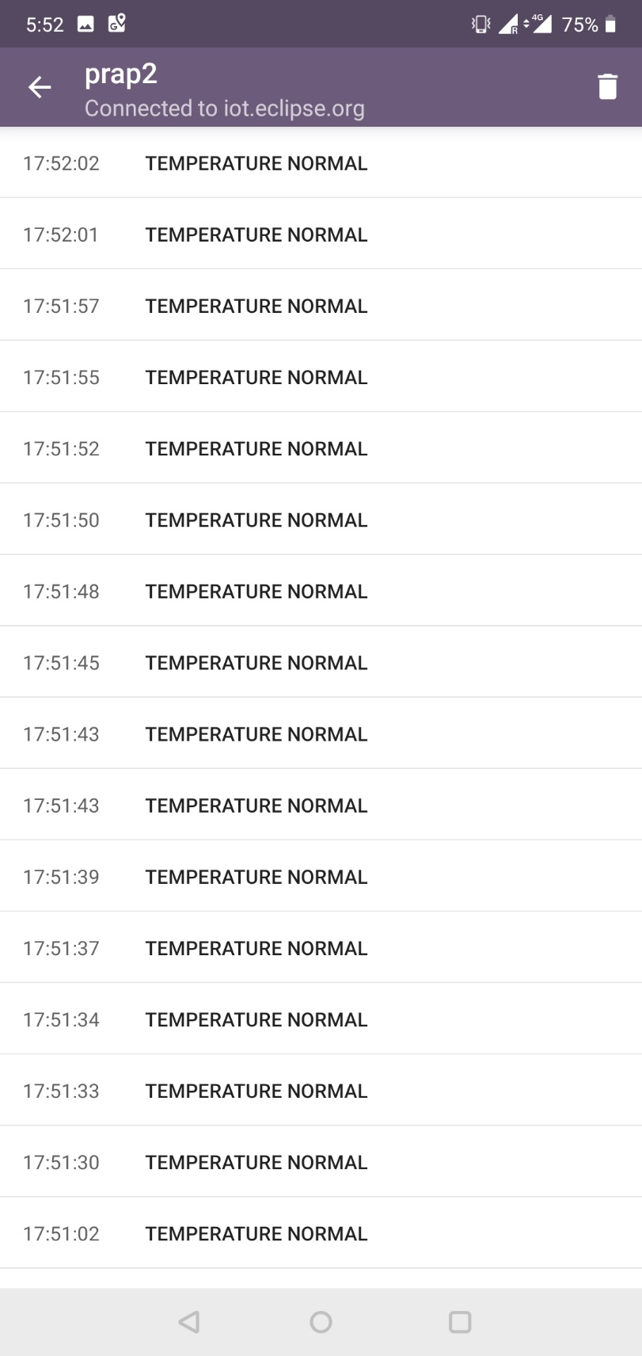

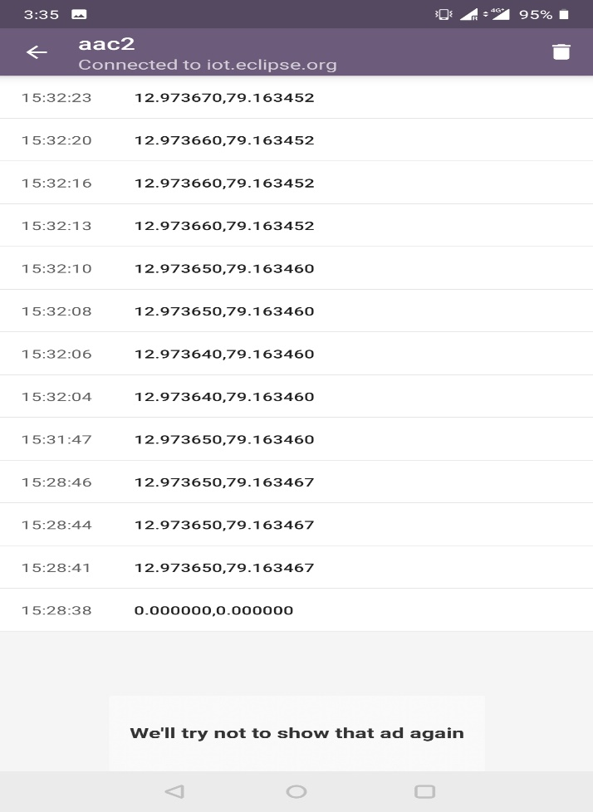**7.6 Output on MQTT dashboard app (for GPS sensor)**

**Conclusion**

A productive framework is being proposed which has a use of following the soldier's area and wellbeing parameters amid the war, which likewise summons the military or armed force officers to design the war procedures. Base station gets area of soldier from GPS and correspondence happens through the GSM modules. A vital administration of the base station is to direct the soldier on right way on the off chance that he is lost in the combat zone. The base station can get to the present status of the soldier which is shown on the PC and this framework utilizes the IOT. Thusly a quick move is made by sending salvage and help for the soldier or sending reinforcement for danger anticipated ahead.

**References**

1. Otto, C., Milenkovic, A., Sanders, C., & Jovanov, E. (2006). System architecture of a wireless body area sensor network for ubiquitous health monitoring. Journal of mobile multimedia, 1(4), 307-326.
2. M. Meenatchi, Dr. V. Baby Deepa (2016) Automatic Patient Monitoring Using Embedded Sensor Network International Journal of Advanced Research in Computer Science and Software Engineering Volume 6, ISSN:2277 128X
3. Islam, S. R., Kwak, D., Kabir, M. H., Hossain, M., & Kwak, K. S. (2015). The internet of things for health care: a comprehensive survey. IEEE Access, 3, 678-8708.
4. Monika V. Bhivarkar, Anuja G. Asole, P. B. Domkondwar (2018).

IOT and GPS Based Soldier Position Tracking and Health Monitoring System. International Journal of Emerging Technologies in Engineering Research (IJETER) Volume 6, Issue 1

1. S. M. RIAZUL ISLAM1, (Member, IEEE), DAEHAN KWAK2, MD. HUMAUN KABIR1, MAHMUD HOSSAIN3 AND KYUNG-SUP KWAK “The Internet of Things for Health Care: Comprehensiveo Survey”, Digital Object Identifier 10.1109/ACCESS.2015.2437951
2. Snehal Sanjay Kale 1, D. S. Bhagwat 2 ”Highly Secured IoT Based Health Care System for Elderly People using Body Sensor Network “ in International Journal of Innovative Research in Science, Engineering and Technology (An ISO 3297: 2007 Certified Organization) Vol. 5, Issue 10, October 2016 ISSN(Online) : 2319-875 ISSN (Print) : 2347-6710
3. Narendra Kumar3, Alok Aggrawal2 and Nidhi Gupta1” Wearable Sensors for Remote Healthcare Monitoring System” in International Journal of Engineering Trends and Technology- Volume3Issue1- 2012