A Minor Project Report

On

**“MODErN wireless entry/exit system based on rfid and gsm technology”**

SUBMITTED IN PARTIAL FULFILLMENT FOR THE AWARD OF DEGREE OF

**Bachelor of Technology**

**IN**

**Electronics and Communication Engineering**



**Submitted By:** **Under the Guidance Of**

**NAME(s) (ENROLMENT) yogesh kumar**

**DEPARTMENT OF ELECTRONICS AND COMMUNICATION ENGINEERING**

**JAYPEE INSTITUTE OF INFORMATION TECHNOLOGY, NOIDA (U.P.)**

**MAY, 2016**

**CERTIFICATE**

This is to certify that the thesis entitled, “**----------**” submitted by **-------** in partial fulfillment of the requirements for the award of Bachelor of Technology Degree in **Electronics and Communication Engineering** of the Jaypee Institute of InformationTechnology, Noida is an authentic work carried out by her/him under my supervision and guidance. The matter embodied in this Report is original and has not been submitted for the award of any other degree.

**Signature of Supervisor:**

**Name of the Supervisor:**

**ECE Department,**

**JIIT, Sec-128,**

**Noida-201301**

**Dated:**

**DECLARATION**

We hereby declare that this written submission represents our own ideas in our own words and where others' ideas or words have been included, have adequately cited and referenced the original sources. We also declare that we have adhered to all principles of academic honesty and integrity and   have not   misrepresented   or   fabricated   or   falsified   any   idea/data/fact/source   in   our submission.

Place:

Date:

Name:

Enrollment:

Name:

Enrollment:

Name:

Enrollment:

**ABSTRACT**

The main goal of this project is to design and implement a smart wireless entry/exit system based on RFID (Radio Frequency Identification) and GSM technology which can be organized in bank, secured offices and homes. In this system only authentic person can have access through gate. We have implemented a wireless entry/exit system based on RFID and GSM technology containing intruder identification system using RFID and GSM which can activate, authenticate, and validate the user and allow in real time for secure access. The main advantage of using passive RFID and GSM is more secure than other systems. This system consists of AVR microcontroller, RFID reader, GSM modem, PIR Motion Sensor and LCD, in this system The RFID reader reads the ID number from passive tag and send to the microcontroller, if the ID number is invalid then microcontroller send the SMS to the authenticated person mobile number, to inform the presence of an unauthorized person, if the person forcefully enters, the PIR Motion Sensor detects the presence of someone and the authenticated person receives a SMS using GSM Modem. If the ID number is valid then the microcontroller disables PIR Motion Sensor so the user is authorized to get access through the door. This system is more secure than other systems. This system can also creates a log containing check-in and check-out of each user along with basic information of user.

ACKNOWLEDGEMENT

**INTRODUCTION**

In this present age, safety has becomes an essential issue for most of the people especially in the rural and urban areas. Some people will try to cheat or steal the property which may endanger the safety of money and other valuable items in the bank, house, and office. To overcome the security threat, a most of people will install bunch of locks or alarm system. There are many types of alarm systems available in the market which utilizes different types of sensor. The sensor can detect different types of changes occur in the surrounding and the changes will be processed to be given out a alert according to the pre-set value. By the same time this system may not be good for all the time. In this paper we have implemented safety of the bank locker, house, and office (treasury) by using RFID and GSM technology which will be more secure than other systems. Radio-frequency identification (RFID) based access-control system allows only authorized persons to have access through, with GSM technology. Basically, an RFID system consists of an antenna or coil, a transceiver (with decoder) and a transponder (RF tag) electronically programmed with unique information. There are many different types of RFID systems in the market. These are categorized on the basis of their frequency ranges. Some of the most commonly used RFID kits are low-frequency (30-500 kHz), mid-frequency (900 kHz-1500MHz) and high-frequency (2.4-2.5GHz). The passive tags are lighter and less expensive than the active tags. Global system for mobile communication (GSM) is a globally accepted standard for digital cellular communication. GSM is a common European mobile telephone standard for a mobile cellular radio system operating at 900 MHz In the current work, SIM300 GSM module is used. The SIM300 module is a Triband GSM/GPRS solution in a compact plug in module featuring an industry-standard interface. It delivers voice, data and fax in a small form factor with low power consumption. In this paper we have designed and implemented a secure entry/exit based on RFID and GSM technology. In this system only authentic person can have access.

COMPONENTS USED:

1. AVR Microcontroller(ATmega8)
2. RFID Reader & Tags
3. GSM Module
4. PIR Motion Sensor
5. 16x2 Alphanumeric LCD
6. Breadboard
7. Resistors:
8. Capacitor:
9. LED’s
10. Buzzer
11. Connecting wires(female-female, female-male, male-male)
12. Programmer

# RFID (Radio Frequency Identification) Technology:

## What is RFID

RFID is short for Radio Frequency Identification. Generally a RFID system consists of 2 parts.  A Reader, and one or more Transponders, also known as Tags. RFID systems evolved from barcode labels as a means to automatically identify and track products and people. You will be generally familiar with RFID  
systems as seen in:

* **Access Control.**  
  RFID Readers placed at entrances that require a person to pass their proximity card (RF tag) to be "read' before the access can be made.
* **Contact less Payment Systems.**  
  RFID tags used to carry payment information. RFIDs are particular suited to electronic Toll collection systems. Tags attached to vehicles, or carried by people transmit payment information to a fixed reader attached to a Toll station. Payments are then routinely deducted from a users account, or information is changed directly on the RFID tag.
* **Product Tracking and Inventory Control.** RFID systems are commonly used to track and record the movement of ordinary items such as library books, clothes, factory pallets, electrical goods and numerous items.

In a very interesting article, the San Jose Mercury News tells us about **Charles Walton, the man behind the radio frequency identification technology (RFID).** Since his first patent about it in 1973, Walton, now 83 years old, collected about $3 million from royalties coming from his patents. Unfortunately for him, his latest patent about RFID expired in the mid-1990s. So he will not make any money from the billions of RFID tags that will appear in the years to come. But he continues to invent and his latest patent about a proximity card with incorporated PIN code protection was granted in June 2004.

## How do RFID’s work

Basically, an RFID system consists of an antenna or coil, a transceiver (with decoder) and a transponder (RF tag) electronically programmed with unique information. There are many different types of RFID systems in the market. These are categorized on the basis of their frequency ranges. Some of the most commonly used RFID kits are low-frequency (30-500 kHz), mid-frequency (900 kHz-1500MHz) and high-frequency (2.4-2.5GHz).Basically, an RFID system consists of three components: an antenna or coil, a transceiver (with decoder) and a transponder (RF tag) electronically programmed with unique information. An RFID reader is a device that is used to interrogate an RFID tag. The reader has an antenna that emits radio waves; the tag responds by sending back its data. An RFID tag is a microchip combined with an antenna in a compact package; the packaging is structured to allow the RFID tag to be attached to an object to be tracked. "RFID" stands for Radio Frequency Identification. The tag's antenna picks up signals from an RFID reader or scanner and then returns the signal, usually with some additional data (like a unique serial number or other customized information). A passive tag is an RFID tag that does not contain a battery; the power is supplied by the reader. When radio waves from the reader are encountered by a passive RFID tag, the coiled antenna within the tag forms a magnetic field. The tag draws power from it, energizing the circuits in the tag. The tag then sends the information encoded in the tag's memory. The RX and TX pins of RFID reader connected to Tx and Rx pins of ATmega8 Microcontroller respectively. Then the reader senses the data from the Tag and transmits the sensed data to microcontroller via serial port.

Shown below is a typical RFID system. In every RFID system the transponder Tags contain information. This information can be as little as a single binary bit, or be a large array of bits representing such things as an identity code, personal medical information, or literally any type of information that can be stored in digital binary format.  
  
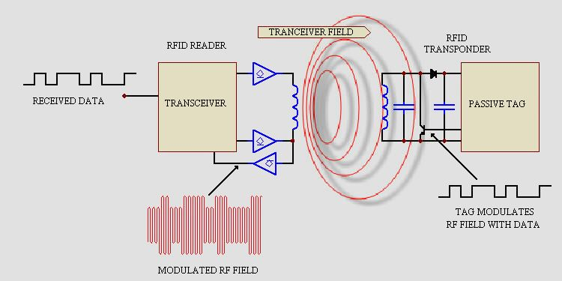  
  
Shown is a RFID transceiver that communicates with a passive Tag. Passive tags have no power source of their own and instead derive power from the incident electromagnetic field. Commonly the heart of each tag is a microchip. When the Tag enters the generated RF field it is able to draw enough power from the field to access its internal memory and transmit its stored information. When the transponder Tag draws power in this way the resultant interaction of the RF fields causes the voltage at the transceiver antenna to drop in value. This effect is utilized by the Tag to communicate its information to the reader. The Tag is able to control the amount of power drawn from the field and by doing so it can modulate the voltage sensed at the Transceiver according to the bit pattern it wishes to transmit.

# AVR Microcontroller (ATmega8)

## Overview

The ATmega8 is a low-power CMOS 8-bit microcontroller based on the AVR RISC

architecture. By executing powerful instructions in a single clock cycle, the ATmega8

achieves throughputs approaching 1 MIPS per MHz, allowing the system designer to **optimize power consumption versus processing speed.**

The AVR core combines a rich instruction set with 32 general purpose working registers.

All the 32 registers are directly connected to the Arithmetic Logic Unit (ALU), allowing

two independent registers to be accessed in one single instruction executed in one clock

cycle. The resulting architecture is more code efficient while achieving throughputs up to

ten times faster than conventional CISC microcontrollers.

The ATmega8 provides the following features: 8K bytes of In-System Programmable Flash with Read-While-Write capabilities, 512 bytes of EEPROM, 1K byte of SRAM, 23 general purpose I/O lines, 32 general purpose working registers, three flexible Timer/Counters with compare modes, internal and external interrupts, a serial programmable USART, a byte oriented Two-wire Serial Interface, a 6-channel ADC (eight channels in TQFP and MLF packages) where four (six) channels have 10-bit accuracy and two channels have 8-bit accuracy, a programmable Watchdog Timer with Internal Oscillator, an SPI serial port, and five software selectable power saving modes. The Idle mode stops the CPU while allowing the SRAM, Timer/Counters, SPI port, and interrupt system to continue functioning. The Power-down mode saves the register contents but freezes the Oscillator, disabling all other chip functions until the next Interrupt or Hardware Reset. In Power-save mode, the asynchronous timer continues to run, allowing the

user to maintain a timer base while the rest of the device is sleeping. The ADC Noise Reduction mode stops the CPU and all I/O modules except asynchronous timer and ADC, to minimize switching noise during ADC conversions. In Standby mode, the crystal/resonator Oscillator is running while the rest of the device is sleeping. This allows very fast start-up combined with low-power consumption.

## Architectural Block Diagram

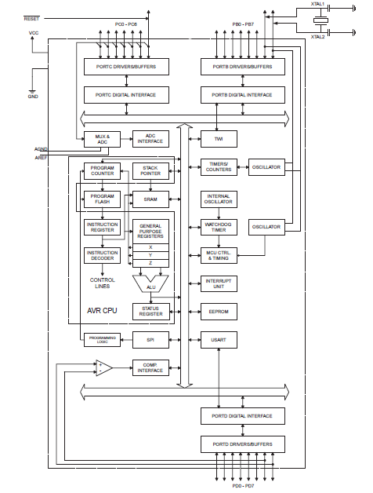

## Pin Descriptions

### VCC:

Digital supply voltage.

### GND:

Ground.

### Port B (PB7..PB0) XTAL1/XTAL2/TOSC1/TOSC2:

Port B is an 8-bit bi-directional I/O port with internal pull-up resistors (selected for each

bit). The Port B output buffers have symmetrical drive characteristics with both high sink

and source capability. As inputs, Port B pins that are externally pulled low will source current if the pull-up resistors are activated. The Port B pins are tri-stated when a reset

condition becomes active, even if the clock is not running. Depending on the clock selection fuse settings, PB6 can be used as input to the inverting Oscillator amplifier and input to the internal clock operating circuit. Depending on the clock selection fuse settings, PB7 can be used as output from the inverting Oscillator amplifier.

If the Internal Calibrated RC Oscillator is used as chip clock source, PB7.6 is used as

TOSC2.1 input for the Asynchronous Timer/Counter2 if the AS2 bit in ASSR is set.

### Port C (PC5.PC0):

Port C is an 7-bit bi-directional I/O port with internal pull-up resistors (selected for each bit). The Port C output buffers have symmetrical drive characteristics with both high sink and source capability. As inputs, Port C pins that are externally pulled low will source current if the pull-up resistors are activated. The Port C pins are tri-stated when a reset condition becomes active, even if the clock is not running.

### PC6/RESET:

If the RSTDISBL Fuse is programmed, PC6 is used as an I/O pin. Note that the electrical characteristics of PC6 differ from those of the other pins of Port C. If the RSTDISBL Fuse is unprogrammed, PC6 is used as a Reset input. A low level on this pin for longer than the minimum pulse length will generate a Reset, even if the clock is not running. Shorter pulses are not guaranteed to generate a Reset.

### Port D (PD7-PD0):

Port D is an 8-bit bi-directional I/O port with internal pull-up resistors (selected for each bit). The Port D output buffers have symmetrical drive characteristics with both high sink and source capability. As inputs, Port D pins that are externally pulled low will source current if the pull-up resistors are activated. The Port D pins are tri-stated when a reset condition becomes active, even if the clock is not running.

### RESET:

Reset input. A low level on this pin for longer than the minimum pulse length will generate a reset, even if the clock is not running. Shorter pulses are not guaranteed to generate a reset.

### AVCC:

AVCC is the supply voltage pin for the A/D Converter, Port C (3-0), and ADC (7-6). It should be externally connected to VCC, even if the ADC is not used. If the ADC is used, it should be connected to VCC through a low-pass filter. Note that Port C (5-4) use digital supply voltage, VCC.

### AREF:

AREF is the analog reference pin for the A/D Converter.

### ADC(7-6) (TQFP and MLF Package Only):

In the TQFP and MLF package, ADC(7-6) serve as analog inputs to the A/D converter. These pins are powered from the analog supply and serve as 10-bit ADC channels.