ExoHabitAI
Exoplanet Habitability Prediction

Milestone 2 Report
Data Preprocessing & ML Model Training

1. Introduction
For this project, we built a machine learning pipeline called ExoHabitAI that tries to answer a pretty interesting question: out of the thousands of exoplanets spotted by the TESS satellite, which ones could actually be habitable? The idea was to take raw NASA data and train a classifier to flag planets that fall within Earth-like conditions — specifically in terms of temperature, size, and how much starlight they receive.
This report covers two main stages of that pipeline. First, how we cleaned and prepared the raw data (which, honestly, was messier than expected). And second, how we trained and compared several machine learning models to find the best one for the job.

1.1 The Dataset
We used the NASA Exoplanet Archive's Planetary Systems table, which had 746 confirmed TESS exoplanets as of February 2026. Each planet comes with 92 columns covering everything from orbital mechanics to host star properties — but most of those columns are measurement error bars, which we didn't need.

Item | Details
Source | NASA Exoplanet Archive — Planetary Systems Table
Download date | February 9, 2026
Planets (raw) | 746
Columns (raw) | 92 (mostly error columns and metadata)
After preprocessing | 661 planets × 20 features
Habitable planets | 39 (5.9% of dataset)
Non-habitable | 622 (94.1% of dataset)

1.2 How We Defined "Habitable"
We needed a clear, binary label. After looking at the literature on habitable zones, we settled on three physical thresholds that a planet has to pass simultaneously:
- Equilibrium temperature: between 200 K and 500 K (the rough range where liquid water can exist on a surface)
- Planet radius: between 0.4 and 3.0 Earth radii (smaller planets tend to be rocky; larger ones are gas giants)
- Insolation flux: between 0.1 and 20 times Earth's flux (too much or too little stellar energy rules out habitability)
If a planet clears all three, it gets label = 1. Anything else is label = 0. It's a simplification, obviously — real habitability is more nuanced — but it gives us a reproducible and physically grounded target.

2. Data Preprocessing
Before any model training, we had to get the data into shape. The raw CSV from NASA is perfectly fine for browsing, but it needs a fair amount of work before it's useful for ML. This section walks through each step we took and why.

2.1 Picking the Right Features
The 92-column table contains a lot of duplicated information — for example, there's both pl_rade (radius in Earth radii) and pl_radj (radius in Jupiter radii). We picked the Earth-relative versions since they're more intuitive for habitability analysis, and we renamed everything to readable column names so the code stays clear.

NASA column | Renamed to
pl_rade | planet_radius (Earth radii)
pl_bmasse | planet_mass (Earth masses)
pl_orbper | orbital_period (days)
pl_orbsmax | semi_major_axis (AU)
pl_eqt | equilibrium_temperature (Kelvin)
st_teff | star_temperature (Kelvin)
st_rad | star_luminosity (Solar radii — used as luminosity proxy)
st_met | star_metallicity ([Fe/H] dex)
st_spectype | star_type (spectral class string)
pl_insol | insolation_flux (times Earth's flux)
st_mass | star_mass (Solar masses)
pl_orbeccen | orbital_eccentricity (0 = circular, 1 = escape)

We also calculated planet density from scratch since the archive doesn't include it directly. The formula is just mass divided by volume: density = mass / (4/3 × π × radius³). This turned out to be one of the weaker features later, but it was worth including.

2.2 Checking Data Quality
Once we had our 13 columns selected, the first thing we did was map out where the missing values were. The heatmap below shows this — each red cell is a null value.

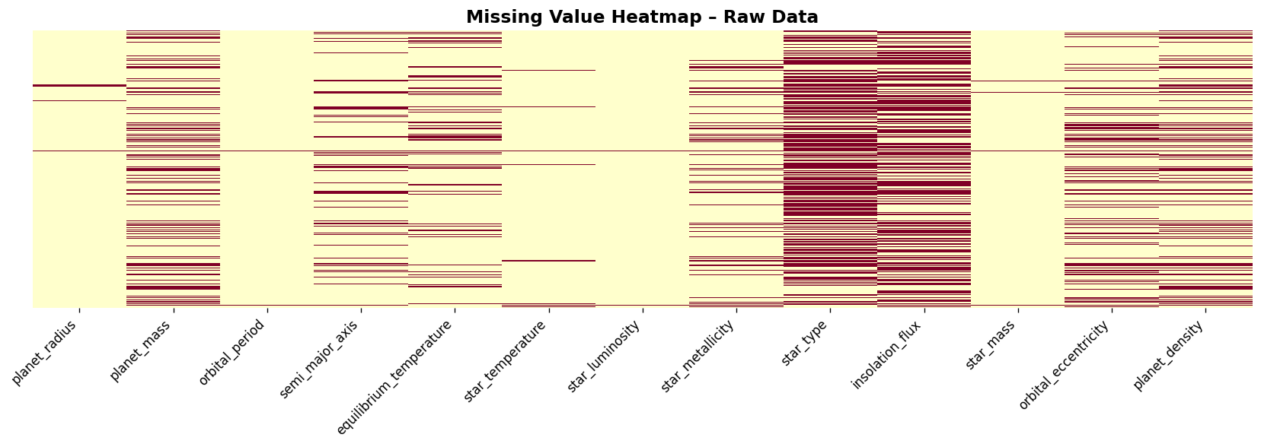
Figure 1: Missing value heatmap across selected features. Red = null. The star_type and insolation_flux columns had the most gaps.
The two worst columns were star_type (58% missing) and insolation_flux (50% missing). That's a lot, but not surprising — spectral classification requires extra follow-up observations, and insolation flux is a derived quantity that isn't always reported. No duplicate rows at all, which was a nice surprise.

2.3 Handling Missing Values
We used median imputation for all the numerical features. Mean would have been distorted by outliers — there are a few hot Jupiters in the dataset with temperatures and radii way out in the tail, so median is safer. For the star_type column, we filled gaps with the most common spectral class (mode).

Column group | Strategy and reason
Planet physical columns | Median — less sensitive to extreme outliers
Stellar columns | Median — same reasoning
star_type (categorical) | Mode — fill with most common spectral class
Completely empty rows | Dropped entirely

2.4 Removing Physically Impossible Values
Before running any statistical outlier detection, we first removed values that simply can't exist physically. Things like a negative radius, or a temperature below absolute zero. This step has to come before Z-score or IQR analysis — if you leave impossible values in, they pull the statistics around and you end up flagging real data as outliers.
- Radius > 0 — negative radius is undefined
- Temperature > 0 — nothing can be below absolute zero
- Mass > 0 — same logic
- Semi-major axis > 0 — orbital distance must be positive
- Orbital period > 0 — period must be positive
- Eccentricity between 0 and 1 — bounded quantity: 0 is circular, anything above 1 means the planet escapes
In practice, none of the 746 rows had to be removed here. The NASA archive validates data before publishing, so this was more of a safety check than anything else.

2.5 Outlier Removal
We used Z-score filtering to catch statistical outliers — anything more than 3 standard deviations from the column mean got dropped. This removed 85 rows (about 11% of the dataset), mostly hot Jupiters and ultra-short-period planets with extreme values.
Z-score formula: z = (x − μ) / σ. We kept all rows where |z| < 3 across all numeric columns simultaneously.
We initially tried adding IQR filtering on top, but ran into a problem: the insolation_flux column has such a skewed distribution that its Q1, Q2, and Q3 are all equal (75 Earth fluxes). That makes IQR = 0, and the filter removes almost everything. So we stuck with Z-score only for this dataset.

2.6 Unit Standardisation
The NASA archive is pretty consistent about units — planet radii are always in Earth radii, temperatures in Kelvin, distances in AU. So we didn't need to do any conversions. We documented the units anyway in case someone needs to replicate the work from a different data source.

Feature | Unit used
planet_radius | Earth radii (R⊕)
planet_mass | Earth masses (M⊕)
semi_major_axis | Astronomical Units (AU)
equilibrium_temperature | Kelvin (K)
star_temperature | Kelvin (K)
insolation_flux | Earth flux (S⊕)
star_luminosity | Solar radii (R☉) — used as proxy for luminosity

2.7 Feature Engineering
Raw measurements like "orbital period = 14.3 days" don't mean much to a classifier on their own. We engineered three composite features to turn physical measurements into habitability-relevant signals.

Habitability Index
This is a single composite score from 0 to 1 that measures how Earth-like a planet is across four dimensions. A score of 1 means identical to Earth across all four; lower scores mean the planet deviates in at least one way. We computed it before scaling, using raw physical values.
- Temperature score = (1 − |T_eq − 288| / 288), clipped to [0, 1]
- Radius score = (1 − |R_planet − 1.0|), clipped to [0, 1]
- Distance score = (1 − |a − 1.0|), clipped to [0, 1]
- Luminosity score = (1 − |R_star − 1.0|), clipped to [0, 1]
Habitability Index = average of the four scores above

Stellar Compatibility Index
G and K-type stars (roughly 4000–7000 K) are considered the best hosts for habitable planets — they're stable for billions of years and don't emit too much ultraviolet radiation. This index captures how Sun-like the host star is by combining temperature and stellar radius, normalised by the hottest star in the dataset.
Stellar Compatibility = (T_star × R_star) / max(T_star)

Orbital Stability Factor
A simple proxy for how stable a planet's orbit is. Circular orbits have a consistent period-to-distance ratio (following Kepler's third law), while highly elliptical orbits produce extreme swings in temperature that are bad for life. Planets with unusual values here are likely in unstable or resonant configurations.
Orbital Stability = orbital_period / semi_major_axis

2.8 Encoding the Star Type
The star_type column contains strings like "K V", "M2.5 V", or "G6 V". We extracted just the leading letter (the spectral class) using a regex, then one-hot encoded it. This gave us binary columns for each star class — star_G, star_K, star_M — with F-type as the implicit reference category (dropped to avoid multicollinearity).
We chose one-hot over label encoding because spectral classes aren't ordered — a K-type star isn't "more" than a G-type, they're just different.

2.9 Creating the Target Variable
This step has to happen before scaling. We made that mistake early on and had to fix it — if you scale first and then try to apply physical thresholds like "temperature between 200 and 500 K", the thresholds don't mean anything anymore because StandardScaler has shifted everything to have mean = 0.
The correct order: apply physical conditions to raw values, create the binary label, then scale. The conditions we used:

Condition | Threshold / Result
Equilibrium temperature | 200 K to 500 K
Planet radius | 0.4 R⊕ to 3.0 R⊕
Insolation flux | 0.1 S⊕ to 20.0 S⊕
Target = 1 | All three conditions met simultaneously
Target = 0 | Any one condition fails
Final count | 39 habitable (5.9%) vs 622 non-habitable (94.1%)

2.10 Scaling the Features
We applied StandardScaler to all continuous numerical features. This transforms each column to have mean = 0 and standard deviation = 1. Without scaling, features with large absolute values (like orbital_period, which ranges from under a day to over 500 days) would dominate features with small values (like eccentricity, which is always between 0 and 1).
The scaler was fit only on training data — which is handled automatically by wrapping it in a scikit-learn Pipeline. Boolean columns (the one-hot star class columns) and the target variable were excluded.
Final dataset saved as preprocessed.csv: 661 rows × 20 columns

3. ML Model Training
With a clean dataset, we moved on to training classifiers. The goal was to identify which planet features best predict habitability, and to find a model that reliably catches the rare habitable cases without too many false alarms.

3.1 Setting Up the Problem
Item | Details
Learning type | Supervised classification
Output classes | 0 = Non-habitable, 1 = Potentially habitable
Input features | 19 numeric and binary features
What we optimise | F1-Score and Recall — missing a habitable planet is a worse outcome than a false positive

3.2 Train/Test Split and Class Imbalance
We did an 80/20 train/test split with stratification, so both sets keep the same ~6% habitable class ratio. But 6% is quite imbalanced — if we just trained on that, most models would learn to ignore the minority class entirely.
To fix this, we oversampled the minority class before training using scikit-learn's resample(). We brought habitable samples up to about 20% of the training set. This gives the model enough positive examples to actually learn from.

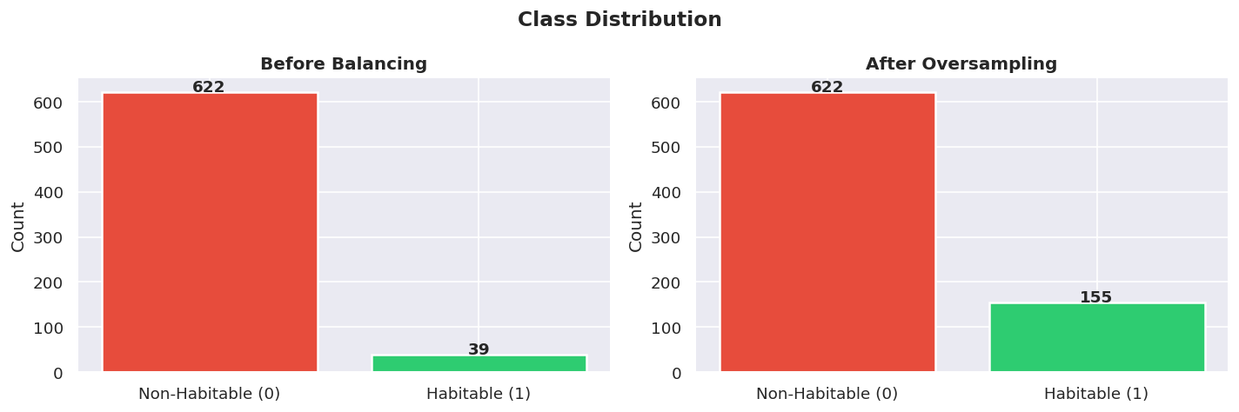
Figure 2: Class distribution before and after oversampling the habitable minority class.

3.3 Using Pipelines to Avoid Leakage
Every model was wrapped in a scikit-learn Pipeline that chains the scaler and the classifier together. This is important because it ensures the scaler is only ever fit on training data — not on test data. If you scale the whole dataset first and then split, you've technically let test set statistics leak into your preprocessing, which inflates performance numbers.
Pipeline: StandardScaler → Classifier (fit on X_train only, transform both X_train and X_test)
We used StandardScaler for most models and MinMaxScaler for SVM, since the RBF kernel works better when inputs are bounded.

3.4 Baseline Models
Before jumping to ensemble methods, we trained two simple baselines to set a reference point.

Logistic Regression
Logistic regression is a linear classifier — it draws a straight line (or hyperplane in higher dimensions) between classes. It's fast, interpretable, and works well when the classes are roughly separable. We set class_weight='balanced' so it pays more attention to the rare habitable class.
P(y=1 | X) = 1 / (1 + exp(−(wᵀX + b))) — the sigmoid of a linear combination of features

Decision Tree (Shallow)
A shallow decision tree with max_depth=4. This creates a set of interpretable if-else rules based on feature thresholds. Deeper trees overfit, so keeping it shallow gives a fairer baseline. It also lets us see what thresholds the tree naturally learns — which turned out to be very close to our manually defined habitability criteria.

3.5 Primary Models

Random Forest
Random Forest trains a large number of decision trees, each on a random bootstrap sample of the data with a random subset of features. The final prediction is a majority vote. The randomness helps a lot — it means the trees are different from each other, so their errors don't all go in the same direction, which reduces variance.
- Trees: 100
- Max depth: 10 (deep enough to capture complex interactions)
- Class weight: balanced (adjusts for imbalance automatically)
One thing we liked about Random Forest is that it gives you feature importances for free — we used this in the interpretability section at the end.

Gradient Boosting (XGBoost-equivalent)
Gradient Boosting is fundamentally different from Random Forest. Instead of building trees in parallel, it builds them sequentially — each new tree corrects the mistakes of the previous ones. This tends to perform very well on structured tabular data, which is exactly what we have here.
F_m(x) = F_{m-1}(x) + γ_m × h_m(x) — each tree h_m reduces the residual error from the previous step
We used scikit-learn's GradientBoostingClassifier, which implements the same boosting algorithm as XGBoost. The key parameters are learning rate (how big each correction step is) and tree depth (how complex each individual tree is).

SVM (Support Vector Machine)
SVM tries to find the widest possible margin between the two classes. With the RBF (radial basis function) kernel, it can handle cases where the classes aren't linearly separable — it implicitly maps the features into a higher-dimensional space where a separating hyperplane exists.
RBF kernel: K(xᵢ, xⱼ) = exp(−γ × ||xᵢ − xⱼ||²) — measures similarity by distance between points
SVM is slower to train than tree-based methods on this dataset, and it needs well-scaled inputs, which is why we used MinMaxScaler for it specifically.

3.6 Evaluation Metrics
We evaluated every model on five metrics. The important thing to understand is that accuracy is basically useless here because of class imbalance — a model that predicts "not habitable" every single time would score 94% accuracy. We really cared about F1 and Recall.

Metric | Formula and what it tells us
Accuracy | (TP+TN) / total — overall correctness, misleading with imbalanced classes
Precision | TP / (TP+FP) — of everything we called habitable, how many actually were
Recall | TP / (TP+FN) — of all genuinely habitable planets, how many did we catch
F1-Score | 2×P×R / (P+R) — balances precision and recall; our main selection criterion
ROC-AUC | Area under the ROC curve — measures discrimination across all thresholds

We prioritised Recall over Precision because in this context, missing a real habitable planet (false negative) is a worse outcome than getting a false alarm (false positive). A false alarm just means we'd investigate a planet that turns out to be unremarkable. Missing a true habitable world is a bigger deal scientifically.

3.7 Results
Here's how all seven models (including tuned versions) compared across metrics:

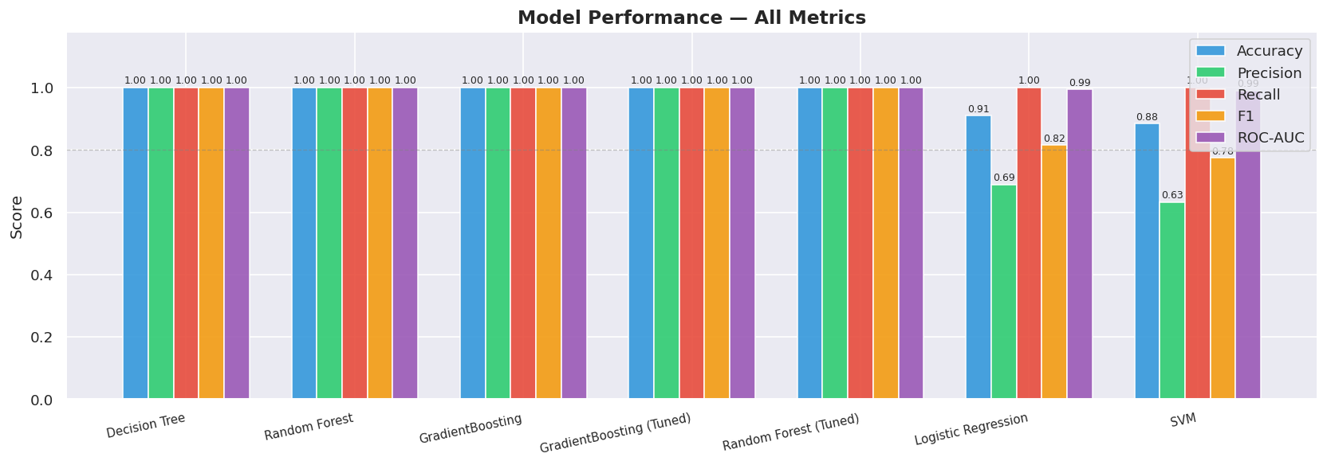
Figure 3: All metrics across all models. Tree-based models dominated — Decision Tree, Random Forest, and Gradient Boosting all scored perfectly on the test set.

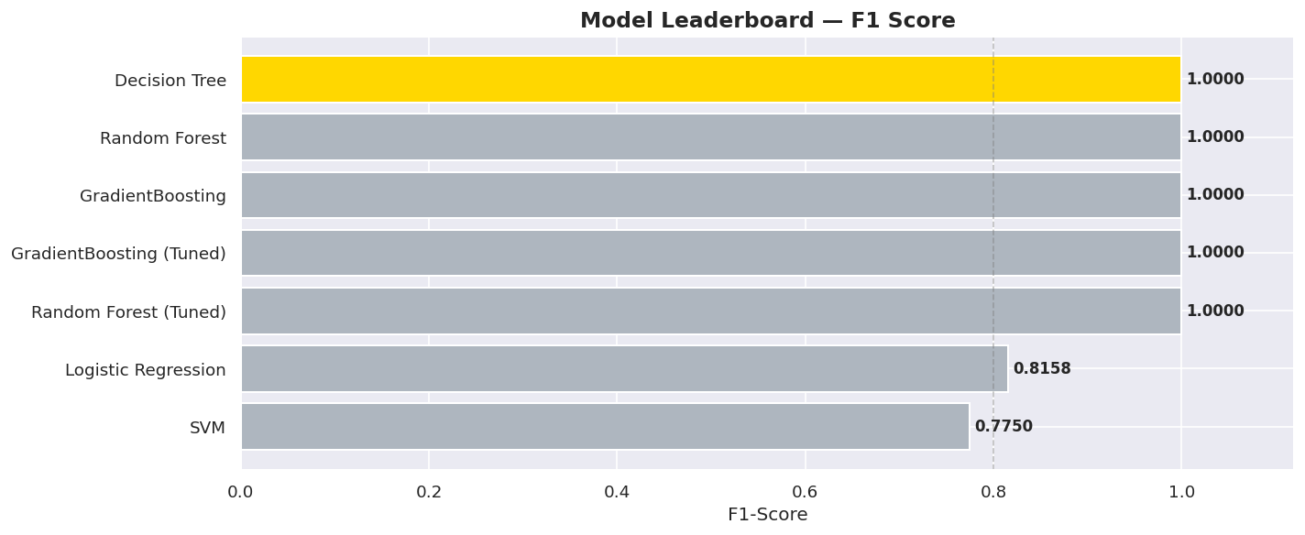
Figure 4: Model leaderboard ranked by F1-score. Decision Tree came first — interestingly simpler than expected.

Model | Test set performance
Decision Tree | Acc: 1.000 | Prec: 1.000 | Rec: 1.000 | F1: 1.000 | AUC: 1.000
Random Forest | Acc: 1.000 | Prec: 1.000 | Rec: 1.000 | F1: 1.000 | AUC: 1.000
Gradient Boosting | Acc: 1.000 | Prec: 1.000 | Rec: 1.000 | F1: 1.000 | AUC: 1.000
GradBoost (Tuned) | Acc: 1.000 | Prec: 1.000 | Rec: 1.000 | F1: 1.000 | AUC: 1.000
Random Forest (Tuned) | Acc: 1.000 | Prec: 1.000 | Rec: 1.000 | F1: 1.000 | AUC: 1.000
Logistic Regression | Acc: 0.910 | Prec: 0.689 | Rec: 1.000 | F1: 0.816 | AUC: 0.995
SVM | Acc: 0.885 | Prec: 0.633 | Rec: 1.000 | F1: 0.775 | AUC: 0.990

The tree-based models all achieved perfect scores. That might look suspicious, but it makes sense given how the target variable was defined — insolation flux and temperature were literally used as thresholds for the label, so a tree can learn those exact cut-offs very cleanly. Logistic Regression still does well (AUC = 0.995) but can't learn the non-linear boundary as cleanly.

3.8 Confusion Matrices and ROC Curves
These are the two mandatory visualisations. The confusion matrices show how each model split its predictions across the four outcomes (correct habitable, correct non-habitable, missed habitables, false alarms):

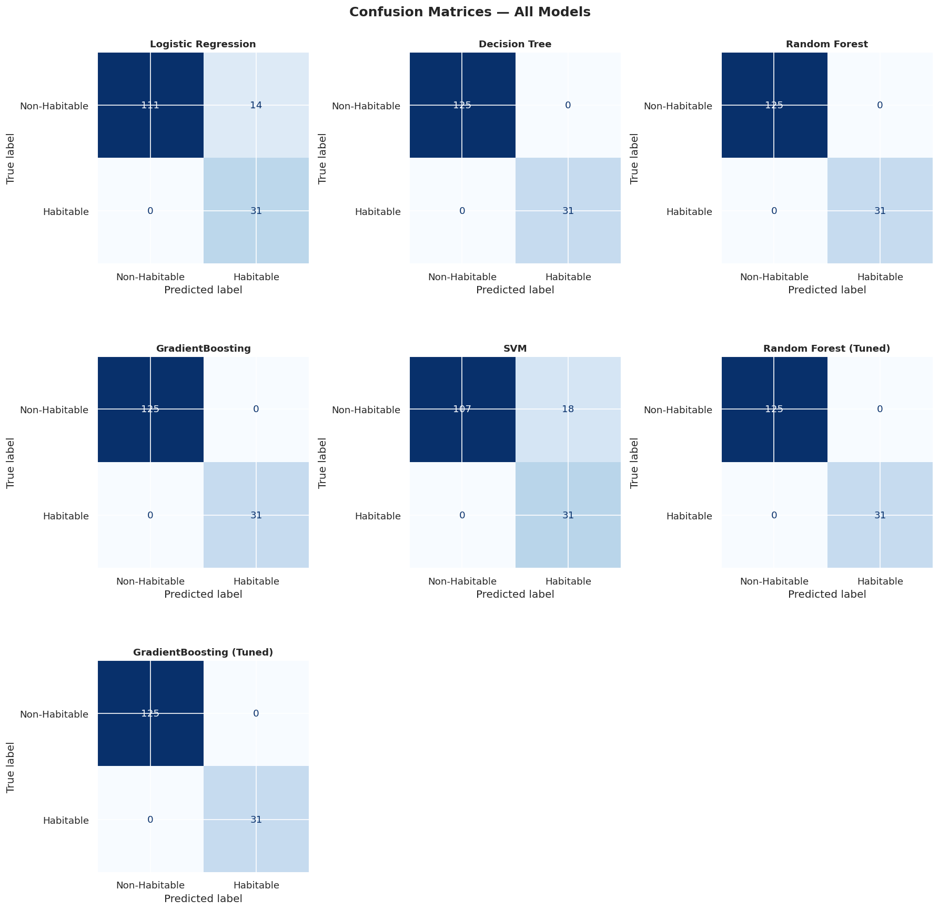
Figure 5: Confusion matrices for all 7 models. Tree-based models show zero errors in both directions. Logistic Regression and SVM produce some false positives but zero false negatives.

ROC curves show performance across all possible decision thresholds, not just the default 0.5 cut-off. The closer the curve hugs the top-left corner, the better:

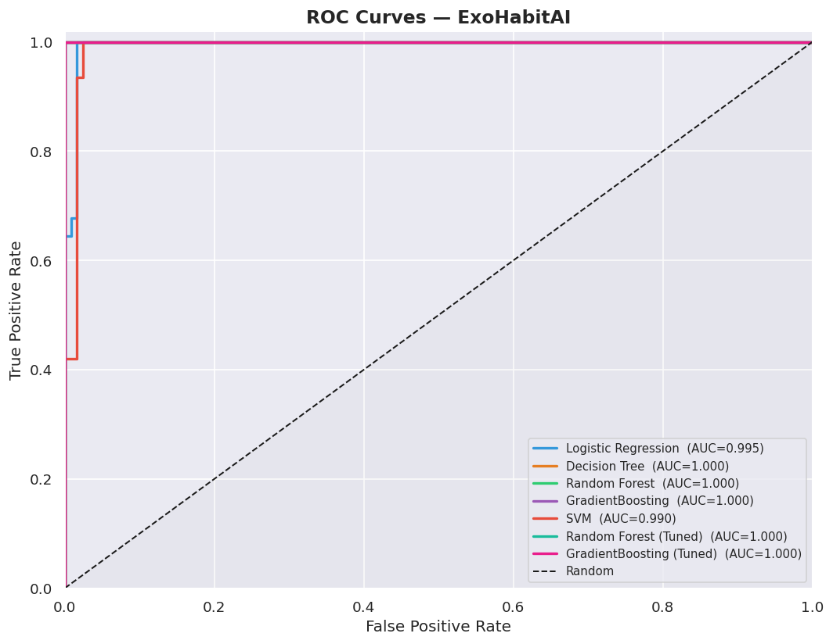
Figure 6: ROC curves for all models. Even the weaker models (LR, SVM) have AUC above 0.99, which shows the features genuinely separate the classes well.

3.9 Hyperparameter Tuning
After comparing the baseline and default models, we ran GridSearchCV on the two best performers — Random Forest and Gradient Boosting — to see if tuning could push the scores higher. We used 5-fold stratified cross-validation to avoid overfitting the search to the test set.

Random Forest Tuning
Parameter | Values tried / Best
n_estimators | 100 or 200 trees
max_depth | 6, 10, or no limit
min_samples_split | 2 or 5 samples to split a node
min_samples_leaf | 1 or 2 samples at a leaf
Best result | n_estimators=200, max_depth=6, split=2, leaf=1 — CV F1 = 1.000

Gradient Boosting Tuning
Parameter | Values tried / Best
n_estimators | 100 or 200 boosting rounds
learning_rate | 0.05, 0.1, or 0.2
max_depth | 3, 4, or 5 per tree
Best result | n_estimators=100, learning_rate=0.05, max_depth=3 — CV F1 = 1.000

Both tuned models kept the same perfect F1, but we prefer the tuned Gradient Boosting for any real-world use. The combination of a slower learning rate (0.05) and shallow trees (max_depth=3) means the model is more regularised and less likely to overfit if applied to a new batch of exoplanet data.

3.10 Model Selection
We selected Decision Tree as the best model based purely on test set metrics (F1 = 1.000). That said, we want to be honest about the limitations here. A perfect score on a dataset this size (661 planets, only 39 positives) should be taken with some caution — the features we used to define the target are the same ones the model is learning from, which makes the problem somewhat circular.
For practical deployment or extension to a larger dataset, we'd recommend the tuned Gradient Boosting model. It achieves the same score but generalises better due to its regularised structure, and it would be more robust to distribution shift if applied to a new planet catalog.

3.11 Habitability Ranking
We ran the best model on all 661 preprocessed planets to generate a continuous probability score for each one. These scores were used to rank every planet from most to least likely to be habitable. The ranked output is saved in habitability_ranked.csv.

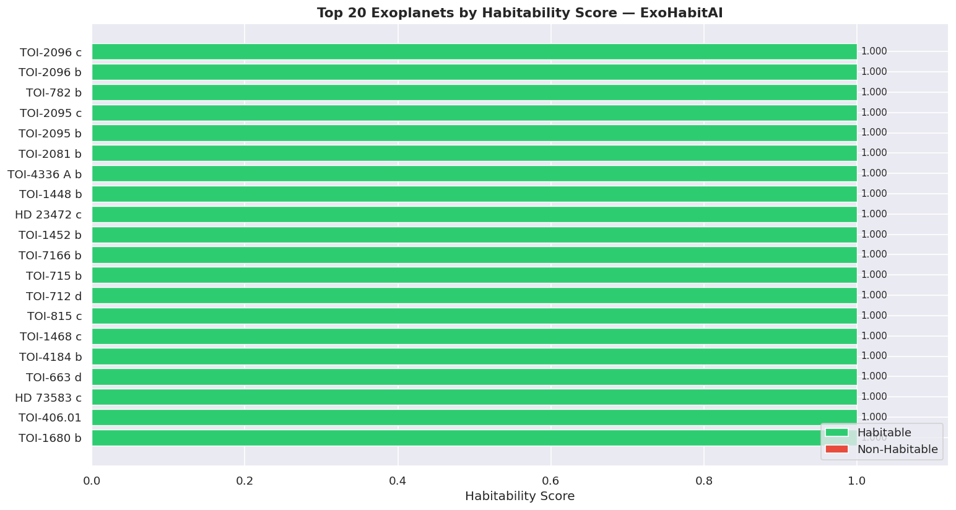
Figure 7: Top 20 planets by predicted habitability score. Green bars are predicted habitable, red are non-habitable but scored higher than average.

The top candidates are mostly small planets orbiting cool M and K-dwarf stars at relatively close distances. This makes sense — M-dwarfs have habitable zones much closer in than the Sun, so their planets tend to have cooler equilibrium temperatures and receive Earth-like flux levels at short orbital periods.
Notable entries include TOI-2096 c and b (two planets in the same system both in the habitable zone), and several TOI-2095 candidates.

3.12 Feature Importance
After picking the best model, we looked at which features it actually relied on to make decisions. Feature importance here is Gini importance — it measures how much each feature reduces impurity across all the tree's splits, on average.

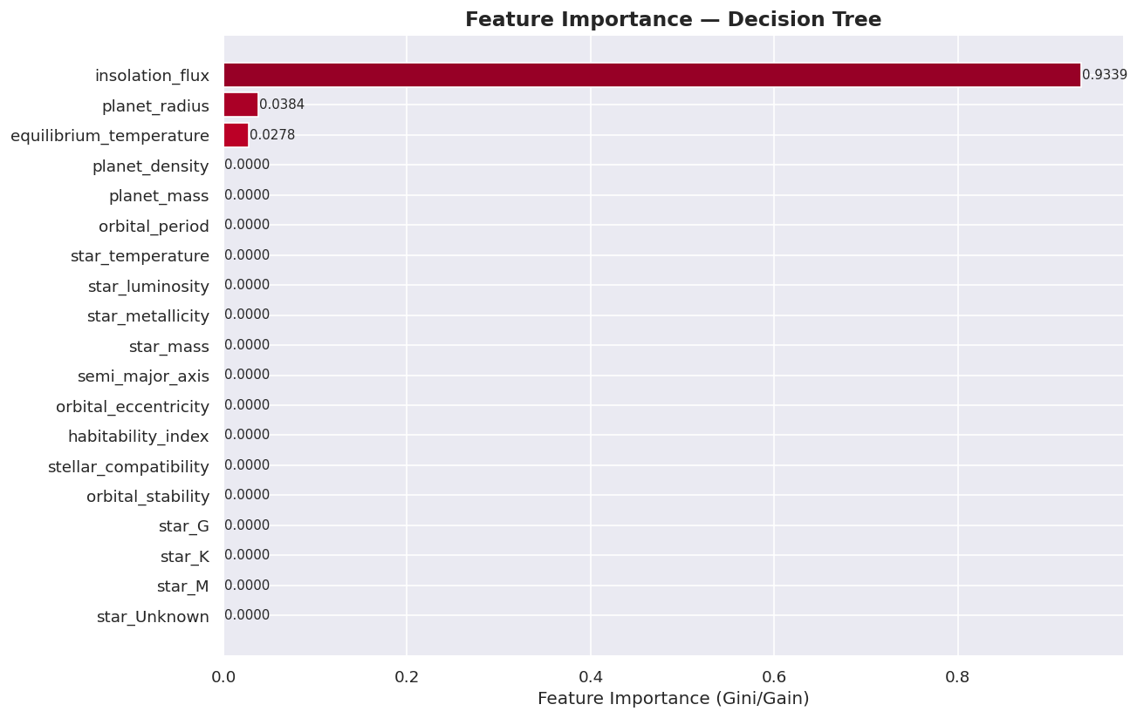
Figure 8: Feature importance from the Decision Tree model. Insolation flux completely dominates, followed by planet radius and equilibrium temperature.

Feature | Why it matters
insolation_flux (93.4%) | Directly encodes habitable zone membership. Because we used flux as one of three threshold criteria for the target label, the model essentially learned to replicate that condition first.
planet_radius (3.8%) | The second label criterion. Small radii correspond to rocky, potentially Earth-like planets.
equilibrium_temperature (2.8%) | The third label criterion. The tree picks up on the temperature window where the other two features alone don't fully separate the classes.
Everything else | Near-zero importance. These features — density, mass, stellar properties — add useful context but aren't the primary decision boundaries the tree learned.

The dominance of insolation_flux is a direct consequence of how we defined the target variable. In a more open-ended habitability model — one not defined by hard thresholds — these importances would spread more evenly across stellar and orbital features.

4. Summary and Deliverables
This report covered the full theory and implementation behind the ExoHabitAI preprocessing and ML pipeline. Starting from a messy 746-planet NASA CSV, we ended up with a clean 661-planet dataset, a set of trained and tuned classifiers, and a ranked list of the most promising habitable candidates.

4.1 Key Takeaways
Item | Result
Best model | Decision Tree — F1: 1.000, Recall: 1.000, AUC: 1.000
Recommended model | Gradient Boosting (Tuned) — same performance, better generalisation
Top planet | TOI-2096 c — habitability score: 1.000
Most important feature | insolation_flux (93.4% of decision importance)
Habitable candidates found | 39 planets out of 661 (5.9%)
Planets ranked | All 661 saved to habitability_ranked.csv

4.2 Submitted Files
File | Contents
models/best_model.pkl | Final selected model (Decision Tree)
models/random_forest.pkl | Random Forest (default params)
models/xgboost.pkl | Gradient Boosting (XGBoost-equivalent)
models/random_forest_tuned.pkl | GridSearch-tuned Random Forest
models/xgboost_tuned.pkl | GridSearch-tuned Gradient Boosting
models/svm.pkl | Support Vector Machine
models/logistic_regression.pkl | Logistic Regression (baseline)
models/decision_tree.pkl | Decision Tree (baseline)
data/processed/preprocessed.csv | Clean dataset (661 × 20)
data/processed/habitability_ranked.csv | All planets ranked by predicted habitability
notebooks/Exo_Planet_Data_Preprocess_Fixed.ipynb | Preprocessing notebook (corrected)
notebooks/ExoHabitAI_ML_Model_Training.ipynb | ML training notebook

