Submitted To:-
Mr. Vikash (IBM)
Submitted By:-
Group B
Section – BCADS21

Babu Banarasi Das University



E-commerce sales analysis
using Hadoop

Case Study
ON

PROJECT

E-commerce Dataset MapReduce Practical

- Architecture:

- The architecture of this project follows a standard Big Data pipeline
using Hadoop ecosystem components.

- Data Flow:

- Raw Dataset → HDFS → MapReduce Processing → Processed Data →
Hive Analysis → Insights

- Explanation:

- Raw dataset (e-commerce dataset) will stored in HDFS
- MapReduce is used to process the data.
- Processed data is store in HDFS
- Hive is used to perform analysis.
- Final insights are generated from the results

- Tools Used:

- Hadoop Distributed File System (HDFS)
- MapReduce (Hadoop Streaming using Python)
- Hive (for data analysis)
- Linux Terminal
- ChatGPT (Generative AI tool)

- Technologies:

- Python (for mapper and reducer)
- CSV dataset
- Hadoop Ecosystem

- Use of Generative AI in the Project:

- In this project, Generative AI tools are used to understand Big Data concepts.

- Areas Where AI is Used:

- Code Generation

- Generative AI was used to generate MapReduce programs (mapper.py and reducer.py).

- Debugging

- Errors in code were identified and fixed using AI assistance.

- Query Writing

- Hive queries were generated and optimized using AI.

- Concept Understanding

- AI helped in understanding:
- HDFS architecture
- MapReduce workflow
- Hive operations

- Benefits of Using AI:

- Faster development
- Reduced coding errors
- Better understanding of concepts
- Improved efficiency

- Validation:

- All AI-generated code was manually tested and verified before execution.

- Dataset Description:

- The dataset used in this project is an e-commerce sales dataset containing details of product transactions, including order date, product name, category, region, quantity, sales, and profit. The data is stored in CSV (Comma Separated Values) format and is analyzed using Hadoop to identify sales trends, top-performing products, and overall business performance.

- Dataset Structure:

- The dataset consists of the following columns:
• Order Date – Date when the order was placed
• Product Name – Name of the product
• Category – Category of the product
• Region – Region where the product was sold
• Quantity – Number of units sold
• Sales – Total sales amount of the product
• Profit – Profit earned from the product

- Dataset Source:

- The dataset is a combination of real-world e-commerce sales for project demonstration.

- Purpose of Dataset:

- The dataset is used to:
- Analyze sales and profit trends
- Identify top-selling products
- Perform data aggregation using MapReduce
- Generate business insights using Hive

- Question-1:- Sales Analysis using Hadoop Streaming

    - Aim: - " To analyze the e-commerce dataset and calculate total sales and profit using Hadoop MapReduce."

Step-01: - Create a “CSV” file.

- Cat > ecommerce.csv

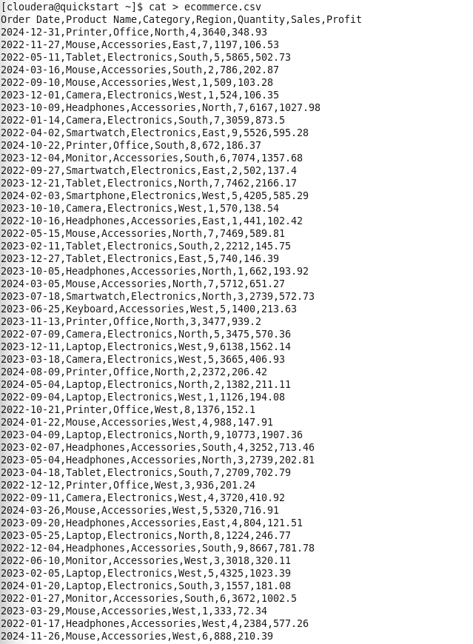

Step-02:- Create a directory

- hdfs dfs -mkdir /user/cloudera/group_no_b/project

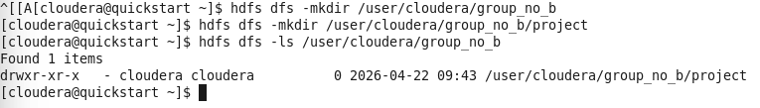

Step-03:- Load the “CSV” on Cloudera’s Server

- hdfs dfs -put ecommerce.csv /user/cloudera/group_no_b/project
- hdfs dfs -ls /user/cloudera/group_no_b/project

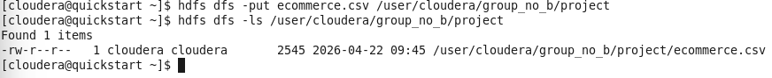

Step-04:- Create a mapper file using “nano”

- nano mapper.py

!/usr/bin/env python
import sys

for line in sys.stdin:
if line.startswith("Order Date"):
continue

data = line.strip().split(',')

try:
print "%s\t%s,%s" % (data[2], data[5], data[6])
except:
pass

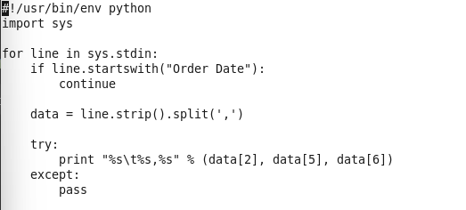

Step-05:- Create a reducer file using “nano”

- nano reducer.py

#!/usr/bin/env python
import sys

current = ""
sales = profit = count = 0

for line in sys.stdin:
cat, val = line.strip().split('\t')
s, p = val.split(',')

s = float(s)
p = float(p)

if cat == current:
sales += s
profit += p
count += 1
else:
if current:
print "%s\t%s\t%s\t%s\t%s" % (current, sales, profit, sales/count, profit/count)
current = cat
sales = s
profit = p
count = 1

if current:
print "%s\t%s\t%s\t%s\t%s" % (current, sales, profit, sales/count, profit/count)
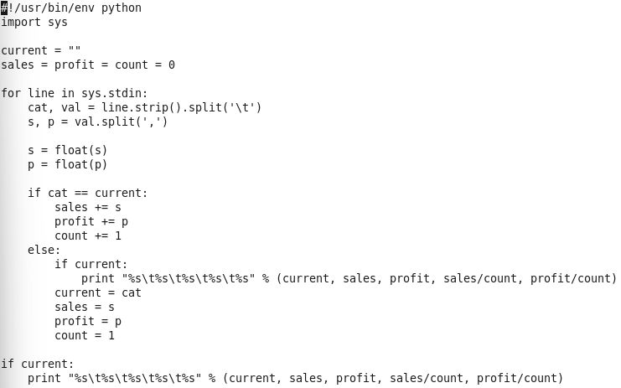

Step-06:- Make executable

- chmod +x mapper.py reducer.py

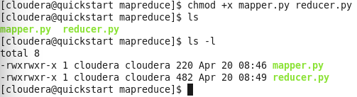

Step-07:- Copy “ecommerce.csv” file, from /home/cloudera to /home/cloudera/mapreduce

- cp /home/cloudera/ecommerce.csv /home/cloudera/mapreduce

Step-08:- Local test

- cat ecommerce.csv | python mapper.py

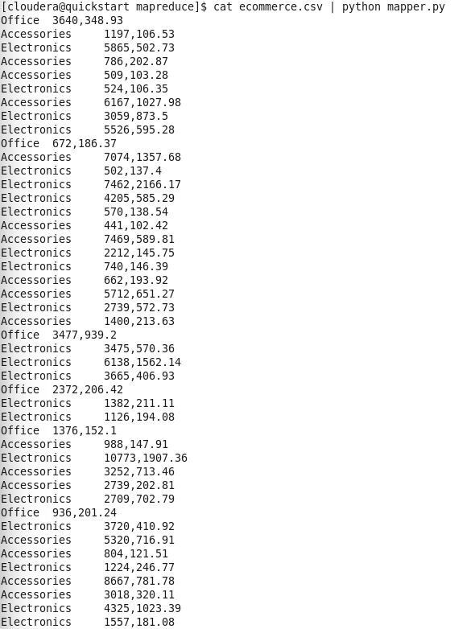

- cat commerce.csv | python mapper.py | sort | python reducer.py

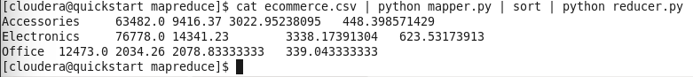

Step-09:- Run Hadoop Job

hadoop jar /usr/lib/hadoop-mapreduce/hadoop-streaming.jar -files mapper.py,reducer.py -input /user/cloudera/group_no_b/project/ecommerce.csv -output /user/cloudera/group_no_b/project/output -mapper "python mapper.py" -reducer "python reducer.py"

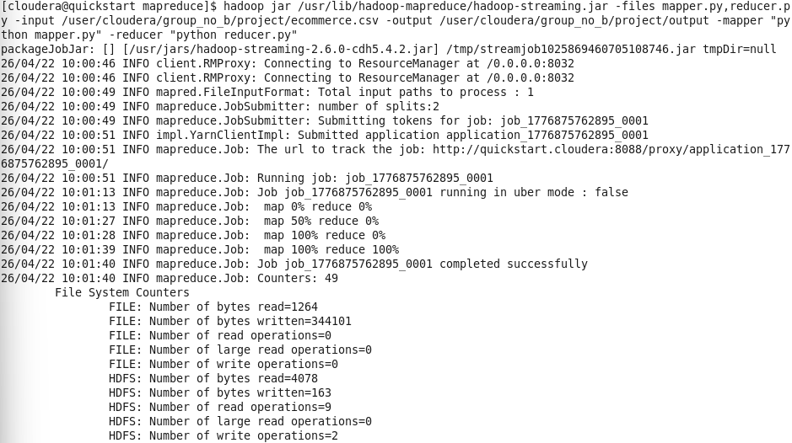

Step-10:- View Output

- hdfs dfs -cat /user/cloudera/group_no_b/project/output/part-00000

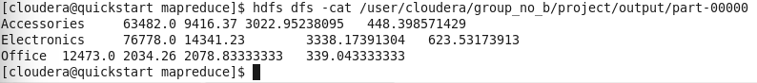

- Question-2:- To perform data analysis on processed ecommerce dataset using
Hive.

- Aim: - " To analyze e-commerce data and identify top-selling products using Hive queries."."

Step-01:- Open Hive

- hive

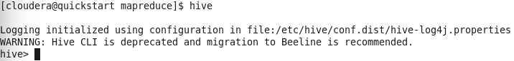

Step-02:- Create table on hive

- CREATE TABLE ecommerce_analysis (
- category STRING,
- total_sales FLOAT,
- total_profit FLOAT,
- avg_sales FLOAT,
- avg_profit FLOAT
- )
- ROW FORMAT DELIMITED
- FIELDS TERMINATED BY '\t';

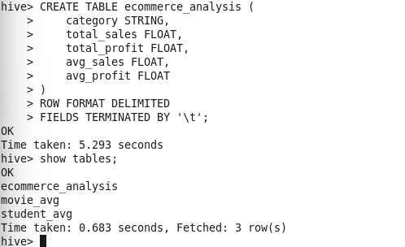

Step-03:- Load data on the table in ecommerce_analysis

- LOAD DATA INPATH '/user/cloudera/group_no_b/project/output'
INTO TABLE ecommerce_analysis;

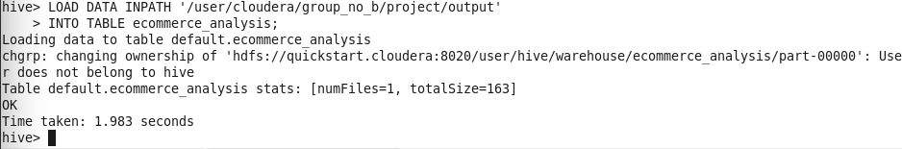

Step-04:- View Data

- SELECT * FROM ecommerce_analysis;

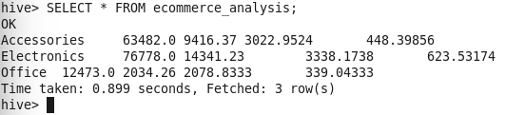

Step-05:- Top category (highest profit)

- SELECT category, total_profit
- FROM ecommerce_analysis
- ORDER BY total_profit DESC
- LIMIT 1;

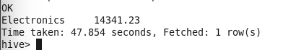

Step-06:- Highest sales category

- SELECT category, total_sales
- FROM ecommerce_analysis
- ORDER BY total_sales DESC
- LIMIT 1;
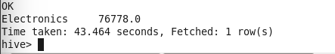

Step-07:- Average sales > 3000

- SELECT * FROM ecommerce_analysis
- WHERE avg_sales > 3000;

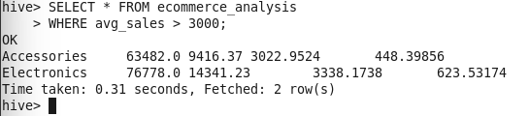

- Output:

- Hive successfully displayed:
- Total sales and profit
- Top-selling products

