INTRODUCTION

What Is A Music Streaming Portal?

A music streaming portal allows us to search and play any music online for free, if the user wants to download the music or stream offline then a paid subscription will be required. The music can be searched based on the album, genre or the artist.

Why it is popular?

Would it be possible to imagine a life without music? And if yes, then what kind of life would that be? Whenever we go, whatever we do, there always is a trustworthy friend who does not ask silly questions; a friend who understands; a friend who apparently is your playlist. Only a decade ago our playlists used to consist mainly out of downloaded songs, but today, as the speed of our Internet connection increases, we are looking at the era of increased popularity of online music streaming services. Statistics gives a support to this claim - by presenting the rapidly-growing number of paid users in the main digital music streaming apps.

Potential market in India

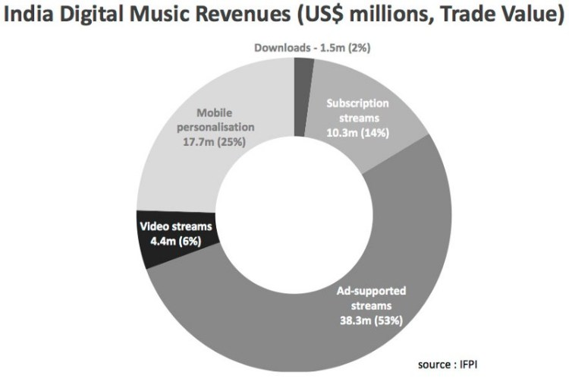

Looking forward 5 years to 2022, India will likely have overtaken China to become the most populous nation on Earth, with some 1.4bn people; It will also likely have over 1bn mobile internet users, 80% of which will be on 3G/4G at rock bottom data prices, with 5G in the early stages of rollout; The economy will be largely cashless (despite the recent demonetisation fumble), with frictionless digital payments being the norm; India’s economy is also expected to be consistently posting over 7% annual GDP growth during this period, maintaining its top spot as the fastest growing major economy in the world.

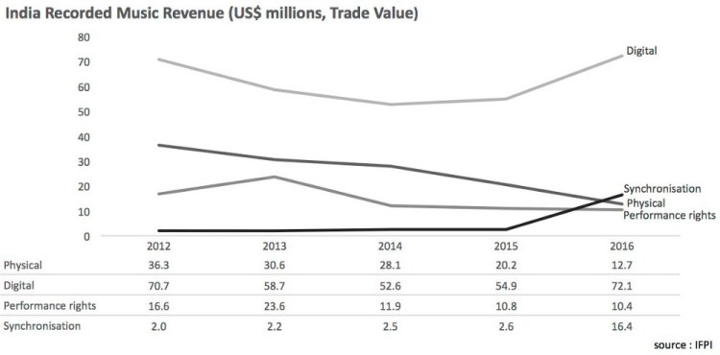

Streaming revenues grew by 52.9% to US$53m in 2016 (IFPI), however, helping India’s music industry to an overall 26.2% growth after 3 years of contraction, so things now finally seem to be on an upward curve.

The list of impressive numbers goes on indefinitely, making it an undeniably exciting market. The real deal-breaker, however — and the one that almost all major rights owners and (the overwhelming majority of) platforms are betting on — is that premium content subscriptions need to take off.

Basically, the reason behind the intense popularity of music streaming portal development is:

- Quick access
- Affordability
- Unlimited storage
- Social engagement

Our users will be able to:

- Sign up
- Search for all their favorite artists, albums and songs in real time!
- Create and customize their own playlists
- Control the music with all the usual controls such as play, pause, skip, previous, shuffle, repeat etc.
- And much, much more!

How much does it cost to make a music app like Slotify?

Just like any other app, the cost of developing an app like Slotify depends on two factors: the developer rate per hour and the number of hours.

Applications Supported

- Online music listening
- On demand music for streaming media
- Music library
- Music stores

Overview of Project

- Concentration on online music streaming
- Songs added by admin, accessed by registered users.
- Search a song as per its album, genre, lyrics, artist
- Can create playlists
- Select and maintain favorite songs
- Users can maintain their music files on their account

