**CHAPTER 1:**

**INTRODUCTION**

## INTRODUCTION

The world is growing at a very fast pace with high level of technological advancements. Globalization is now reaching to almost every corner of the world at a very rapid rate. Parking of vehicle is one of the basic necessities required in a city.

Vehicle Parking System is used for managing the records of the incoming and outgoing vehicles in a parking lot. It’s easy for Admin to retrieve the data if the vehicle has been visited through number, he can get that data. Nowadays in many public places such as malls, multiplex system, hospitals, offices there is crucial problem of vehicle parking.

The objective of this project is to build a Vehicle Parking management system that enables the time management and control of vehicles using number plate recognition It is a system that will track the entry and exit of cars, maintain a listing of cars within the parking lot, and determine if the parking lot is full or not. It will determine the cost of per vehicle according to their time consumption. The customers/drivers can login or register to the system, can search for a parking area available near him/her, book a parking area or reserve a parking area and view parking report in the system.

Also, once the admin logs in to the system, he/she can take actions like approve the parking requests accordingly, check the invoice bill of the customer and view the parking report of the customers.

This system has used front-end tools like HTML, CSS, Laravel PHP Framework and backend tools like Laravel PHP Framework, MySQL, and JavaScript to develop the system. Thus, in the modern age of technology, there is need for a smart parking management system that is faster, secure, has effective management of visitors and reduces the long wait time for customers.

## PROBLEM STATEMENT

Manual parking of vehicle possesses a lot of challenge like time taken and the hassle factor of locating an available parking space. Not being able to accurately direct a driver to an available space has many environmental demerits like CO2 emissions, noise and other pollutants. The inability for someone to locate a parking space may result in influencing them to shop at alternative locations.

With the introduction of web-based Vehicle Parking System, the drawbacks of manual parking can be solved in effective way. When a driver knows exactly where they need to go; it reduces idling and unnecessary driving – therefore optimizes traffic flows in built-up areas.

## Objective

* + - * 1. To maintain records in a short period of time.
        2. To track the entry and exit of cars.
        3. To determine if the parking lot is full or not.
        4. To search for available parking space using FCFS scheduling algorithm.

## Scope and Limitation

### scope

1. It can be utilized in private parking lots, hospitals, hotels, shopping malls, public parking garages, offices, etc. to make the parking hassle free and time consuming.
2. With the help of computerized system, we can deliver a good service to customer who wants to park their vehicle into the any organization’s premises.

### limitation

1. The system will only be used by those who can get access to the internet because the system is online.
2. There can be issues related to regular maintenance.

## Development Methodology

A software development methodology or system development methodology is a framework that is used to structure, plan and control the process of developing a system.

The Iterative Model is used in our system because the initial requirements are already clearly defined and more features are added to the base software product with the ongoing iterations until the final system is created.

At each iteration, design modifications are made and new functional capabilities are added. The basic idea behind this method is to develop a system through repeated cycles (iterative) and in smaller portions at a time (incremental).

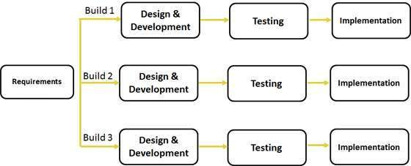

**Figure 1.1. Iterative Model**

Unlike the more traditional waterfall model, which focuses on a stringent step-by-step process of development stages, the iterative model is best thought of as a cyclical process.

* + - * 1. Planning & Requirements

As with most any development project, the first step is go through an initial planning stage to map out the specification documents, establish software or hardware requirements, and generally prepare for the upcoming stages of the cycle.

* + - * 1. Design & Development

Once planning is complete, the design stage occurs here, establishing any technical requirements (languages, data layers, services, etc.) designing software by the different diagrams like Data Flow diagram, activity diagram, class diagram, state transition diagram, etc.

* + - * 1. Coding

With the planning and analysis out of the way, the actual implementation and coding process can now begin. All planning, specification, and design docs up to this point are coded and implemented into this initial iteration of the project.

* + - * 1. Testing

After completing the coding stage, software testing starts using different test methods. There are many test methods, but the most common are white box, black box, and grey box test methods.

* + - * 1. Implementation and Evaluation

In the implementation stage, requirements are written in the coding language and transformed into software. It is time for a thorough evaluation of development up to this stage once all prior stages have been completed. This allows the entire team, as well as clients or other outside parties, to examine where the project is at, where it needs to be, what can or should change, and so on.

## Report Organization

The report on 'Vehicle Parking System' consists of five chapters. The report starts with the introductory chapter which discusses the need of a smart parking system along with the problem statement and objectives of the project. Here, we have introduced why our system is built and the tools used in making the system. Chapter 2 analyses the existing system along with background study and literature review of other systems. Chapter 3 summarizes the system design along with the requirement analysis and feasibility analysis. The system design can be architectural design, database schema design, interface design, process modeling, and data modeling. Chapter 4 explains the tools that are used on our project’s front end, back end, and purpose. The modules and the development model used are also explained. The unit testing and system testing along with the test cases performed is also explained in this part. Chapter 5 discusses the conclusion of how the project is accomplished, its findings, and many more. We also discuss the recommendation for future enhancements of the project. In conclusion, this chapter overview’s purpose of doing this project including its scopes and objectives.

# 

# background study and literature review

## Background Study

Parking is the action of moving a vehicle into a place in a car park or by the side of the road where it can be left. Parking facilities can be divided into public parking and private parking. Public parking is managed by local government authorities and available for all members of the public to drive to and park in. Private parking is owned by a private entity. It is usually a time consuming and frustrating process that a lot of citizens have to go through. So, there is need of a smart parking management system in this modern time. Smart Parking is a parking solution that can include in-ground Smart Parking sensors, cameras or counting sensors. These devices are usually embedded into parking spots or positioned next to them to detect whether parking bays are free or occupied.

Parking Management System is a system that helps people, companies, and organizations to manage their parking spaces. Using a parking management system can help reduce a business’s administrative overhead on parking and reduce the impact of their parking space on their local community. A Smart Parking Management System improve the occupancy rate of the car park, have a better view of the number of vehicles already present and therefore the number of spaces available, manage the profiles of the users and give different access rights.

## Literature review

## MANTRA Mantra is ready to cater to tomorrow’s markets, and to serve evolving customer needs through cutting-edge solutions. Mantra's focus is to provide innovative products and solutions with a set of innovation. Mantra emphasizes to promote intellectual qualities in an individual and amongst the team to provide the best solutions before various clients in a cost-effective manner. The system helps an individual to pre-book the parking spot from the distant area, reducing traffic congestion and allowing a user to know the availability of parking space in advance. [1]

### METRO Infrasys

Metro Infrasys has set its service, integration and development centre as per the international standards at IMT Manesar, Gurgaon (Haryana). The company has made state-of–art mock lane through which it demonstrates various technologies for tolling, traffic management and parking. The facility is also being used for simulation, testing, innovation, and training. Metro Infrasys offers its advance parking management system designed and built from the drawing board to the final delivery. Our technologically streamlined parking solutions are as unique as our projects and capable of withstanding the parking challenges in a city. The speed at which the number of vehicles is increasing has put the authorities in a fix. The ever-growing parking issue needs instant and innovative approach to deal with. [2]

### PHUDINAWALA, HASAN & MALUSARE, OMKAR & MAHADIK, RUSHIKESH. (2022). Vehicle Parking Management System. International Journal of Advanced Research in Science, Communication and Technology. The aim of the paper is to develop application for vehicle parking management. As you can see lot of increase in number of vehicles which is the major problem for traffic control and below standard parking management. Another issue to vehicle owner is to get availability of space to park vehicle. So we intent to create an application that user can book or pre-book parking slot for their vehicle at parking areas. The user can use the application by signing up and then selecting the space or slot for vehicle according to vehicle type at parking area. This application can be applicable in big multi-national companies, shopping centers, airports and event at large public parking areas etc. [3]

### Sowndharya, V & S, Hebziba & D, Susmitha. (2019)

Implementation of Smart Vehicle Parking System. In today’s era one of the most common problems which the world is facing is an exponential increase in population. This has indirectly increased a lot of other issues; one of them being the quantity of vehicles on the road. The increased number of vehicles results in shortage of parking areas. This project aims to present an intelligent parking system for vehicles that identifies the parking slot automatically through sensors and displays it without making the drivers to circle around the parking area. The availability of parking slots will be displayed to the drivers at the entrance. It also captures the number plate of vehicles by using camera and recognises the number using image processing and stores it in the server at the entrance and also at the exit of parking area for ease of payment purposes. [4]

**Bharathi, V. (2021)** Smart Parking System. International Journal for Research in Applied Science and Engineering Technology. In the modern age, many people have vehicles. Vehicle is now a primary need. Every place is under process of urbanization. There are many supermarkets and shopping centers etc. There are many creative places where people used to go for refreshing and relaxation. All these places are full of with people so they need a parking space where people can park their vehicles safely and easily. Every parking area needs a website or system that records the detail of vehicles to give the parking facility. With the help of iot based system we can deliver a good service to users/people who wants to park their vehicles into organization’s premises. Present days in parking areas they just maintain the vehicles just with tokens and they have records of vehicle details in books so that during some critical situations like police enquiry of terrorist car or vehicle missing that case it is difficult to find the details of particular vehicle. But with our parking management system it is easy to find within 1 to 2 seconds. By parking the vehicle in public place, the vehicle can be claimed by other person but in this case, there is no such problem and no need to give fine for anything we can park our vehicle with securely. [5]

# 

# system analysis and design

## System analysis

System analysis is a process of gathering and interpreting facts, diagnosing problems and the information about the Employee Leave Management System. It is done to recommend improvements on the system. It is a problem-solving activity that requires intensive communication between the system users and system developers. It is an important phase of any system development process. The system is studied to the minutest detail and analyzed. The system analyst plays the role of the interrogator and dwells deep into the working of the present system. The system is viewed as a whole and the input to the system is identified. The outputs from the organizations are traced to the various processes. System analysis is concerned with becoming aware of the problem, identifying the relevant and decisional variables, analyzing and synthesizing the various factors and determining an optimal or at least a satisfactory solution or program of action. A detailed study of the process must be made by various techniques like interviews, questionnaires etc. The data collected by these sources must be scrutinized to arrive at a conclusion. The conclusion is an understanding of how the system functions. This system is called the existing system. Now the existing system is subjected to close study and problem areas are identified.

### Requirement analysis

#### Functional requirement

* + - * 1. Register: One customer has to register on this interface with his/her user credentials and then press enter to be saved in the database. Further, move on to login
        2. Login: The customer inputs its secure user email and password and enters the system. The user can enter their own personal account.
        3. Add, Update and delete: The customer can add parking/vehicle details, update the vehicle details and parking details and delete parking details.
        4. Search Parking Space: Users can search whether the parking space is available or not.
        5. Payment Gateway: The System uses Khalti Payment Gateway for the payment transaction.
        6. Search user data: The admin can search for all the registered vehicles and also the reserved vehicles available for parking.
        7. Logout: In the end, the user can logout the system to release the resources held for the purpose of anything else.

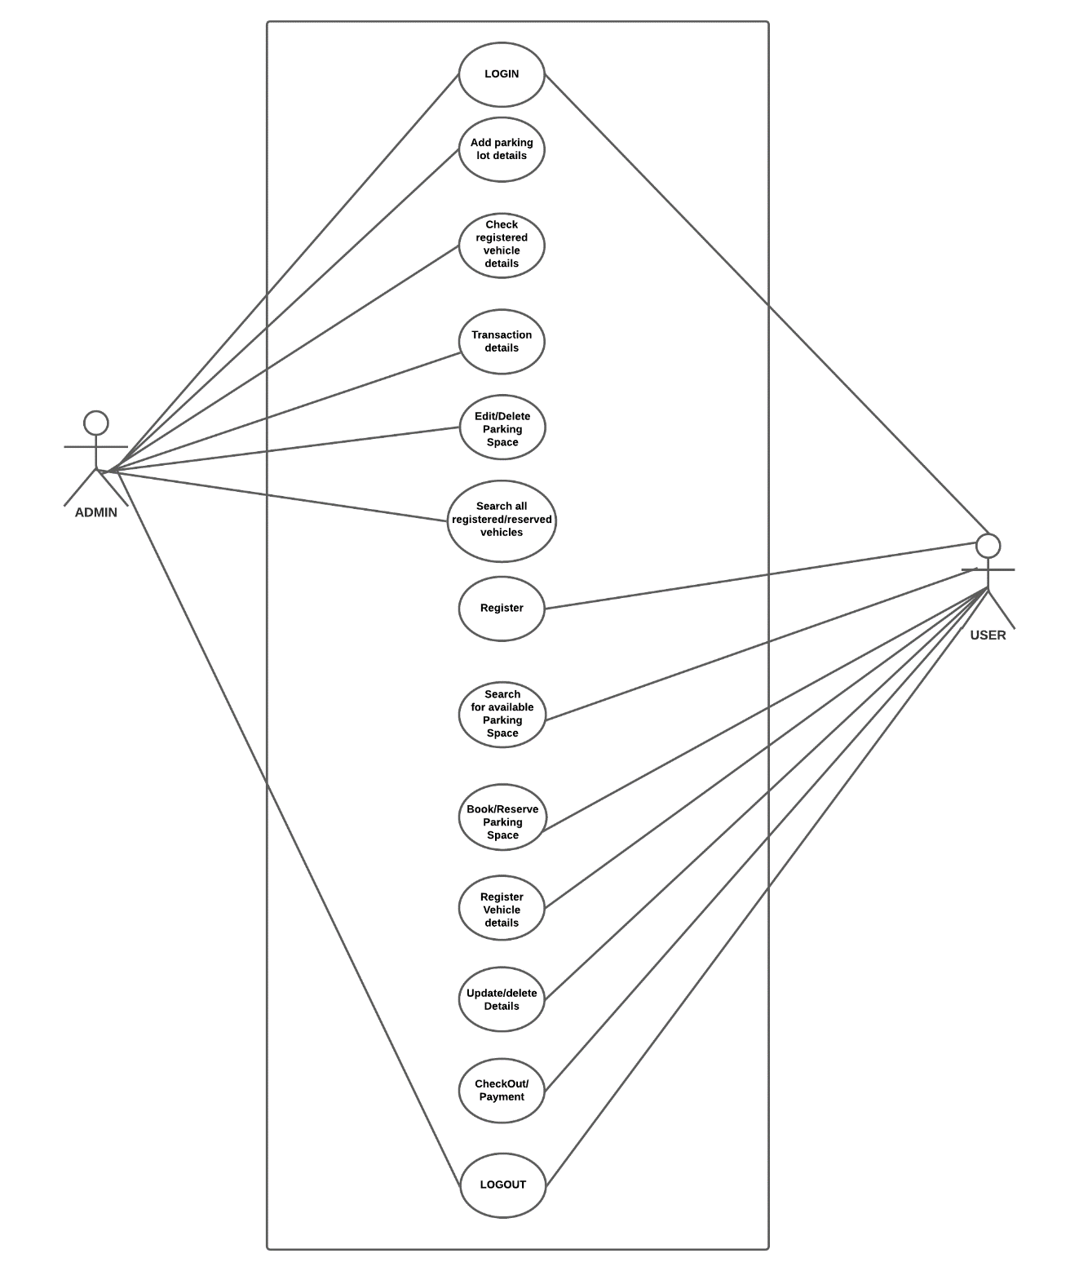

**Figure 3.1. USE CASE Diagram**

#### Non-functional requirement

* + - * 1. The user needs to be able to register in the portal with his own set of attributes as required in the entity attributes.
        2. User should be able to search for the parking area.
        3. The website is portable as it is online website running across the net
        4. Keep things simple and consistent
        5. This website is capable to secure the data and easily retrieve the data.
        6. The database may get crashed at any certain time due to virus or operation system failure. Therefore, it is required to take the database backup.
        7. Scalability: This system can further be modified in future.
        8. Usability: This system has appropriate user interface and adequate information to guide the user in order to use the website.

### Feasibility analysis

After doing the project ‘Vehicle Parking System’, study and analyze all the existing or required functionalities of the system, the next task is to do the feasibility study for the project. All projects are feasible if given unlimited resources and infinite time.

Feasibility study includes consideration of all the possible ways to provide a solution to the given problem. The proposed solution should satisfy all the user requirements and should be flexible enough so that future changes can be easily done based on the future upcoming requirements.

#### Economic feasibility

Economic feasibility is the most frequently used method for evaluating the effectiveness of a new system. This procedure is to determine the benefits and savings that are expected from the system and compare them with costs. We have estimated that the cost of the development of this system will be minimal which will benefit both users and developers, then the decision is made to design and implement the system.

#### Technical Feasibility

Technical feasibility is used to evaluate the hardware and software of the proposed system. The proposed system will be developed in web bases completely and it is required to use web technologies like Laravel appropriately. The system is developed using Laravel Framework as the main development language and Apache has been chosen to be the web server due to its high reliability and flexibility. And, MySQL is chosen to be the DBMS of the system. Thus using such platforms, we studied complete functionality to be provided in the system for this feasibility study.

**Table: 3.1 Hardware Requirements**

|  |  |
| --- | --- |
| PROCESSOR TYPE | I3 Processor or above for optimum performance. |
| SYSTEM RAM | 1.00GB and above |
| INPUT DEVICE | BASIC KEYBOARD AND TOUCH PAD |
| OUTPUT DEVICE | STANDARD COLOR MONITOR |

**Table: 3.2 Software Requirements**

|  |  |
| --- | --- |
| OPERATING SYSTEM | WINDOWS 7,8,10,11 |
| FRONT END | HTML, CSS, JavaScript |
| BACK END | Laravel, JavaScript |
| DATABASE | My SQL, Xampp Server |
| SOFTWARE | Visual Studio Code |

#### Operational Feasibility

Operational Feasibility is the measure of how well a proposed system solves the problems and takes advantage of the opportunities identified during the scope definition. It includes everyone who creates, operates, or uses the system. Programs that reduce costs without reducing the quality of a product are an example of operational feasibility.

The essential questions that help in testing the operational feasibility of a system include the following:

* + - * 1. Does the current mode of operation provide adequate throughput and response time?
        2. Will it reduce the time (operation) considerably?
        3. If the system is developed, will it be used?

#### Schedule Feasibility

The project to be completed, realistic, and achievable under a deadline according to a strategy that is known as schedule feasibility study. It is developed within the time limit. Hence, it is feasible in the respective schedule. The below Gantt chart will show the mandatory deadlines that are expected to be achieved.

|  |  |  |  |  |  |  |  |  |  |  |  |  |  |  |  |  |
| --- | --- | --- | --- | --- | --- | --- | --- | --- | --- | --- | --- | --- | --- | --- | --- | --- |
| **Weeks** | **1st** | **2nd** | **3rd** | **4th** | **5th** | **6th** | **7th** | **8th** | **9th** | **10th** | **11th** | **12th** | **13th** | **14th** | **15th** | **16th** |
| **Planning** |  |  |  |  |  |  |  |  |  |  |  |  |  |  |  |  |
| **Requirement**  **Analysis** |  |  |  |  |  |  |  |  |  |  |  |  |  |  |  |  |
| **System Design** |  |  |  |  |  |  |  |  |  |  |  |  |  |  |  |  |
| **Implementation** |  |  |  |  |  |  |  |  |  |  |  |  |  |  |  |  |
| **Testing** |  |  |  |  |  |  |  |  |  |  |  |  |  |  |  |  |
| **Documentation** |  |  |  |  |  |  |  |  |  |  |  |  |  |  |  |  |

**Figure 3.2. GANTT Chart**

### Object Modelling: Class Diagram

Class diagram represents the static view of an application. Class diagram describes the attributes and operations of a class and also the constraints imposed on the system. It shows a collection of classes, interfaces, associations, collaborations, and constraints.

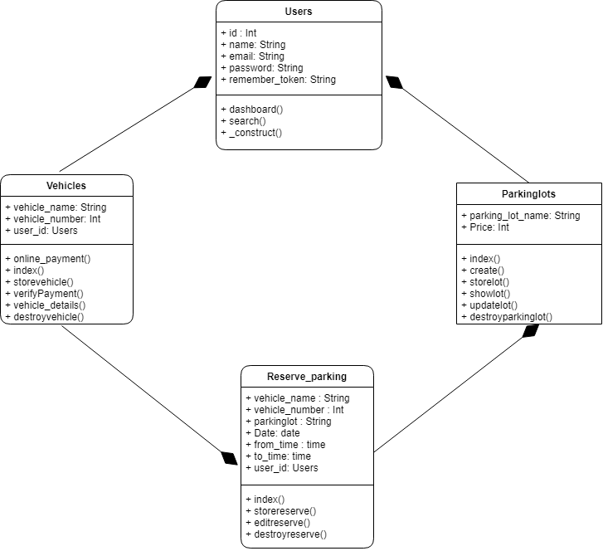

**Figure 3.3. Class diagram**

### Dynamic Modelling: State & Sequence diagram

Sequence Diagrams are interaction diagrams that detail how operations are carried out.

It describes interactions among classes in terms of an exchange of messages over time.

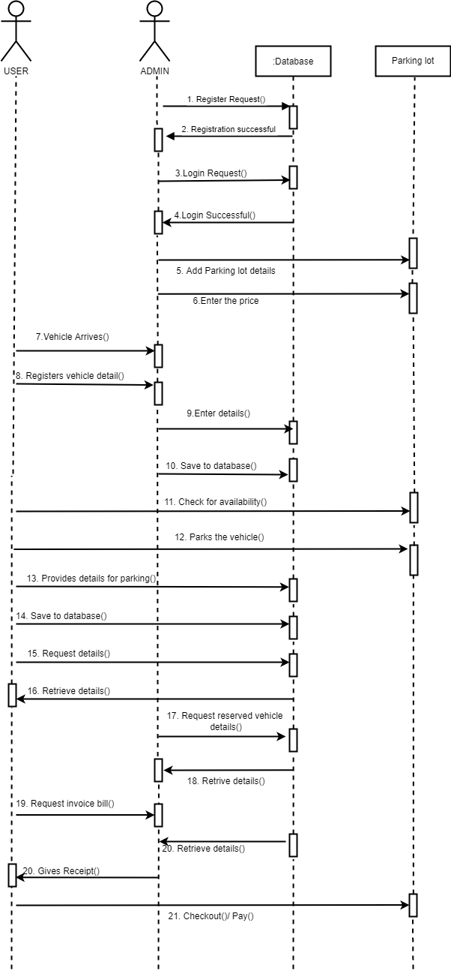

***Figure 3.4.* Sequence Diagram of the Syste**

**3.1.5 PROCESS MODELLING: ACTIVITY DIAGRAM**

The activity diagram is a flowchart to represent the flow of control among the activities in a system. It is another important diagram in UML to describe the dynamic aspects of the system. The activity can be described as an operation of the system.

It consists of activities that are made up of smaller actions. It is an advancement of a flowchart that contains some unique capabilities.

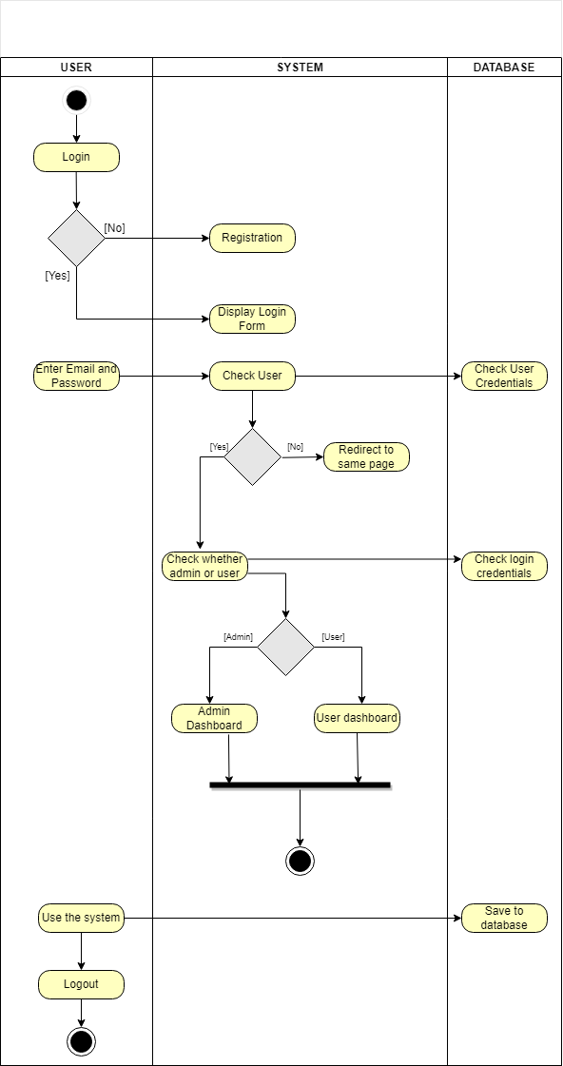

**Figure 3.5. Activity diagram for User Authentication**

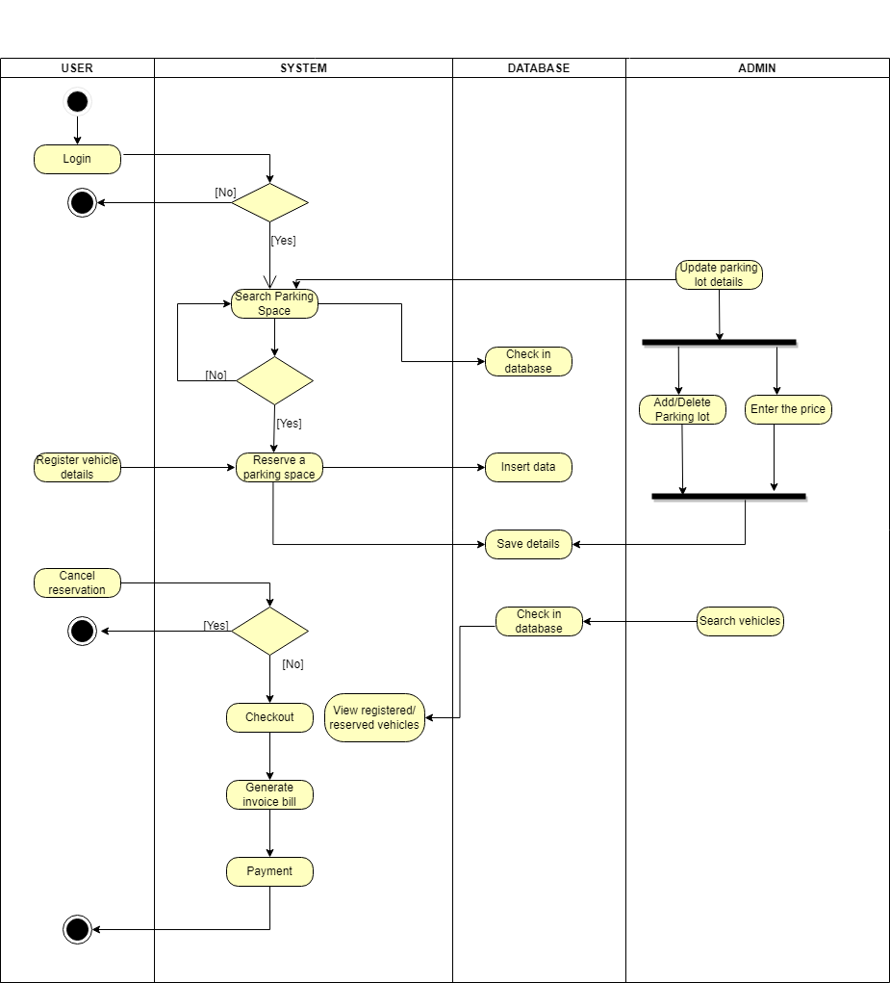

**Figure 3.6. Activity diagram for System Use**

## System desigN

### REFINEMENT OF CLASSES AND OBJECT

Large and complicated UML models are not useful, because they are difficult to understand. This problem can be solved by using several diagrams of the same system at different levels of abstraction. Diagram refinement is intuitive, and applicable to several kinds of UML diagrams. The refinements will help in further process smoothing and enhance the workflow.



***Figure 3.7.* Refinement of classes and object**



**Figure: Sequence diagram of the System**

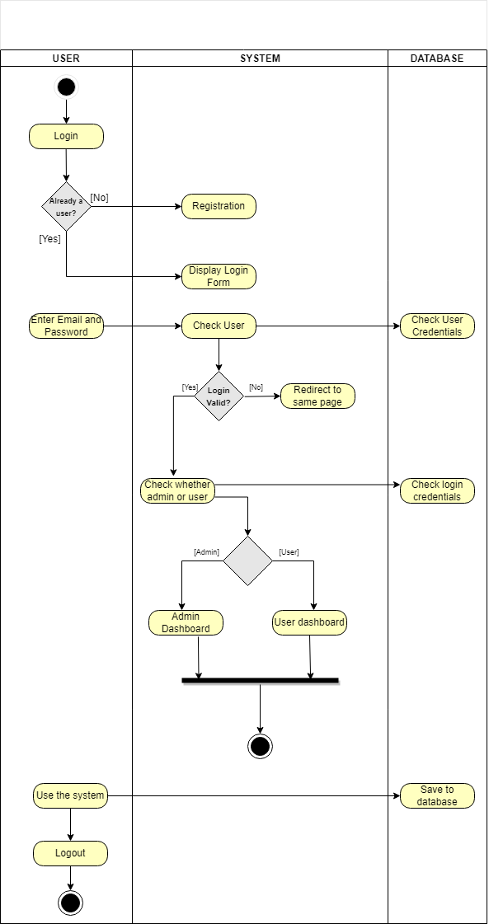

**Figure: Activity Diagram for User Authentication**

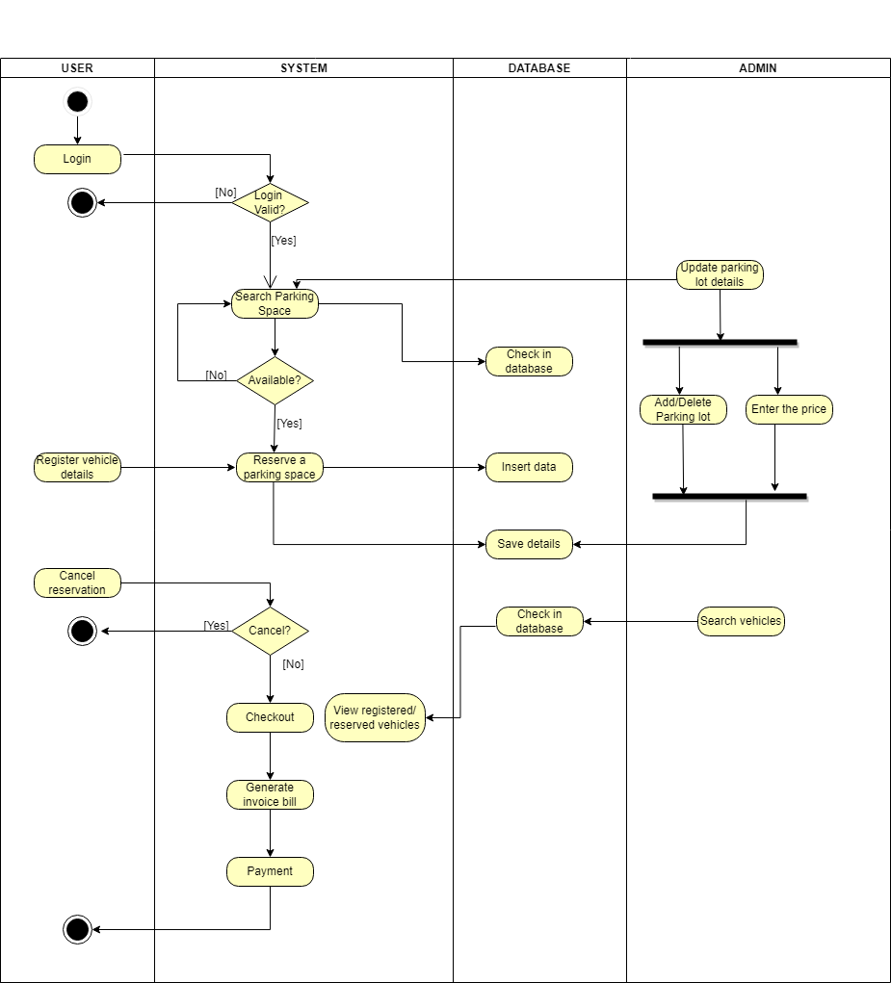**Figure: Activity diagram for System Use**

### COMPONENT DIAGRAM

Component diagram can be described as a special kind of diagram in UML as it shows static implementation view of a system. They are used to visualize the organization and relationships among components in a system. The purpose of the component diagram is to construct executables by using forward and reverse engineering. And, they are used during the implementation phase of an application.

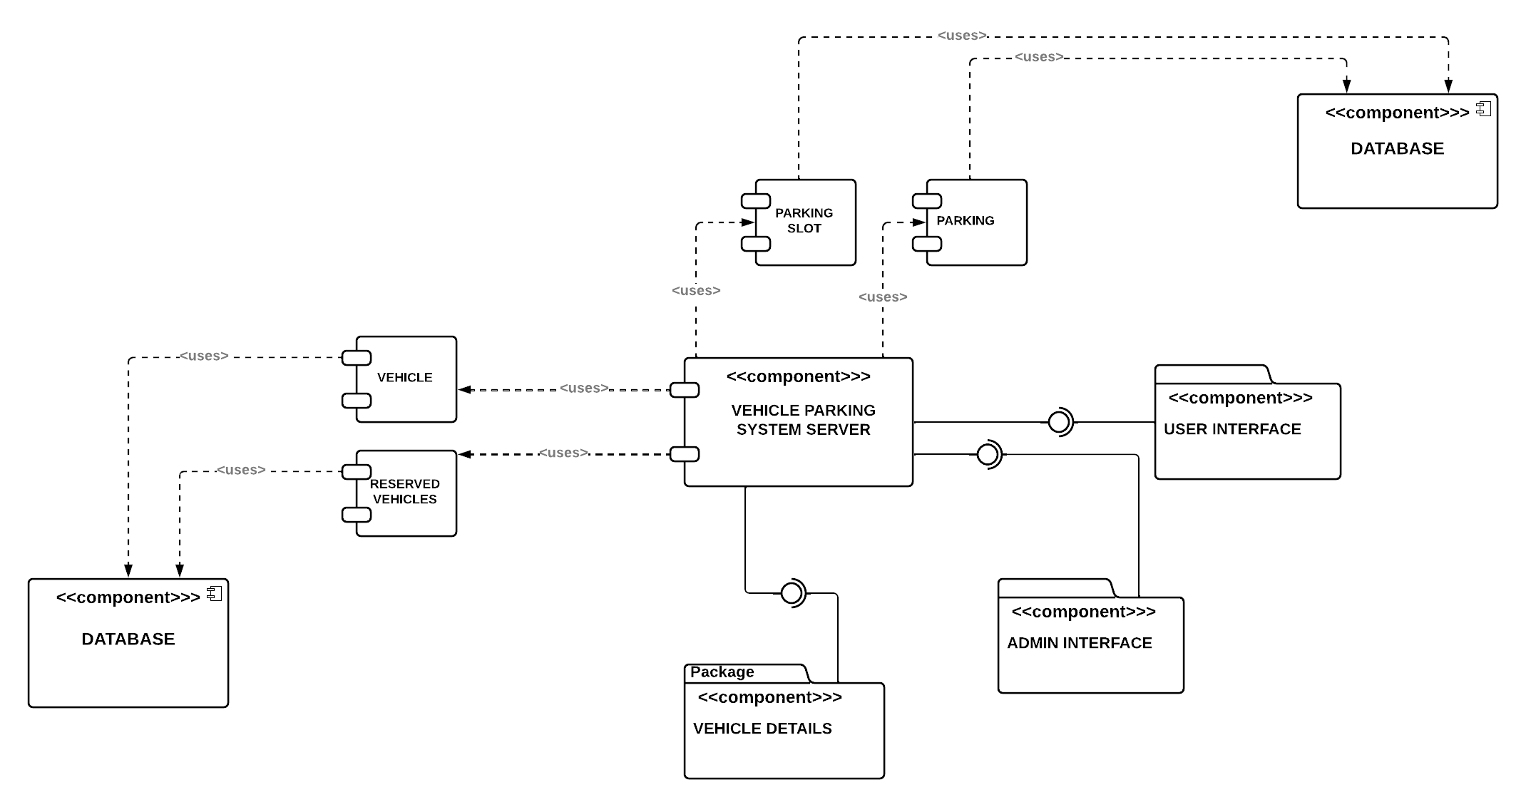

***Figure 3.8.* Component diagram**

### DEPLOYMENT DIAGRAM

In the context of Unified Modeling Language, A deployment diagram is a diagram that shows the execution architecture of a system, including nodes such as hardware or software execution environments, and the middleware connecting them. Deployment diagrams are typically used to visualize the physical hardware and software of a system. It consists of nodes and their relationships.

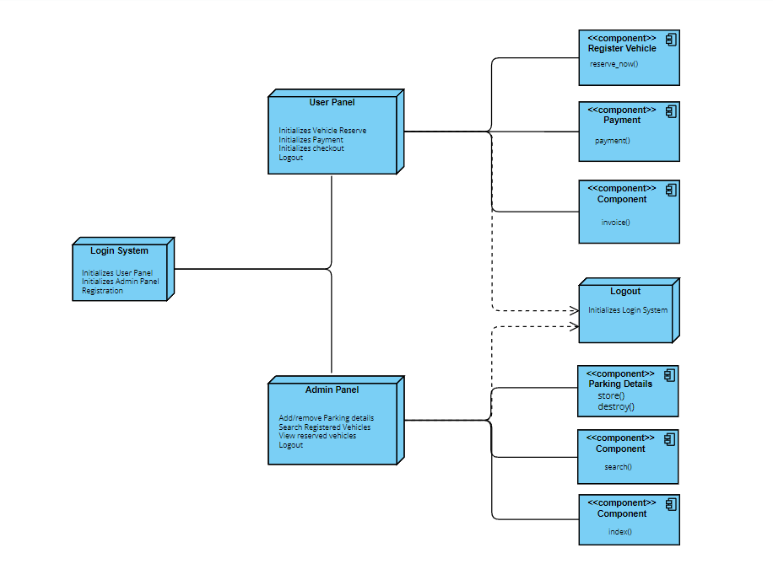

**Figure 3.9. Deployment diagram**

## Algorithm details

In vehicle parking system, the algorithms play a very vital role for giving the nearest empty parking lot, traffic management at a time of entry and exit, Load balancing at each entrance of very large and complex parking area. The algorithms that can be in smart vehicle parking system are:

* + - * 1. FCFS (Queue Allocation for vehicle)
        2. Linear Searching Algorithm

1. **First Come First Serve (FCFS)**

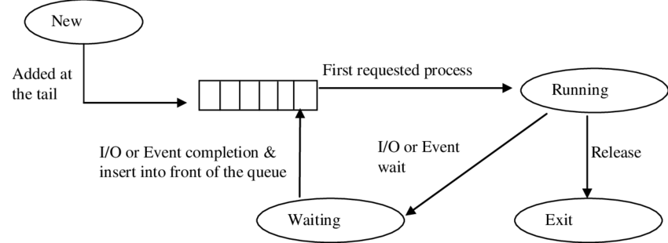It is an operating system scheduling algorithm that automatically executes queued requests and processes in order of their arrival. It is the easiest and simplest scheduling algorithm. This is managed with a FIFO queue. It is easy to implement and use. The customer can search for available parking space according to FCFS algorithm. It searches up the available parking detail from database and sends response if the parking space is available or already booked.

1. **Linear** **Searching Algorithm**

Searching Algorithms are designed to check for an element or retrieve an element from any data structure where it is stored. Based on the type of search operation, these algorithms are generally classified into two categories:

* Linear Search (Sequential Search)
* Interval Search

Linear Search is the algorithm I have implemented in this system. A linear search is the simplest approach employed to search for an element in a data set. It examines each element until it finds a match, starting at the beginning of the data set, until the end. The admin can search for all the registered vehicles and reserved vehicles for parking.

The procedures for implementing linear search are as follows:

* + - 1. First, read the search element (Target element) in the array.
      2. Compare the search element with the first element in the array.
      3. If both are matched, display "Target element is found" and terminate the Linear Search function.
      4. If both are not matched, compare the search element with the next element in the array.
      5. In this step, repeat steps 3 and 4 until the search (Target) element is compared with the last element of the array.
      6. If the last element in the list does not match, the Linear Search Function will be terminated, and the message "Element is not found" will be displayed.

References

* [1] Mantra Softech India Private Limited, “Innovation that counts”, 2006. [Online] Available:<https://www.mantratec.com/Solutions/Parking-Management-System> [Accessed on: March 05 2022,]
* [2] S. Bhatia & R.Choudhary, “Parking Management System” 2019.[Online] Available: <https://www.metroinfrasys.com/parking-management-system/>[Accessed on: April 01,2022]
* [3] Phudinawala, Hasan & Malusare, Omkar & Mahadik, Rushikesh, *International Journal of Advanced Research in Science, Communication and Technology.* Vol. 10p. 556-559 March 03 2022. [Online] Available: <https://www.researchgate.net/publication/359568444_Vehicle_Parking_Management_System> [Accessed on: April 22, 2022]
* [4] Sowndharya, V & S, Hebziba & D, Susmitha, *International Research Journal of Multidisciplinary Technovation.* Vol. 1*,* p. 18 March 2019. [Online] Available:<https://www.researchgate.net/publication/349527243_Implementation_of_Smart_Vehicle_Parking_System> [Accessed on: April 19,2022.]
* [5] Bhairathi, V. “Smart Parking System”, *International Journal for Research in Applied Science and Engineering Technology,* Vol. 9, p. 1823 July 2021, [Online] Available:<https://www.researchgate.net/publication/353423423_Smart_Parking_System> [Accessed on: April 20,2022]