Walmart Store Sales Forecasting
Beating a Classical Time-Series Baseline with a Tuned Machine Learning Model

1. Problem Statement
Business Context
Walmart operates 45 stores across multiple regions, each with up to 81 merchandise departments. Weekly sales at the store-department level are volatile and heavily influenced by seasonality, promotional markdowns, and holiday timing — most notably Thanksgiving. Inaccurate forecasts lead directly to overstocking (markdown losses, wasted shelf space) or understocking (lost sales, poor customer experience) during the highest-value weeks of the year.
Objective
This project forecasts total weekly sales using historical sales, holiday calendar, and store-level economic indicators (temperature, fuel price, CPI, unemployment, and markdown activity). Two modeling approaches are compared head-to-head on an out-of-sample holdout period:
- SARIMAX — a classical statistical time-series model with exogenous regressors, representing the traditional forecasting baseline.
- XGBoost — a gradient-boosted tree model using engineered lag, rolling-window, and calendar features.
Success Criterion
The explicit goal is to optimize the XGBoost model — through feature engineering and hyperparameter tuning — until it outperforms the SARIMAX baseline on held-out forecast accuracy (RMSE and MAPE), while remaining a fair, apples-to-apples comparison on the same train/test split and forecast horizon.
Scope & Data
Data covers 143 weeks (Feb 2010 – Oct 2012) across train.csv, features.csv (store-level economic indicators and promotional markdowns), and stores.csv (store type and size). Sales are aggregated to a total weekly series to give both models a common, directly comparable forecasting target.

2. Data Understanding & Feature Engineering
Dataset Overview
The raw data spans 421,570 store-department-week records (45 stores × 81 departments) merged with weekly economic indicators. After merging and aggregating to a single total-sales-per-week series, 143 weeks remain (2010-02-05 to 2012-10-26). Key data quality findings: the five MarkDown promotional columns are 50–64% missing (most stores ran no promotions before Nov 2011), CPI/Unemployment are ~7% missing and were forward/backward filled, and 1,285 records have negative sales, consistent with product returns. Weekly sales are right-skewed — most weeks cluster near $46M with a long tail toward $50M+ holiday weeks.
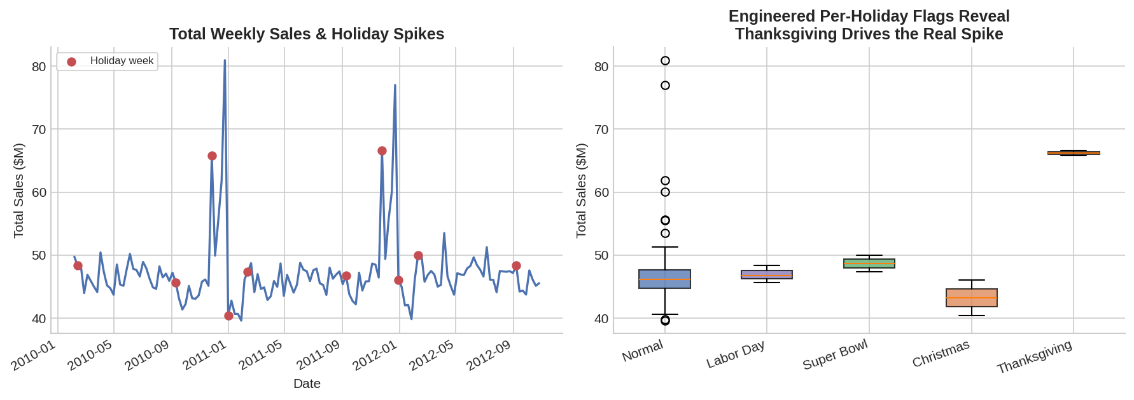
Figure 1. Left: total weekly sales, 2010–2012 — holiday weeks (red) show sharp, recurring spikes. Right: splitting the generic IsHoliday flag into named holidays reveals Thanksgiving is the true outlier driving the biggest spikes — signal the raw flag hides.
Feature Engineering
Beyond the raw fields, the following features were engineered to give the models predictive signal beyond the current week's exogenous variables:
- Lag features: Sales_Lag1–Lag4 (previous 1–4 weeks' total sales) capture short-term momentum.
- Rolling statistics: 4-week rolling mean and standard deviation smooth noise and capture local trend/volatility.
- Calendar features: Month and ISO week-of-year encode seasonality directly for the tree model.
- Named holiday flags: the generic IsHoliday flag was split into Super Bowl, Labor Day, Thanksgiving, and Christmas indicators (Figure 1, right).
- MarkDown_Total: the five promotional markdown columns summed into a single signal (missing values treated as $0 in promotion).
Prior-week sales (Sales_Lag1) and the Thanksgiving flag show the strongest linear relationship with the target, and both feed directly into the models on the next page.

3. Model Results
Setup
Both models were trained on the first 119 weeks and evaluated on the final 20 held-out weeks (2012-06-15 to 2012-10-26) — an identical time-based split for a fair comparison. SARIMAX(2,0,2) was selected via AIC grid search over (p,d,q) with the economic indicators as exogenous regressors. XGBoost was first fit with default parameters, then tuned via RandomizedSearchCV using 5-fold time-series cross-validation (60 parameter combinations) over tree depth, learning rate, subsampling, and regularization.
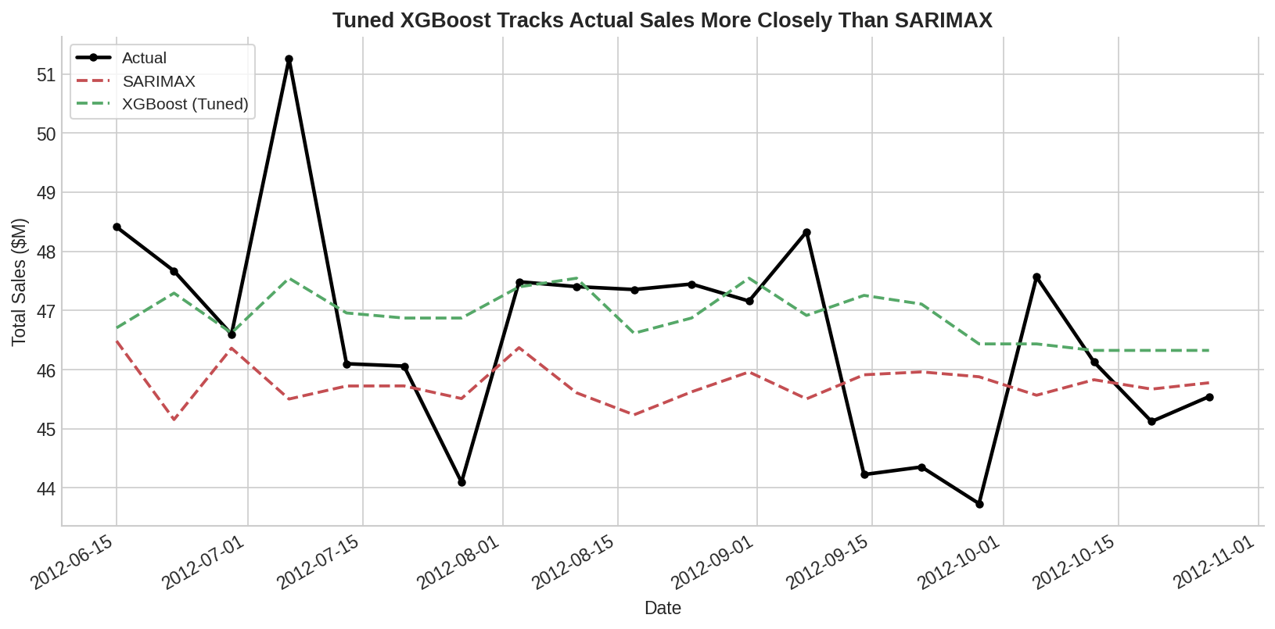
Figure 2. Actual vs. predicted weekly sales on the 20-week holdout. Tuned XGBoost tracks the actual series' turning points more closely than SARIMAX, which under-reacts to short-term swings.
Accuracy Comparison
Model | RMSE ($) | MAE ($) | MAPE
SARIMAX (2,0,2) | 2,019,396 | 1,597,162 | 3.37%
XGBoost (baseline) | 1,958,797 | 1,448,948 | 3.16%
XGBoost (tuned) | 1,678,849 | 1,269,753 | 2.75%
Table 1. Holdout accuracy across all three models (lower is better across all metrics).
The tuned XGBoost model reduces RMSE by 16.9% and MAPE by 18.4% relative to the SARIMAX baseline, meeting the project's success criterion. Best hyperparameters: max_depth=2, learning_rate=0.01, n_estimators=300, subsample=1.0, colsample_bytree=0.9, reg_lambda=2 — a shallow, heavily-regularized ensemble, appropriate given the modest sample size (119 training weeks).
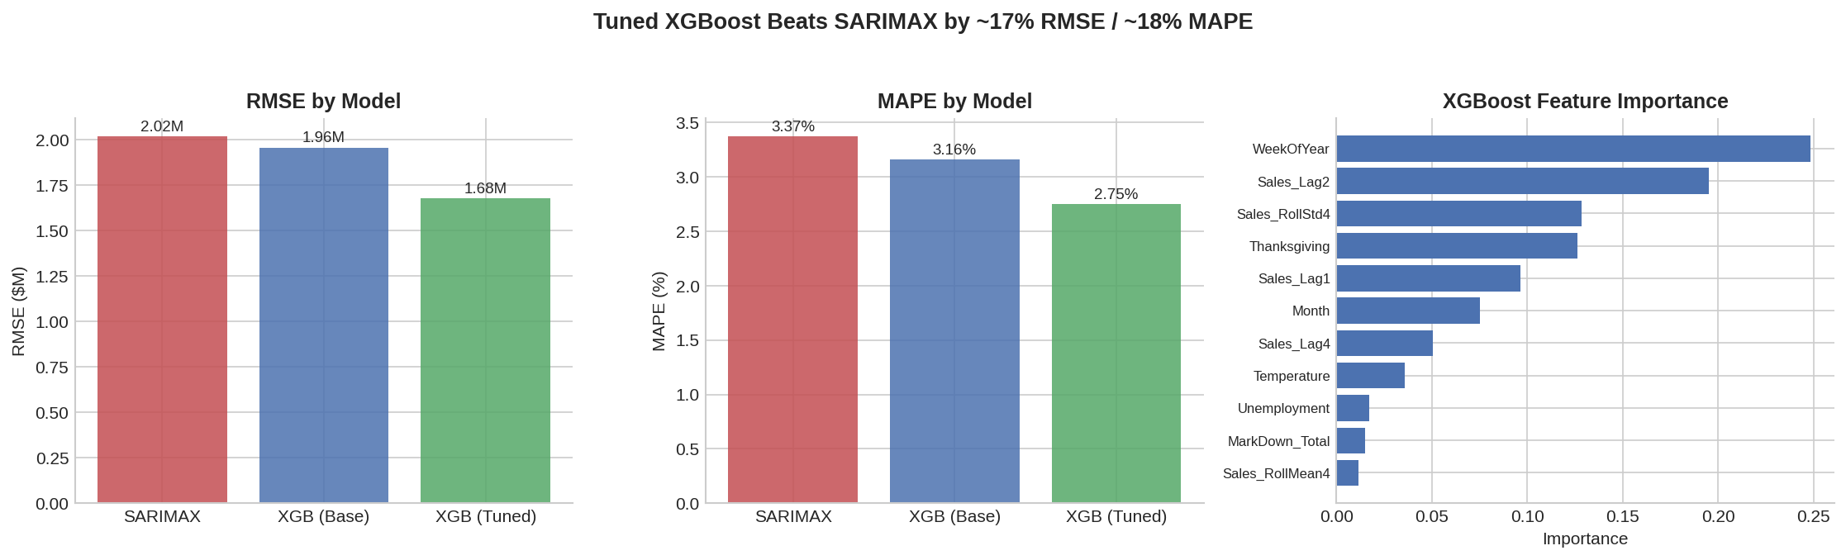
Figure 3. Tuned XGBoost outperforms both SARIMAX and the untuned baseline on RMSE and MAPE (left, center); week-of-year and prior-week sales carry the most predictive weight in the tuned model (right).

4. Business Insights & Recommendations
Key Findings
- Tuned XGBoost is the recommended forecasting model: it cuts forecast error by ~17–18% versus the SARIMAX baseline, translating directly into more reliable inventory and staffing plans.
- Seasonality (week-of-year) and short-term momentum (prior-week sales) are the two strongest drivers of next-week sales — together accounting for over 44% of the tuned model's predictive weight.
- Not all holidays are equal: Thanksgiving week sales run well above every other holiday, while Labor Day and Super Bowl show almost no lift over a normal week. Treating all holidays as one generic flag — as SARIMAX effectively does — blurs this distinction and likely explains part of its higher error.
- Promotional markdown activity (MarkDown_Total) has a modest but real positive relationship with sales, despite being missing for roughly half of all store-weeks, suggesting cleaner, more consistent markdown reporting could unlock further model gains.
Recommendations
- Deploy tuned XGBoost for operational weekly forecasting, with SARIMAX retained as a sanity-check / ensemble input rather than the primary model.
- Plan inventory and staffing around Thanksgiving week specifically — not the broader holiday calendar — given its outsized, statistically distinct impact on sales.
- Prioritize fixing MarkDown data capture (currently 50–64% missing) since promotional spend is a controllable lever the model can act on once the signal is more complete.
- Retrain and re-tune the model quarterly as new weeks of data arrive; the small sample size (139 usable weeks) means hyperparameters found here should be revisited as more history accumulates.
Limitations
This analysis forecasts total company-wide weekly sales rather than individual store-department combinations; a production deployment would likely need store- and department-level models, which would also unlock store Type/Size as additional features. The 20-week holdout, while time-ordered and leakage-free, is a single test window — rolling-origin backtesting across multiple holdout periods would give a more robust estimate of the XGBoost-vs-SARIMAX gap before full production rollout.

