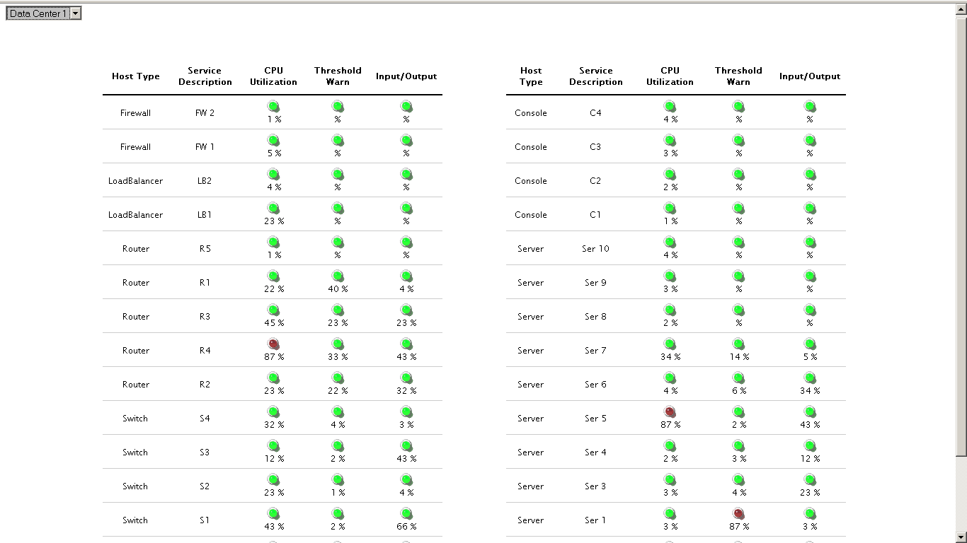
http://10.10.10.23:8888/dropdown_led_grid/index1.php

http://10.10.10.23:8888/img_gauge_dash/frame.php
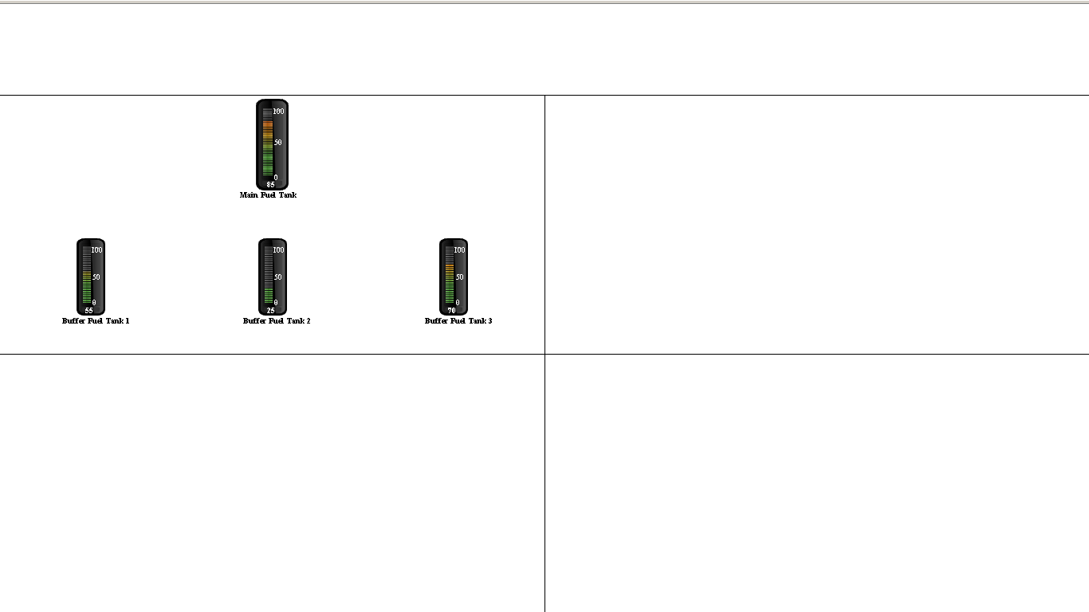

http://10.10.10.23:8888/New_srv_mnt/tab.php
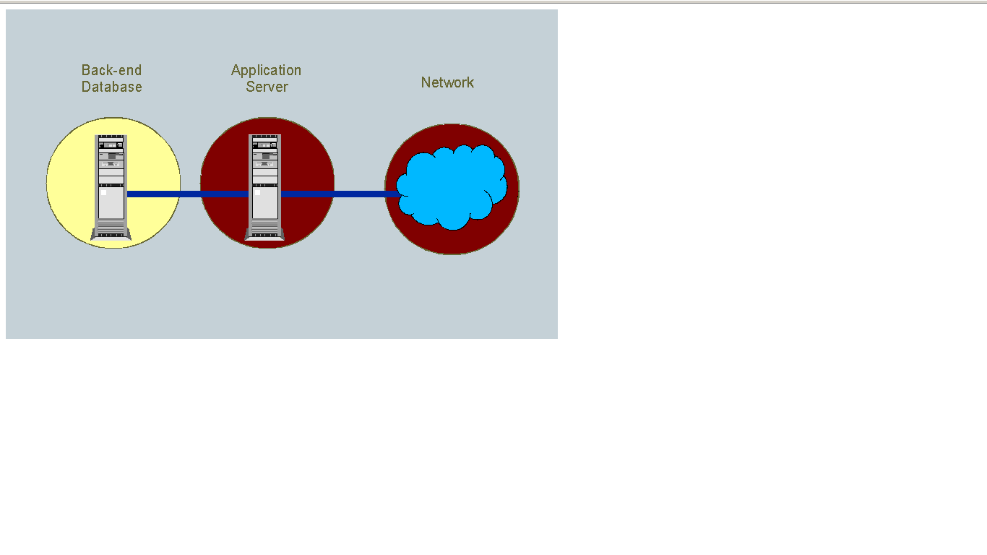

http://10.10.10.23:8888/server_monitor/athenta/grid.php

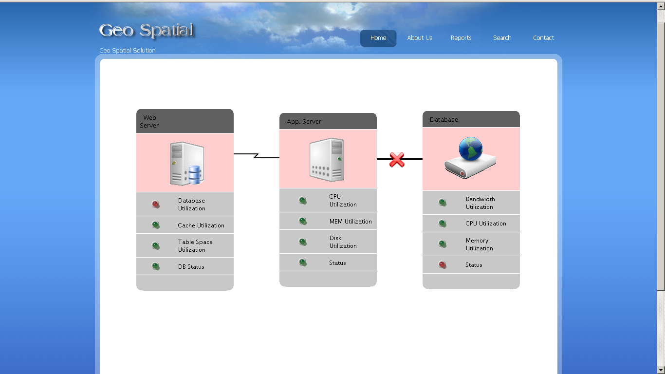

http://10.10.10.23:8888/server_monitor/athenta2/grid.php
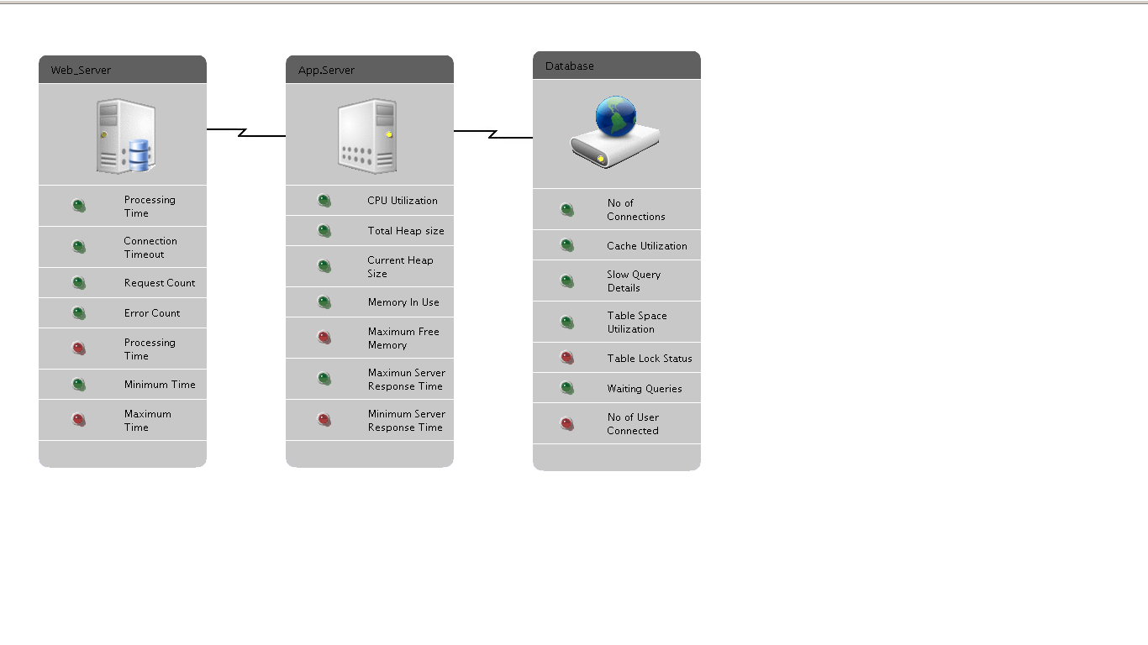
http://10.10.10.23:8888/gen_led/frame.php

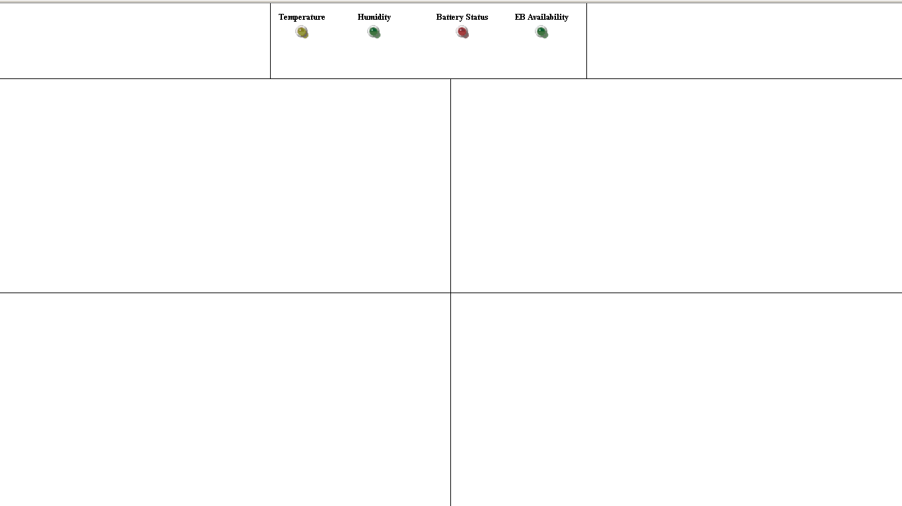

DB:geocode Table:value Field:val5, val6
http://10.10.10.23:8888/img_gauge_2oneforth/frame.php
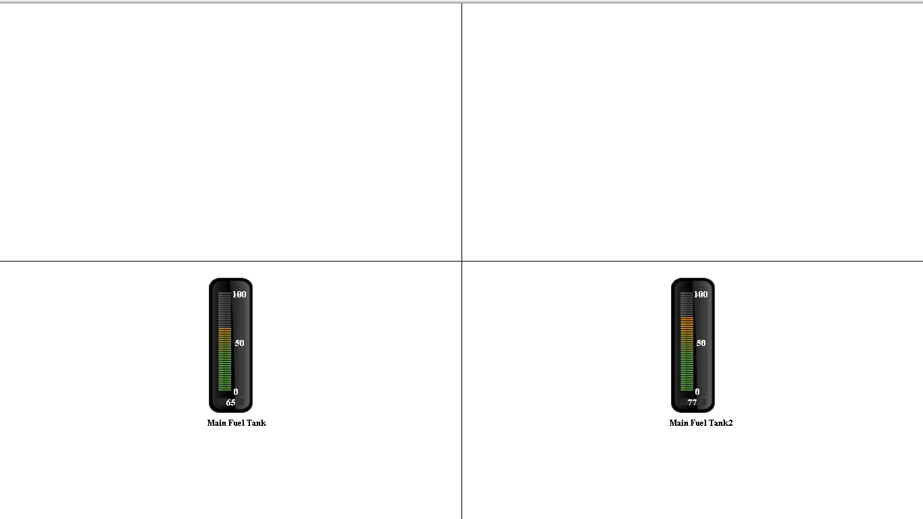

http://localhost:8888/not_done/Weather_dashboard/weth/wath.php?city=jaipur
