# 

# Assignment 2: SQL Review

### Part 1: Basic queries with SELECT

1. 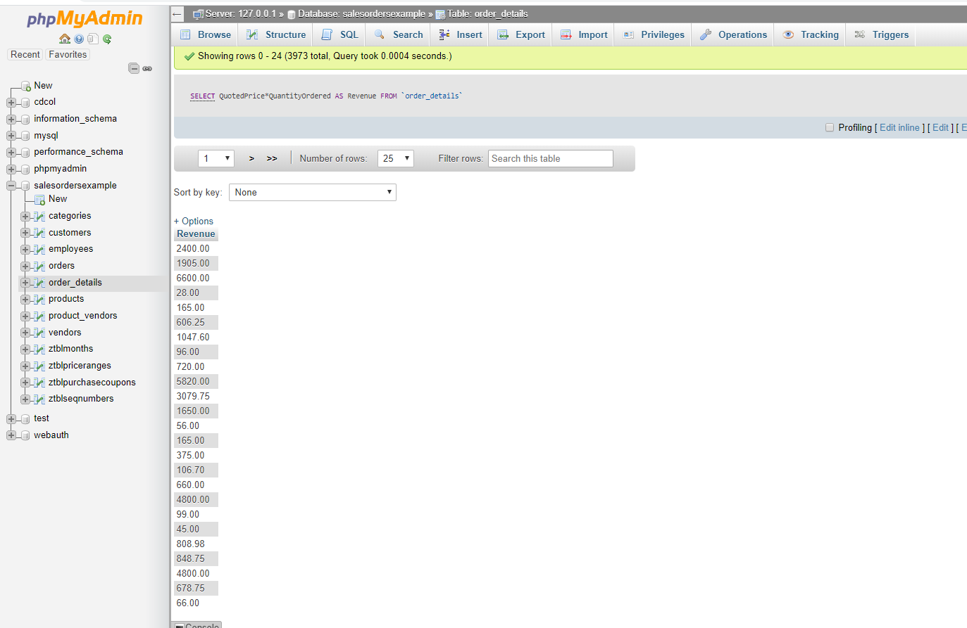Using the order_details table, find the revenue (price * quantity) earned on each order.

* [SELECT](http://localhost/phpmyadmin/url.php?url=https://dev.mysql.com/doc/refman/5.5/en/select.html) QuotedPrice*QuantityOrdered AS Revenue FROM order_details;

1. 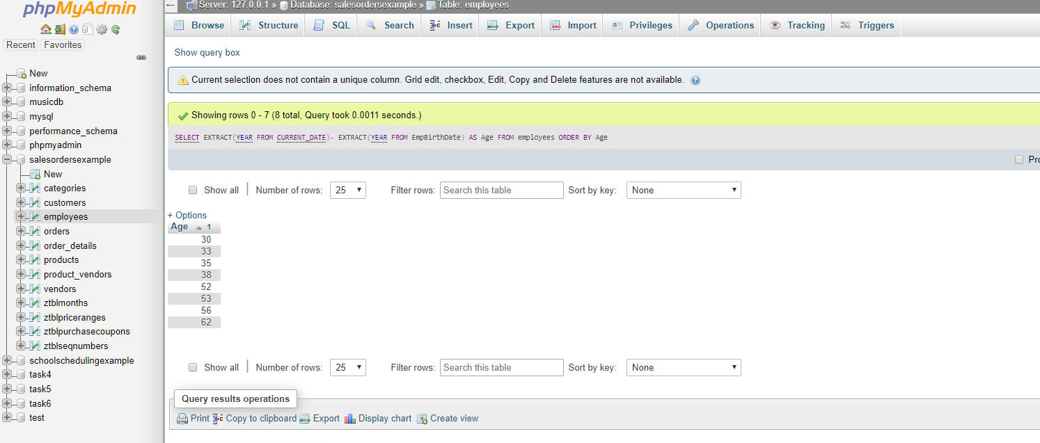Using the employees table, find the age of each employee in years and order from youngest to oldest.

* [SELECT](http://localhost/phpmyadmin/url.php?url=https://dev.mysql.com/doc/refman/5.5/en/select.html) EXTRACT([YEAR](http://localhost/phpmyadmin/url.php?url=https://dev.mysql.com/doc/refman/5.5/en/date-and-time-types.html) FROM [CURRENT_DATE](http://localhost/phpmyadmin/url.php?url=https://dev.mysql.com/doc/refman/5.5/en/date-and-time-functions.html#function_current_date))- EXTRACT([YEAR](http://localhost/phpmyadmin/url.php?url=https://dev.mysql.com/doc/refman/5.5/en/date-and-time-types.html) FROM EmpBirthDate) AS Age FROM employees ORDER BY Age;

### Part 2: Conditional queries

1. 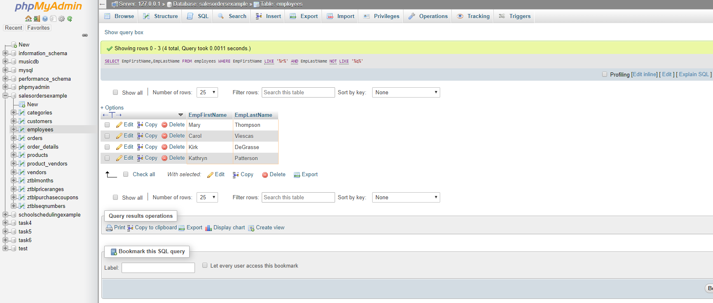Using the employees table, find all employees with a first name that contains an 'r' and a last name that does not contain a 'q'.

* [SELECT](http://localhost/phpmyadmin/url.php?url=https://dev.mysql.com/doc/refman/5.5/en/select.html) EmpFirstName,EmpLastName FROM employees WHERE EmpFirstName [LIKE](http://localhost/phpmyadmin/url.php?url=https://dev.mysql.com/doc/refman/5.5/en/string-comparison-functions.html#operator_like) '%r%' [AND](http://localhost/phpmyadmin/url.php?url=https://dev.mysql.com/doc/refman/5.5/en/logical-operators.html#operator_and) EmpLastName [NOT](http://localhost/phpmyadmin/url.php?url=https://dev.mysql.com/doc/refman/5.5/en/logical-operators.html#operator_not) [LIKE](http://localhost/phpmyadmin/url.php?url=https://dev.mysql.com/doc/refman/5.5/en/string-comparison-functions.html#operator_like) '%q%';

### Part 3: Database Design

1. Explain what is wrong with the following table and how you would fix it.

|  |  |  |  |  |
| --- | --- | --- | --- | --- |
| CompanyName | Address | Email | Products | Phone |
| Telle. Co | 12 Dirk St | Rep@telle.com | Computer, Phone, Power cables | 519-555-4410 |
| Barba. Co | 133 Shep St | Rep@barb.com | Hair care, Shampoo, Dye, Combs | NULL |

**Create a table company**

[CREATE](http://localhost/phpmyadmin/url.php?url=https://dev.mysql.com/doc/refman/5.5/en/create-table.html) [TABLE](http://localhost/phpmyadmin/url.php?url=https://dev.mysql.com/doc/refman/5.5/en/create-table.html) `salesordersexample`.`company` ( `companyId` [INT](http://localhost/phpmyadmin/url.php?url=https://dev.mysql.com/doc/refman/5.5/en/numeric-types.html)(10) [NOT](http://localhost/phpmyadmin/url.php?url=https://dev.mysql.com/doc/refman/5.5/en/logical-operators.html#operator_not) NULL AUTO_INCREMENT , `CompanyName` [VARCHAR](http://localhost/phpmyadmin/url.php?url=https://dev.mysql.com/doc/refman/5.5/en/string-types.html)(35) [NOT](http://localhost/phpmyadmin/url.php?url=https://dev.mysql.com/doc/refman/5.5/en/logical-operators.html#operator_not) NULL , `Address` [VARCHAR](http://localhost/phpmyadmin/url.php?url=https://dev.mysql.com/doc/refman/5.5/en/string-types.html)(50) [NOT](http://localhost/phpmyadmin/url.php?url=https://dev.mysql.com/doc/refman/5.5/en/logical-operators.html#operator_not) NULL , `Email` [VARCHAR](http://localhost/phpmyadmin/url.php?url=https://dev.mysql.com/doc/refman/5.5/en/string-types.html)(50) [NOT](http://localhost/phpmyadmin/url.php?url=https://dev.mysql.com/doc/refman/5.5/en/logical-operators.html#operator_not) NULL , `Products` [VARCHAR](http://localhost/phpmyadmin/url.php?url=https://dev.mysql.com/doc/refman/5.5/en/string-types.html)(50) [NOT](http://localhost/phpmyadmin/url.php?url=https://dev.mysql.com/doc/refman/5.5/en/logical-operators.html#operator_not) NULL , `ProductNumber` [INT](http://localhost/phpmyadmin/url.php?url=https://dev.mysql.com/doc/refman/5.5/en/numeric-types.html)(10) [NOT](http://localhost/phpmyadmin/url.php?url=https://dev.mysql.com/doc/refman/5.5/en/logical-operators.html#operator_not) NULL , `Phone` [INT](http://localhost/phpmyadmin/url.php?url=https://dev.mysql.com/doc/refman/5.5/en/numeric-types.html)(30) NULL , PRIMARY KEY (`companyId`)) ENGINE = InnoDB;

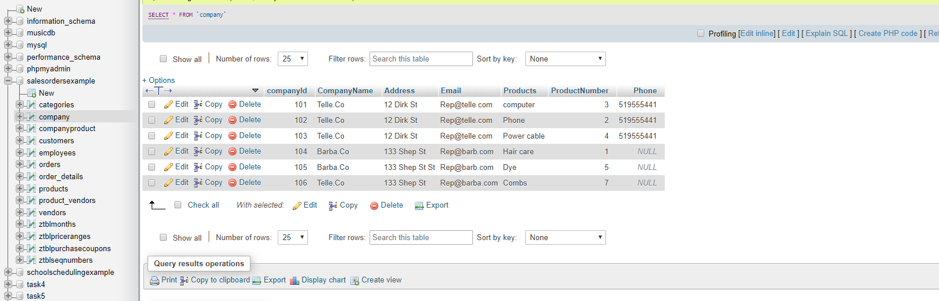

**Inserting the values in company table**

***INSERT INTO `company`(`companyId`, `CompanyName`, `Address`, `Email`, `Products`, `ProductNumber`, `Phone`) VALUES (Telle.Co,12 Dirk St,Rep@telle.com,computer,3,519-555-441);***

**Create one more table companyProduct**

***CREATE TABLE companyProduct (***

***Productid INT NOT null,***

***companyId INT NOT null,***

***ProductName varchar(10),***

***PRIMARY key (productId),***

***FOREIGN KEY (companyId_id)***

***REFERENCES company(companyId)***

***) ;***

### Part 4: Joins

1. Find the first name and phone number of all customers who have ever ordered a helmet.

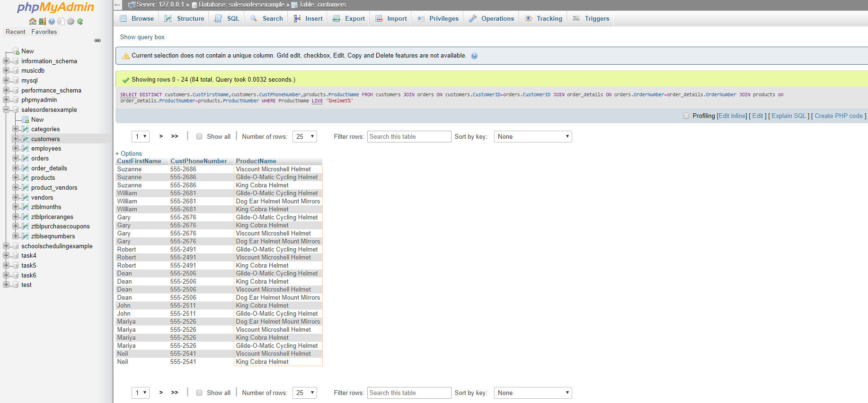

* [SELECT](http://localhost/phpmyadmin/url.php?url=https://dev.mysql.com/doc/refman/5.5/en/select.html) DISTINCT customers.CustFirstName,customers.CustPhoneNumber,products.ProductName FROM customers JOIN orders ON customers.CustomerID=orders.CustomerID JOIN order_details ON orders.OrderNumber=order_details.OrderNumber JOIN products on order_details.ProductNumber=products.ProductNumber WHERE ProductName [LIKE](http://localhost/phpmyadmin/url.php?url=https://dev.mysql.com/doc/refman/5.5/en/string-comparison-functions.html#operator_like) '%Helmet%;

1. 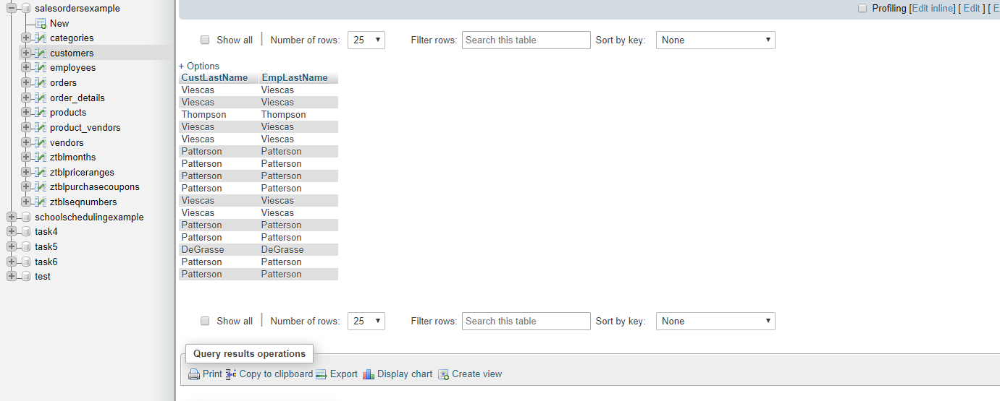Display the last name of all customers who have the same last name as an employee.

* [SELECT](http://localhost/phpmyadmin/url.php?url=https://dev.mysql.com/doc/refman/5.5/en/select.html) customers.CustLastName,employees.EmpLastName FROM `customers` INNER JOIN employees ON customers.CustLastName=employees.EmpLastName;

### Part 5: Aggregate Functions

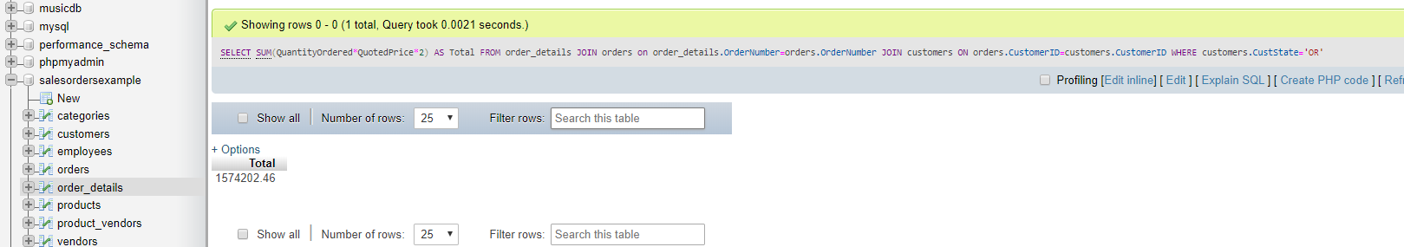1. Find the combined total value (QuantityOrdered*QuotedPrice) of all orders made by customers from the state of 'OR'

* [SELECT](http://localhost/phpmyadmin/url.php?url=https://dev.mysql.com/doc/refman/5.5/en/select.html) [SUM](http://localhost/phpmyadmin/url.php?url=https://dev.mysql.com/doc/refman/5.5/en/group-by-functions.html#function_sum)(QuantityOrdered*QuotedPrice*2) AS Total FROM order_details JOIN orders on order_details.OrderNumber=orders.OrderNumber JOIN customers ON orders.CustomerID=customers.CustomerID WHERE customers.CustState='OR';

***Submitted by: Amanpreet Kaur***

***StudentID: 8622722***