**Organ Donation and Procurement Network Management System**

DBMS MINI PROJECT

**Group Members:**

*Manish Kumar,2006121*

*Jayesh Badgujar,2006122*

*Aman,2006149*

*Himanshu Rai,2006150*

*Shreyash Karmankar,2006151*

***Problem Statement***

**Organ transplantation**is a medical procedure in which an organ is removed from one body and placed in the body of a recipient, to replace a damaged or missing organ. The donor and recipient may be at the same location, or organs may be transported from a donor site to another location.

**Organ Donation and Procurement Organizations**play a pivotal role in today’s medical institutions. Such organizations are responsible for the evaluation and procurement of organs for organ transplantation. These organizations represent the front line of organ procurement, having direct contact with the hospital and the family of a recently deceased donor. The work of such organizations includes identifying the best candidates for the available organs and coordinating with the medical institutions to decide on each organ recipient. They are also responsible for educating the public to increase awareness of and participation in the organ donation process. Also, it keeps track of all transplantation operations carried till date.

**The Organ Donation and Procurement Network Management System** is a database management system that uses database technology to construct, maintain and manipulate various kinds of data about a person’s donation or procurement of a particular organ. It maintains a comprehensive medical history and other critical information like blood group, age, etc of every person in the database design. In short, it maintains a database containing statistical information regarding the network of organ donation and procurement in different countries.

***Organ Wastage****is a major issue that can only be solved by having a proper database of all Patient and Donors in a well-formed way, that can be processed easily.*

*Records of donors and patients are created when a person donates or procures an organ from a Medical Institution. Records may include the following information:*

* *Personal Information*
* *Medical History*
* *Medical insurance (if any)*
* *Allergies to any medicine (if any)*
* *The need for an organ presently*
* *Medical Insurance provided by any private or government insurers.*
* *Address and contact information*

***AIM:****Our aim is to create a solution that effectively deals with the problems of finding donors and providing Statistical data on the transplants that can help to form better rules and regulations.*

***Basic Steps in Implementation***

*• Every user has an account with can only be registered by a government-certified hospital, which will keep all the information as defined in Problem Statement.*

*• Only Hospitals are eligible to request a donation or procurement transaction.*

*• Government organizations will keep a watch on the pairing of donors and Patients and can approve a transplantation operation if all the rules are satisfied.*

*• Collecting Statistical Data through the history of Transplantation transactions.*

***Technologies Used:***

* *MySQL*
* *HTML*
* *CSS/Bootstrap*
* *JavaScript*
* *Express/NodeJS*

***ER Analysis: Entity Sets and Relationship Sets***

**Entity Sets:**

**1. User**

* *User ID*
* *Name*
* *Date of birth*
* *Phone Number (multi-valued)*
* *Medical Insurance*
* *Medical History*
* *Address*

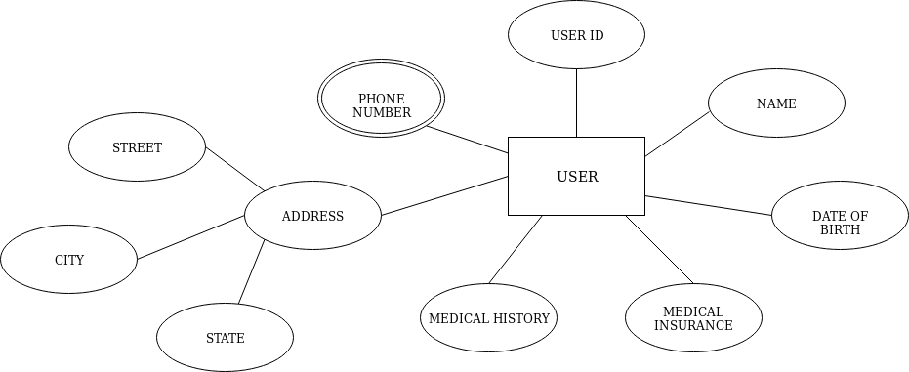

**2. Patient**

* *Patient ID*
* *Organ Required*
* *Reason of procurement*
* *User ID (foreign key)*

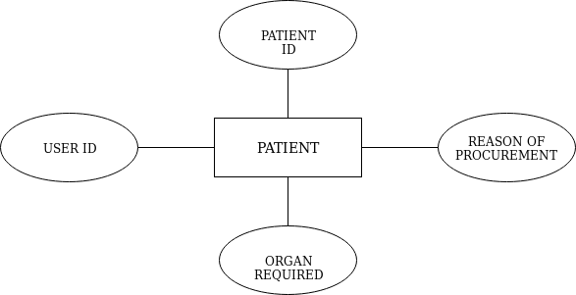

**3. Donor**

* *Donor ID*
* *Organ Donated*
* *Reason of donation*
* *User ID (foreign key)*

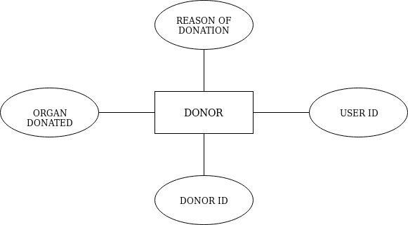

**4. Organ Available**

* *Organ ID*
* *Organ Name*
* *Donor ID (foreign key)*

**5. Organization**

* *Organization ID*
* *Organization Name*
* *Location*
* *Government approved organization or not*
* *Phone Number (multi-valued)*

**6. Doctor**

* *Doctor ID*
* *Doctor Name*
* *Phone Number (multi-valued)*

**7. Organization Head**

* *Head Name*
* *Date of Joining*
* *Term Length*

**Relationship Sets:**

**1. Donates -** *The act of donation of an organ from a donor*

* *Date**– Date of donation*

**2. Procures -** *The act of procuring an organ by the patient*

**3. Transaction -**

* *Date of transaction*
* *Status – whether the surgery was successful or not*

**4. Organ Donated -***The organ donated by a donor, which is then stored in Organ_available table.*

**5. Attended By -***The transplantation performed by doctor –procuring an organ from a donor and transplanting it to the patient by surgery.*

**6. Registers -** *Donor is registered in which organization*

**7. Works in –** *The organization where the doctor works.*

**8. Headed By –** *The organization is headed by which person*

***ER DIAGRAM***

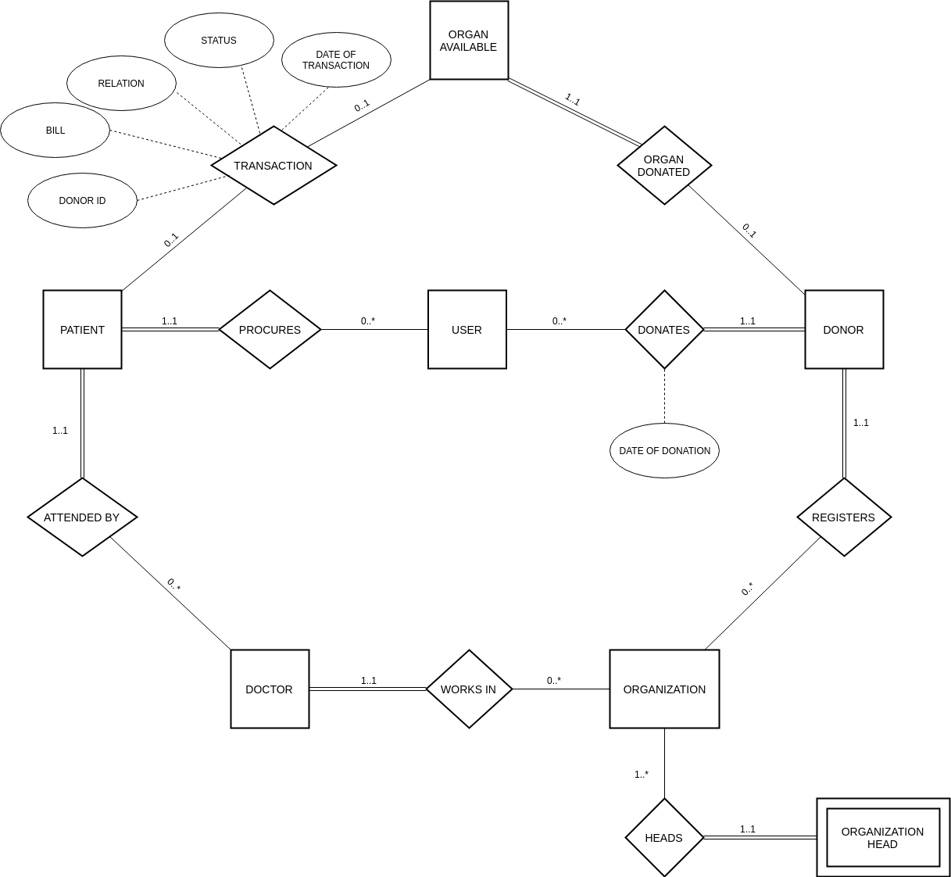

***Tables and their Functional Dependencies***

**1) User** (User_ID, Name, Date _of_birth, Medical_Insurance, Medical_History, Street, City, State)

**FD= {**User_ID → Name, Date _of_birth, Medical_Insurance, Medical History, Street, City, State**}**

**2) User_phone_no** (User_ID, phone_no)

**FD= {**User_ID -> phone_no**}**

**{**User_ID**}** *- Foreign Key*

**3) Patient** (Patient_ID, organ_req, reason_of_procurement, Doctor_ID,

User_ID)

**FD= {**Patient_ID, organ_req -> reason_of_procurement,

Doctor_ID, User_ID**}**

**{User_ID, Doctor_ID}** *- Foreign Keys*

**4) Donor** (Donor_ID, organ_donated, reason_of_donation,

Organization_ID, User_ID)

**FD= {**Donor_ID, organ_donated -> reason_of_donation,

Organization_ID, User_ID**}**

**{User_ID, Organization_ID}** *- Foreign Keys*

**5) Organ Available** (Organ_ID, Organ_name, Donor_ID)

**FD= {**Organ_ID -> Organ_name, Donor_ID**}**

**{Donor_ID}** *- Foreign Key*

**6) Transaction** (Patient_ID, Organ_ID, Donor_ID, Date_of_transaction,

Status)

FD= {Patient_ID, Organ_ID -> Donor_ID, Date_of_transaction,

Status}

**{Patient_ID, Donor_ID}** *- Foreign Keys*

**7) Organization** (Organization_ID, Organization_name, Location, Government_approved)

**FD= {**Organization_ID -> Organization_name, Location, Government_approved**}**

**8) Organization_phone_no** (Organization_ID, phone_no)

**FD= {**Organization_ID -> phone_no**}**

**{**Organization_ID**}** *- Foreign Key*

**9) Doctor** (Doctor_ID, Doctor_name, Department_name, Organization_id)

**FD= {**Doctor_ID -> Doctor_name, Organization_id**}**

**{**Organization_ID**}** - *Foreign Key*

**10) Doctor_phone_no** (Doctor_ID, phone_no)

**FD= {**Doctor_ID -> phone_no**}**

{Doctor_ID} *- Foreign Key*

**11) Organization_head** (Organization_ID, Employee_ID, Name, Date_of_joining, Term_length)

**FD= {**Organization_ID, Employee_ID -> Name, Date_of_joining,

Term_length**}**