1)

Create a directory named test_dir using mkdir.

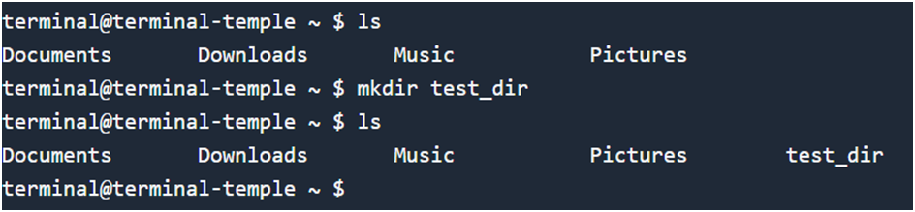

Inside test_dir, create an empty file called example.txt

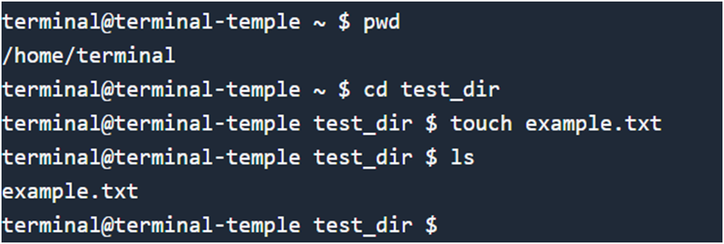

Rename example.txt to renamed_example.txt using mv

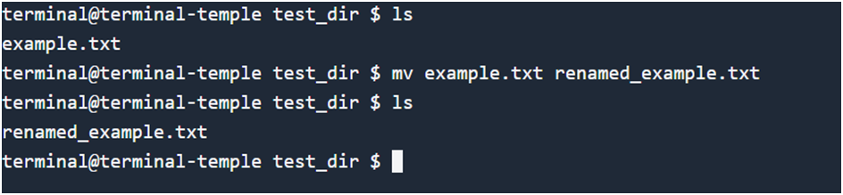

2)

Use cat to display the contents of /etc/passwd.

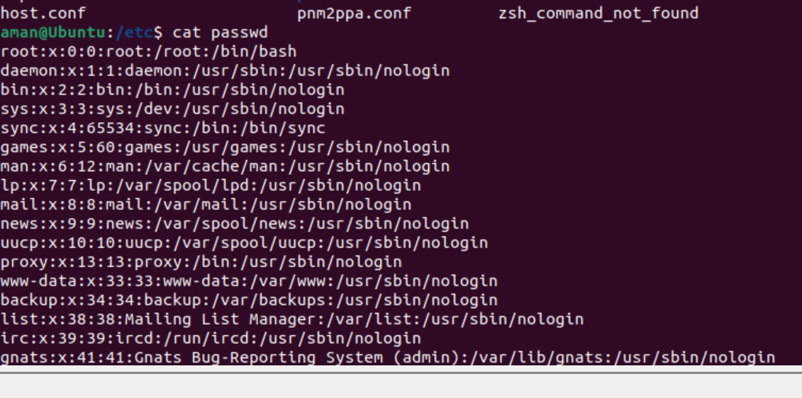

Display only the first 5 lines of /etc/passwd using head

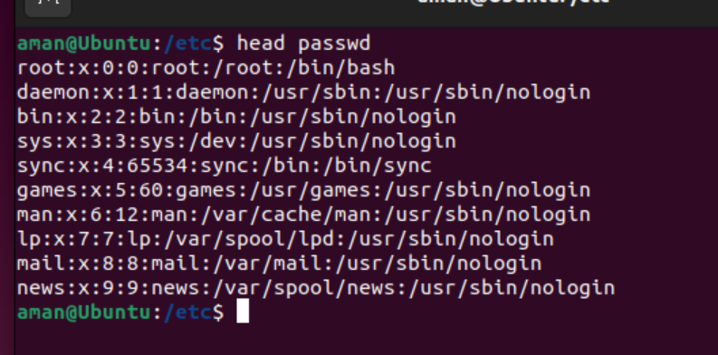

Display only the last 5 lines of /etc/passwd using tail.

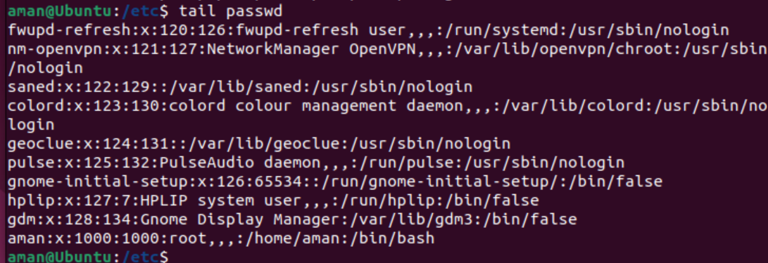

3) Use grep to find all lines containing the word "root" in /etc/passwd.

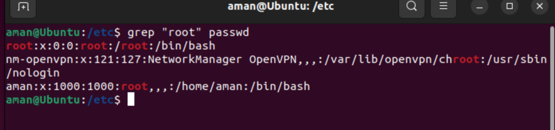

4) Compress the test_dir directory into a file named test_dir.zip using zip. And

5) Use wget to download a file from a URL

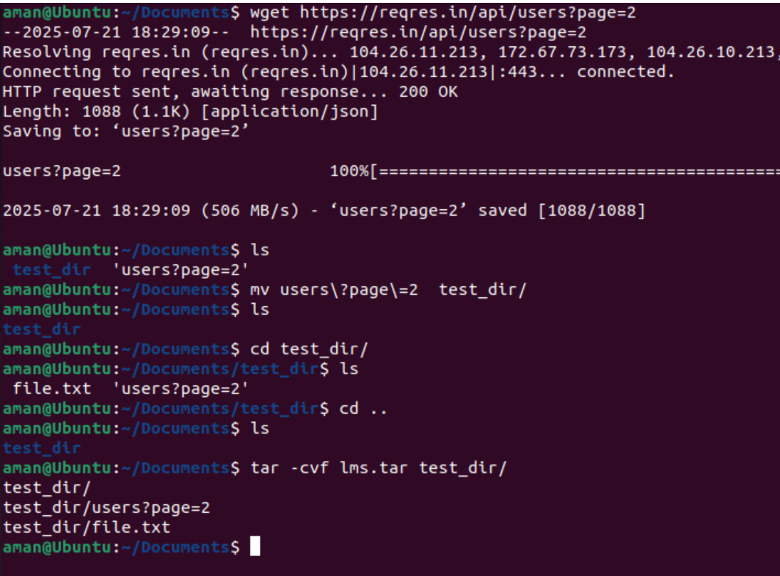

Unzip test_dir.zip into a new directory named unzipped_dir.

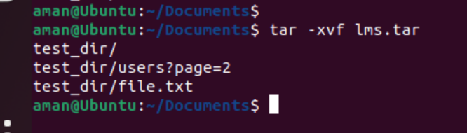

5) Wget done for reques api in above Snip

6 Create a file named secure.txt and change its permissions to read-only for everyone using chmod.

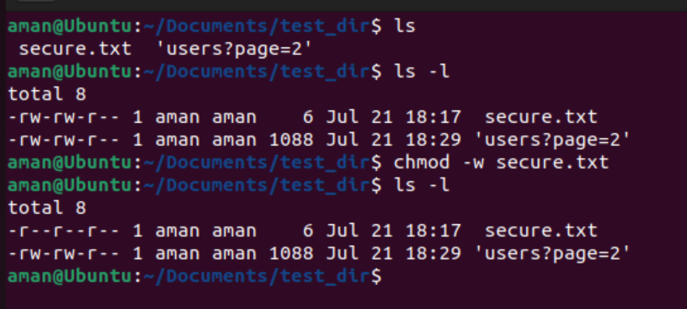

7) Use export to set a new environment variable called MY_VAR with the value "Hello, Linux!"

