1. Grade Checker:

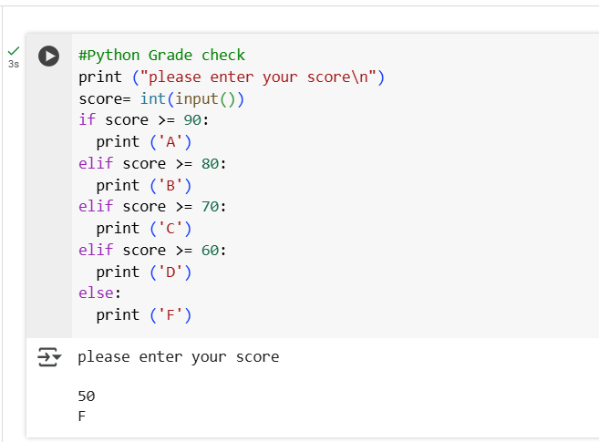

2 Student Grades:

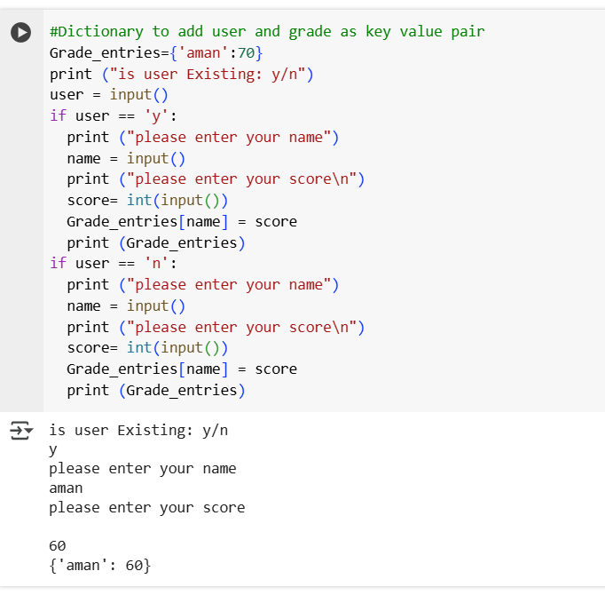

3.Write to a File

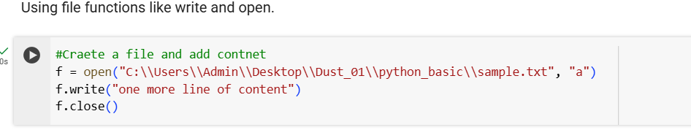

4. Read from a File:

