TECHNICAL CAPSTONE REPORT: PROJECT SENTINELAUTH
Automated Mini-SIEM Infrastructure Deployment & Incident Response Simulation
1. Executive Summary
Project SentinelAuth is an end-to-end blue-team security engineering implementation designed to establish localized threat monitoring, centralized log ingestion, and active network-layer incident containment.
By designing and deploying a containerized microservice matrix running an Elasticsearch and Kibana (ELK) database pipeline, this lab successfully monitors infrastructure authentication events in real time. The ecosystem was subjected to a simulated high-velocity, multi-threaded network brute-force authentication attack. Acting as a Security Operations Center (SOC) analyst, the threat vector was successfully detected using custom Kibana Query Language (KQL) indicators, forensics were analyzed, and persistent remediation was engineered at the host kernel firewall interface, reducing attack traffic back to zero.
2. Project Planning & Objectives
The core scope of this technical capstone revolves around the implementation of an enterprise-grade log analysis strategy tailored to lightweight virtual infrastructure:
- Objective 1: Build a sustainable, containerized logging engine utilizing open-source microservices.
- Objective 2: Configure host-level telemetry shipping to monitor high-risk access vectors (/var/log/auth.log).
- Objective 3: Simulate adversarial credential-stuffing exploits to validate data flow pipelines.
- Objective 4: Establish defensive playbook actions to achieve rapid threat containment and network isolation.
3. Environment Architecture & Technical Topology
The project operates across a three-tier virtual network mapping matrix. All systems communicate through a local bridged virtual networking interface to simulate an active internal enterprise subnet.
🔄 Telemetry Data Flow Pipeline
The operational lifecycle of every log follows this linear path:
$$\text{[Ubuntu Auth Logs (/var/log/auth.log)]}⟶\text{[Filebeat Ingestion Agent]}⟶\text{[Elasticsearch DB (Port 9200)]}⟶\text{[}\text{Kibana Control Panel (Port 5601)]}$$
Network Architecture Topographical Diagram
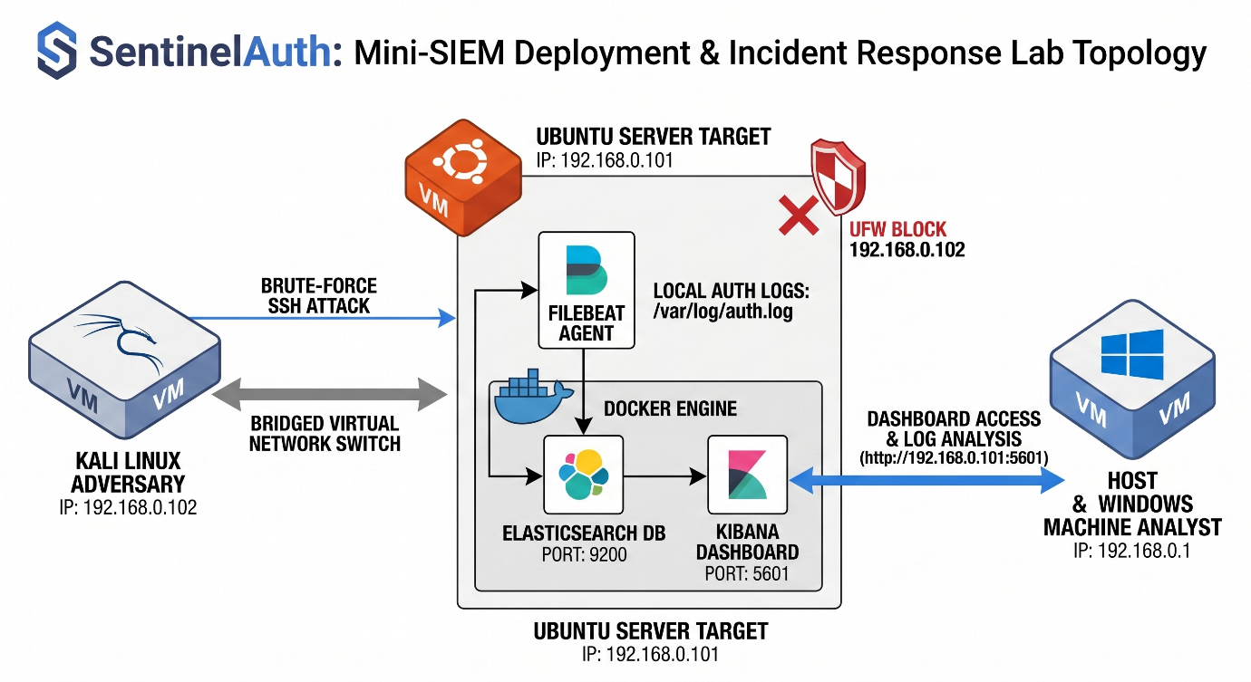4. System Implementation & Deployment Phase
4.1 Microservice Engine Prototyping
The backend logging nodes are built using lightweight container virtualization. To guarantee platform isolation and service persistence, an optimized multi-container configuration script (docker-compose.yml) was executed, allocating dedicated internal processing space for the Elasticsearch engine and Kibana graphical query platform.
To overcome memory allocation errors common when launching heavy Java database frameworks inside modern Linux kernels, the virtual host memory allocation boundaries were dynamically altered via system controls (vm.max_map_count=262144) before provisioning the virtual infrastructure.
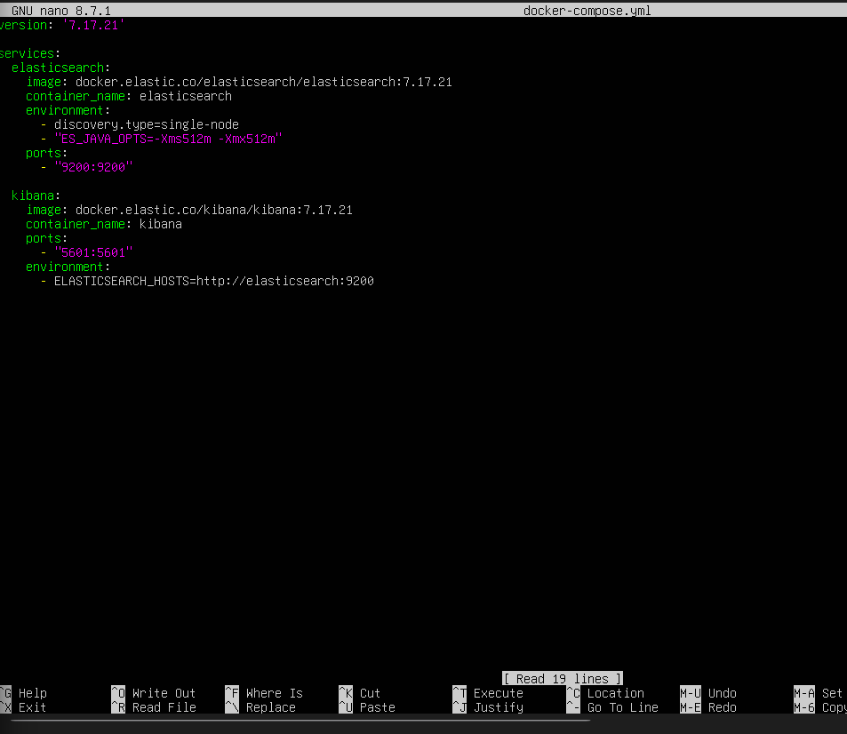4.2 Logging Agent Configuration
The log forwarding pipeline is powered by an independent Filebeat agent deployment. The core authentication modules were activated directly on the target node, binding the log forwarding path to watch the Linux kernel authorization logs (/var/log/auth.log). This guarantees that every local SSH connection attempt, authentication failure, or root elevation request is automatically parsed into a standardized schema and indexed for searching.
5. Incident Response Simulation & Forensic Timeline
This security simulation follows the industry-standard NIST Incident Response Lifecycle: Preparation, Detection/Analysis, Containment, and Post-Incident Verification.
Plaintext
[ Phase 1: Preparation ] ───> [ Phase 2: Detection ] ───> [ Phase 3: Containment ] ───> [ Phase 4: Review ]
📋 Consolidated Incident Response Timeline
Real-Time Marker (IST) | Incident Phase | Analytical Observations & Defensive Action Protocols
10:35 AM | 1. Preparation | Ingestion pipeline activated. Normal system administration activities are monitored to create a baseline profile. Baseline log traffic registers as minor bars scattered safely across the dashboard chart.
10:47 AM | 2. Exploitation Attack | A threat actor initializes a high-velocity, automated password-spraying credential attack against the target's network interface using Hydra from a Kali Linux instance.
10:48 AM | 3. Incident Detection | An active analyst runs a targeted search filtering for event.outcome : "failure". The timeline immediately spikes with a massive 48-hit vertical green column anomaly, signaling a live brute-force attack. Forensic extraction identifies the threat actor's machine address as 192.168.0.102 targeting root administrative accounts.
10:52 AM | 4. Containment Phase | Defenses are immediately deployed at the target server's network layer. The Uncomplicated Firewall (UFW) is activated, and a strict system-level block rule is introduced to drop all traffic originating from the malicious address (192.168.0.102).
10:55 AM | 5. Post-Incident Review | Verification checks are performed. Adversary terminals confirm complete connection timeout failure, and live dashboard telemetry drops back down to zero hits, confirming total threat containment.
Forensic Threat Detection Evidence
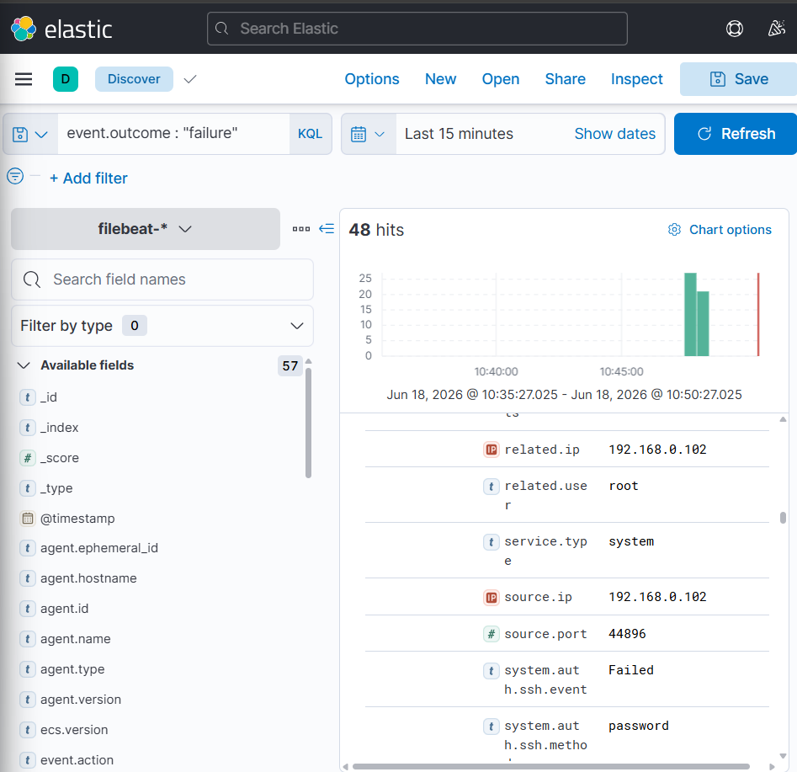Active Network Containment Evidence
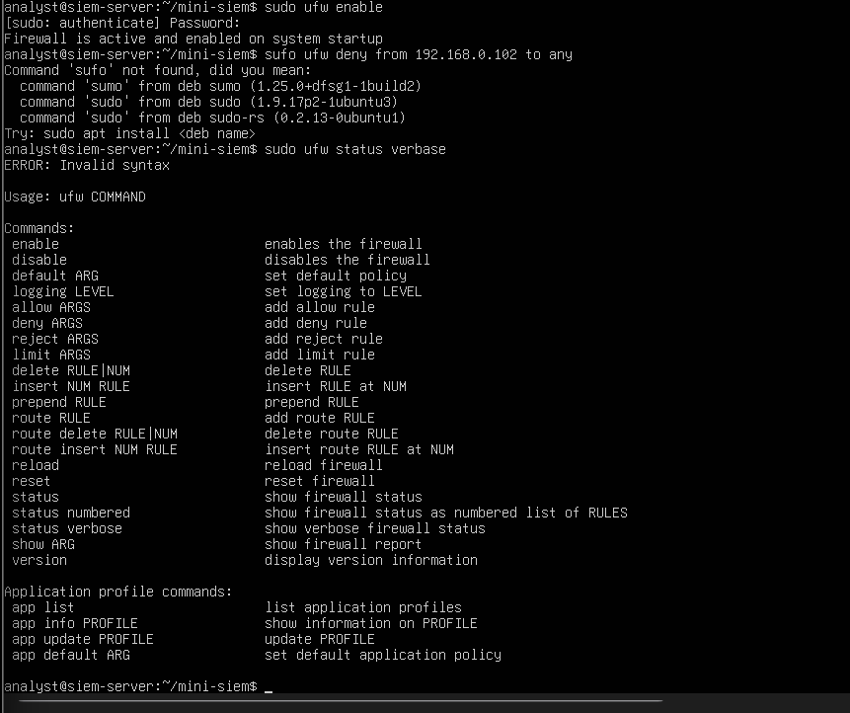6. Suggested Long-Term Mitigation Strategies
To transition the infrastructure from a reactive containment posture to proactive protection, the following defense-in-depth measures are recommended for production environments:
- Public Key Authentication: Completely disable password-based logins inside the SSH daemon configuration (/etc/ssh/sshd_config), enforcing mandatory RSA/Ed25519 cryptographic key pairs.
- Automated Brute-Force Banning: Implement an intrusion prevention service like Fail2ban. This service dynamically scans systemic auth logs and automatically scripts temporary or permanent firewall block actions without requiring manual analyst intervention.
- Port Obfuscation: Relocate the administrative listening interface away from standard default access ports (Port 22) to an alternative private registration port, drastically dropping exposure to automated web scanners.
7. Conclusion
Project SentinelAuth successfully validates how a lightweight, containerized SIEM ecosystem can equip security analysts with the visibility needed to defend infrastructure. By structuring clear telemetry pipelines, tracking behavioral metrics, and pairing visibility with rapid host-level firewall containment, the security loop was closed smoothly, proving the design resilient against automated network exploits.

